ST JULIE CATHOLIC PRIMARY SCHOOL

ECCLESTON

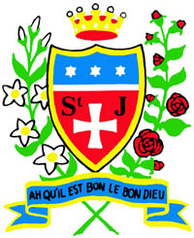

School Worship Policy

Reviewed by Governing Body and staff
Spring term 2019

ST JULIE CATHOLIC PRIMARY SCHOOL
MISSION STATEMENT:
A caring, family school where we learn, grow and walk in the footsteps of Jesus.

In consequence of our school mission it is a fundamental aim of St. Julie’s to be an inclusive school. To be a school which:-
- Has a sense of community
- Provides equal opportunities
- Offers partnership between school parents and parish
- Reflects upon the teachings of Christ and puts them into practice
- Values all members of the school community
- Its members show respect for themselves and each other
- Is a caring community.

We define an inclusive school as one where…
- Everyone, irrespective of age, gender, ability or disability, race or religion is encouraged and given equal opportunity to participate in the full life of the school,
- All members of the school community are given the opportunity and support to achieve their true potential,
- All members of the school community, and the contributions they make to the life of the school, are valued and where everyone is treated with mutual respect, care and consideration, and
- Everyone feels empowered to play a full an effective role in the school.

Rationale

Collective Worship is the celebration of everything in our lives. It is making the stuff of our daily lives holy. The daily act of Collective Worship ensures that at least once in every day we take the time to celebrate the presence of God in our lives through words and action. It must be central to our Catholic ethos and in keeping with the traditions of a catholic school.
It is our loving response in word and action to God’s invitation to enter into relationship with him, made possible through the work of Jesus and the Holy Spirit.

In consequence of our school mission it is a fundamental aim of St. Julie’s to be an inclusive family. To be a school which:-
- Has a sense of community
- Provides equal opportunities
- Offers partnership between school parents and parish
- Reflects upon the teachings of Christ and puts them into practice
- Values all members of the school community
- Its members show respect for themselves and each other
- Is a caring community.

We define an inclusive school as one where…
- Everyone, irrespective of age, gender, ability or disability, race or religion is encouraged and given equal opportunity to participate in the full life of the school,
- All members of the school community are given the opportunity and support to achieve their true potential,
- All members of the school community, and the contributions they make to the life of the school, are valued and where everyone is treated with mutual respect, care and consideration,
- Everyone feels empowered to play a full and effective role in the school.

Purposes
- To provide opportunities to celebrate through liturgy, sacrament, ritual, symbol and prayer, the liturgical season and special feasts.
- To celebrate in worship the common themes in curriculum Religious Education.
- To stimulate spiritual growth and to promote reflection on moral and social issues.
- To enable children to identify with the whole school or group and to experience being part of a worshipping community whether through active involvement in presentation or responding to the worship experience.
- To enable the school community to celebrate, to give thanks, to wonder, to acknowledge success, applaud achievement and to respond to loss and difficulties.
- To reinforce prayers which are part of the Catholic tradition,
- To be sensitive to the perspective of those who may be of other
faith traditions.
- To fulfil the legal requirements of a daily act of worship for all pupils.

Legal requirements

- A daily act of worship, either as a whole school, in classes or groups.
- More than saying a prayer led by the teacher (this does not fulfil requirements)
- Not designated curriculum time. Outside the curriculum.

Time Allocation

Should be short and compatible to children's attention span.
Approximately one minute for each year of their life.

5 yrs = 5 minutes etc.

Key Stage 1 = approx 10 minutes

Key Stage 2 = approx 15 minutes.

The collective worship can take place at any point in the day as long as it is not part of curriculum time.

Guidelines
1. All acts of worship will:
- Give glory to God, honour and praise and thanks
- Reflect the Catholic nature of the school
- Give children a positive liturgical experience
- Take place in a variety of groupings and settings and at different times of the day
- Be appropriately paced for the age and the experience of the children
- Provide opportunities to listen, to reflect and to respond within an appropriate setting and atmosphere.

2. Collective Worship is planned with reference to the Church’s seasons, current Come and See topics, significant dates and events of importance to individuals in the community.

3. Pupils of all ages have the opportunity to develop skills in preparing, organising and leading worship.

4. Opportunities are provided for parents, and the wider school and parish community, to take part in Acts of worship.

5. Eucharistic celebrations take place in St Julie’s Church to mark feasts in the church year and significant events during the school year.

6. Over the course of the year opportunities are provided to meet for prayer at lunchtime or playtime as during Advent and Lent.

7. Collective worship is planned, resourced, monitored, recorded and evaluated.

Planning
Collective worship is planned following Diocesan guidelines, using the format of:
- Preparation
- Gathering
- Listen
- Respond
- Go forth
(See Appendix 1)

Forms of worship
Children have the opportunity to engage in worship in many different formats and prayer styles. Each class has a folder of traditional church prayers but are also encouraged to participate in personal / spontaneous prayer and prayerful silence/ meditation.
They participate through:
- Collective Acts of Worship (appendix 2)
- Class prayer
- Celebrations of Holy Mass on Holydays of Obligation; Eucharistic Celebration; School Leavers’ Mass
- Other occasions: The children participate in services throughout the year, reflecting seasonal celebrations.

Daily Acts of Worship
The children attend Key stage and whole school Collective Worship as outlined in the Collective Worship policy.

Worship Welcomers are pupils in Y1 and KS2 who support daily acts of worship. Supported by an adult they will have an increasing role in this process as they progress through school. The school follows themed acts of worship each week, with readings provided by the coordinator. These themes are published on the website in order that adults at home may reflect on these readings should they choose to do so.
Children are encouraged to learn traditional prayers, appropriate to their age and engage in personal / spontaneous prayer

Prayer Focus Tables
In each classroom, a small area or table is to be set aside for collective worship. It can contain anything that is relevant to the topic covered in "Come and See". The table should be constantly changing so it becomes a focal point. Children are to be encouraged to provide objects for this display, making it personal and meaningful to them.

Atmosphere and Setting

- The atmosphere should be quiet, tranquil and peaceful
- The person leading the Collective Worship should greet the children and invite them to prayer.
- When Collective Worship takes place in the hall, classes should be encouraged to enter and leave in a quiet, reflective and respectful manner.
- Seating arrangement should be varied e.g. in the round, in a square etc.
- The content of the Collective Worship should be easily understood by the children and appropriate to the age-range of the children present.
- Music will be played as the children enter and leave the hall. This music will reflect the current theme of the week or month. The leader of the Collective Worship will encourage the children to pause and reflect before commencing to engender an appropriate atmosphere.

Equality and SEN
At St Julie Primary School we aim to provide equality of opportunity for all children whatever their age, ability, gender, race, religion or background. We aim to create an environment that values each pupil and enables them to achieve their full potential. We provide a broad and balanced curriculum appropriately differentiated to respond to pupils’ diverse learning needs. Ensuring differentiation is a fundamental and core element of inclusion. As such we plan and resource our learning, in line with our whole school policies, to enable all pupils to make good and sustained progress. In our differentiated planning we take due regard of factors such as classroom organisation, learning materials and the learning environment.
The opportunities and experiences we provide enable our pupils to participate fully and give their best across all aspects of school life. We place great value on the quality of relationships within our school community and celebrate the achievements of all pupils. We appreciate that children may have special educational needs throughout, or at any time during their school career. At St Julie Primary School we aim to facilitate the full inclusion of pupils with special educational needs.
We encourage all children, whatever their ability, in accordance with the school curriculum policy of providing a broad and balanced education to all children. Teachers provide learning opportunities matched to the needs of children in their class.

Policy Reviewed: Spring 2023 Next review: 2026
Appendix 1



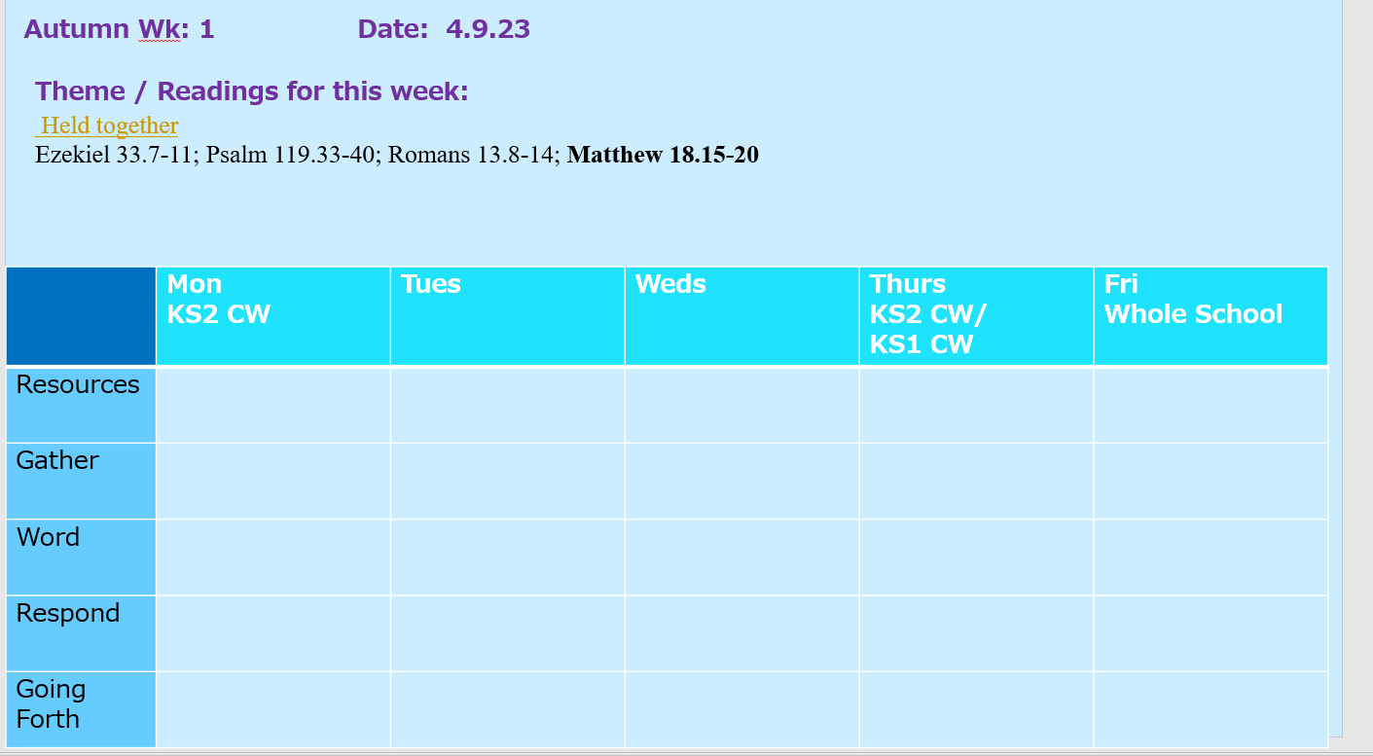

Appendix 2
Key Stage/ whole school Collective Worship

Monday - KS2 Collective worship and assembly led by Deputy.

Tuesday -

Wednesday

Thursday - KS2 Collective worship / KS1 Collective Worship

Friday - KS1 and KS2 collective worship led by Headteacher or Deputy

