Dear parents and carers,


This week the children have had a taster morning in what will be their new classroom in September. They have spent time getting to know their new teachers and teaching assistants, who have in turn been getting to know them. Year 6 have also spent time in their new High Schools getting to know their routines and expectations ready for their new adventure. We have also welcomed our new intake for a stay and play session which they all thoroughly enjoyed. They will be joining us again next Thursday for the Teddy Bears’ picnic.



End of Year reports
Today your child should have brought home their end of year report which will provide you with an overview of your child’s achievements and progress over this academic year. If you have any questions or comments we will be holding our drop-in Open Evening after school on Thursday 11th July from 3:20pm until 4:15pm. Year 6 who have been at De La Salle this week will bring their reports home on Monday.

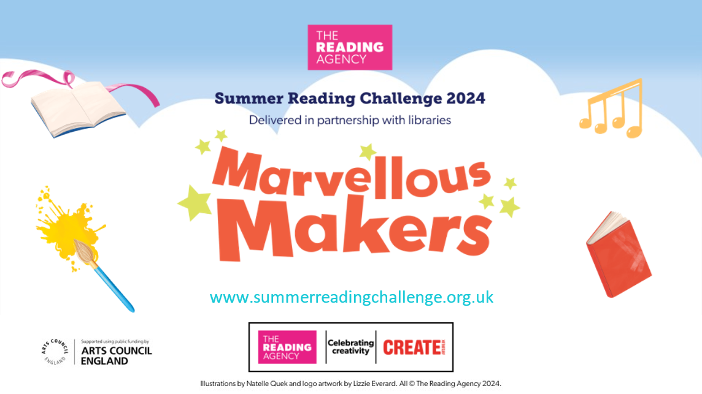
Summer Reading Challenge
Unleash your Creative Side and join the Summer Reading Challenge with St Helens Library Service This summer, dive into a world of creativity and imagination with our Marvellous Makers Summer Reading Challenge! Running from Saturday, July 6th, in all libraries across St Helens, this challenge is designed to inspire the inner storyteller in every child. We invite young readers to embark on an exciting journey of discovery, curiosity, and creativity. How to Get Involved Signing up is easy and free! Simply visit any library in St Helens from Saturday, July 6th, to register. Then read 6 books throughout the summer holidays. Children will receive an age suitable Summer Reading Challenge pack upon borrowing their first book.
Exciting Events and Activities Throughout the summer: St Helens libraries will host a variety of events designed to engage and inspire young makers. Don't miss out on any of the action! Check out our What's On calendar for a full list of events and details https://sthlibrarieswp.koha-ptfs.co.uk/ whats-on/
Year 3 had a marvellous time on Thursday afternoon when they visited Eccleston Library to hear all about this year’s Summer Reading Challenge.


This week’s flyer from National Online Safety is, “What parents and educators need to know about online trolling.”

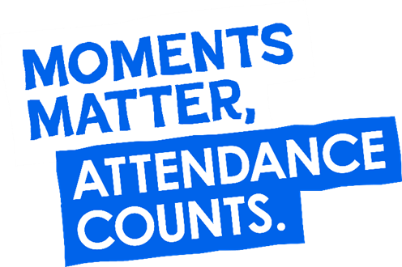
“From the first day of term to the last, the small moments in a school day make a real difference to your child.” #AttendanceCounts
At St Julie’s our attendance is excellent and we know that parents and carers value the education that your children receive. This week you should have received an email from us informing you that the Government is launching a national campaign to remind parents and carers of the importance of school attendance and promoting the importance of being in school, on time, every day.

Useful website Is my child too ill for school? - NHS (www.nhs.uk)

Year Group | % Attendance for w/e 05.07.24
Year R | 89.70
Year 1 | 97.59
Year 2 | 88.0
Year 3 | 97.94
Year 4 | 98.86
Year 5 | 98.86
Year 6 | 97.65

Well done to Years 4 & 5 who jointly had the highest attendance this week.
Our whole school attendance this week is 95.51%


St Julie’s Awards of the Week

 | Star of the week for showing hope | Book explorer | Marvellous mathematician
Reception | Whole class | Blake He | Orlagh
Year 1 | Poppy D | Vienna | Caleb
Year 2 | Raphie | Noah C | Joel
Year 3 | Holly | Bobby George M | Dominic
Year 4 | Scarlett | Aoife | Zachary
Year 5 | Thomas K | Amelia B | Thomas H

Pre-loved St Julie’s uniform
Before you spend money ordering uniform for September, don’t forget that the PFA have many items of school uniform available in the school foyer and more online. If you can, a small donation of any amount would be useful for school funds.

Diary w/c 08.07.2024


Monday 8am Gymnastics
Year 3 Forest School
KS2 Football club 3:20 – 4:15
KS2 Forest School club 3:20 – 4:15

Tuesday Year 1 Forest School
KS2 Football club 3:20 – 4:15

Wednesday Altru Drama workshops for Junior classes in school
KS2 Athletics club 3:20 – 4:15
KS2 Arts & Crafts club 3:20 – 4:15
Y1/2 Arts & Crafts club 3:20 – 4:15

Thursday Year 2 Forest School day
9:30-10:30 Teddy Bear’s Picnic for new intake for Sept 24
Year 1 Class Collective Worship 3pm
End of year drop-in Open Evening from 3:20pm until 4:15pm
YR Arts & Crafts club 3:20 – 4:15
Friday

Further dates for your Diary
Monday 15 July Year 5 Forest School
Wednesday 17 July Year 3 trip to Liverpool World Museum
Wednesday 17 July Year 6 Sports Celebration at Ruskin Drive
Wednesday 17 July Year 2 Class collective worship 3pm
Thursday 18 July Year 6 Leavers’ Celebration event 2:00pm (Parents and grandparents)
Monday 22 July Year 6 Leavers’ Mass 6pm followed by disco in Parish Hall
Tuesday 23 July School closes for Summer



“A caring family school, where we learn, grow and walk in the footsteps of Jesus.”

St Julie pray for us, protect us and bless us.

