Dear parents and carers,


On Tuesday we received our Y6 children’s Key Stage 2 SAT results and are absolutely delighted for the children who have worked so hard throughout their time at St Julie’s. We recognise their many achievements along the way, their creative and sporting talents, their knowledge and understanding in so many curriculum areas and their huge impact in developing the values and ethos of our school. What wonderful young citizens each one of them has become - our whole school community are proud of what they have achieved.

All of the children in school should have received their end of year reports and it was lovely that so many parents were able to come on Thursday and spend time in the classroom looking at their books and work displayed. Looking back over the year, it is amazing to realise just how much the children have experienced and we are proud to celebrate the many and varied achievements of each and everyone of our children. Well done!

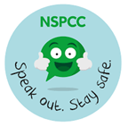
NSPCC’s Speak out. Stay safe. programme
Next Monday we will participating in the NSPCC’s Speak out. Stay safe programme. Speak out. Stay safe. is a programme for children aged 5-11 which aims to help children understand abuse in all its forms and to recognise the signs of abuse. Children are taught to speak out if they are worried, either to a safe adult or Childline.
This child friendly programme is aligned with the curriculum and consists of age-appropriate virtual assemblies and supporting classroom based activities which we have reviewed. The content is delivered in an engaging and interactive way with the help of the NSPCC mascot Buddy.
Parents and carers are asked to let school know if their child may have experienced anything (in the past or happening now) which may mean they need extra support before, during or after taking part in this programme.
If you would like to know more about the Speak out. Stay safe. programme visit www.nspcc.org.uk/speakout.

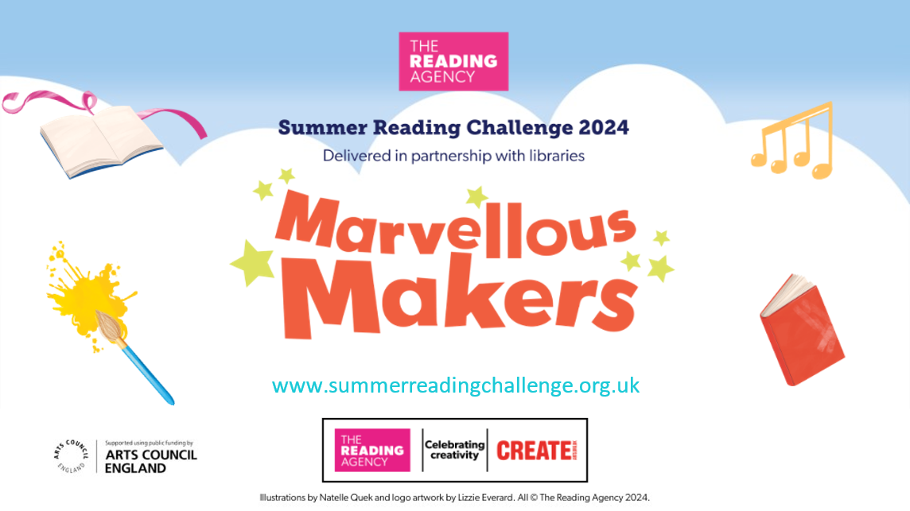
Summer Reading Challenge
Unleash your Creative Side and join the Summer Reading Challenge with St Helens Library Service This summer, dive into a world of creativity and imagination with our Marvellous Makers Summer Reading Challenge! Running from Saturday, July 6th, in all libraries across St Helens, this challenge is designed to inspire the inner storyteller in every child. We invite young readers to embark on an exciting journey of discovery, curiosity, and creativity. How to Get Involved Signing up is easy and free! Simply visit any library in St Helens from Saturday, July 6th, to register. Then read 6 books throughout the summer holidays. Children will receive an age suitable Summer Reading Challenge pack upon borrowing their first book.
Exciting Events and Activities Throughout the summer: St Helens libraries will host a variety of events designed to engage and inspire young makers. Don't miss out on any of the action! Check out our What's On calendar for a full list of events and details https://sthlibrarieswp.koha-ptfs.co.uk/ whats-on/
Year 3 had a marvellous time on Thursday afternoon when they visited Eccleston Library to hear all about this year’s Summer Reading Challenge.
Year 2 Transition meeting
There will be a short transition meeting for current Year 2 parents as their child leaves the infants to start the juniors. The meeting will be in the Year 3 classroom on Wednesday 17th July straight after school. The teacher will explain the Junior routines and expectations and how you can help to prepare your child for Year 3. The children will be looked after in the hall while the meeting takes place.
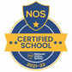
This week’s flyer from National Online Safety is, “What parents and educators need to know about sharing intimate images.”

Reminder: Earrings CANNOT be worn in school. If a child is wearing earrings or any other form of jewellery they will be asked to remove it for health and safety reasons. If a child is having their ears pierced, we advise that this is done at the start of school summer holiday so that the ears are sufficiently healed to enable earrings to be removed for school. If they cannot be removed then they must be covered with tape in school until sufficiently healed: tape in itself is also a health and safety hazard. Thank you in supporting our uniform policy.

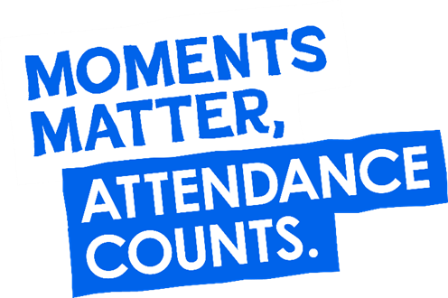
“From the first day of term to the last, the small moments in a school day make a real difference to your child.” #AttendanceCounts
At St Julie’s our attendance is excellent and we know that parents and carers value the education that your children receive. This week you should have received an email from us informing you that the Government is launching a national campaign to remind parents and carers of the importance of school attendance and promoting the importance of being in school, on time, every day.

Useful website Is my child too ill for school? - NHS (www.nhs.uk)

Year Group | % Attendance for w/e 12.07.24
Year R | 99.09
Year 1 | 99.66
Year 2 | 83.71
Year 3 | 95.88
Year 4 | 97.71
Year 5 | 97.71
Year 6 | 94.71

Well done to Y1 who had the highest attendance this week.
Our whole school attendance this week is 95.50%


St Julie’s Awards of the Week

 | Star of the week for showing hope | Book explorer | Marvellous mathematician
Reception | Stanley Jacob | Jack | Ezra
Year 1 | Cameron | Teddy | Vienna
Year 2 | Eliza Theo H | Ella | Ivy
Year 3 | Jackson H | Teddy H | William
Year 4 | Joseph | Jude | Scarlett
Year 5 | Henry | Tommy D | Matthew T
Year 6 | Bella | Grace | Evie

School meals questionnaire
We have been asked by St Helens Local Authority, to share the following questionnaire QR code and hyperlink with our parents. This is an opportunity for parents to express their thoughts on school meals, this will help to develop the service they offer and make improvements where possible.

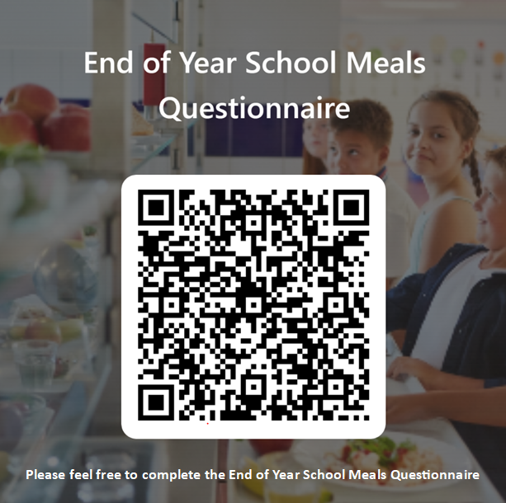

https://forms.office.com/e/WYpP5ErKa4

Pre-loved St Julie’s uniform
Before you spend money ordering uniform for September, don’t forget that the PFA have many items of school uniform available in the school foyer and more online. If you can, a small donation of any amount would be useful for school funds.

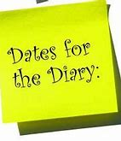
Diary w/c 08.07.2024

Monday 8am Gymnastics
Year 5 Forest School
NSPCC Speak out. Stay Safe. assembly

Tuesday Summer Craft Club 3:20 – 4:45

Wednesday 8am Multi-skills
Year 3 trip to Liverpool World Museum
Year 6 Sports Celebration at Ruskin Drive
Year 2 Class collective worship 3pm
3:20 Y2 transition to Y3 meeting for parents in Y3 classroom
Full Governing Body meeting 5pm

Thursday Year 6 Leavers’ Celebration event 2:00pm (Parents and grandparents)
KS2 Dodgeball 3:20 – 4:14

Friday Whole school Forest School and Wellbeing day: clothing suitable for
exploring the outdoors (if anything like the weather we have had so far – wet
weather clothing!)

Further dates for your Diary
Monday 22 July Year 6 Leavers’ Mass 6pm followed by disco in Parish Hall
Tuesday 23 July School closes for Summer

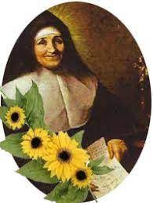

“A caring family school, where we learn, grow and walk in the footsteps of Jesus.”

St Julie pray for us, protect us and bless us.

