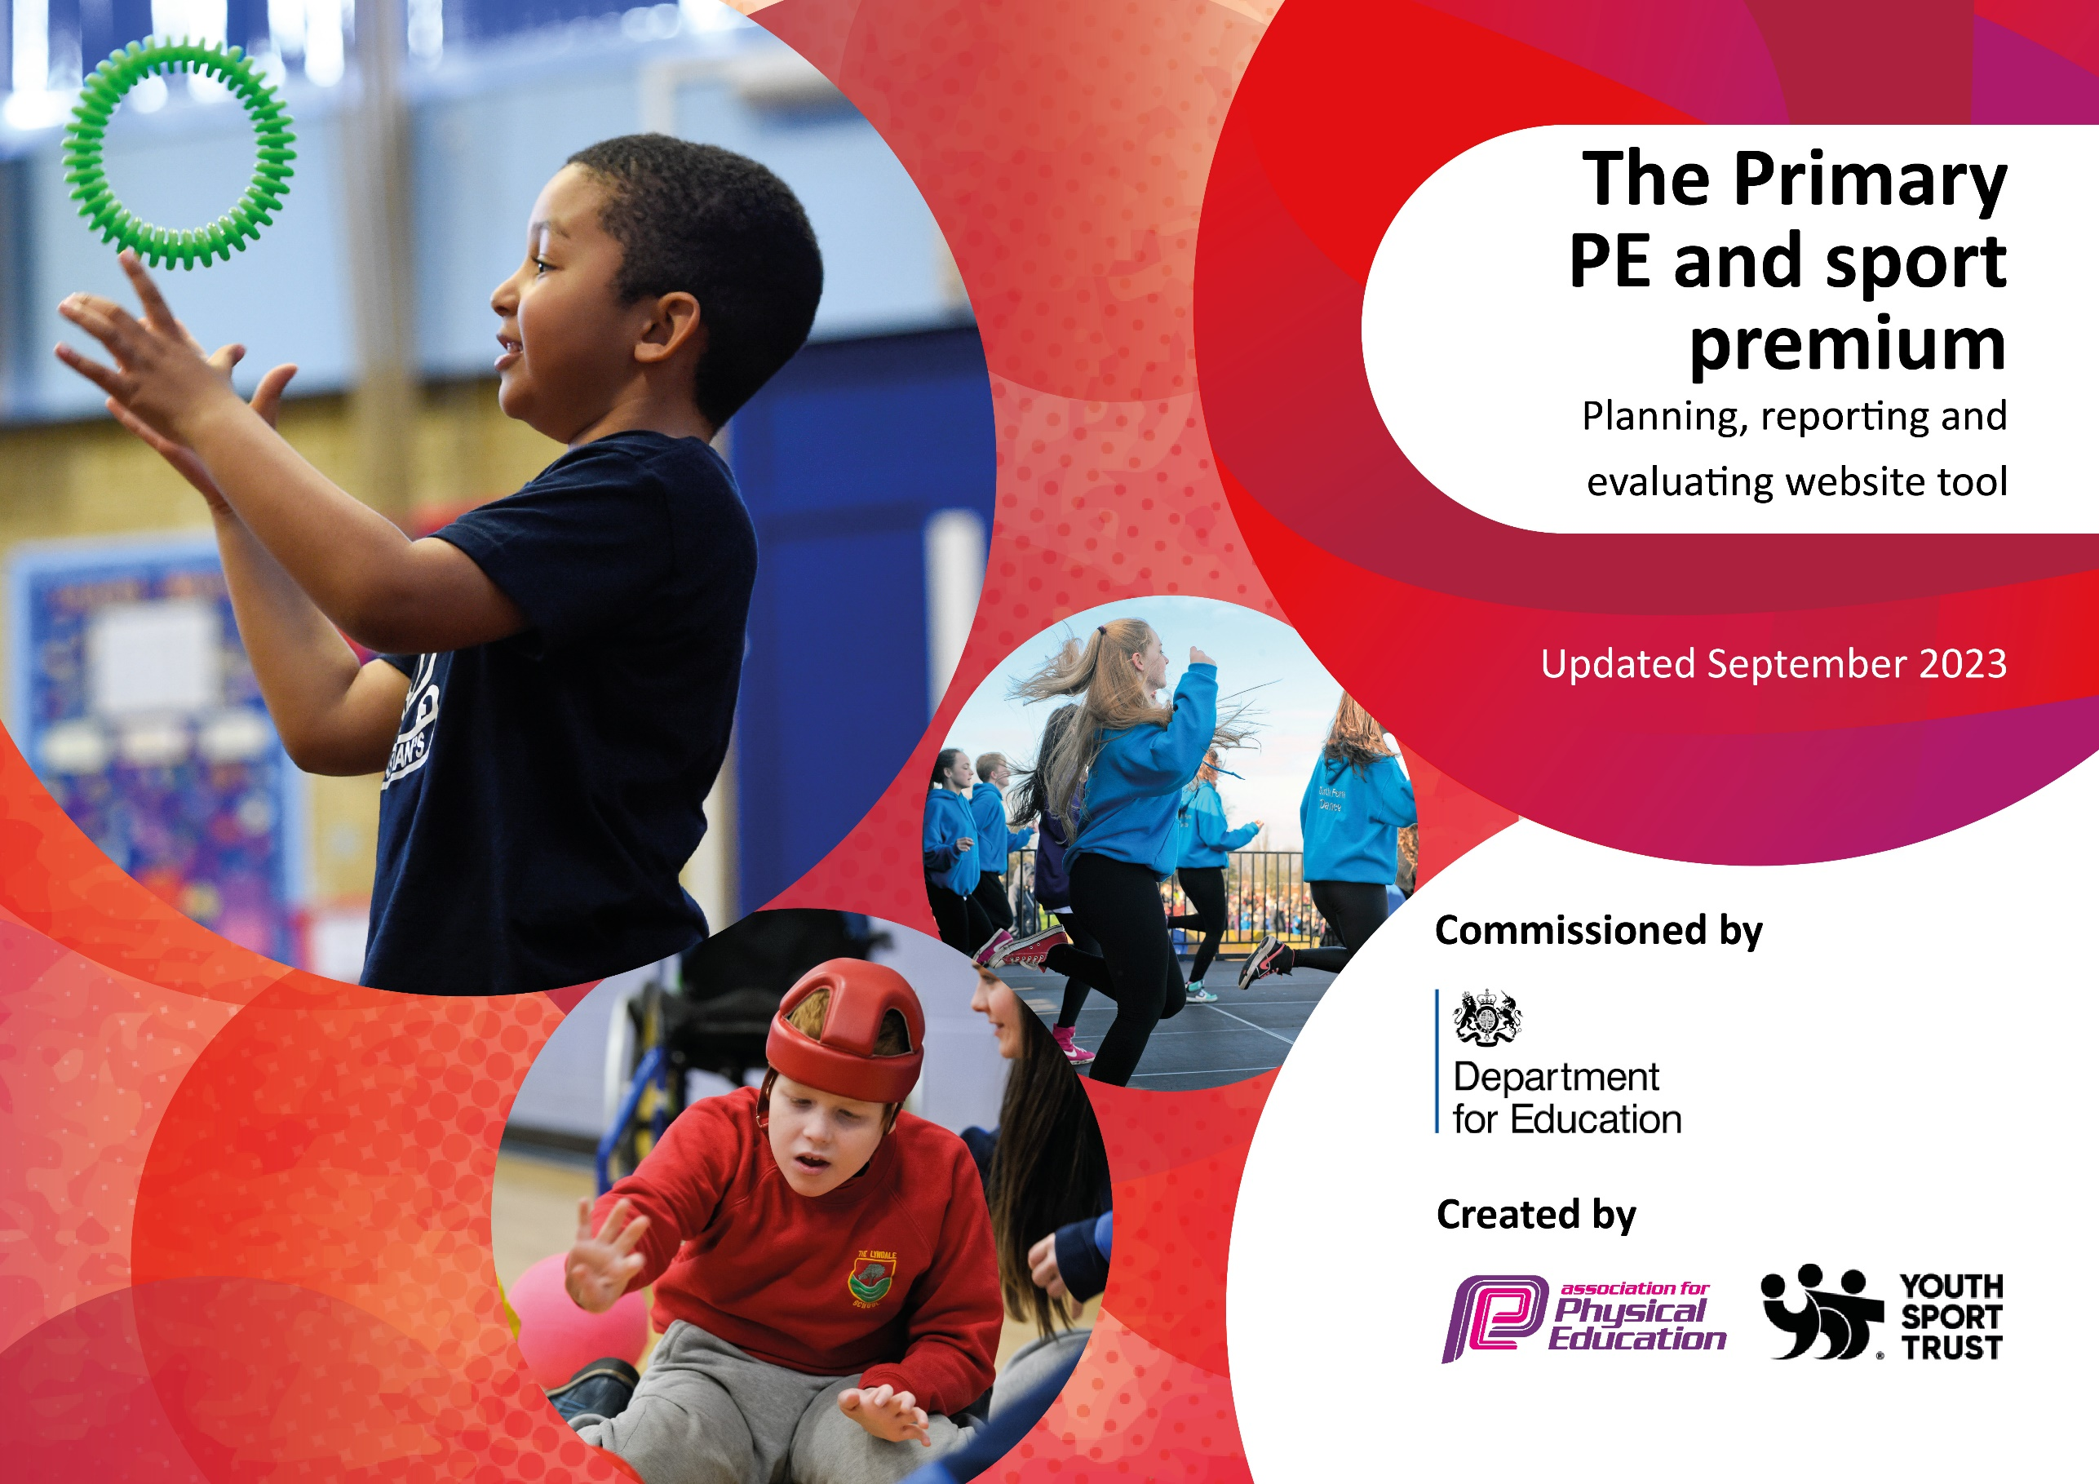

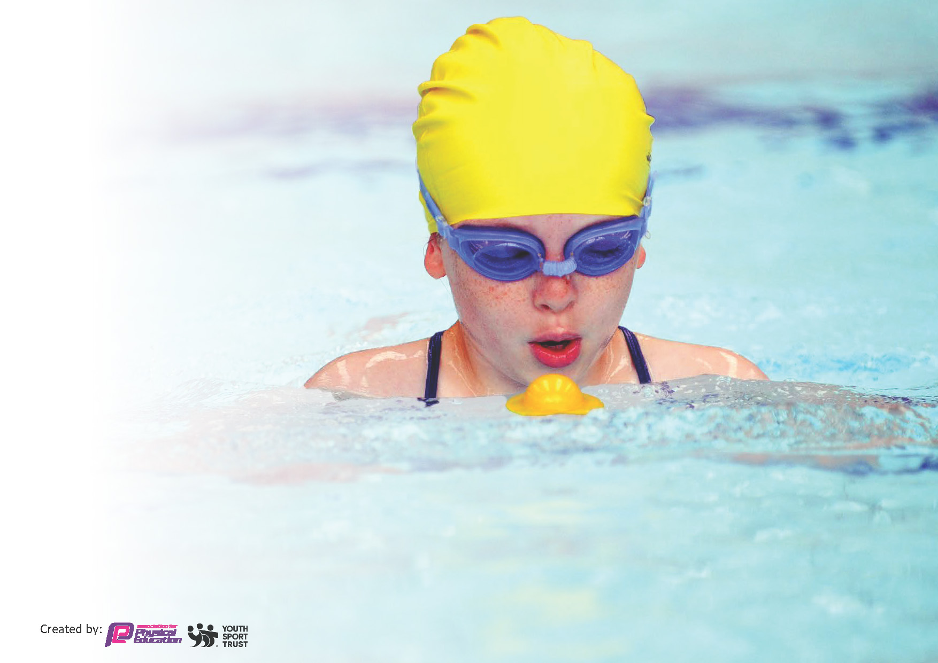
This template can be used for multiple purposes:
by:
- It enables schools to effectively plan their use of the Primary PE and sport premium
- It helps schools to meet the requirements (as set out in guidance) to publish information on their Primary PE and sport premium
- It will be an effective document to support Ofsted inspections enabling schools to evidence progress in Physical Education (PE) and evidence swimming attainment, which forms part of the PE National Curriculum. We would recommend schools consider
the Intent, Implementation and Impact of any spend, as examined within the Education Inspection Framework.

It is important that your grant is used effectively and based on school need.

Schools must use the funding to make additional and sustainable
improvements to the quality of the PE, School Sport and Physical Activity (PESSPA)
they offer. This means that you should use the Primary PE and sport premium to:

- Build capacity and capability within the school to ensure that improvements made now will benefit pupils joining the school in future years
- Develop or add to the PESSPA activities that your school already offers.

The Primary PE and sport premium should not be used to fund capital spend projects; the school’s core budget should fund these. Further detail on capital expenditure can be found in the updated Primary PE and sport premium guidance.

The Primary PE and sport premium guidance, outlines 5 key priorities that funding should be used towards. It is not

necessary that spending has to meet all the key priorities, you should select the priorities that you aim to use any funding towards.

Although completing this template is not a requirement for schools, schools are required to publish details of how they spend this funding. Schools must also outline what the impact this funding has had on pupils’ PE and sport participation and attainment and how any spending will be sustainable in the future. All funding must be spent by 31st July 2024.

The Department for Education has worked closely with the Association for Physical Education (afPE) and the Youth Sport Trust (YST) to develop this template and encourages schools to use it. This template is an effective way of meeting the reporting requirements of the Primary PE and sport premium.
Review of last year’s spend and key achievements (2022/2023)

We recommend you start by reflecting on the impact of current provision and reviewing your previous spend.

Activity/Action | Impact | Comments
- During 2022-23 we continued to ensure 2 hours quality PE lessons each week (KS1 and KS2)  - We continued to offer a wide range of after-school sports clubs.  - We continued to subscribe to the enhanced membership of SHAPES.  - Via the St Helens School Games programme, we participated in a wide range of inter-school sports competitions (across KS1 and KS2)  - Whole School promotion of 60 Active Minutes Daily (Monthly Mile/Active Playtimes.  - In working towards the achievement of the Wellbeing Award for Schools we ensured that all children were aware of the importance of a healthy lifestyle – including diet, mental health and wellbeing, as well as regular exercise.  - Playground Leader programme to support EYFS and KS1 in lunchtime and curriculum sport sessions/activities for pupils.  - Via the Children’s University Programme, children are rewarded for their participation in a range of extra-curricular activities.  . | - All children take part in regular physical activity within St Julie’s during PE lessons, active breaks, brain breaks, etc.  - A PE specialist and school staff offered a range of sports clubs after school – including football, multi-skills and athletics.  - 20 inter-school competitions were attended – which targeted all abilities. We currently hold the School Games Platinum Award.  - The least active children are becoming more active throughout the school day.  - Children are more aware of the links between their physical and mental health. St Julie’s also received a Wellbeing Award for their efforts and achievements throughout recent years.  - Children are more active at break-times and the Year 6 children have developed their communication skills and had lots of fun!  - Children take part in a wide range of extra-curricular activities. | - Via pupil voice – children say that they enjoy PE and trying new sports.  - We targeted Pupil Premium children and the least active when engaging in inter-school and intra-school sports. We also strive to eradicate any gender stereo types in sports.  - All abilities of children are targeted via the School Games programme of “inspire, aspire and celebrate” events. We always enter a range of events.  - Sports Ambassadors help to filter this message through school, as well as staff. The Physical Activity Tracker has been used to provide evidence for the 2nd year of School Games Platinum Award. All children have daily access to a variety of playground equipment, to a daily mile track, play area equipment, football pitches, table tennis and extensive fields.  - Children are aware that there is more to a healthy lifestyle than just physical exercise. Pupil voice evidences that children are knowledgeable about the link between being active and having good mental health. Throughout PE, DT (Food Technology), Science and PSHE – staff remind children of the importance of a healthy diet and looking after our mental/physical health and wellbeing. Themed Wellbeing Days further enforce this message.  - Beneficial to all involved and helped to develop strong bonds between the younger and older children. Activity Leaders trained by St Helens School Games leaders have encouraged participation in playground games and Year 6 Buddies have supported active playtimes on a daily basis with lunchtime supervisors commenting on increased engagement in playground activities.  - Via the school bulletin and website, children are encouraged to take part in additional physical activities/challenges during holiday times. Participation in activity clubs is evidenced through Childrens’ University logs, with 138 children receiving awards this year.

Key priorities and Planning
This planning template will allow schools to accurately plan their spending.

Action – what are you planning to do | Who does this action impact? | Key indicator to meet | Impacts and how sustainability will be achieved? | Cost linked to the action
- 2 hours quality PE lessons (KS1 and 2)  - Monthly Mile Competition/  Trophies  - Promotion of the 60 Active Minutes and healthy lifestyles throughout school  - Improving active playtime by participating in the Playground Leader Scheme via S.G.  - Enhanced membership of SHAPES  (Focus on disadvantaged pupils and girls)  - Swimming lessons for Years 4, 5 and 6 during curriculum time  - Children’s University – to continue to promote this opportunity throughout the school  - Specialist sports coaching  (Mr Woodward) | Children and staff.  Children and staff.  Children (Buddies, Play Leaders and Sports Ambassadors)  Adults – teaching staff and lunchtime staff.  Children and staff  All children to participate in sport)  Children and staff  Head teacher, all staff and children  Staff and children | Key indicator 2: The engagement of all pupils in regular physical activity – the Chief Medical Officer guidelines recommend that all children and young people aged 5 to 18 engage in at least 60 minutes of physical activity per day, of which 30 minutes should be in school.  Key indicator 2 and Key Indicator 3: The profile of PESSPA is being raised across the school as a tool for whole school improvement.  Key indicator 4: Broader experience of a range of sports and activities offered to all pupils.  Key Indicator 5: Increased participation in competitive sport.  Key Indicator 1  Key indicators 1, 2 and 4  Key Indicator 1: Increased confidence, knowledge and skills of all staff in teaching PE and sport. | More pupils meeting their daily physical activity goal, more pupils encouraged to take part in PE and Sport Activities. All children are involved in a range of intra and inter-school sports competitions.  Whole school assemblies/walking and cycling to school initiatives have encouraged all children to become more active and adopt more healthy life style choices for the future.  We shall enter a range of inter-school St Helens School Games competitions – ensuring that we cover all abilities. E.g Inspire, aspire and celebrate events.  All staff receive some specialist coaching throughout the academic year. | £189.99  (Purchase of additional playtime resources e.g. balls, frisbees etc.)  SHAPES Subscription  £480.00  (St Helens Community Transport)  £300  (The Big Coach Company)  Additional hours for TAs: £  Swimming SLA £762.00  SLA £2,400  Coach to University £1,050  £9,712.50

- To increase the number of extra-curricular sports clubs and “friendly” matches  - Repair and maintain our outdoor play areas  - Inter house competitions and a KS1 and KS2 annual sports day | External sports coach/children  Children and staff  Children, parents and staff | Key indicators: 1, 2, 3, 4 and 5.  Key indicator:2  Additional sports clubs before school | Additional sports clubs before school.  Including gymnastics, dodgeball and multi-skills. (Friendly matches v another local school.)  Active playtimes will help children to maintain their physical health.  Following questionnaires from parents/pupils our sports day format now ensures that all children participate in a range of sports events within their house teams. The activities were decided upon following discussions with our Sports Ambassadors. E.g. Space Hoppers and Vortex Howlers. | £3,488.88  House flags and School Core Value Trophies  £ 65.00  Additional sports day equipment e.g. Vortex Howlers  £50

Key achievements 2023-2024
This template will be completed at the end of the academic year and will showcase the key achievements schools have made with their Primary PE and sport premium spending.

Activity/Action | Impact | Comments
- We have maintained the School Games Platinum Award  - We have ensured that we continue to have “active” playtimes  (Repairs to play areas and additional equipment.)  - We now offer a wider range of extra curricular sports clubs  - We have had great success this year in inter school competitions (School Games.) We have continued to encourage more disadvantaged children and girls into a variety of sports. | We continue to promote an active life-style throughout many areas of the curriculum – e.g. PE/PSHE/DT/Science.  TAs, Year 6 Buddies and Play Leaders help children to have active and fun playtimes.  More children now attend a wider variety of sports clubs. (See registers saved on T Share Drive.)  St Helens School Games Inter- School Competitions: 3rd place Y4 Gymnastics, Y3/4 Athletics and Y6 Athletics; 2nd place Y4 Dodgeball; 1st place in Rugby, Hockey and Netball (mixed boys/girls teams.) | Throughout St Julie’s children understand and can articulate what it means to have a healthy lifestyle. Supported in class and during assemblies.  Our children are keen to try new sports/activities.  Our children are proud to represent the school in various inter-school competitions and learn to work well as part of a TEAM (Together Everyone Achieves More.)

Swimming Data
Meeting National Curriculum requirements for swimming and water safety.
Priority should always be given to ensuring that pupils can perform safe self-rescue even if they do not fully meet the first two requirements of the National Curriculum programme of study

Question | Stats: | Further context  Relative to local challenges
What percentage of your current Year 6 cohort can swim competently, confidently and proficiently over a distance of at least 25 metres? | 88 %  (30/34) | Year 6 children went swimming for a half-term this year.
What percentage of your current Year 6 cohort can use a range of strokes effectively [for example, front crawl, backstroke, and breaststroke]? | 85%  (29/34) | Children in Year 6 practised back stroke, breast stroke and front crawl. Only children who attended outside swimming clubs mastered butterfly.

What percentage of your current Year 6 cohort are able to perform safe self-rescue in different water-based situations? | 88%  (30/34) | This % corresponded to the children who were able to confidently swim.
If your schools swimming data is below national expectation, you can choose to use the Primary PE and sport premium to provide additional top-up sessions for those pupils that did not meet National Curriculum  requirements after the completion of core lessons. Have you done this? | No
Have you provided CPD to improve the knowledge and confidence of staff to be able to teach swimming and water safety? | Yes | We have three TAs who have an accredited certificate in teaching swimming. They now teach a group during swimming sessions.

Signed off by:

Head Teacher: | Anne Hodgson
Subject Leader or the individual responsible for the Primary PE and sport premium: | Lisa Clayton
Governor: | Sue O’Reilly
Date: | 17th July 2024

