
Celebration Sports Day
Thankfully we chose the perfect week for our Sports Day this year as we were blessed with sunshine on Tuesday. The children thoroughly enjoyed the variety of fun team events and being cheered on by their families.
The points earned for each event have been tallied and the winning house teams this year are Juniors, St Francis and Infants, St Teresa’s. Everyone showed true TEAM (Together Everyone Achieves More) spirit throughout the day.

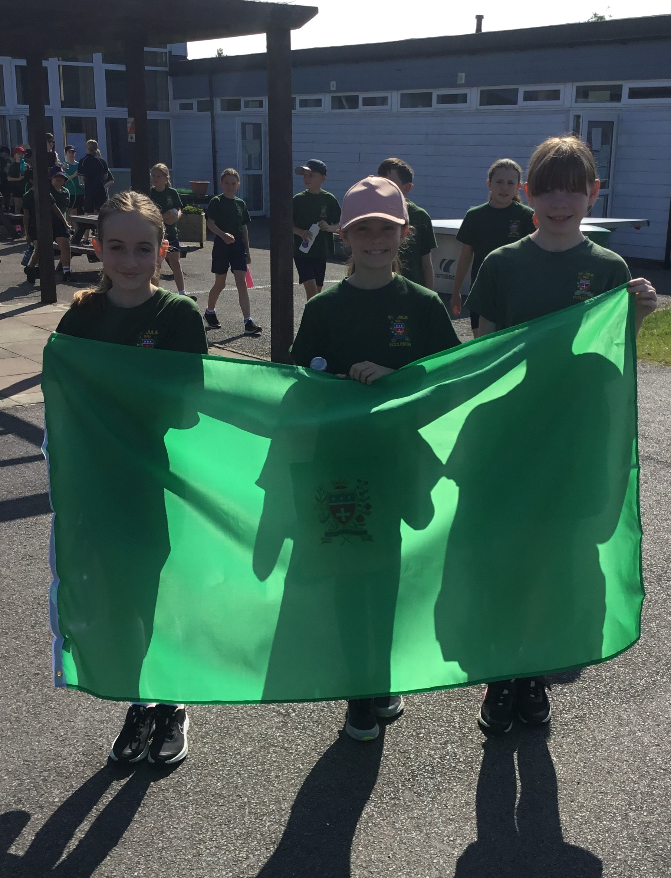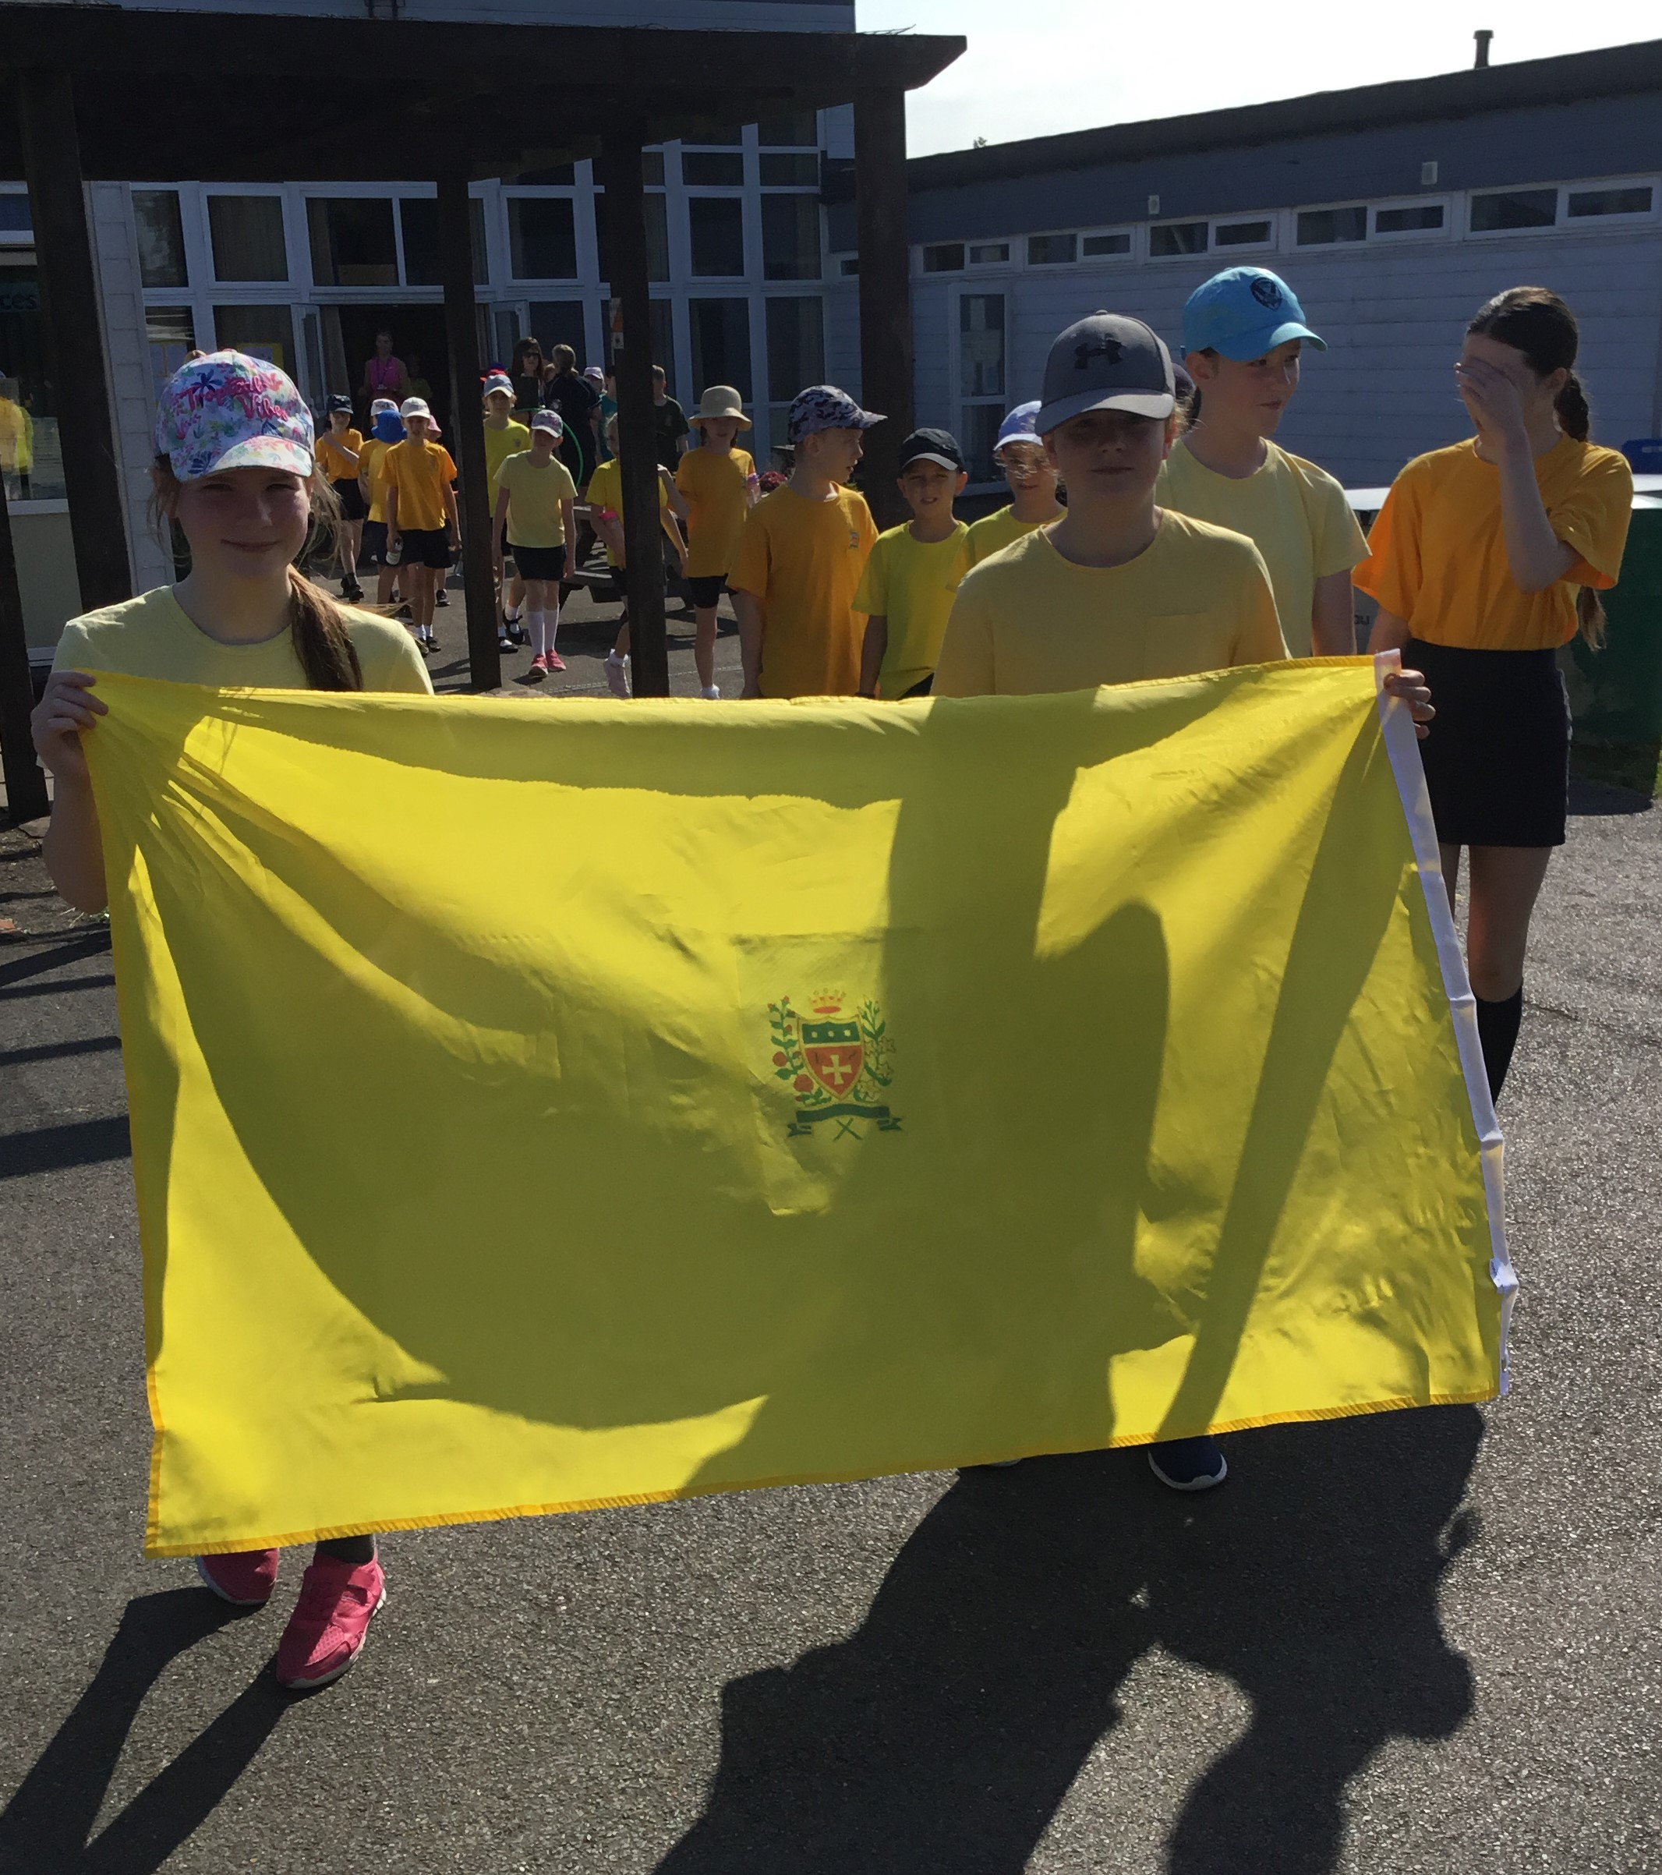

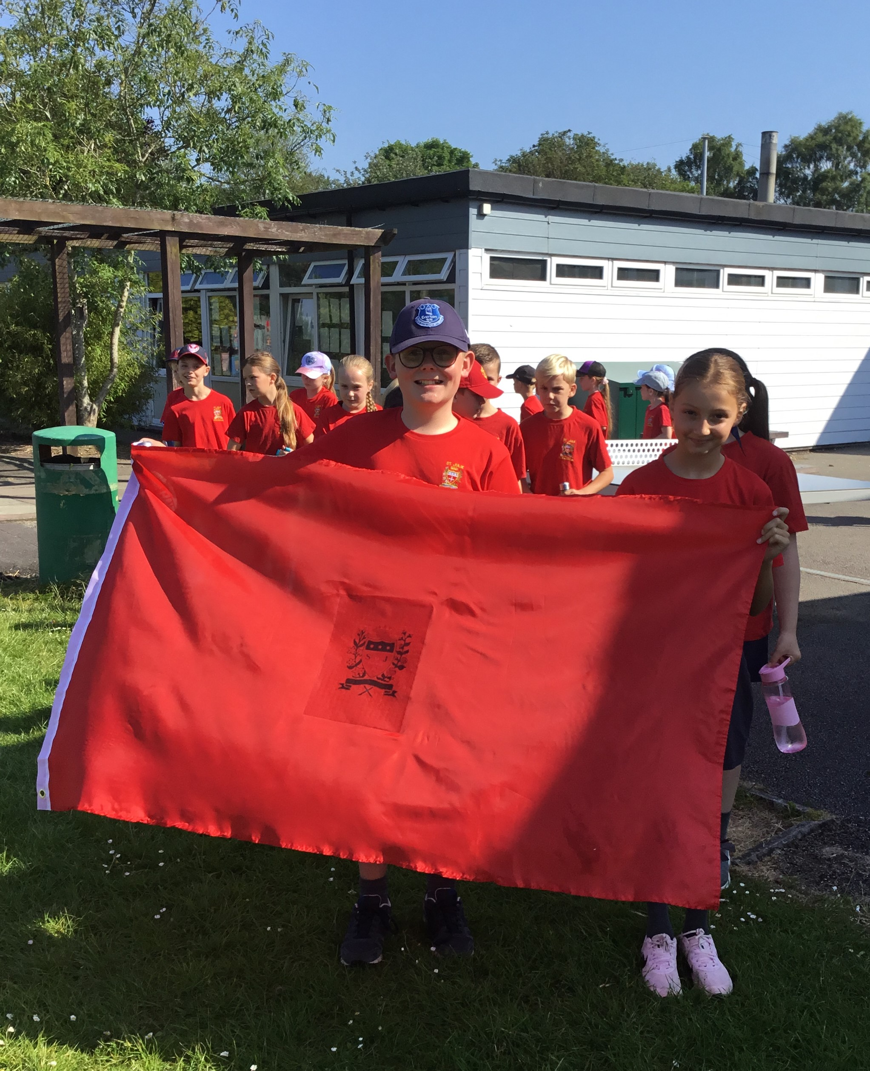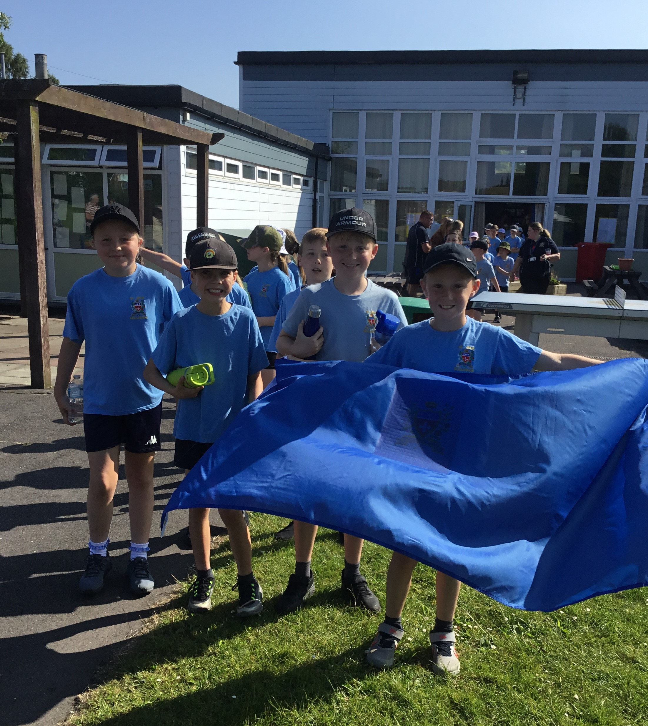


Netball Merseyside Finals
On Wednesday this week, our Netball Team took part in the Merseyside Finals having qualified by winning the St Helens competition. There were many schools competing from across Merseyside and we are proud to say that the St Julie’s team came 3rd in their group. Well done everyone on your fantastic achievement.

Year 3/4 Quadkids
Congratulations to the team of year 3 and year 4 children who took part in the Quadkids competition at Sutton Academy this week. They thoroughly enjoyed the day and demonstrated their skills in the four events. Well done to the children who received their certificates in assembly this morning.

Meet your new teacher morning – Tuesday 2nd July
Next Tuesday morning all of the children will move up to the next year group for the morning. This will be an opportunity for them to see what their classroom will be like in September and to meet their new teacher.
De La Salle will be running the full Year 6 Transition week from 1st to 5th July and should attend every day.
Our new intake visits for Reception September 2024 will also take place on Wednesday 3rd July.
The class teachers from September 2024 will be:
Reception – Mrs Ashcroft
Year 1 - Mrs Kernick and Mrs Slocombe
Year 2 - Mrs Mannion (1 day Miss Wood)
Year 3 - Miss Pratt (1 day Miss Wood)
Year 4 - Mr Royle
Year 5 - Mrs McCahey
Year 6 - Miss Carr and Mrs Clayton
There will be a transition meeting later in the term for current Year 2 parents as their child leaves the infants to start the juniors – date to be confirmed.

Year 6 De La Salle Transition week
Next week our Year 6 pupils who will be joining our feeder high school, De La Salle, in September will be spending the whole week in their new school. There is a mixture of excitement and nerves from the children but we wish them a happy time next week as they have a taste of the lessons and get used to their surroundings.

New intake for Reception September 2024
Next Wednesday we will welcome our new starters for Reception in September as they come to school for a stay and play session with Mrs Ashcroft.


End of Year reports
School reports will be sent out on Friday 5th July to provide you with an overview of your child’s achievements and progress over this academic year. If you have any questions or comments we will be holding our drop-in Open Evening after school on Thursday 11th July from 3:20pm until 4:15pm.

Year 6 Mini-enterprise
Year 6 proved themselves to be upcoming entrepreneurs this week with their hugely successful mini-enterprise. They had worked hard for a number of weeks planning the event and making the games and products. On Thursday there was huge excitement: each class enjoyed coming to Year 6 to take part and even more children came back at the end of the day. Thank you to everyone who took part. Year 6 are proud to announce that they have raised £565.50. Watch out Lord Sugar!

This week’s flyer from National Online Safety is, “What parents and educators need to know about gambling.”


“From the first day of term to the last, the small moments in a school day make a real difference to your child.” #AttendanceCounts
At St Julie’s our attendance is excellent and we know that parents and carers value the education that your children receive. This week you should have received an email from us informing you that the Government is launching a national campaign to remind parents and carers of the importance of school attendance and promoting the importance of being in school, on time, every day.

Useful website Is my child too ill for school? - NHS (www.nhs.uk)

Year Group | % Attendance for w/e 28.06.24
Year R | 99.09
Year 1 | 97.93
Year 2 | 88.00
Year 3 | 98.53
Year 4 | 98.00
Year 5 | 95.43
Year 6 | 94.12

Well done to Year 3 who had the highest attendance this week.
Our whole school attendance this week is 95.29%


St Julie’s Awards of the Week

 | Star of the week for showing hope | Book explorer | Marvellous mathematician
Reception | Myles | Grace | Jacob
Year 1 | Georgie | Matthew | Henry
Year 2 | Gia Jaxon | Zac | Theo
Year 3 | Jackson H | Sam | Zara
Year 4 | Molly | Alivia | Lucy B
Year 5 | Ivan | Isla R | Teddie C
Year 6 | Daniel H | Jack F | Noah D

Pre-loved St Julie’s uniform
Before you spend money ordering uniform for September, don’t forget that the PFA have many items of school uniform available in the school foyer and more online. If you can, a small donation of any amount would be useful for school funds.
A reminder of our School Uniform Policy ahead of September: (Full document on the school website)

- Expectations for school uniform
The children are encouraged at all times to be tidy in their dress and in the care of their belongings. Adherence to the Uniform Policy is essential for maintaining expectations of good behaviour and health and safety regulations.

4.1 Our school’s uniform is:
Long or short grey trousers
Grey skirt or pinafore
Navy-blue sweatshirt/cardigan – available with an embroidered school badge from school’s uniform suppliers or without from any retailer
Sky-blue polo shirt – available with an embroidered school badge from school’s uniform suppliers or without from any retailer
Plain navy blue, grey or white socks
Plain navy blue or grey tights
Plain black flat school shoes, not trainer style or boots. Shoes with heels or flimsy sandals are not permitted for health and safety reasons.
Any colour of coat may be worn
Also available but not part of the official uniform are navy blue reversible fleece/waterproof jackets with St Julie’s embroidered logo (from Touchline Ltd)
Optional for Summer: sky-blue gingham dress available from any retailer
Black or white flat, sturdy sandals (no jelly/beach sandals) with socks
PE kit:
Navy blue loose shorts - no cycling shorts & no branded/logo shorts,
School T Shirt in the colour of their house/team with or without school logo
Slip on pumps.
Trainers for outdoor use
Plain navy blue fleece – from any retailer
Plain navy blue jogging bottoms – from any retailer

We ask that all uniform is clearly labelled with your child’s full name

Long hair must be tied back. Hair accessories should be small and in school colours – blue or black.
No extreme hair styles, e.g. multi-coloured, dyed hair, shaved lines, zig-zag, patterns
No nail varnish is to be worn

A watch or Fit Bit can be worn but must not have internet access or photo facility Jewellery, unless for cultural reasons, must not be worn for school.
Earrings, necklaces, rings and all other forms of jewellery CANNOT be worn in school. If a child is wearing earrings or any other form of jewellery they will be asked to remove it for health and safety reasons.
If a child is having their ears pierced we advise that this is done at the start of school summer holiday so that the ears are sufficiently healed to enable earrings to be removed for school. If they cannot be removed then they must be covered with tape in school until sufficiently healed.

We thank you for supporting the school in maintaining standards and a consistent approach.


PFA 100 Club – June winners!
The June draw of the PFA 100 Club took place today in Assembly with 3 children each picking a card from the pot. Congratulations to our winners:
1st prize – Mrs Ashcroft
2nd prize – Lauren Newall
3rd prize – Cathy Worthington
Application forms to join are available from the school office.

Diary w/c 01.07.2024
Year 6 transition week at De La Salle for those going to that High School


Monday 8am Gymnastics
Year4 trip to Chester
KS2 Football club 3:20 – 4:15
KS2 Forest School club 3:20 – 4:15
KS2 Crest Science Award 3:20 – 4:15

Tuesday Transition morning for each class
KS2 Football club 3:20 – 4:15

Wednesday New intake Stay and Play sessions
KS2 Athletics club 3:20 – 4:15
KS2 Arts & Crafts club 3:20 – 4:15
Y1/2 Arts & Crafts club 3:20 – 4:15
Judo club 3:20 – 4:15

Thursday Reception class trip to Imagine That!
Year 3 visit to Eccleston Library – Summer Reading Challenge
Year 4 Class Collective Worship 3pm
YR Arts & Crafts club 3:20 – 4:15
Lost In Music 3:20 - 4:15
Friday

Further dates for your Diary
Monday 8 July Year 3 Forest School
Tuesday 9 July Year 1 Forest School
Wednesday 10 July Altru Drama workshops for Junior classes in school
Thursday 11 July Year 2 Forest School day
Thursday 11 July 9:30-10:30 Teddy Bear’s Picnic for new intake for Sept 24
Thursday 11 July Year 1 Class Collective Worship 3pm
Thursday 11 July End of year drop-in Open Evening from 3:20pm until 4:15pm
Monday 15 July Year 5 Forest School
Wednesday 17 July Year 3 trip to Liverpool World Museum
Wednesday 17 July Year 6 Sports Celebration at Ruskin Drive
Wednesday 17 July Year 2 Class collective worship 3pm
Thursday 18 July Year 6 Leavers’ Celebration event 2:00pm (Parents and grandparents)
Monday 22 July Year 6 Leavers’ Mass 6pm followed by disco in Parish Hall
Tuesday 23 July School closes for Summer



“A caring family school, where we learn, grow and walk in the footsteps of Jesus.”

St Julie pray for us, protect us and bless us.

