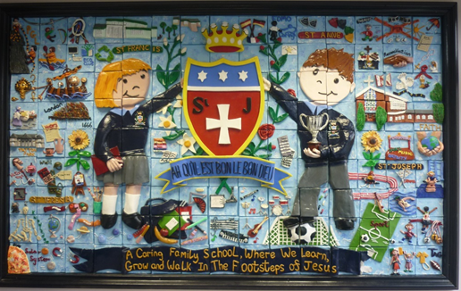
Welcome Back!
What a delight to welcome back all our children and families this week. We hope that you all had a restful break! The children were full of news and stories of their holiday experiences. This week we welcomed Mrs Mooney as our new Administrative Assistant in the school office who will be happy to help you with any queries. We also welcomed Ivy into Year 6 and Hugo into Year 3 – we are so pleased that you have joined our school family.
We would like to give a big welcome to all our Reception children who started their St Julie’s journey on Wednesday and have been staying until after their lunch. They all looked smart in their new school uniforms and settled well in their new classroom. We are looking forward to seeing the children again next week when they attend full time.
St Julie’s school mission and core values
Staff and governors started the school year on Monday by joining the parish Mass and receiving a blessing for the year ahead.
In assembly this morning we started the school year by reviewing our school mission statement and core values with all staff and children. Everyone agreed that our mission statement, “A caring family school where we learn, grow and walk in the footsteps of Jesus,” is lived out every day in our school and truly reflects how we treat each other. We also thought about how our six core values guide our footsteps. The children spoke so confidently about what the values mean to them and how they link to our British Values too.

During the school year we will focus on one of our core values each half term starting with Respect. Our Star of the Week award will be for a child in each class who that week has shone brightly for showing Respect.
Over the week we have also been talking about how we can show that we are “smart and ready for learning.” This begins with us being on-time for school and in school every day and wearing our correct uniform. The picture shows you the other important actions we discussed. Ask your child what they mean…

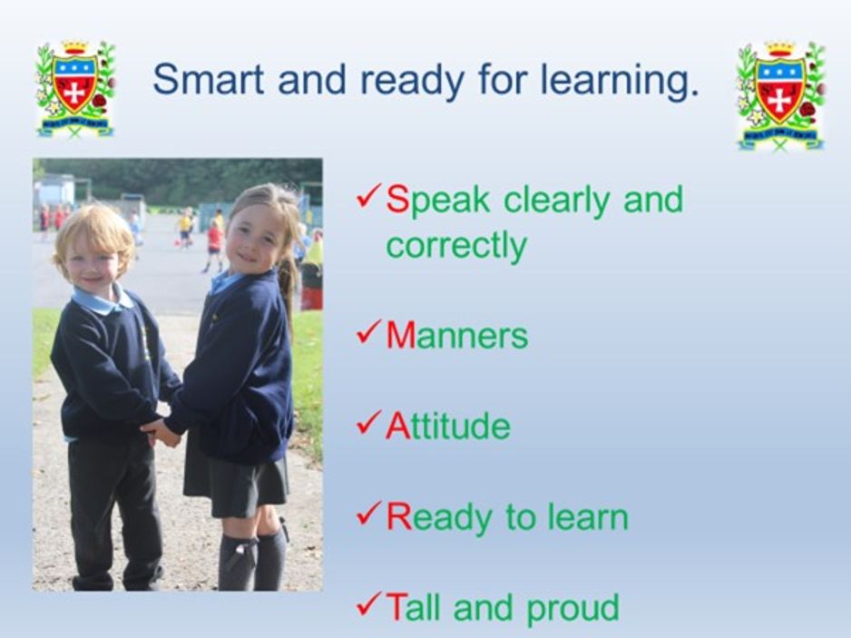
Thank you to parents and grandparents for your patience with the change to the entrance to school via the church which was given to school at very short notice.
Parking is permitted on the church car park in front of the church and school will open the pedestrian gate down to school before drop-off and pick-up. The church committee have stated that this is the safest way to prevent an accident from moving vehicles in the confines of the parish hall car park.
Where possible, please park a few minutes away from school and walk to either entrance to ease congestion on Brooklands Road and around Howards Lane. Please park with consideration for other road users at all time. Do not park on the junction of Acacia Grove and Brooklands Road as this obstructs the view of other cars and causes a bottle neck.


Year Group Meetings for parents
As we start the new school year you are invited to attend a meeting led by the class teacher to outline the approach to teaching mathematics and reading for the year group and how you can support your child in their reading journey. We believe that children should have access to as many reading opportunities as possible, to read widely and deeply, and that being read to should continue throughout primary school so that all children can experience the sheer joy of reading, read books with powerful themes, books by modern authors as well as great works of literature.
The meetings will be held in your child’s classroom and should last no longer than 30 minutes. It would be great if all children are represented by an adult attending and you will have the opportunity to ask questions:

Monday 9th September 4:30pm Year 3

Tuesday 10th September 4:30pm Year 6

Wednesday 11th 4:30pm Year 4
5:00pm Year 1

Thursday 12th 4:30pm Year 2
5:00pm Year 5

The Reception class meeting will be held on Thursday 19th September at 4:30pm.

Home School Agreement
Home School Agreements will be sent out during the week. Please ensure that you read it and that you also share it with your child as these form part of our behaviour policy. Once read, please sign the agreement and return it to school. Thank you.

Instrumental Tuition at St Julie's Catholic Primary School for Junior children.
A message from the Schools Music Service:
We are delighted to let you know that The Schools Music Service will be returning to provide instrumental music tuition in your school from this term onwards.
We currently offer classes on guitar, keyboard and violin in school, in small group half hour sessions, during the school day.
It is our belief that music greatly enriches the life of a child, both academically and socially.
If you would like more information about classes here is a link to our website where you can see how everything works - www.schoolsmusicservice.co.uk
If you know what instrument your child would like to learn, or you have learned with us before, you can register for classes on our website and I will sort everything out for you.
Please watch our short video for more information.
Also, if your child has had music tuition with us in the previous academic year, please ensure that you have made a new application for this year's tuition to put them back onto the teacher's pupil list.
Our teachers are extremely excited to be coming back to your school and we look forward to meeting you all soon. Classes will commence during the week beginning 23rd September.
Start of the year reminders:

Earrings A reminder that earrings CANNOT be worn in school. If a child is wearing earrings or any other form of jewellery they will be asked to remove it for health and safety reasons. A message was posted in the July bulletin that if a child is having their ears pierced, we advise that this is done at the start of school summer holiday so that the ears are sufficiently healed to enable earrings to be removed for school. Thank you.

Pre-loved St Julie’s uniform
A reminder that we have many items of pre-loved school uniform in school. If you require any pieces of uniform please call at the school office where we have uniform sorted into age groups. If you can, a small donation of any amount would be useful for school funds.

School lunch changes
A reminder that the school catering staff ask for 2 weeks’ notice of a change from packed lunch to hot meal or vice versa.

Packed lunches
For children having a packed lunch I encourage you to not send in too much food. We are a Healthy School and so a sandwich/wrap, fruit and one small treat is sufficient. Children can bring in a healthy snack for break times and infant children continue to receive milk and fruit.


Food Allergies
Please take care not to include nut based products in lunch boxes as we have several children in school who suffer from nut allergies. We encourage the children to bring a healthy snack of fruit or toast for break time (no cereal bars please). If your child is bringing grapes, please ensure that they are sliced down the middle lengthways.


Water bottles
Please remember to send a water bottle in to school with your child so that they can remain hydrated throughout the day. Juice or flavoured water is not permitted.

Asthma inhalers
Forms have been given out to those children who we have been notified use an inhaler. Please update the form for this year and return to school as soon as possible. If your child no longer uses an inhaler please inform school so we can remove them from the register.
Administering medicine in school: If children do need prescribed medication to be given whilst in school it can be administered providing the correct paperwork is completed which is available from the school office. However, school cannot administer the first dose of any medication due to potential allergic reactions. Only prescribed medication can be administered in school.


Tissues
We would be grateful if every child could bring in a box of tissues for their class. These will be kept as a stock by the teacher to get us through the year. Bless you!!

Please ensure names are in all school uniform – it is extremely difficult to find lost items if there are no names in them.


This week’s flyer from National Online Safety is, “10 top tips for parents and educators supporting children going back to school.”


Punctuality
Thank you to all those parents/carers and grandparents who have ensured that the children are in school on time this week; we have had very few late marks this week.
The children can come in from 8:40am but MUST be in their classroom for 8:50am when the register is called.
From next Monday if your child is marked as late, you will receive a text reminder about being in school on time.


“From the first day of term to the last, the small moments in a school day make a real difference to your child.” #AttendanceCounts
At St Julie’s our attendance is excellent and we know that parents and carers value the education that your children receive. This week you should have received an email from us informing you that the Government is launching a national campaign to remind parents and carers of the importance of school attendance and promoting the importance of being in school, on time, every day.

Useful website Is my child too ill for school? - NHS (www.nhs.uk)

Year Group | % Attendance for w/e 06.09.24
Year R
Year 1 | 98.48
Year 2 | 96.55
Year 3 | 96.53
Year 4 | 97.79
Year 5 | 98.93
Year 6 | 97.92

Well done to Y5 who had the highest attendance this week.

TERM TIME ABSENCE: You should be aware that the law has now changed regarding penalty notices for unauthorised absence from school. This change came into effect from 19th August 2024. A letter was sent home documenting these changes and how it will impact on families and schools before the summer holiday.


St Julie’s Awards of the Week

 | Star of the week for showing respect
Year 1 | Jessica W
Year 2 | Jennifer W Harry F
Year 3 | Logan
Year 4 | George Mc
Year 5 | Benji
Year 6 | Bertie


St Julie’s Sunflower Club
Our Sunflower Club is now up and running and will provide breakfast and after school wraparound care for the children of St Julie Catholic Primary School. The club is to be run by experienced, trained staff who aim to provide a safe, fun environment with a variety of enrichment activities. Both breakfast and after school club are available throughout term time but must be booked in advance.

The Sunflower Club opening hours are:
Breakfast Club 7:45am to 8:40am Monday to Friday term time only
After School Club 3:20pm – 5:45pm Monday to Friday term time only

BREAKFAST CLUB - The cost is £5.00 per session per day per child
AFTER SCHOOL CLUB - The cost from 3.20pm to 4.30pm is £5.00 or from 3.20pm to 5.45pm is £9.00
per session per day per child.

If your child attends a school run activity club, staff will collect them from their activity when it finishes and the charge for Sunflower Club will be £5.

Music Ensemble
St Helens Council Music Service are delighted to share their range of ensemble for 24/25 that they continue to provide FREE for all students who live in the Borough. Any students that learn a musical instrument, from the real beginners right through to the more advanced musicians are welcome. Please see the attached flyer for dates and full details.

After School Clubs
Due to the teachers running the Year Group meetings for each class next week, our programme of after school clubs for Year 1 up to Year 6 will begin week commencing Monday 16th September. A full list of clubs available will be sent home next week for you to sign up to.


Diary w/c 09.09.2024

Monday 8am Gymnastics Years 1 - 6
4:30pm Maths/Reading Meeting Y3

Tuesday 4:30pm Maths/Reading Meeting Y6

Wednesday 8am Multi-sports Years 1 - 6
4:30pm Maths/Reading Meeting Y4
5:00pm Maths/Reading Meeting Y1

Thursday Year 6 swimming 2-3pm
Y3 Eccleston Library – Roald Dahl
4:30pm Maths/Reading Meeting Y2
5:00pm Maths/Reading Meeting Y5
KS2 Dodgeball 3:20 – 4:15
Friday

Make do and mend at the Smithy! Saturday 14th and Sunday 15th September, 12noon – 5pm Free admission
Come along and find out about life on the Home Front during World War Two.
Refreshments in the Tea Room.
9th Great Eccleston Bake-off on Sunday 15th September – see attached flyer for further details on how to enter.


“A caring family school, where we learn, grow and walk in the footsteps of Jesus.”

St Julie pray for us, protect us and bless us.

