Dear Parents and Carers,

Well done to all of our Reception class who have completed their first full week at school! They are so settled in their routine and joined us for our celebration assembly this morning, sitting and listening as if they have been coming to St Julie’s for months. We are so proud of you all.

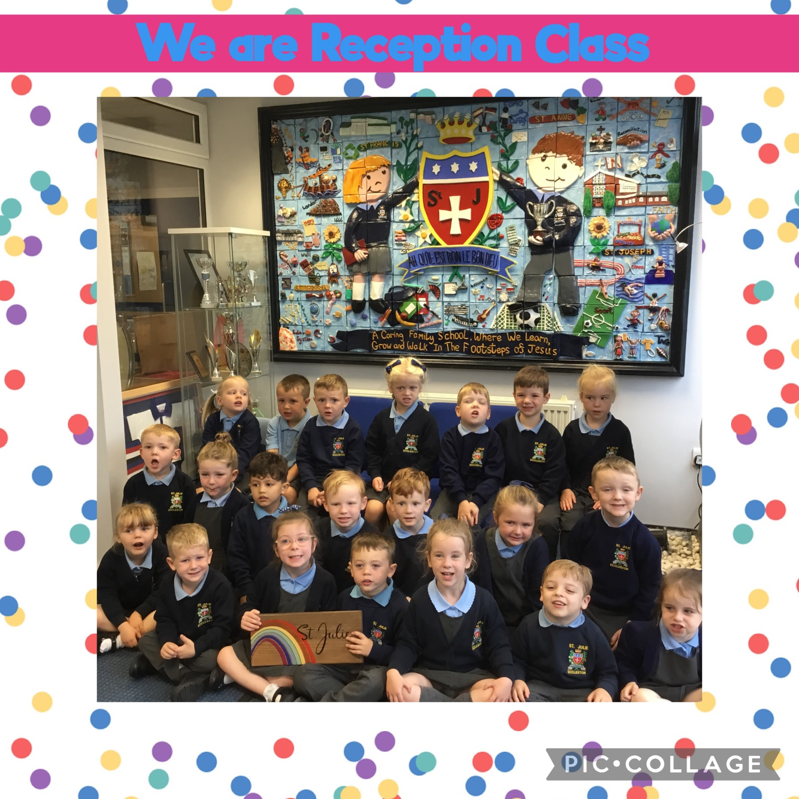

Year Group Meetings
Thank you to all those parents/carers who were able to attend the curriculum information meetings held in classes this week. For those who were unable to make it, the teachers have put the Powerpoints used on the class Teams page and on the website on the relevant class page. If you have any further questions please email or phone the school office.


Reception class Reading Meeting
Parents/Carers are invited to attend a meeting led by the class teacher to outline the approach to teaching reading and how you can support your child in their reading journey. We believe that children should have access to as many reading opportunities as possible, to read widely and deeply, and that being read to should continue throughout primary school so that all children can experience the sheer joy of reading, read books with powerful themes, books by modern authors as well as great works of literature.
The meeting will be held in the classroom on Thursday 19th September at 4:30pm. It is essential that all children are represented by an adult attending and you will have the opportunity to ask questions.

After-school clubs
From next week we will begin our programme of after-school clubs. A letter was emailed with a list of the clubs on offer this half term. The clubs are run voluntarily by staff so please be aware that clubs may need to be cancelled at short notice if for any reason the member of staff is not available. We do not run clubs for Reception children as we feel the school day is long enough for them at this time.
The cost of each club is £4.00 per session and must be paid on School Money – it can be paid in instalments, but you must have paid before each session for your child to be on the register for the club. Where clubs have a set limit of children who can safely attend and are oversubscribed, your child may be given a turn at a later date. The clubs we offer are determined by the goodwill/availability of volunteers to run them. Payment must be received before your child can start the club. All children must be collected on time by an adult from the school foyer.
Please see the weekly diary below for details of each club.
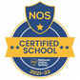
This week’s flyer from National Online Safety is, “10 top tips for parents and educators supporting children to manage conflict effectively.”


M&M Productions: “Alice in Wonderland.”
We are excited to welcome back M&M Theatrical Productions to St Julie’s on Friday 27th September. They have presented Classic Literature Adaptations for several years at the school and this year will be performing an adaption of Lewis Carroll’s “Alice in Wonderland.” The children thoroughly enjoy the thrilling adaptions of the classic stories, performed so that they are suitable for all ages. The performances provide a lasting memory as the school hall is transformed into a theatre where all the children can enjoy the production.
The overall cost of the production is an expensive cost to the school but we consider it to be good value in providing the children with a theatrical experience without the additional cost of a coach – unfortunately, coach travel makes all trips more expensive now. To cover some of the cost of the performance we ask for £5 per child which can be paid via School Money. The payment will be made available on Monday.


Money Minds
On Tuesday this week the children in Year 3 and Year 4 received lessons in financial budgeting from staff from the Yorkshire Building Society. During their Money Minds sessions the Year 3 children learnt about where money comes from and where to put it to keep it safe. In Year 4 the children learnt about the difference between what we need to have and what we would like to have. They were encouraged to talk about the value of money and to understand that we can’t have everything we would like; therefore we have to prioritise our needs and likes within our budget. Thank you to Nicola and Louisa for their valuable financial advice.


Year 3 Library visit – Roald Dahl Day
Yesterday the children in Year 3 were very excited for their first school trip of the year! They walked to Eccleston library to celebrate Roald Dahl Day where they deepened their knowledge about the author and shared in the pleasure of reading some of his stories.
We are so lucky to have such a wonderful library just around the corner. Please remember to visit it yourselves and make the most of the variety of books on loan.


James Ketchell
You will remember that last year James came to talk to the children about his adventures around the world – adventures that started through his motivation to overcome serious injuries suffered when he was a teenager.
This week all the children logged into a Zoom call with James in their classrooms with Year 4 and 5 having the opportunity to ask questions on behalf of the school. James showed us around his boat that he is busy preparing for his solo sail around the word. This included the ‘Starling’ which will give him internet access as he travels so that he is able to have live link ups with us as he attempts to become the first person to circumnavigate the earth by land, air and sea.
As always, the children were completely engaged and are excited to be able to follow his progress. Feel free to follow the journey at home; James’s website has a ‘Round the World’ tab that will have updates that the children can follow. There are also school resources, put together by The National Oceanography Centre (NOC) and our very own Mrs Kernick, that can be used at home as well as by us in school. These have activity and discussion ideas with various links to supporting resources and videos online.
James sets off on his adventure from Gosport on Sunday 22nd September and I am sure that you will join us in wishing him a very safe journey.

Round the World - James Ketchell


St Julie’s Sunflower Club
Our Sunflower Club is now up and running and will provide breakfast and after school wraparound care for the children of St Julie Catholic Primary School. The club is to be run by experienced, trained staff who aim to provide a safe, fun environment with a variety of enrichment activities. Both breakfast and after school club are available throughout term time but must be booked in advance.

The Sunflower Club opening hours are:
Breakfast Club 7:45am to 8:40am Monday to Friday term time only
After School Club 3:20pm – 5:45pm Monday to Friday term time only

BREAKFAST CLUB - The cost is £5.00 per session per day per child
AFTER SCHOOL CLUB - The cost from 3.20pm to 4.30pm is £5.00 or from 3.20pm to 5.45pm is £9.00
per session per day per child.

If your child attends a school run activity club, staff will collect them from their activity when it finishes and the charge for Sunflower Club will be £5.

Please could we ask that parents book their child's Sunflower Club place in advance via School Money whenever possible, this helps to plan for catering purposes. We fully understand that this is not always possible and last minute places can be booked through the school office or by emailing:- stjulies-sunflowerclub@sthelens.org.uk

When collecting your child from the Club please come to the double doors in the school foyer and use the Sunflower Club bell.

If your child is booked into Club until 4.30pm please can you ensure you collect your child no later than 4.30pm, any later and the full session of £9 will be charged.

The new telephone number for the Sunflower Club is:- 07355 925641

Nasal Flu Vaccination
A message from the Flu Immunisation Team was sent by email this week providing information regarding the vaccination programme and containing a link to consent to your child receiving the vaccine in school on Thursday 17th October 2024. Please ensure you complete the on-line consent which is required for all children from Reception up to Year 6.


Punctuality
Thank you to all those parents/carers and grandparents who have ensured that the children are in school on time this week; we have had very few late marks this week.
The children can come in from 8:40am but MUST be in their classroom for 8:50am when the register is called.
If your child is marked as late, you will receive a text reminder about being in school on time.

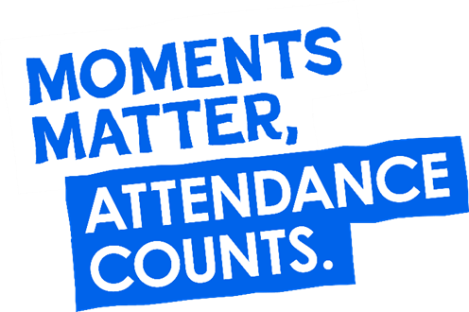
“From the first day of term to the last, the small moments in a school day make a real difference to your child.” #AttendanceCounts
At St Julie’s our attendance is excellent and we know that parents and carers value the education that your children receive. This week you should have received an email from us informing you that the Government is launching a national campaign to remind parents and carers of the importance of school attendance and promoting the importance of being in school, on time, every day.

Useful website Is my child too ill for school? - NHS (www.nhs.uk)

Year Group | % Attendance for w/e 13.09.24
Year R | 99.55
Year 1 | 100
Year 2 | 100
Year 3 | 98.86
Year 4 | 95.76
Year 5 | 97.14
Year 6 | 97.43

Well done to Years 1 and 2 who had the highest attendance this week.

TERM TIME ABSENCE: You should be aware that the law has now changed regarding penalty notices for unauthorised absence from school. This change came into effect from 19th August 2024. A letter was sent home documenting these changes and how it will impact on families and schools before the summer holiday.


St Julie’s Awards of the Week

 | Star for showing Respect | Book explorer | Marvellous mathematician
Year 1 | Daniel O | Evie | Faith
Year 2 | Georgie W | Charlotte | Teddy F
Year 3 | Gia | Ella | Mikey
Year 4 | Fraser | William | Gabriella
Year 5 | Findlay | Rory | Thomas
Year 6 | Phoebe | Elsie | Harry

Primary School Admissions
The website will open for parents who wish to apply online: www.sthelens.gov.uk/admissions on 16th September 2024.
Children who turn 5 between 1 September 2025 and 31 August 2026 are eligible to apply for a place in primary school. The deadline for submission of primary school applications is 15 January 2025. The Archdiocese have asked us to remind parents seeking a reception class place at our school, even if you have a sibling in the school, of the need for baptism prior to application and to take prompt action if baptism has not already taken place.
New intake for September 2025
If you have a child due to start school in September 2025, we will be holding a new intake meeting on Monday 14th October 2024 at 2pm and Tuesday 19th November at 2pm. There will be an opportunity to have a look around our school and speak to the Headteacher, Mrs Hodgson.
Secondary School Admission
Children in Y6 should apply for a secondary school place by 31 October 2024 apply online: www.sthelens.gov.uk/admissions


Diary w/c 16.09.2024

Monday 8am Gymnastics Years 1 - 6
Y1 & Y2 Multi-skills club 3:20 – 4:15

Tuesday KS2 Football club 3:20 – 4:15

Wednesday 8am Multi-sports Years 1 - 6
Y2 Spanish club 3:20 - 4:00
Y5 & Y6 Ukulele 3:20 - 4:15
KS2 Art club 3:20 - 4:15

Thursday Year 6 swimming 2-3pm
Y1 & Y2 Lego/Construction club 3:20 - 4:15
KS2 Dodgeball 3:20 – 4:15
4:30pm Maths/Reading Meeting – Reception parents

Friday Year 6 trip to Tatton Park for Viking themed day.

Make do and mend at the Smithy! Saturday 14th and Sunday 15th September, 12noon – 5pm Free admission
Come along and find out about life on the Home Front during World War Two.
Refreshments in the Tea Room.
9th Great Eccleston Bake-off on Sunday 15th September – see attached flyer for further details on how to enter.

Further dates for your Diary
Thursday 26 September - 9:30 Welcome Mass and celebration of St Julie in church, whole school
Friday 27 September - M&M Productions “Alice in Wonderland” cost £5 (School Money)
Tuesday 1 October - School photographs: individual and group photos
Monday 14 October - Open afternoon for new intake 2025 2pm
Thursday 17 October - Flu immunisations in school
Tuesday 22 October - Parents’ Evening: appointments in school
Wednesday 23 October - Harvest Festival in church 2pm
Thursday 24 October - School closes for half-term


“A caring family school, where we learn, grow and walk in the footsteps of Jesus.”

St Julie pray for us, protect us and bless us.

