Dear Parents and Carers,



Welcome Mass and celebration of St Julie
All families are warmly invited to join us and the parish community on Thursday morning at the 9:30am Mass as we welcome our new starters into our St Julie family. We will also be celebrating our patron, St Julie Billiart, founder of the Sisters of Notre Dame. Please come along and join us on this very special occasion.


M&M Productions: “Alice in Wonderland.”
We are excited to welcome back M&M Theatrical Productions to St Julie’s on Friday 27th September. They have presented Classic Literature Adaptations for several years at the school and this year will be performing an adaption of Lewis Carroll’s “Alice in Wonderland.” The children thoroughly enjoy the thrilling adaptions of the classic stories, performed so that they are suitable for all ages. The performances provide a lasting memory as the school hall is transformed into a theatre where all the children can enjoy the production.
The overall cost of the production is an expensive cost to the school but we consider it to be good value in providing the children with a theatrical experience without the additional cost of a coach – unfortunately, coach travel makes all trips more expensive now. To cover some of the cost of the performance we ask for £5 per child which can be paid via School Money. Please pay via School Money as soon as possible.

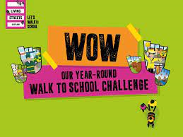
Wow (Walk Once a Week) - the walk to school challenge 2024/25
We all know how difficult it is to park around school so we want to encourage as many children and their families as possible to walk to school. WOW - the walk to school challenge is delivered by Living Streets, the UK charity for everyday walking, to help as many children as possible experience the benefits of walking to school.
The pupil led challenge will see children self-report how they get to school and if they travel sustainably at least once a week for a month, they will get rewarded with a badge. If you live too far away or don't have time to walk the whole way to school, you can Park and Stride to help your child earn their WOW badge.

And on the same theme…this Year's "Cycle to School Week" is from 23rd – 27th September.
Cycle to School Week is a week-long event where families are encouraged to try cycling and scooting to school.
It’s a great way to celebrate the vast benefits an active school run brings, including its positive impact on children’s health and wellbeing, local air quality and carbon emissions.
However, please remind your children that for the safety of others, they must not ride bikes and scooters on the playground or school drive on the way home. Thank you.


Sacramental programme for Year 4
Parents/carers of children in Year 4 who have been baptised and wish their child to receive the Sacraments of Forgiveness (First Confession) and the Eucharist (First Holy Communion) are invited to attend an initial meeting on Wednesday 2nd October at 6pm in St Julie’s Church. The catechists will explain the Sacramental preparation required in the Always With You programme in order for your child to prepare to make the Sacraments. It is essential that if you wish to start the Sacramental journey you attend the meeting. Further dates will be given out at the meeting.

Schools’ Music Service Roadshow
The Schools’ Music Service will be in the school hall on Wednesday 25th September straight after school for the parents/grandparents of Junior children to come along with their child to have a look at the musical instruments that the Schools Music Service provide tuition for. Please come along. If you are undecided about whether to learn to play an instrument or which to choose, there will be the opportunity to speak to the music tutors and find out more.
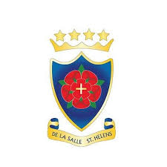

De La Salle Open Evening
Parents of Year 6 students are warmly invited to the Open Evening event at De La Salle High School on Wednesday 2nd October, starting at 4.30pm.
Families are welcome to visit the school from 4.30pm through to 7.30pm to have a tour of the school, speak to staff and students and listen to a talk given by the headteacher.

School Photographs

The school photographer will be coming into school on Tuesday 1st October to take photographs of the children. All children will have their photo taken for our school Sims system. The photographer will take individual photographs of each child and also group photos of siblings but you are not obliged to purchase a photograph.
Proof copies of the photographs along with an order form will be sent home as soon as they are available.


Nasal Flu Vaccination
A message from the Flu Immunisation Team was sent by email this week providing information regarding the vaccination programme and containing a link to consent to your child receiving the vaccine in school on Thursday 17th October 2024. Please ensure you complete the on-line consent which is required for all children from Reception up to Year 6.



Punctuality
Thank you to all those parents/carers and grandparents who have ensured that the children are in school on time this week; we have had very few late marks this week.
The children can come in from 8:40am but MUST be in their classroom for 8:50am when the register is called.
If your child is marked as late, you will receive a text reminder about being in school on time.

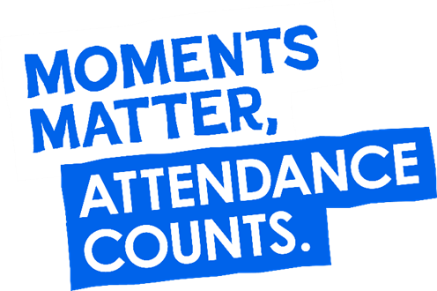
“From the first day of term to the last, the small moments in a school day make a real difference to your child.” #AttendanceCounts
At St Julie’s our attendance is excellent and we know that parents and carers value the education that your children receive.
Excellent attendance at school is important to allow a child to fulfil their potential. I am confident in your support in ensuring that your child strives for 100% attendance each week and is on time every day.
Holidays during term time will not be authorised.

Useful website Is my child too ill for school? - NHS (www.nhs.uk)

Year Group | % Attendance for w/e 20.09.24
Year R | 98.64
Year 1 | 98.71
Year 2 | 94.14
Year 3 | 100
Year 4 | 99.70
Year 5 | 100
Year 6 | 98

Well done to Years 3 and 5 who had the highest attendance this week.

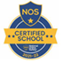
This week’s flyer from National Online Safety is, “What parents and educators need to know about Final Fantasy XIV.”



St Julie’s Awards of the Week

 | Star for showing Respect | Book explorer | Marvellous mathematician
Reception | Mae | Oliver | Calvin
Year 1 | Isabelle | Leya | Teddy
Year 2 | Reggie | Vienna | Henry
Year 3 | Luke | Jaxon | Jack
Year 4 | Zara | Olivia | Jackson H
Year 5 | Rory | Georgia | Xavier
Year 6 | Teddie | Lily | Marley


Diary w/c 23.09.2024

Monday 8am Gymnastics Years 1 - 6
Y1 & Y2 Multi-skills club 3:20 – 4:15

Tuesday KS2 Football club 3:20 – 4:15

Wednesday 8am Multi-sports Years 1 – 6
Schools Music Service Roadshow straight after school
Y2 Spanish club 3:20 - 4:00
Y5 & Y6 Ukulele 3:20 - 4:15
KS2 Art club 3:20 - 4:15

Thursday 9:30 Welcome Mass and celebration of St Julie in church, whole school
Year 6 swimming 2-3pm
Y1 & Y2 Lego/Construction club 3:20 - 4:15
KS2 Dodgeball 3:20 – 4:15

Friday M&M Productions “Alice in Wonderland” cost £5 (School Money)

Further dates for your Diary
Tuesday 1 October - School photographs: individual and group photos
Wednesday 2 October - Y4 Sacramental programme meeting in St Julie’s church, 6pm
Monday 14 October - Open afternoon for new intake 2025 2pm
Thursday 17 October - Flu immunisations in school
Tuesday 22 October - Parents’ Evening: appointments in school
Wednesday 23 October - Harvest Festival in church 2pm
Thursday 24 October - School closes for half-term

Primary School Admissions
The website will open for parents who wish to apply online: www.sthelens.gov.uk/admissions on 16th September 2024.
Children who turn 5 between 1 September 2025 and 31 August 2026 are eligible to apply for a place in primary school. The deadline for submission of primary school applications is 15 January 2025. The Archdiocese have asked us to remind parents seeking a reception class place at our school, even if you have a sibling in the school, of the need for baptism prior to application and to take prompt action if baptism has not already taken place.

New intake for September 2025
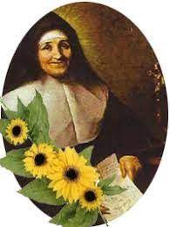
If you have a child due to start school in September 2025, we will be holding a new intake meeting on Monday 14th October 2024 at 2pm and Tuesday 19th November at 2pm. There will be an opportunity to have a look around our school and speak to the Headteacher, Mrs Hodgson.

Secondary School Admission
Children in Y6 should apply for a secondary school place by 31 October 2024 apply online: www.sthelens.gov.uk/admissions

“A caring family school, where we learn, grow and walk in the footsteps of Jesus.”

St Julie pray for us, protect us and bless us.

