Dear Parents and Carers,
What a busy week we have had! As you know we had our special visitors from Ofsted with us on Tuesday and Wednesday. The children were excited to show them around our school, to talk to them about their learning and all the wonderful experiences they have at St Julie’s and how they live out our mission statement and core values. As always, we are extremely proud of all of our amazing children and of our dedicated and hardworking staff. The Ofsted Report will be shared in due time but these do take some weeks to be published. Thank you to those parents who offered to come into school on Monday to help out and for the wellbeing treats sent in for staff – all much appreciated. Many thanks to all for your continued support as part of our St Julie Family.
Next Friday we will be holding a Wellbeing and Forest School day for the whole school with fun learning activities inside and outside so children should come to school in suitable outdoor clothing.
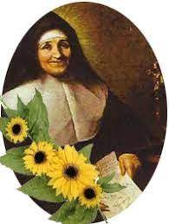

Following on from our visit, on Thursday morning we were delighted to officially welcome our new Reception children to our St Julie’s family. Our whole school gathered together in St Julie’s Parish Church to celebrate in song and prayer as our newest children start their journey in our school and parish community. Our Year 6 children paired up with our Reception children and showed great care towards the younger children in sitting with them during the Mass and then walking them up to the altar for a blessing from Fr Michael. Thank you to all those who were able to attend and celebrate Mass with us, during which we also honoured St Julie herself.

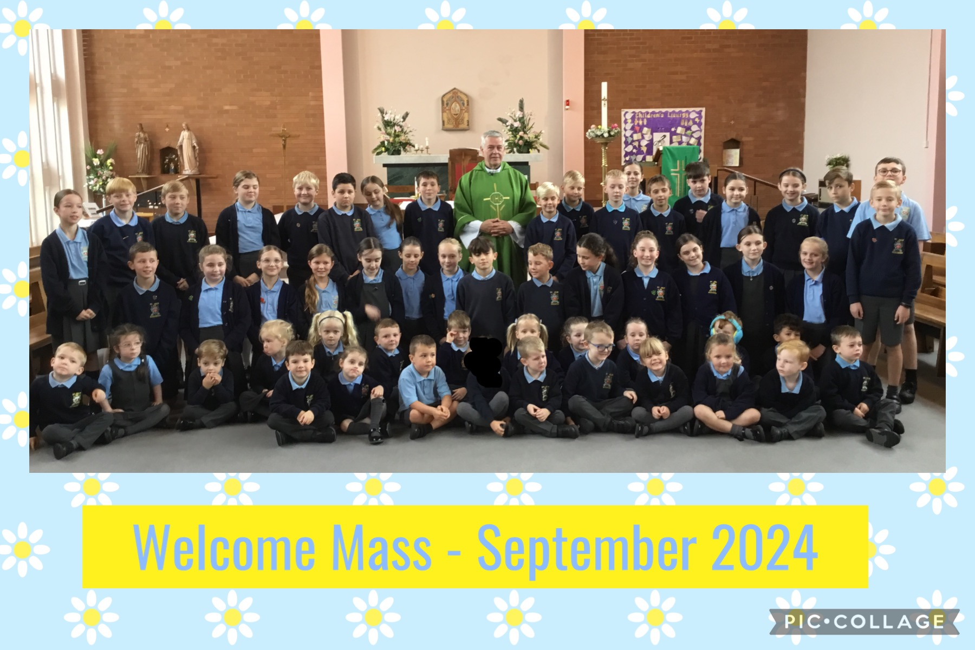

M&M Productions: “Alice in Wonderland”
This morning the children thoroughly enjoyed the experience of having the school hall transformed into a theatre. Today’s adaptation of Lewis Carroll’s “Alice in Wonderland” featured atmospheric music, adventure and high drama to immerse the children in a retelling of this classic story. The performance was marvellous and enjoyed by everyone! After the show, Year 6 took part in a workshop with the cast and learned about how they use sound, light, and performance skills to create entertaining experiences. To cover the cost of the performance we ask for £5 per child which can be paid via School Money. Please pay via School Money as soon as possible. Thank you to those who have already paid.

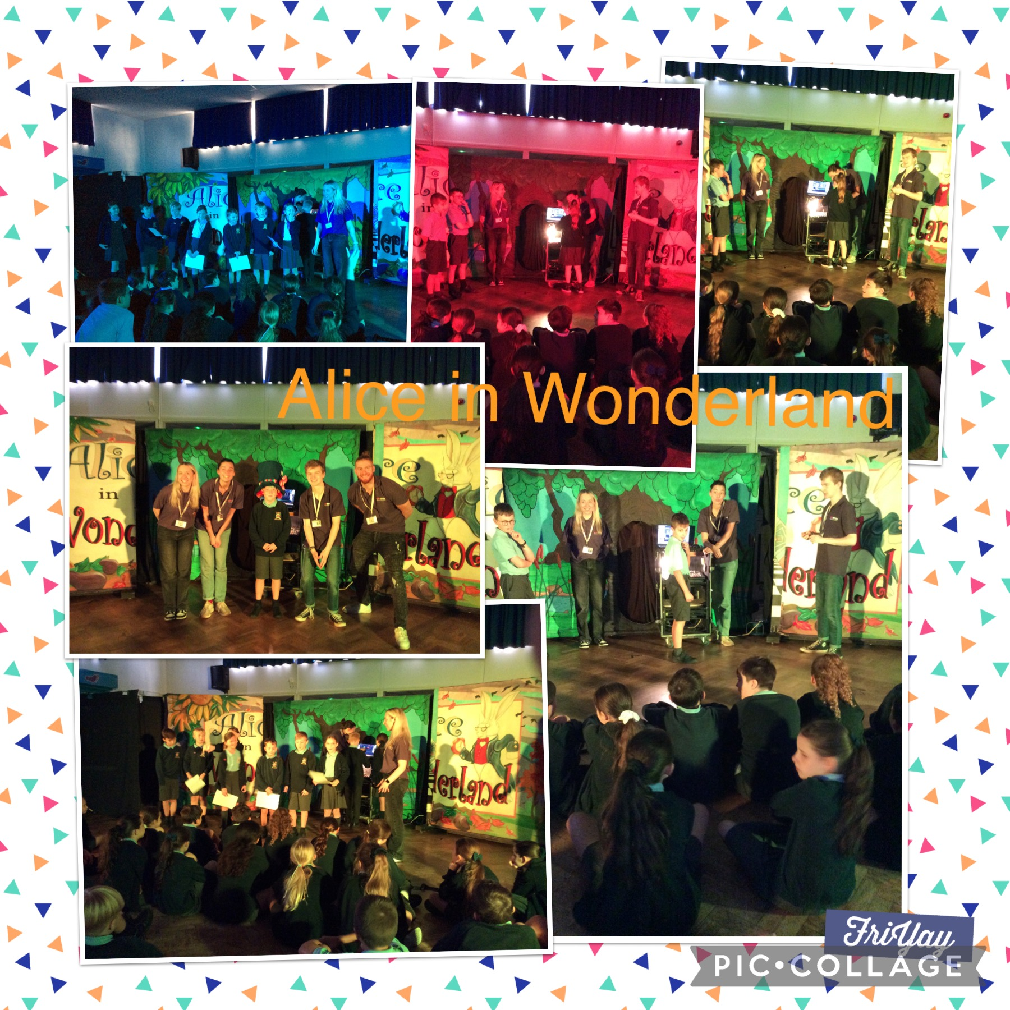

School Photographs

The school photographer will be coming into school on Tuesday 1st October to take photographs of the children. All children will have their photo taken for our school Sims system. The photographer will take individual photographs of each child and also group photos of siblings but you are not obliged to purchase a photograph.
Proof copies of the photographs along with an order form will be sent home as soon as they are available.


Sacramental programme for Year 4
Parents/carers of children in Year 4 who have been baptised and wish their child to receive the Sacraments of Forgiveness (First Confession) and the Eucharist (First Holy Communion) are invited to attend an initial meeting on Wednesday 2nd October at 6pm in St Julie’s Church. The catechists will explain the Sacramental preparation required in the Always With You programme in order for your child to prepare to make the Sacraments. It is essential that if you wish to start the Sacramental journey you attend the meeting. Further dates will be given out at the meeting.


The PFA AGM will be held in school on Wednesday 9th October at 6pm.
As I have said before, our school receives one of the lowest budgets in St Helens due to the area we are in so we do rely heavily on funds raised by the PFA for additional resources and funding of activities for our children. We really do need your help!
Please come along on the evening of Wednesday 9th October at 6pm to find out what the PFA is all about – they are always looking for support in any way you can and for fresh ideas. All are welcome!
For our new parents in the Reception class, this is a great way to meet other parents and get involved in school events.
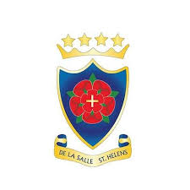
De La Salle Open Evening
Parents of Year 6 students are warmly invited to the Open Evening event at De La Salle High School on Wednesday 2nd October, starting at 4.30pm.
Families are welcome to visit the school from 4.30pm through to 7.30pm to have a tour of the school, speak to staff and students and listen to a talk given by the headteacher.


Nasal Flu Vaccination
A message from the Flu Immunisation Team was sent by email this week providing information regarding the vaccination programme and containing a link to consent to your child receiving the vaccine in school on Thursday 17th October 2024. Please ensure you complete the on-line consent which is required for all children from Reception up to Year 6.

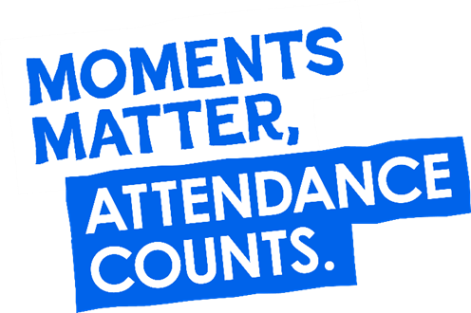
“From the first day of term to the last, the small moments in a school day make a real difference to your child.” #AttendanceCounts
At St Julie’s our attendance is excellent and we know that parents and carers value the education that your children receive.
Excellent attendance at school is important to allow a child to fulfil their potential. I am confident in your support in ensuring that your child strives for 100% attendance each week and is on time every day.
Holidays during term time will not be authorised.

Useful website Is my child too ill for school? - NHS (www.nhs.uk)

Year Group | % Attendance for w/e 27.09.24
Year R | 100
Year 1 | 99.35
Year 2 | 98.62
Year 3 | 96.57
Year 4 | 99.09
Year 5 | 100
Year 6 | 99.43

Well done to Reception and Year 5 who had the highest attendance this week.
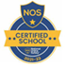
This week’s flyer from National Online Safety is, “What parents and educators need to know about Instagram.”

Parking
A reminder to park considerately when dropping off and collecting children from school. Police are regularly monitoring the parking.
Today we have been sent evidence of a car parking on the corner of Brooklands Road and Acacia Grove, across the Parking Buddy which is clearly placed to indicate that you MUST not park there.
We have allowed time for parents to drop off from 8:40 so that there is time to park further up or down the road and walk to the gate.
We also ask that parents/grandparents do not park in the bays marked C and EM on the church car park.


Diary w/c 30.09.2024

Monday 8am Gymnastics Years 1 - 6
Y1 & Y2 Multi-skills club 3:20 – 4:15

Tuesday KS2 Football club 3:20 – 4:15

Wednesday 8am Multi-sports Years 1 – 6
School photographs: individual and siblings in school
Y2 Spanish club 3:20 - 4:00
Y5 & Y6 Ukulele 3:20 - 4:15
KS2 Art club 3:20 - 4:15
Y5 & Y6 Young Voices 3:20 – 4:15
6pm Year 4 Sacramental meeting in church

Thursday National Poetry Day
Year 6 swimming 2-3pm
Y1 & Y2 Lego/Construction club 3:20 - 4:15
KS2 Dodgeball 3:20 – 4:15

Friday Year 4 Trip to World of Glass
Year 3 Poetry Workshop morning

Further dates for your Diary
Tuesday 1 October - School photographs: individual and group photos
Wednesday 2 October - Y4 Sacramental programme meeting in St Julie’s church, 6pm
Wednesday 9 October - SEND drop-in with Mrs Ashcroft 2 – 3pm
Wednesday 9 October - 6pm PFA meeting in school: all parents very welcome
Thursday 10 October - World Mental health day (children to wear bright colours)
- Tea and Talk 2:30pm in the school hall, all welcome
Monday 14 October - Open afternoon for new intake 2025 2pm
Thursday 17 October - Flu immunisations in school
Tuesday 22 October - Parents’ Evening: appointments in school
Wednesday 23 October - Harvest Festival in church 2pm
Thursday 24 October - School closes for half-term

Primary School Admissions
The website will open for parents who wish to apply online: www.sthelens.gov.uk/admissions on 16th September 2024.

Children who turn 5 between 1 September 2025 and 31 August 2026 are eligible to apply for a place in primary school. The deadline for submission of primary school applications is 15 January 2025. The Archdiocese have asked us to remind parents seeking a reception class place at our school, even if you have a sibling in the school, of the need for baptism prior to application and to take prompt action if baptism has not already taken place.

New intake for September 2025
If you have a child due to start school in September 2025, we will be holding a new intake meeting on Monday 14th October 2024 at 2pm and Tuesday 19th November at 2pm. There will be an opportunity to have a look around our school and speak to the Headteacher, Mrs Hodgson.

Secondary School Admission
Children in Y6 should apply for a secondary school place by 31 October 2024 apply online: www.sthelens.gov.uk/admissions

“A caring family school, where we learn, grow and walk in the footsteps of Jesus.”

St Julie pray for us, protect us and bless us.

