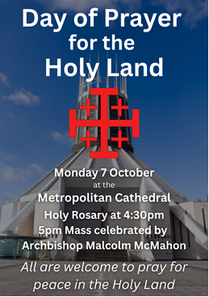
Dear Parents and Carers,


Month of the Rosary
Every year we celebrate the memorial of Our Lady of the Rosary on October 7th and the month of October is dedicated as the Month of the Rosary. We have our lovely prayer garden dedicated to Mary which the children can visit for quiet prayer and reflection.
Parishioners from St Julie’s Rosary Group will be coming in to visit Year 3 next week to talk to them about the Mysteries of the Rosary.


Sacramental programme for Year 4
Thank you to everyone who was able to come to St Julie’s Parish Church on Wednesday evening for the first session of preparation for the Sacraments of First Confession and First Holy Communion. The children enjoyed discovering the treasures of the church as they took part in the treasure hunt. The children will now need to attend Mass with a parent to take part in the formal enrolment for the Sacraments at Mass this and next weekend. Please let us know in advance which Mass you will be attending so that Fr Michael can have your certificate ready for you to receive.

Mass at St Thomas of Canterbury Saturday 6pm
Mass at St Julie’s Sunday 9:30am

Poetry Competition

Yesterday we celebrated National Poetry Day. The theme for National Poetry Day 2024 is ‘Counting’.
Today Year 3 took part in a poetry workshop led by the Arts in Libraries creative writing tutor, Kevin Dyer.
To mark National Poetry day we are holding our very own poetry competition. We would like the poem to be about the theme ‘Counting.’ Poems must be returned to school by Thursday 10th October. All children entering the competition will receive a certificate and the reading ambassadors will judge the winning entries.


The PFA AGM will be held in school on Wednesday 9th October at 6pm.
As I have said before, our school receives one of the lowest budgets in St Helens due to the area we are in so we do rely heavily on funds raised by the PFA for additional resources and funding of activities for our children. We really do need your help!
Please come along on the evening of Wednesday 9th October at 6pm to find out what the PFA is all about – they are always looking for support in any way you can and for fresh ideas. All are welcome!
For our new parents in the Reception class, this is a great way to meet other parents and get involved in school events.


World Mental Health Day St Julie’s Catholic Primary School will be hosting a Tea and Talk event on Thursday 10th October in the school hall from 2:30pm to 3:15pm. Parents, grandparents and parishioners are very welcome to join us for refreshments with our Minnie Vinnies, to relax and have a chat.


World Mental Health day – Thursday 10th October
The theme for 2024’s World Mental Health day, set by the World Foundation of Mental Health, is “It's Time to Prioritise Mental Health in the Workplace.”
World Mental Health Day is about raising awareness of mental health and driving positive change for everyone’s mental health.
It’s also a chance to talk about mental health, how we need to look after it, and how important it is to get help if you are struggling.
World Mental Health Day is when we are also encouraged to think about our own mental health and that of those around us so to raise awareness the children can come to school wearing brightly coloured clothes on Thursday 10th October.
Our school’s Educational Mental Health Practitioner, Jayne Aspinall, who is in school every Monday will be leading an assembly on mental health and wellbeing for the whole school this Thursday.
If you know anyone who is struggling, please encourage them to seek help and support. The Health and Wellbeing section of our school website has ideas, suggestions and websites to support you and your family and friends.

Competitions this term:
Our children have got off to a great start this year competing in sporting competitions. Last week a team of Year 4 and Year 5 took part in the first ever Phoenix Network football tournament held at Rectory Primary School – a network of St Helens schools that St Julie’s is part of. As always, our children showed great team spirit and proudly won the tournament and received their medals in assembly this morning.
Yesterday a team from Year 4 competed in a football competition at Ruskin organised by St Helens School Games. The children representing St Julie’s performed well as a team and enjoyed competing against other local schools. Well done everyone!

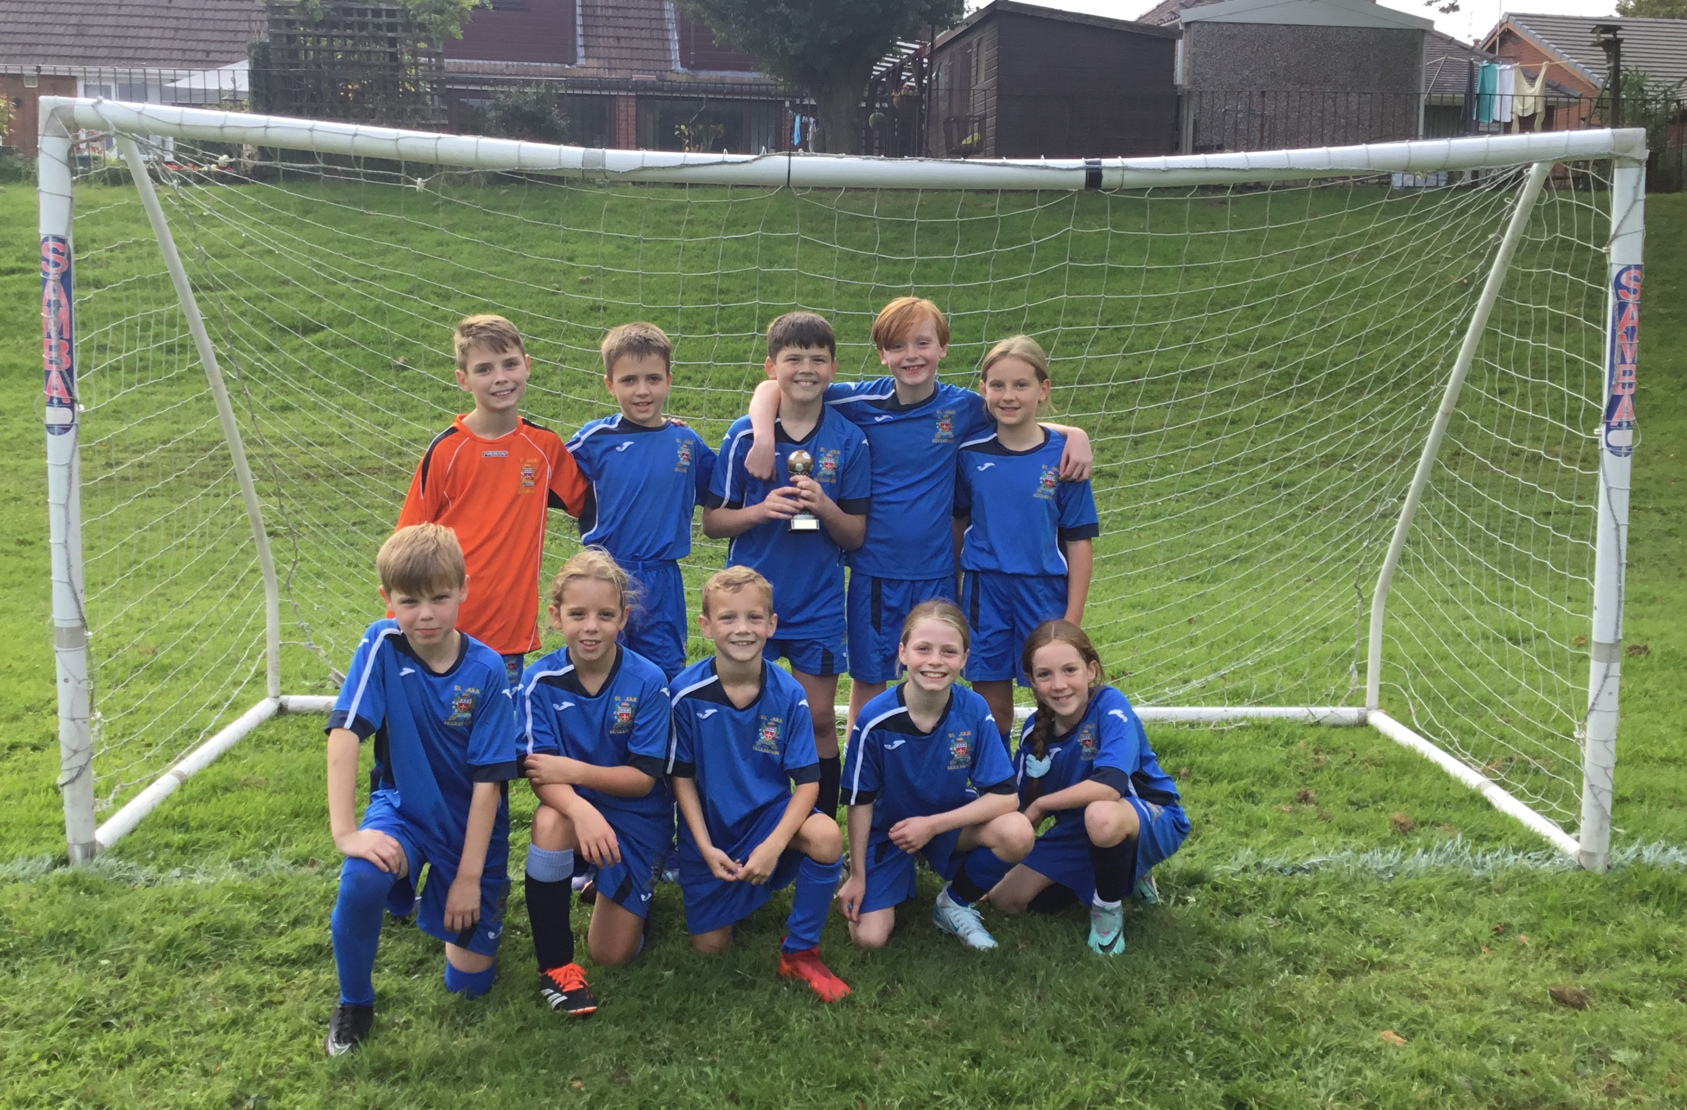



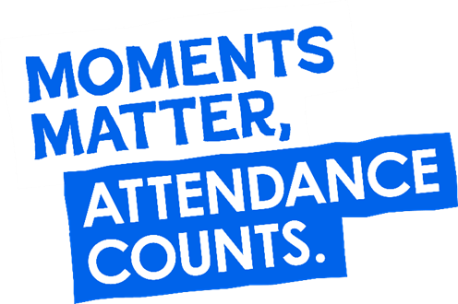
“From the first day of term to the last, the small moments in a school day make a real difference to your child.” #AttendanceCounts
At St Julie’s our attendance is excellent and we know that parents and carers value the education that your children receive.
Excellent attendance at school is important to allow a child to fulfil their potential. I am confident in your support in ensuring that your child strives for 100% attendance each week and is on time every day.
Holidays during term time will not be authorised.

Useful website Is my child too ill for school? - NHS (www.nhs.uk)

Year Group | % Attendance for w/e 04.10.24
Year R | 96.36
Year 1 | 98.71
Year 2 | 98.28
Year 3 | 94.29
Year 4 | 98.48
Year 5 | 96.57
Year 6 | 95.71

Well done to Year 1 who had the highest attendance this week.



St Julie’s Awards of the Week

 | Star for showing Respect | Book explorer | Marvellous mathematician
Reception | Imelda | Marty | Remi
Year 1 | Bella | Myles | Isla
Year 2 | Poppy | Teddy | Matthew
Year 3 | Zac T | Daniel R | Callum
Year 4 | Jackson H | Seth C | Thomas G
Year 5 | Alexa | Phinnaeus | India
Year 6 | Robert E | Robert F | Elizabeth


Nasal Flu Vaccination
A message from the Flu Immunisation Team was sent by email this week providing information regarding the vaccination programme and containing a link to consent to your child receiving the vaccine in school on Thursday 17th October 2024. Please ensure you complete the on-line consent which is required for all children from Reception up to Year 6.

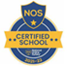
This week’s flyer from National Online Safety is, “What parents and educators need to know about in-game chat.”

Office Lines of Communication via School

SchoolMoney: This system is used for all payments to school, please use the Eduspot Website or download the Eduspot App and log in. Please note that when entering your details you must ensure that no space is typed after your mobile number or email address and your child’s first name only should be used and must be in lower case, again no space after their name. When payments are made available on SchoolMoney you will receive an alert to inform you.

Teachers2Parents: This is used to send text messages to your phone from school. You will receive an alert when a message is available to read. You can access both Teachers2Parents and SchoolMoney via the Eduspot website or App.

SchoolSpider: SchoolSpider is our usual method for sending out emails, weekly bulletins and setting up parental surveys. This can be accessed via our website or you can download the App. Emails, bulletins and surveys are sent via SchoolSpider to your email address and should show in your usual email inbox.

School Website: This will contain all information needed under your child’s “class page” and further information about the curriculum that your child is learning.

If for any reason you cannot access any of the above platforms can you please contact the School Office as soon as possible as it is vital that you use these systems to receive important information and alerts from School.
School cannot be held responsible if a parent doesn’t complete a survey or engage with online platforms.

Diary w/c 07.10.2024


Monday 8am Gymnastics Years 1 - 6
Y1 & Y2 Multi-skills club 3:20 – 4:15

Tuesday KS2 Football club 3:20 – 4:15

Wednesday 8am Multi-sports Years 1 – 6
SEND drop-in with Mrs Ashcroft 2 – 3pm
Y2 Spanish club 3:20 - 4:00
Y5 & Y6 Ukulele 3:20 - 4:15
KS2 Art club 3:20 - 4:15
Y5 & Y6 Young Voices 3:20 – 4:15
6pm PFA meeting in school: all parents very welcome

Thursday World Mental health day (children to wear bright colours)
Year 6 swimming 2-3pm
Tea and Talk 2:30pm in the school hall, all welcome
Y1 & Y2 Lego/Construction club 3:20 - 4:15
KS2 Dodgeball 3:20 – 4:15
Friday

Further dates for your Diary
Monday 14 October - Open afternoon for new intake 2025 2pm
Thursday 17 October - Flu immunisations in school
Tuesday 22 October - Parents’ Evening: appointments in school
Wednesday 23 October - Harvest Festival in church 2pm
Thursday 24 October - School closes for half-term

Primary School Admissions
The website will open for parents who wish to apply online: www.sthelens.gov.uk/admissions on 16th September 2024.

Children who turn 5 between 1 September 2025 and 31 August 2026 are eligible to apply for a place in primary school. The deadline for submission of primary school applications is 15 January 2025. The Archdiocese have asked us to remind parents seeking a reception class place at our school, even if you have a sibling in the school, of the need for baptism prior to application and to take prompt action if baptism has not already taken place.

New intake for September 2025
If you have a child due to start school in September 2025, we will be holding a new intake meeting on Monday 14th October 2024 at 2pm and Tuesday 19th November at 2pm. There will be an opportunity to have a look around our school and speak to the Headteacher, Mrs Hodgson.

Secondary School Admission
Children in Y6 should apply for a secondary school place by 31 October 2024 apply online: www.sthelens.gov.uk/admissions

“A caring family school, where we learn, grow and walk in the footsteps of Jesus.”

