Dear Parents and Carers,

World Mental Health day
On Thursday the children came to school looking vibrant in their brightly coloured clothes to show their awareness of supporting mental health. Our school’s Educational Mental Health Practitioner, Jayne Aspinall, led a whole school assembly reminding the children of how they can look after their own mental health and support each other by talking and listening. In the afternoon we held a tea and talk event. Thank you to those who attended. Some of our Minnie Vinnies and Wellbeing Ambassadors enjoyed helping to serve the tea and cakes and were delighted to welcome and chat with those who came. Thank you for the many cakes that were donated, we raised £60 to be donated to the St Vincent de Paul society, to which our Minnie Vinnies belong.

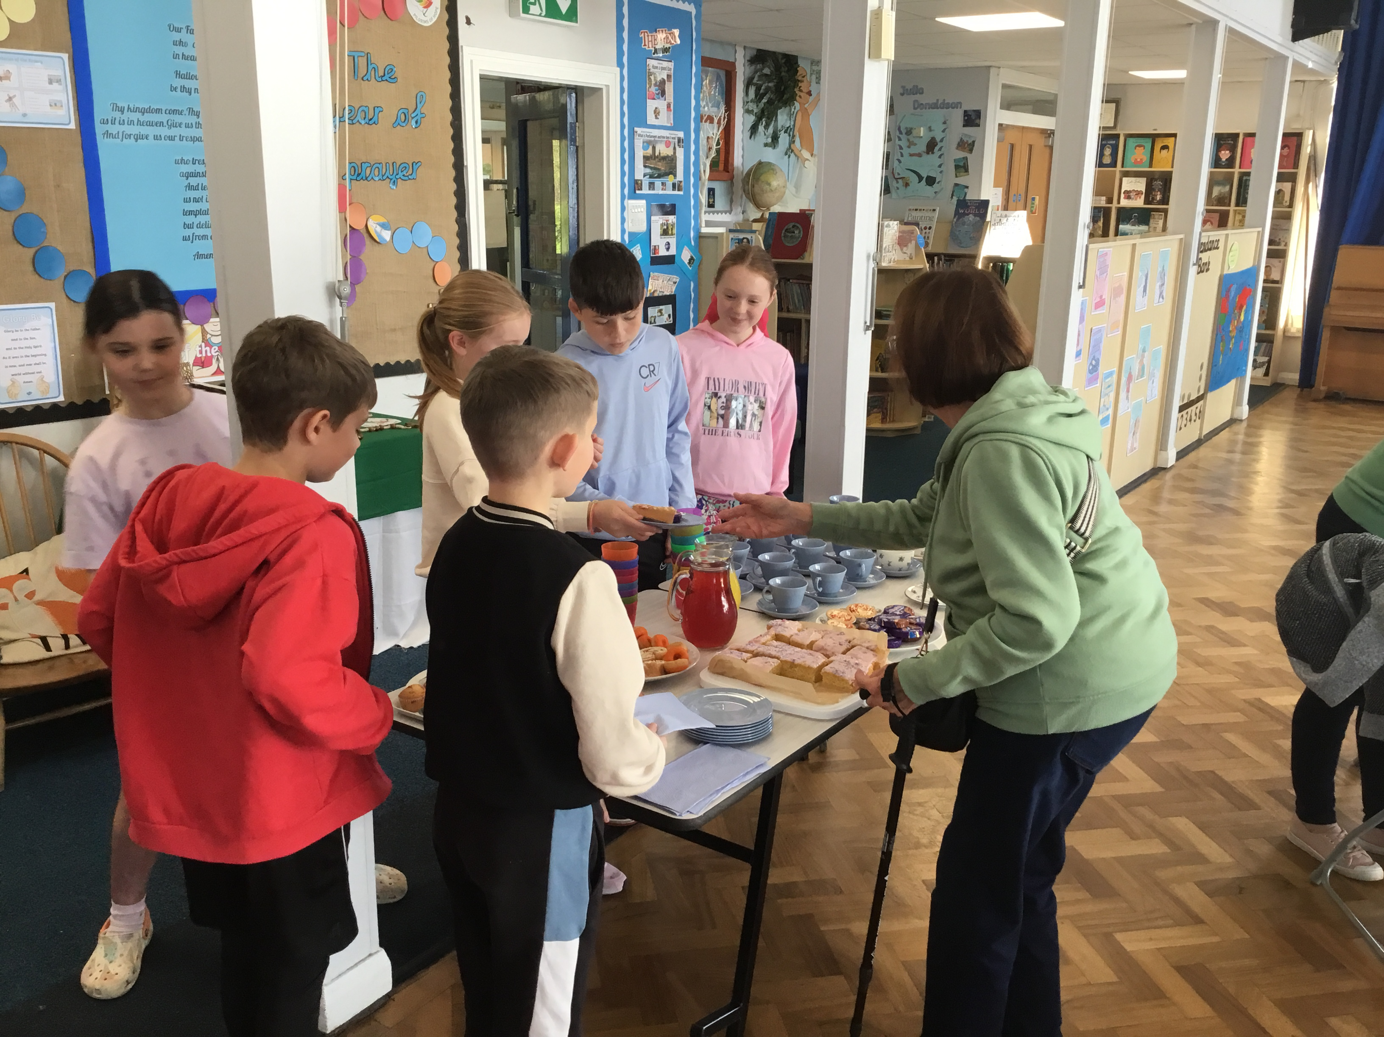


Sacramental programme for Year 4
Congratulations to the children in Year 4 who attended Mass last weekend at the start of the next stage of their faith journey. Together with their families they took part in the rite of enrolment for the Sacraments of First Confession and First Holy Communion as part of the parish. Families in Year 4 who have not yet enrolled and want their children to receive the sacraments during this academic year need to attend Mass this weekend. Following the formal enrolment, you will receive a certificate from Fr Michael.
Mass at St Thomas of Canterbury Saturday 6pm
Mass at St Julie’s Sunday 9:30am


PFA
Thank you to all those who came along to the meeting last Wednesday – it was wonderful to see new faces and many great ideas were shared.
The new committee of the PFA were duly elected as:
Co-Chairs: Lynsey Hyland
Treasurer: Rick Fassioms
Secretary: Lizzie Helsby
In preparation for future events, the PFA would be very grateful for donations of baskets for hampers. Please bring to the school office if you have any to donate.
The next meeting of the PFA will be held on Wednesday 13th November at 6.00 pm in the school.
The first event this term is:
Friday 18th October – Junior and Infant Film Afternoon: see flyers sent home today.


Raise valuable funds for St Julie’s while you shop with “Easyfundraising”
By downloading this app you can collect FREE funds for St Julie’s every time you shop online!
Just visit easyfundraising.org.uk, search for St Julie Catholic Primary PFA and follow the simple steps to sign up. Then start shopping using the links to over 2,000 retailers including Amazon, John Lewis, M&S, Argos, Next, ASOS and many more. Every time you shop, you’ll earn a donation for the school at no additional cost to you!


Nasal Flu Vaccination – NEXT THURSDAY
A message from the Flu Immunisation Team was sent by email this week providing information regarding the vaccination programme and containing a link to consent to your child receiving the vaccine in school on Thursday 17th October 2024. Please ensure you complete the on-line consent which is required for all children from Reception up to Year 6.

Parents Evening – Tuesday 22nd October
As usual at this time of year, our first parent’s night is a pastoral chat to see how your child has settled in their new class and so appointments will be 5mins. These will be face to face and to avoid over-running and causing long waits for parents, please stick to the time allotted. Appointments will be available via School Spider next week.

Year 6 and Year 5 Collective Worship
Year 6 would like to invite family members to join them in their classroom for their first Collective Worship of the year on Wednesday 16th October at 3pm followed by Year 5 on Thursday 17th October at 3pm. Please enter the school via the main school entrance on Brooklands Road.


Year 3 Football Competition
This afternoon a team from Year 3 competed in a football competition at Ruskin organised by St Helens School Games. The children representing St Julie’s showed great team spirit and enjoyed competing against other local schools. They also demonstrated their skill and determination and were rewarded by achieving 1st place. The children each received a medal and brought home a trophy for our school! Well done to Joel, Jack, River, Alba, Jasmine, Luke, Callum, Daisy, Hugo H and Zac – we are very proud of you all.

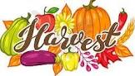
Harvest Service
At this time of year we take time to reflect on the nutritious food that we have readily available to us and give thanks to God. All parents are invited to join us as we celebrate our Harvest Festival in church on Wednesday 23rd October starting at 2:00pm. We will very grateful for donations of tinned and dried food products which we will then be taken to the St Helens Foodbank. Please send in donations from Monday 21st October – Items needed at the food bank include: Coffee/sugar/pasta sauces/noodles/tinned fruit/custard/toiletries/long life milk/juice/instant mash/pasta in sauce/long grain rice/tinned tomatoes/jam/chocolate/crisps. Thank you.
Following the service, you are invited to join us in the school hall for refreshments. Once again we will be grateful for donations of cakes nearer to the time.

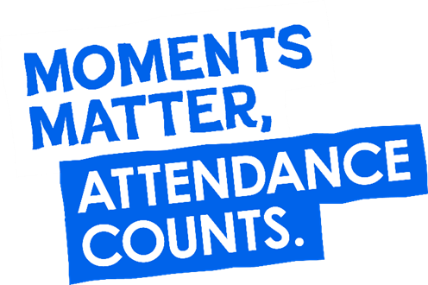
“From the first day of term to the last, the small moments in a school day make a real difference to your child.” #AttendanceCounts
At St Julie’s our attendance is excellent and we know that parents and carers value the education that your children receive.
Excellent attendance at school is important to allow a child to fulfil their potential. I am confident in your support in ensuring that your child strives for 100% attendance each week and is on time every day.
Holidays during term time will not be authorised.

Useful website Is my child too ill for school? - NHS (www.nhs.uk)

Year Group | % Attendance for w/e 11.10.24
Year R | 99.09
Year 1 | 97.10
Year 2 | 92.41
Year 3 | 96.57
Year 4 | 98.79
Year 5 | 99.71
Year 6 | 96.57

Well done to Year 5 who had the highest attendance this week.



St Julie’s Awards of the Week

 | Star for showing Respect | Book explorer | Marvellous mathematician
Reception | Ivy | Jessie-May | Luca
Year 1 | Thomas S | Harry | Grace
Year 2 | Charlotte | Joseph | Arthur
Year 3 | Josefina | Lennie | Raphie
Year 4 | Olly Mc | Holly | Nuala
Year 5 | Alice | Jude | Teddy B
Year 6 | Lexi-Mai | Archie | Luca

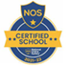
This week’s flyer from National Online Safety is, “10 top tips for parents and educators teaching children fire safety.”

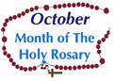
Diary w/c 14.10.2024

Monday 8am Gymnastics Years 1 – 6
Open afternoon for new intake 2025 2pm
Y1 & Y2 Multi-skills club 3:20 – 4:15

Tuesday Y3 trip to White Scar Caves
KS2 Football club 3:20 – 4:15

Wednesday 8am Multi-sports Years 1 – 6

Y2 Spanish club 3:20 - 4:00
Y5 & Y6 Ukulele 3:20 - 4:15
KS2 Art club 3:20 - 4:15
Y5 & Y6 Young Voices 3:20 – 4:15

Thursday Flu immunisations in school
Year 6 swimming 2-3pm
Y1 & Y2 Lego/Construction club 3:20 - 4:15
KS2 Dodgeball 3:20 – 4:15

Friday PFA Film night – Infants and Juniors until 5pm

Further dates for your Diary
Tuesday 22 October - Parents’ Evening: appointments in school
Wednesday 23 October - Harvest Festival in church 2pm
Thursday 24 October - School closes for half-term

Primary School Admissions
Children who turn 5 between 1 September 2025 and 31 August 2026 are eligible to apply for a place in primary school. The deadline for submission of primary school applications is 15 January 2025. The Archdiocese have asked us to remind parents seeking a reception class place at our school, even if you have a sibling in the school, of the need for baptism prior to application and to take prompt action if baptism has not already taken place.
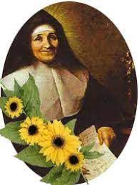
New intake for September 2025
If you have a child due to start school in September 2025, we will be holding a new intake meeting on Monday 14th October 2024 at 2pm and Tuesday 19th November at 2pm. There will be an opportunity to have a look around our school and speak to the Headteacher, Mrs Hodgson.

Secondary School Admission
Children in Y6 should apply for a secondary school place by 31 October 2024 apply online: www.sthelens.gov.uk/admissions

“A caring family school, where we learn, grow and walk in the footsteps of Jesus.”

