Dear Parents and Carers,


Harvest Service
At this time of year we take time to reflect on the nutritious food that we have readily available to us and give thanks to God. All parents are invited to join us as we celebrate our Harvest Festival in church on Wednesday 23rd October starting at 2:00pm. We will very grateful for donations of tinned and dried food products which we will then be taken to the St Helens Foodbank. Please send in donations from Monday 21st October – Items needed at the food bank include: Coffee/sugar/pasta sauces/noodles/tinned fruit/custard/toiletries/long life milk/juice/instant mash/pasta in sauce/long grain rice/tinned tomatoes/jam/chocolate/crisps. Thank you.

Following the service, you are invited to join us in the school hall for refreshments up until hometime. We will be very grateful for donations of cakes which can be sent in on the day.
Cafod fundraising
The theme for harvest this year is to brighten up the harvest in support of our brothers and sisters around the world who are hungry and build a brighter world together.
On Thursday 24th October we would like children to wear bright clothes in return for a monetary donation to Cafod. As the children will also be taking part in a carousel of wellbeing activities inside and out, we would like them to wear bright clothes that are suitable for the outdoors.

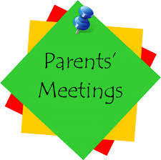
Parents Evening – Tuesday 22nd October
As usual at this time of year, our first parent’s night is a pastoral chat to see how your child has settled in their new class and so appointments will be 5 minutes. These will be face to face and to avoid over-running and causing long waits for parents, please stick to the time allotted. The teachers will be using a 5-minute timer to keep on track so please do not be offended when the time is up; teachers are ensuring that everyone gets a fair share of time. If you feel you need more time, please arrange a further appointment or a phone call home after half term. Thank you for your understanding.


November is the month of the Holy Souls
Looking ahead to next half-term, traditionally during the month of November, we remember and pray for those who have died and gone before us. Mrs McCahey has asked if you wish to have the name of a loved one included in our Remembrance Book for the month of November, please send it into school in an envelope marked for her attention as soon as possible.
Our whole school Remembrance Mass will take place in St Julie’s church on Thursday 14th October at 9:30am – all are welcome.


The Royal British Legion Poppy Appeal
Poppies, wristbands, reflectors, zip pulls and snap bands will be available from the school office from next week for a donation of £1 per item in aid of the Royal British Legion poppy appeal

Poetry Competition winners

On National Poetry Day we launched a competition for children to write a poem with the theme of Counting. We were delighted with the huge number of entries from our enthusiastic poets. Our Year 6 Reading Ambassadors, Thomas H and Phoebe H, had the tough job of choosing the winners and this morning in assembly presented them with their certificates and prizes. The winning poets proudly read their poems out loud in the hall; they were:

Infants – Samantha
Juniors – Liberty, Harry G and Poppy T from Year 6
You can use the QR code to listen to their poems.


PFA
In preparation for future events, the PFA would be very grateful for donations of baskets for hampers. Please bring to the school office if you have any to donate.
The next meeting of the PFA will be held on Wednesday 13th November at 6.00 pm in the school.
Amazon Wishlist
Last year, the PFA organised the setting up of Amazon Wishlists for each class so that families could choose to purchase and donate a gift directly to their child’s class. Thank you to all those parents and grandparents who donated gifts. The children, and teachers, were excited to receive their Amazon parcels and the resources were very much viewed as special gifts from the parents of the class. In total over all the classes last year, £1,006 was spent on the Amazon Wishlist. Thank you so much for your generosity.
Cards have been sent home with children today in their bookbags with details of the Amazon Wishlist for your child’s classroom this year.


Raise valuable funds for St Julie’s while you shop with “Easyfundraising”
By downloading this app you can collect FREE funds for St Julie’s every time you shop online!
Just visit easyfundraising.org.uk, search for St Julie Catholic Primary PFA and follow the simple steps to sign up. Then start shopping using the links to over 2,000 retailers including Amazon, John Lewis, M&S, Argos, Next, ASOS and many more. Every time you shop, you’ll earn a donation for the school at no additional cost to you!


Year 6 Rugby Competition
This afternoon a team from Year 6 competed in a rugby competition at Ruskin organised by St Helens School Games. The children representing St Julie’s showed great team spirit and enjoyed competing against other local schools. They also demonstrated their skill and determination and were rewarded by achieving 2nd place. The children each received a medal and arrived back at school triumphant! Well done to Thomas K, Zack T, Marley, Ivan, Robert E, Ollie P and Bertie.

Packed lunches
A reminder that we are a Healthy School and so a sandwich/wrap, fruit and one small treat is sufficient for packed lunch. Please include healthy items rather than crisps, chocolate and sweets.


Food Allergies
Please take care not to include nut based products in lunch boxes as we have several children in school who suffer from nut allergies. We encourage the children to bring a healthy snack of fruit or toast for break time (no cereal bars please). If your child is bringing grapes, please ensure that they are sliced down the middle lengthways.

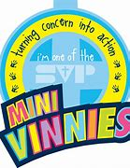
Who are the Mini Vinnies?
At St Julie’s our Minnie Vinnies meet together with Mrs McCahey to think about ways in which they can support people in our local community.
Mini Vinnies follow in the footsteps of Christ and St Vincent de Paul.
The Mini Vinnies are the youngest members of the St Vincent de Paul Society (SVP), an international Christian voluntary organisation dedicated to tackling poverty in all its forms by providing practical assistance to people in need.
The Mini Vinnies get together in primary schools and parishes across England and Wales to live out their mission of see, think, do, supporting their school community and beyond alongside the SVP.
Minnie Vinnies would like you to support our Local St Vincent de Paul charity shop on Cambridge Road. If you have any unwanted clothes or toys that are in good, saleable condition please send them into the school office for us to donate on your behalf. Thank you.

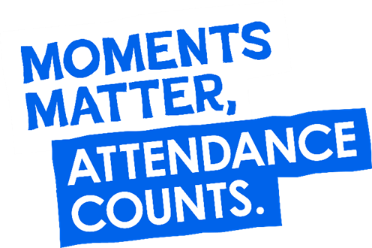
Parents must apply for leave of absence during term time in all instances. A form, to request in writing a leave of absence, is available from the school office or alternatively it can be requested via email. Parents must apply to the Headteacher at least 2 weeks before the intended absence and provide necessary evidence of the exceptional circumstance. The Headteacher will decide if the leave will be granted and how many days will be authorised. Where the Headteacher does not grant an application for leave of absence and parents decide to take the leave anyway, the absence will be unauthorised, and the parents may receive a Penalty Notice Fine.
Useful website Is my child too ill for school? - NHS (www.nhs.uk)

Year Group | % Attendance for w/e 18.10.24
Year R | 99.09
Year 1 | 92.26
Year 2 | 99.66
Year 3 | 95.43
Year 4 | 99.39
Year 5 | 98.57
Year 6 | 98.29

Well done to Year 2 who had the highest attendance this week.


St Julie’s Awards of the Week

 | Star for showing Respect | Book explorer | Marvellous mathematician
Reception | Charlotte | Geoffrey | Marty
Year 1 | Orlagh | Iris | Jack
Year 2 | Samantha | Easton | Caleb
Year 3 | Kayla | Joel | Penelope
Year 4 | Freddie F | Lucas | Sofia
Year 5 | Alissa | Annabelle | Joseph
Year 6 | Gracie | Thomas H | Elsie

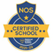
This week’s flyer from National Online Safety is, “What parents and educators need to know about horror films and age ratings.”

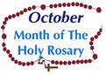
Diary w/c 21.10.2024

Monday 8am Gymnastics Years 1 – 6
Y1 & Y2 Multi-skills club 3:20 – 4:15

Tuesday KS2 Football club 3:20 – 4:15
Parents’ evening appointments

Wednesday 8am Multi-sports Years 1 – 6
Harvest Festival in church 2pm followed by coffee afternoon school hall
Y2 Spanish club 3:20 - 4:00
Y5 & Y6 Ukulele 3:20 - 4:15
KS2 Art club 3:20 - 4:15
Y5 & Y6 Young Voices 3:20 – 4:15

Thursday Cafod fundraising – wear bright clothes suitable for outdoors (donation)
Year 6 swimming 2-3pm
Y1 & Y2 Lego/Construction club 3:20 - 4:15

KS2 Dodgeball 3:20 – 4:15

Friday INSET

Further dates for your Diary
Thursday 24 October - School closes for half-term
Monday 4 November - School re-opens
Tuesday 5 November - Year 2 Collective Worship 3pm
Wednesday 6 November - Year 1 Collective Worship 3pm
Thursday 7 November - Share a Story session Reception
Thursday 7 November - Year 4 sacramental Programme session 2, 3:20-4pm
Monday 11 November - Year 5 trip to Imperial War Museum
Tuesday 12 November - Odd socks day with uniform

Primary School Admissions
Children who turn 5 between 1 September 2025 and 31 August 2026 are eligible to apply for a place in primary school. The deadline for submission of primary school applications is 15 January 2025. The Archdiocese have asked us to remind parents seeking a reception class place at our school, even if you have a sibling in the school, of the need for baptism prior to application and to take prompt action if baptism has not already taken place.
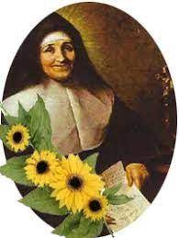
New intake for September 2025
If you have a child due to start school in September 2025, we will be holding a new intake meeting on Tuesday 19th November at 2pm. There will be an opportunity to have a look around our school and speak to the Headteacher, Mrs Hodgson.

Secondary School Admission
Children in Y6 should apply for a secondary school place by 31 October 2024 apply online: www.sthelens.gov.uk/admissions

“A caring family school, where we learn, grow and walk in the footsteps of Jesus.”

