Dear Parents and Carers,


November is the month of the Holy Souls
Looking ahead to next half-term, traditionally during the month of November, we remember and pray for those who have died and gone before us. Mrs McCahey has asked if you wish to have the name of a loved one included in our Remembrance Book for the month of November, please send it into school in an envelope marked for her attention as soon as possible.
Our whole school Remembrance Mass will take place in St Julie’s church on Thursday 14th November at 9:30am – all are welcome.


The Royal British Legion Poppy Appeal
Poppies, wristbands, reflectors, zip pulls and snap bands are still available from the school office for a donation of £1 per item in aid of the Royal British Legion poppy appeal

Walk Once a Week

Well done to all those who have walked to school at least once a week during October.
Reception | 17 children
Year 1 | 10 children
Year 2 | 16 children
Year 3 | 18 children
Year 4 | 14 children
Year 5 | 15 children
Year 6 | 14 children

Well done to the winning class, Y3, who will look after the trophy this month.

Anti-Bullying Week 
Anti-Bullying Week 2024 will take place from Monday 11th - Friday 15th November, with the theme: Choose Respect. From playgrounds to parliament, our homes to our phones, this Anti-Bullying Week let's 'Choose Respect' and bring an end to bullying which negatively impacts millions of young lives. This year, we’ll empower children and young people to not resort to bullying, even when we disagree and remind adults to lead by example, online and offline. Imagine a world where respect and kindness thrives — it’s not just a dream, it's in the choices we make. Join us this Anti-Bullying Week and commit to 'Choose Respect'. We know we won’t always get along with everyone and we don’t always agree, but we can choose respect and unity – out St Julie’s core values.

Odd Socks Day is taking place on Tuesday 12th November. The children are encouraged to wear odd socks to school on Tuesday to highlight that we are all unique and that it is good to be different


TT Rockstars Battles
The Battle of the Bands has begun again on TT Rockstars! In the latest times tables challenge:
Year 5 v Year 6 Year 3 v Year 4
Beginning Thurs 7th Nov at 5pm and ending Thurs 21st Nov at 5pm.
Points can only be earned between 7am and 8pm!
Let battle commence…
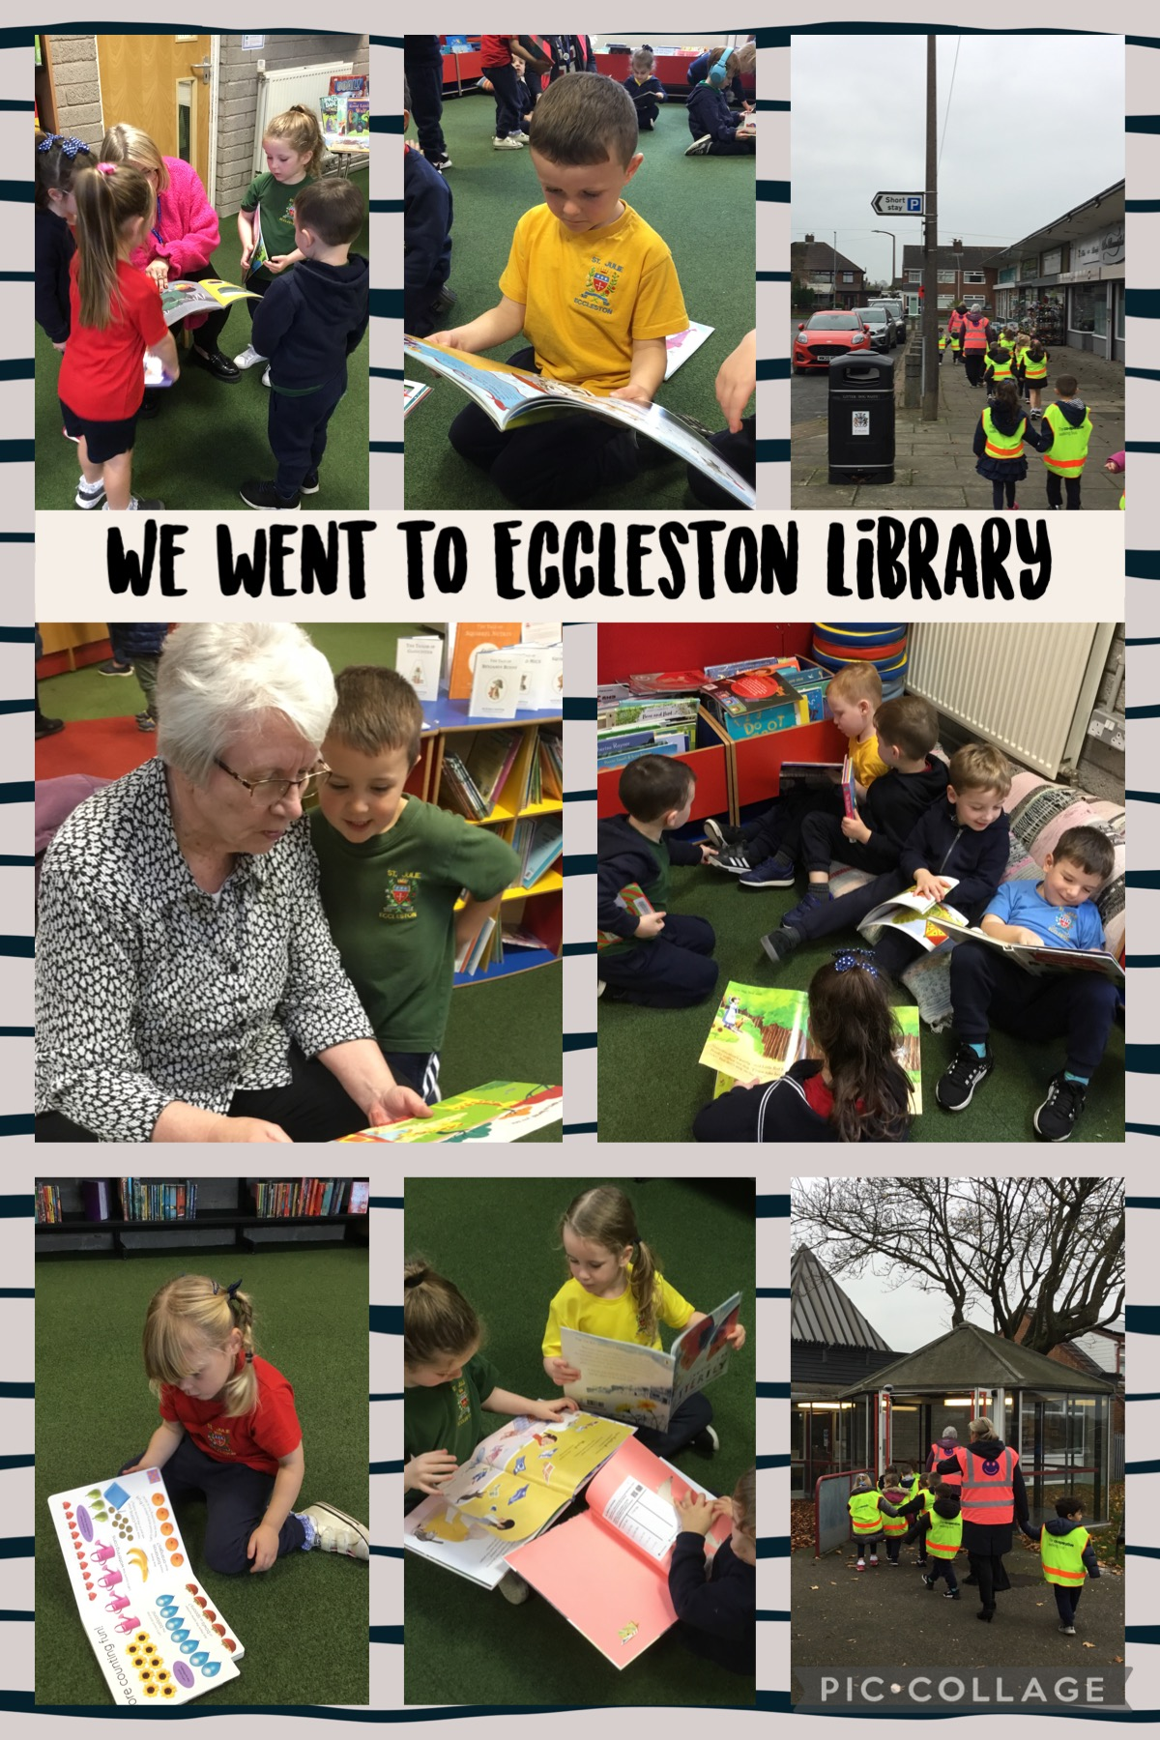

Reception Class – Eccleston Library
On Monday 4th November our Reception class had a great time when they visited Eccleston Library for the first time. The children really enjoyed their visit and loved looking at the wide range of books available. The Library Staff were very impressed and commented that their behaviour was perfect! If you are not already a member the Library is free to join, offering excellent resources


PFA
In preparation for future events, the PFA would be very grateful for donations of baskets for hampers. Please bring to the school office if you have any to donate.
The next meeting of the PFA will be held on Wednesday 13th November at 6.00 pm in the school. Thank you for the many gifts that have been delivered this week to each class from the Amazon Wishlist. The teachers are extremely grateful for your generosity.

Children in Need

The children are invited to come in wearing spots on Friday 15th November in return for a donation for Children in Need to be made via School Money. The amount can be overtyped to allow you to donate what you feel is appropriate. This will be set up from next Monday. Spotty accessories with their school uniform may be worn: Pudsey ears, spotty ties, spotty tops, socks, bows etc. School shoes must be worn – no boots or trainers


Share a Story Sessions
The children of St Julie’s are enthused by their love of books and find great pleasure in their reading. Once again, we would like to invite parents/carers to come into school to share a story – or more – with their child in the school hall.

The first session was on Thursday 7th November for the Reception class. One adult is invited to come to school via the front entrance on Brooklands Road at 2:40pm to join their child for a cosy reading session. School will provide the books and don’t worry if you can’t make it, there will be school staff around to make sure all children can have a fun reading time.
Further sessions are:
Wednesday 13th November – Year 5
Thursday 14th November – Year 4
Thursday 21st November – Year 1
Monday 25th November – Year 6
Tuesday 26th November – Year 3


Parents must apply for leave of absence during term time in all instances. A form, to request in writing a leave of absence, is available from the school office or alternatively it can be requested via email. Parents must apply to the Headteacher at least 2 weeks before the intended absence and provide necessary evidence of the exceptional circumstance. The Headteacher will decide if the leave will be granted and how many days will be authorised. Where the Headteacher does not grant an application for leave of absence and parents decide to take the leave anyway, the absence will be unauthorised, and the parents may receive a Penalty Notice Fine.

Year Group | % Attendance for w/e 08.11.24
Year R | 98.18
Year 1 | 96.77
Year 2 | 96.21
Year 3 | 96.00
Year 4 | 100
Year 5 | 99.14
Year 6 | 91.43

Well done to Year 4 who had the highest attendance this week.



St Julie’s Awards of the Week

 | Star for showing Unity | Book explorer | Marvellous mathematician
Reception | Whole Class | Noah | Felicity
Year 1 | Bobby O | Toby | Theo
Year 2 | Cameron | Lucy | Elliott
Year 3 | Sienna | Alba | Ali
Year 4 | Teddy | Darcey | Sam
Year 5 | Luca | Aveah | Harrison
Year 6 | Amelia | Thomas K | Mia Ford


This week’s flyer from National Online Safety is, “What parents and educators need to know about horror films and age ratings.”


Diary w/c 11.11.2024

Monday 8am Gymnastics Years 1 – 6
Year 5 trip to Imperial War Museum
Y1 & Y2 Multi-skills club 3:20 – 4:15

Tuesday Odd socks day with uniform
KS2 Table Tennis 3:20 – 4:15

Wednesday 8am Multi-sports Years 1 – 6
Year 5 Share a Story session 2:40pm
Y2 & Y1 Spanish club 3:20 - 4:00
KS2 Crochet and sewing club 3:20 - 4:15
Y5 & Y6 Young Voices 3:20 – 4:15
PFA meeting in school 6pm – all welcome

Thursday Remembrance Mass for whole school 9:30am – all welcome
Year 4 Share a Story session 2:40pm
Y1 & Y2 Art club 3:20 - 4:15
KS2 Dodgeball 3:20 – 4:15

Friday Children In Need day – wear spots/spotty accessories with uniform
PFA Bingo in Parish Hall

Further dates for your Diary
Monday 18 November - Year 4 Class Collective Worship 3pm
Tuesday 19 November - Open afternoon for new intake 2025 2pm
Tuesday 19 November - Year 3 Class Collective Worship 3pm
Thursday 21 November - Class Mass in church for Year 5 and Year 3 9:30am – parents welcome
Thursday 21 November - Year 1 Share a Story session 2:40pm
Monday 25 November - Year 6 Share a Story session 2.40pm
Tuesday 26 November - Year 3 Share a Story 2:40pm
Thursday 28 November - Class Mass in church for Year 4 and Year 6 9:30am – parents welcome
Friday 29 November - PFA Christmas tree light switch on after school
Thursday 5 December - Year 4 sacramental programme session 3, 3:20 – 4pm
Wednesday 11 December - Christmas dinner
Friday 13 December - Christmas Jumper day and Santa Dash
Friday 13 December - Year 4 Sacrament of First Forgiveness in church 5pm
Monday 16 December - Junior Christmas Party day
Tuesday 17 December - Infant Christmas Party day
Thursday 19 December - Nativity led by Year 2 in church 2pm
Friday 21 December - School closes for Christmas break.
Monday 6 January 2025 - School re-opens. Whole school Mass 9:30 Feast of the Epiphany
Thursday 9 January - Year 5 begin weekly swimming lessons at Queens Park Leisure centre

Primary School Admissions
Children who turn 5 between 1 September 2025 and 31 August 2026 are eligible to apply for a place in primary school. The deadline for submission of primary school applications is 15 January 2025. The Archdiocese have asked us to remind parents seeking a reception class place at our school, even if you have a sibling in the school, of the need for baptism prior to application and to take prompt action if baptism has not already taken place.

New intake for September 2025
If you have a child due to start school in September 2025, we will be holding a new intake meeting on Tuesday 19th November at 2pm. There will be an opportunity to have a look around our school and speak to the Headteacher, Mrs Hodgson.


“A caring family school, where we learn, grow and walk in the footsteps of Jesus.”



