Dear Parents and Carers,


Advent
This Sunday is the third Sunday of Advent and we focus on the meaning of ’Joy.’ “Rejoice in the Lord always. I shall say it again: rejoice!” (Phil 4:4). On this Sunday we celebrate and rejoice in the eternal power of God.
Please see the RE tab on the website for more Advent activities and the RE newsletter.
Mass is at 9:30 am every Sunday at St Julie’s Church.


Bambinelli Sunday
Bambinelli is Italian for the figure of Jesus in your Christmas Crib. Traditionally they are brought to Mass for a blessing during Advent on Gaudete Sunday. You are invited to bring your baby Jesus from your home crib to 9.30am Mass at St Julie’s this Sunday,17th December, for a special blessing during the Mass.

Sacrament of First Forgiveness – today at 5pm in St Julie’s church
Please keep Year 4 in your prayers as they prepare to receive the Sacrament of First Forgiveness today, Friday 13th December at 5pm at St Julie’s Church. All members of school community are invited to join them and to receive the Sacrament of Confession at this special time of year.

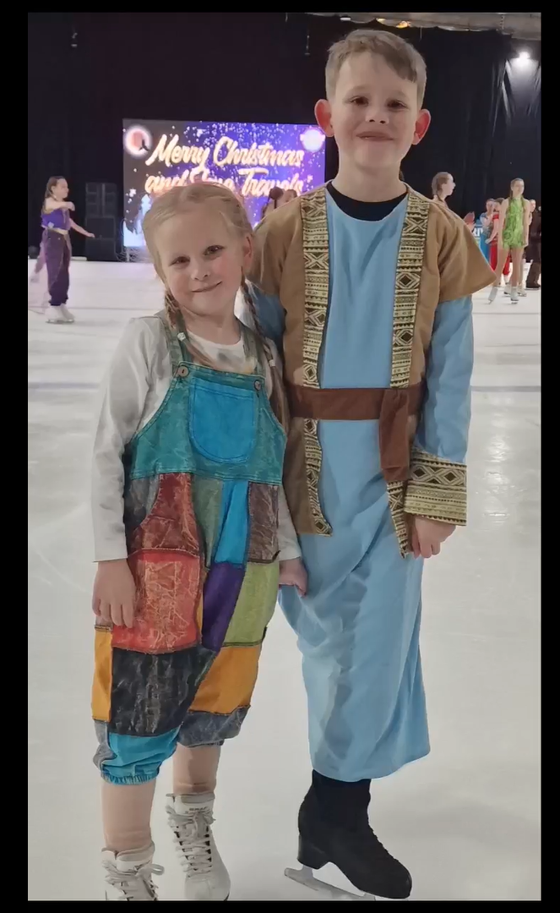
Year 3 and Year 5 trip to Aladdin on Ice
Children from Year 3 and Year 5 had a fabulous time on Monday afternoon watching their classmates Ivy (Y3) and Rory (Y5) in a fun-filled version of Aladdin on ice. The performance included local amateur skaters, with support from a professional touring cast. We loved clapping, singing and dancing along! Congratulations to Ivy and Rory on their wonderful performance.
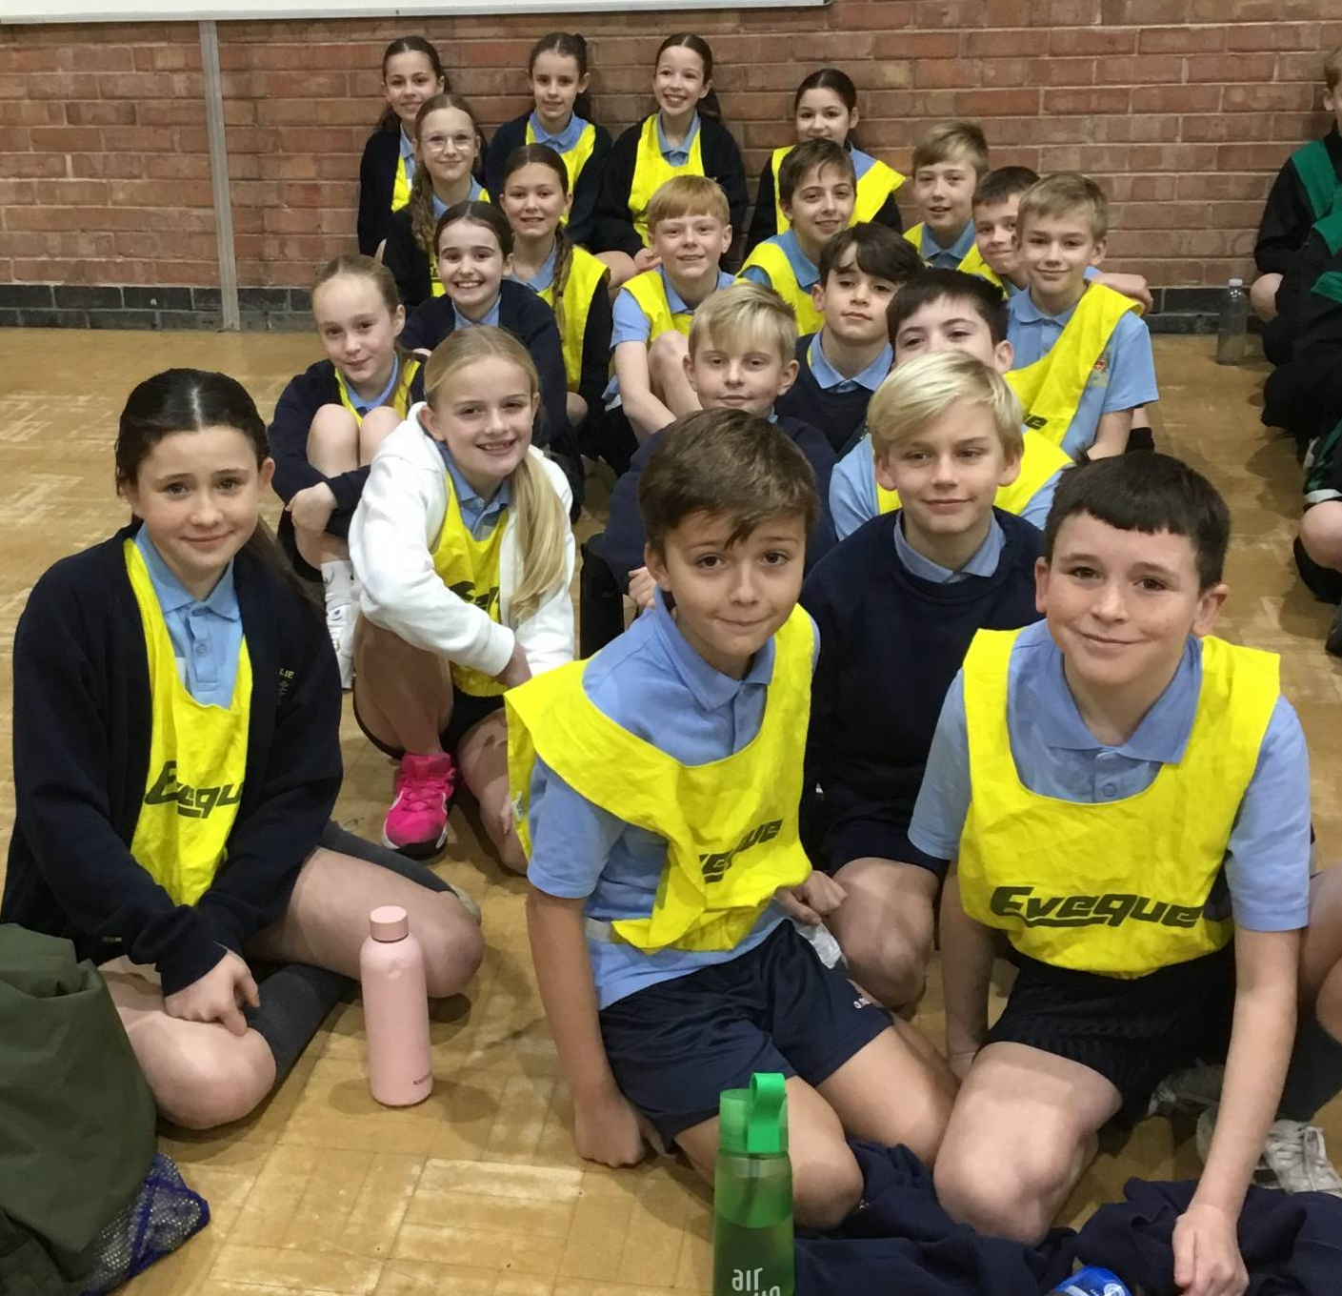

Year 6 Athletics Competition
The St Julie's Athletics Squad performed brilliantly at the recent School Games Indoor Athletics Competition. Taking part in a range of track and field events. Well done Year 6!

Christmas Carol Services
Thank you to those who came to listen to the Year 5, Year 1 and Year 3 carol performances this week. It was wonderful for the children to be able to perform in front of an audience and certainly reminded us all of the true meaning of Christmas. Well done to all the children who have brought joy to us with their beautiful singing over the past two weeks of Carol Concerts.
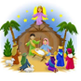
Year 2 Nativity and Christmas Carol Services
Everyone is invited to join us in St Julie’s Church for the performance of the Nativity by Year 2 on Thursday 19th December at 2pm. The whole school will be joining in with the Carols and the traditional retelling of the birth of Jesus, bringing us the true meaning of Christmas.

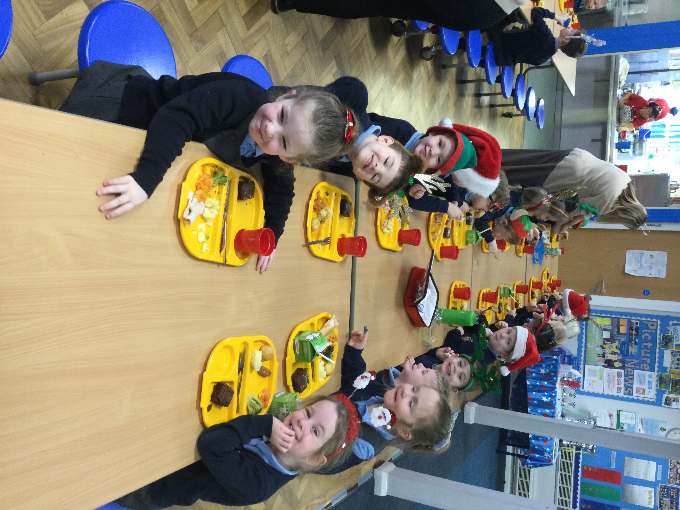

Christmas Dinner and Wear it well for Willowbrook.
On Wednesday children enjoyed a delicious Christmas Dinner cooked by Mrs Finney and her team in the kitchen. The children were invited to wear festive headwear in return for a donation to the local Willowbrook Hospice. Thank you for all your kind donations received.


Christmas Party Days
A reminder that Monday is Christmas Party day for the Juniors and Tuesday is Christmas Party day for the infants. The children should come to school dressed in their party clothes but please remember that they will still be playing out at break and lunchtime so should be warmly dressed and have sensible footwear.
Party Lunch Boxes will be served at lunchtime to those who have ordered them.

Christmas Card Competition 2024
Children from Year 5 and Year 6 were invited by St Helens College and Knowsley Community College to take part in a Christmas Card Competition. The children had to use their imagination and as much colour and creativity as possible to complete their designs.
Congratulations to the winners:
1st place – Molly T (Year 5) - £50 Amazon voucher
2nd place – Elissa W (Year 5) - £30 Amazon voucher
3rd place – Lexi-Mai B (Year 6) - £20 Amazon voucher

Could we please remind parents that your child must be in school by 8.50am – if you arrive later than 8.50am please could you walk your child into school via the office and wait for a member of staff to escort them into their class room. Children must be accompanied to the office to ensure they are handed over to a staff member, they must not be left to walk into school from the main gate without a parent/carer/adult.

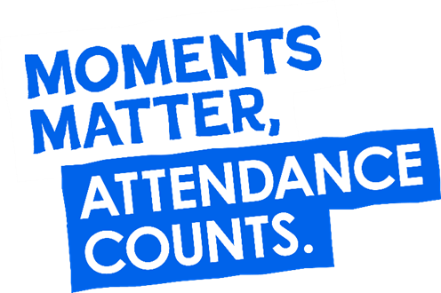
Parents must apply for leave of absence during term time in all instances. A form, to request in writing a leave of absence, is available from the school office or alternatively it can be requested via email. Parents must apply to the Headteacher at least 2 weeks before the intended absence and provide necessary evidence of the exceptional circumstance. The Headteacher will decide if the leave will be granted and how many days will be authorised. Where the Headteacher does not grant an application for leave of absence and parents decide to take the leave anyway, the absence will be unauthorised, and the parents may receive a Penalty Notice Fine.

Year Group | % Attendance for w/c 09.12.24
Year R | 97.16
Year 1 | 88.71
Year 2 | 99.57
Year 3 | 87.14
Year 4 | 98.86
Year 5 | 95.71
Year 6 | 97.50

Well done to Year 2 who had the highest attendance this week.

St Julie’s Awards of the Week

 | Star for showing Unity | Book explorer | Marvellous mathematician
Reception | Felicity | Imelda | James D
Year 1 | All of Year 1 | Faith | Toby
Year 2 | Sophie J | Joseph | Reggie
Year 3 | Ivy | Josie | Jacob
Year 4 | Seth | Callum | Dominic
Year 5 | Jude | Lucas | Ryan
Year 6 | Marley | Elsie | Thomas K

The Winter Holiday Activity and Food Programme (HAF)
The Winter Holiday Activity and Food Programme (HAF) will be running from Monday 23rd December 2024 to Friday 3rd January 2025 for all eligible children, young people and families.
The activity bookings links will go live on Tuesday 3rd December at 1.00pm for families to book their Winter activities, please note that activity places are subject to availability. We would like to ensure that as many eligible families take this offer up over the Winter to remove some of the financial burden to families who may already be on the brink.
Please see below the link to the HAF webpage with all of the information about the Winter programme.
HAF Winter Programme 2024 - St Helens Borough Council

Diary w/c 16.12.2024

Monday KS2 Party Day

Tuesday KS1/EYFS Party Day

Wednesday Christmas Craft Club 3:20

Thursday Year 2 Nativity – 2pm
Mince Pies & Refreshments served in the school hall – all welcome!

Friday School Closes for Christmas

Reminder: There are no after school clubs, including any run by Gilchrist Sports Coaching during the last week of term with the exception of the Christmas Craft Club on Wednesday 18th December. Our Sunflower Club will run as normal.

Christmas Mass Schedule:
Christmas Eve (1st Mass of Christmas day) 6pm St Thomas of Canterbury – carols from 5:30pm
Christmas Day 9:30am St Julie’s church – carols from 9am
Christmas Day 11am St Mary’s, Lowe House – carols from 10:30am
St Stephen (26th December) 9:30am St Julie’s church; 11am St Thomas of Canterbury.

Further dates for your Diary
Monday 6 January 2025 - School re-opens. Whole school Mass 9:30 Feast of the Epiphany
Thursday 9 January - Year 5 begin weekly swimming lessons at Queens Park Leisure centre
Wednesday 5 February - Reception Hearing Screening

Primary School Admissions
Children who turn 5 between 1 September 2025 and 31 August 2026 are eligible to apply for a place in primary school. The deadline for submission of primary school applications is 15 January 2025. The Archdiocese have asked us to remind parents seeking a reception class place at our school, even if you have a sibling in the school, of the need for baptism prior to application and to take prompt action if baptism has not already taken place.

“A caring family school, where we learn, grow and walk in the footsteps of Jesus.”
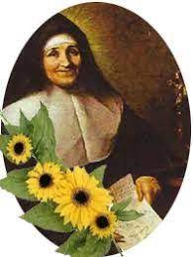

St Julie pray for us, protect us and bless us.



