|  |  |  |
| --- | --- | --- |
| St Julie Catholic Primary - History | | |
| Enquiry Question: What did the Ancient Egyptians believe? | Year: 3 | Logo_smallStrand: Depth Study – Ancient Egypt |

|  |  |
| --- | --- |
| **Vocabulary** | |
| Pharaohs | King or Queen of Ancient Egypt. |
| Mummification | The preserving of a body after death. |
| Afterlife | An existence after death. |
| Egyptologist | A person who studies ancient Egyptian history, language, religion etc. |
| Hieroglyphs | A writing system that uses pictures and symbols instead of letters and words. |
| Papyrus | A tall African plant that grows especially in Egypt. A material like paper used by ancient people to write on. |
| Cartouche | Usually oval with your name written in the middle of it. A cartouche is attached to your coffin. |

**What should I already know?**

Historical figures- Queen Victoria and Queen Elizabeth II.Samuel Taylor, Florence Nightingale. Changes across time- 1950s toys Ordering events on a time line- Great Fire of London.

**Our Enquiry Questions.**

What did the Egyptians believe? Who were the Egyptian Gods?

What importance did animals have in Ancient Egypt?

Why did the Egyptians build temples, tombs and pyramids?

What did the Egyptians believe about death?

How did Egyptians bury their dead and why?

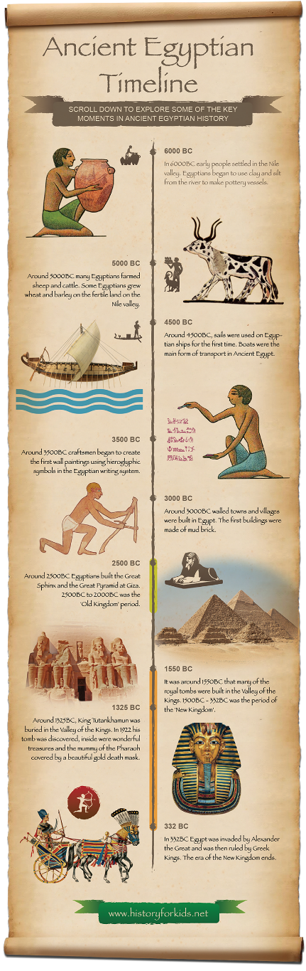

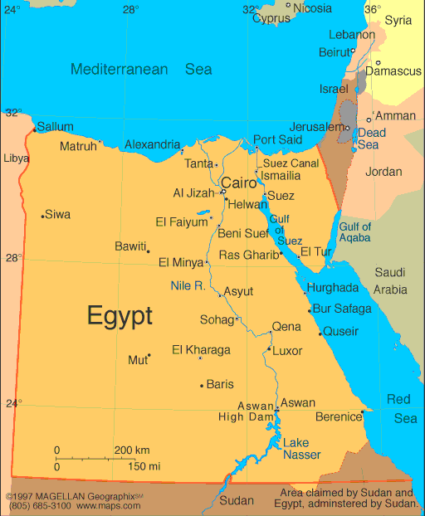

**Egypt** is in the continent of **Africa**.

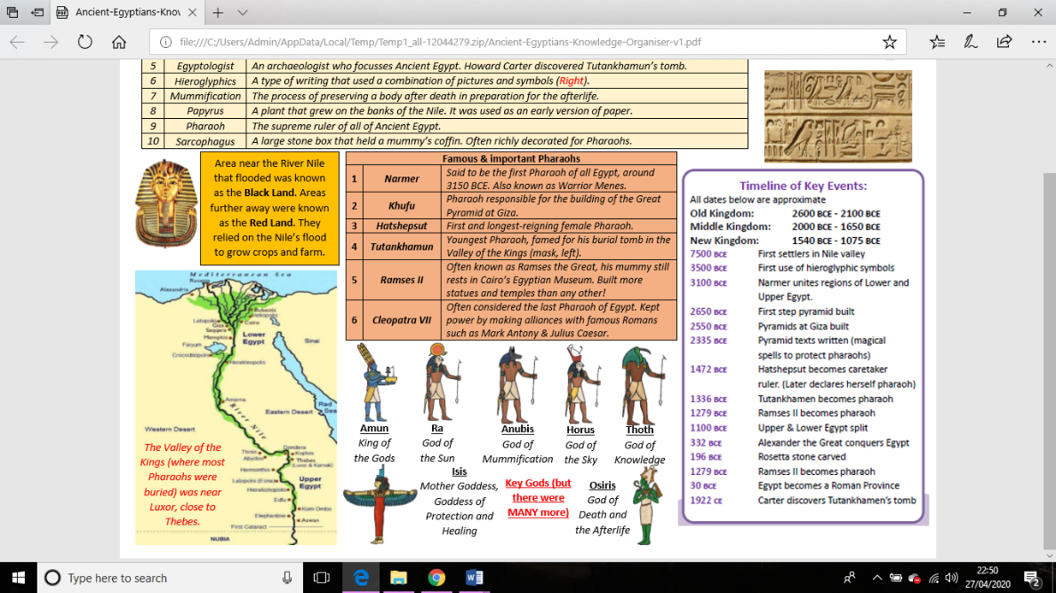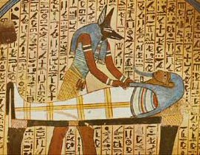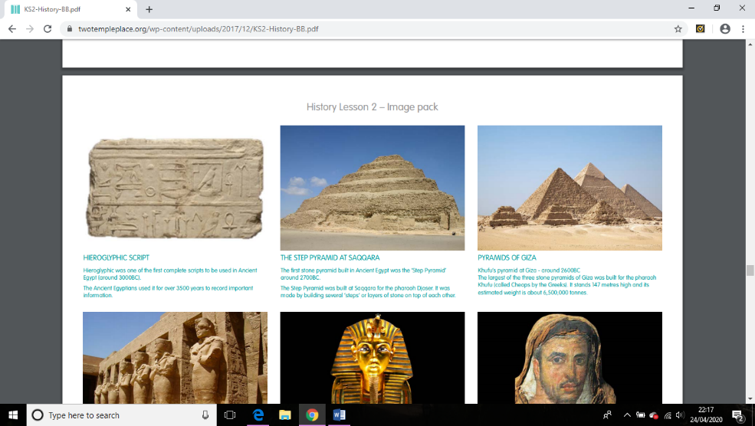

**Disciplinary Knowledge**

I can recall that Egyptians built temples as houses for the Egyptian gods. Pyramids were built as giant burial tombs, for the most important people in their society, the pharaohs.

I can explain the 7 stages and process of mummification; clean, organs, brain, stuff, dry, wrap, coffin.

**Howard Carter**

(1874-1939)

Discovered the tomb of Tutankhamun.

**Substantive Knowledge (Sticky Knowledge)**

The Ancient Egyptians worshipped thousands of different gods and goddesses, which were often shown as humans with animal features

They believed that they had to preserve their bodies so they could use them in the afterlife.

Pyramids were built to protect the body of the deceased pharaoh. These massive tombs were constructed to withstand the elements of time and were intended to last forever.