|  |  |  |
| --- | --- | --- |
| Geography | | |
| Topic: Why are jungles so wet and deserts so dry? | Year: 3 | Strand: Locational & Place Knowledge, Human & Physical geography |

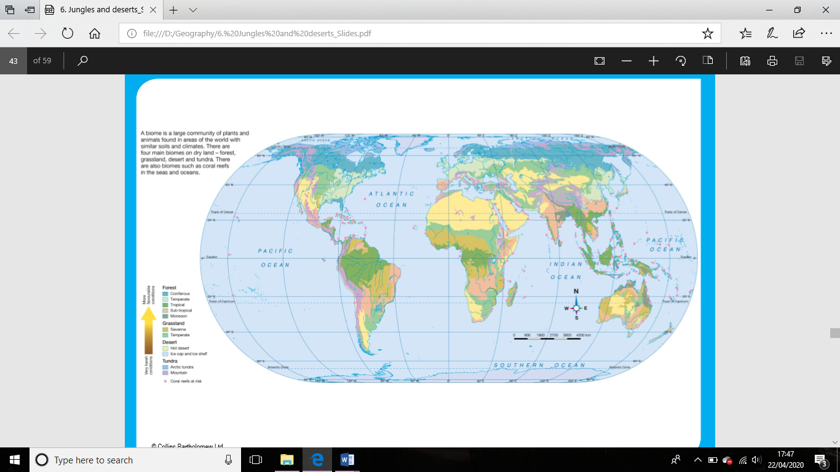

**Substantive Knowledge (Sticky Knowledge)**

Position in relation to the equator makes the climate different across the UK.

The worlds climates are polar, cold and wet, continental, temperate, Mediterranean, warm and wet, tropical, equatorial and dry.

Plants and animals natural environment can be linked to the climate and landscape. For example, a macaw parrot lives in the rainforest.

The Amazon Rainforest is so wet and humid because it is a tropical biome with a lot of rainfall.

Arica’s location to the Andes mountains makes it the driest place on Earth.

**What should I already know?**

* Year 1- Identify four countries that make up the United Kingdom.
* Year 2 - There are 7 continents Asia, Africa, North America, South America, Antarctica, Europe and Oceania.
* There are 5 oceans, The Pacific, Atlantic, Indian, Artic and Southern Ocean.

There are four main biomes on dry land – forest, grassland, desert and tundra.

There are also biomes such as coral reefs in the sea and oceans.

|  |  |
| --- | --- |
| **Vocabulary** | |
| Northern and Southern Hemisphere | The Northern Hemisphere refers to the half of the planet that is north of the equator, while the Southern Hemisphere is all of the planet south of the equator. |
| Climate | The average measurements of temperature, wind, humidity, snow, and rain in a place over the course of years. |
| Biome | A large region of Earth that has a certain climate and certain types of living things. |
| Longitude  Latitude | Lines on a map/globe used to describe the location of any place on Earth. Lines of longitude run in a north-south direction. Lines of latitude run in an east-west direction across Earth. |
| Adaptation | adapts, adapting, adapted  To change for a particular use. |

**Disciplinary Skills**

I can **summarise** and **explain** why areas of tropical rainforest such as the Amazon Basin have so much rainfall and why Arica is the driest inhabited place in the world.

I can **demonstrate understanding** of how climate affects both the landscape of different biomes and the plants and animals that can live there.

Climate varies, even across a relatively small country in terms of land area as the UK e.g. North to South.

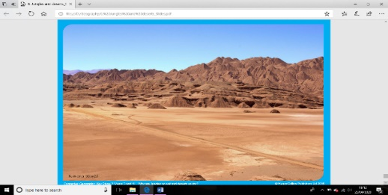

Atacama Desert

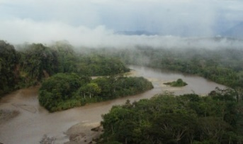

Amazon Basin

**What will I learn during this topic?**

1. Why is the climate different across the United Kingdom?
2. What are the world’s climates?
3. How do climate graphs help Geographers compare the climate of one place with another?
4. How does the climate affect the plants and animals living in a place?
5. Why is the jungle of the Amazon Rainforest is so wet and humid?
6. Why is Arica is the driest inhabited place on Earth?