|  |  |  |
| --- | --- | --- |
| St Julie Catholic Primary School - Computing | | |
| Computing – Summer Term 2 | Year: 3 | **Unit Title: Events and actions in programs.** |



**Events & actions in programs** 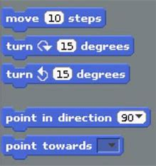

**Sticky Knowledge**

I **know** how to explain the relationship between an event and an action.

I **know** to create a program to move a sprite in four directions.

I **know** how to develop my program by adding features.

**What should I already know?**

* How to program a sprite.
* How to order commands.
* How to sequence sounds and debug.



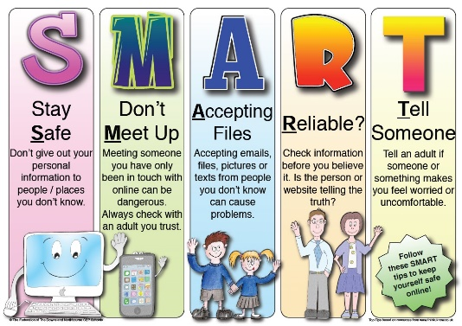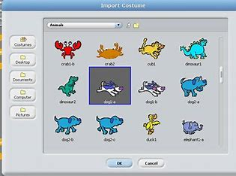

**What I will Learn.**

1 How to move a sprite.

2 How to move in a maze.

3 How to draw lines.

4 How to add features.

5 How to Debug movement.

6 How to make a project.

|  |  |
| --- | --- |
| **Vocabulary** | |
| Project | To develop and test out an idea. |
| Event | An action recognised by the computer program. |
| Adapt | To change an event. |
| Features | Information about the content of an image. |



