|  |  |  |
| --- | --- | --- |
| St Julie Catholic Primary School - Computing | | |
| Computing – Summer Term 1 | Year: 3 | **Unit Title: Creating Media** |



**Sticky Knowledge**

I **know** that text and images have differences.

I **know** how to edit text and layout.

I **know** how to add content to a desktop publishing publication.

**Desk Top Publishing**

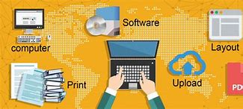

What should I already know?

* That I have taken digital photographs.
* That I changed an image.
* That you can write digitally using text.



|  |  |
| --- | --- |
| **Vocabulary** | |
| Desk Top publishing | To combine text, numerical data, photographs, charts, and other visual elements in a document that can be printed. |
| Layout | How text or pictures are set out on a page. |
| Content | The text within an e-mail, web page, or another file. |

**What I will Learn.**

1 What are words and pictures?

2 Can you edit it?

3 What is a great template?

4 Can you add content?

5 How to lay it out.

6 Why desk top publishing?

