|  |  |  |
| --- | --- | --- |
| St Julie Catholic Primary School - Computing | | |
| Computing – Spring Term 2 | Year: 3 | **Unit Title: Data & Information – Branching Diagrams.** |



**Sticky Knowledge**

I **know** how to create two groups of objects separated by one attribute.

I **know** how to arrange objects into a tree structure.

I **know** how to create a branching diagram.

What should I already know?

* That I have made pictograms.
* That I have recorded data in a tally chart.
* That I have entered data into a computer.

**Branching Diagrams**

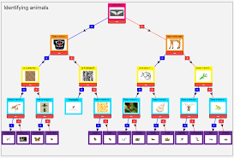



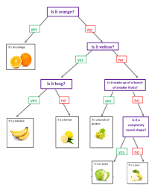

**What I will Learn.**

1 How to answer Yes or no questions.

2 How to make groups.

3 How to create a branching database.

4 How to structure a branching database.

5 How to use a branching database.

6 There are other ways of presenting information.

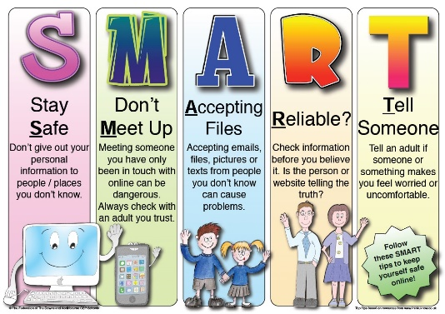

|  |  |
| --- | --- |
| **Vocabulary** | |
| Branching database | A way of classifying a group of objects. |
| Database | A collection of data. |
| Attribute | A certain value of an object. |
| Structure | A design and operation. |



