|  |  |  |
| --- | --- | --- |
| St Julie Catholic Primary School - Computing | | |
| Computing – Spring Term 1 | Year: 3 | **Unit Title: Programming – sequencing sounds.** |



**Sequencing sounds**

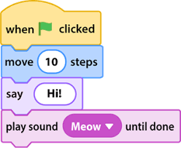

**Sticky Knowledge**

I **know** how to program a sprite.

I **know** how to order commands.

I **know** how to sequence sounds and debug.

**What should I already know?**

* That I can give a route on a mat.
* That I can change the order of directions.
* That I can make an algorithm.



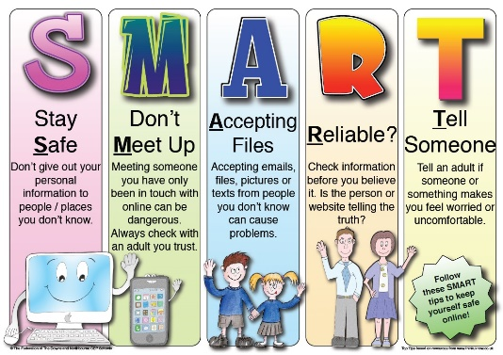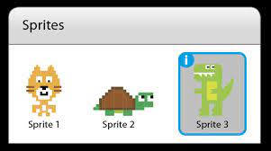

**What I will Learn.**

1 What is the program Scratch?

2 How to program a sprite?

3 What are sequences?

4 How to order commands?

5 How does it look good?

6 How to make an instrument?

|  |  |
| --- | --- |
| **Vocabulary** | |
| Sprite | A 2D bitmap image. |
| Programming | Instructions a computer can understand. |
| Commands | To direct a computer to complete a task. |
| Sequencing | To order algorithms. |
| Coding | How we communicate with computers. |



