Dear parents and carers,

Science Week
St Julie’s scientists have had a very busy week! Our annual Science fair was held on Tuesday after school and was once again a huge success. Thank you to all the children who researched, planned and presented their investigations. We were all very impressed by the knowledge the children demonstrated and their confidence in explaining their scientific enquiry to other children and adults in the hall. Thank you to Mr Bain, one of our Governors and a grandad, who spoke to Year 5 this week about molecules and also to Mrs Cassidy who came in to speak about her job as nurse specialist specialising in endocrinology. Year 4 and Year 5 were fascinated and enthused about possible future careers in science.

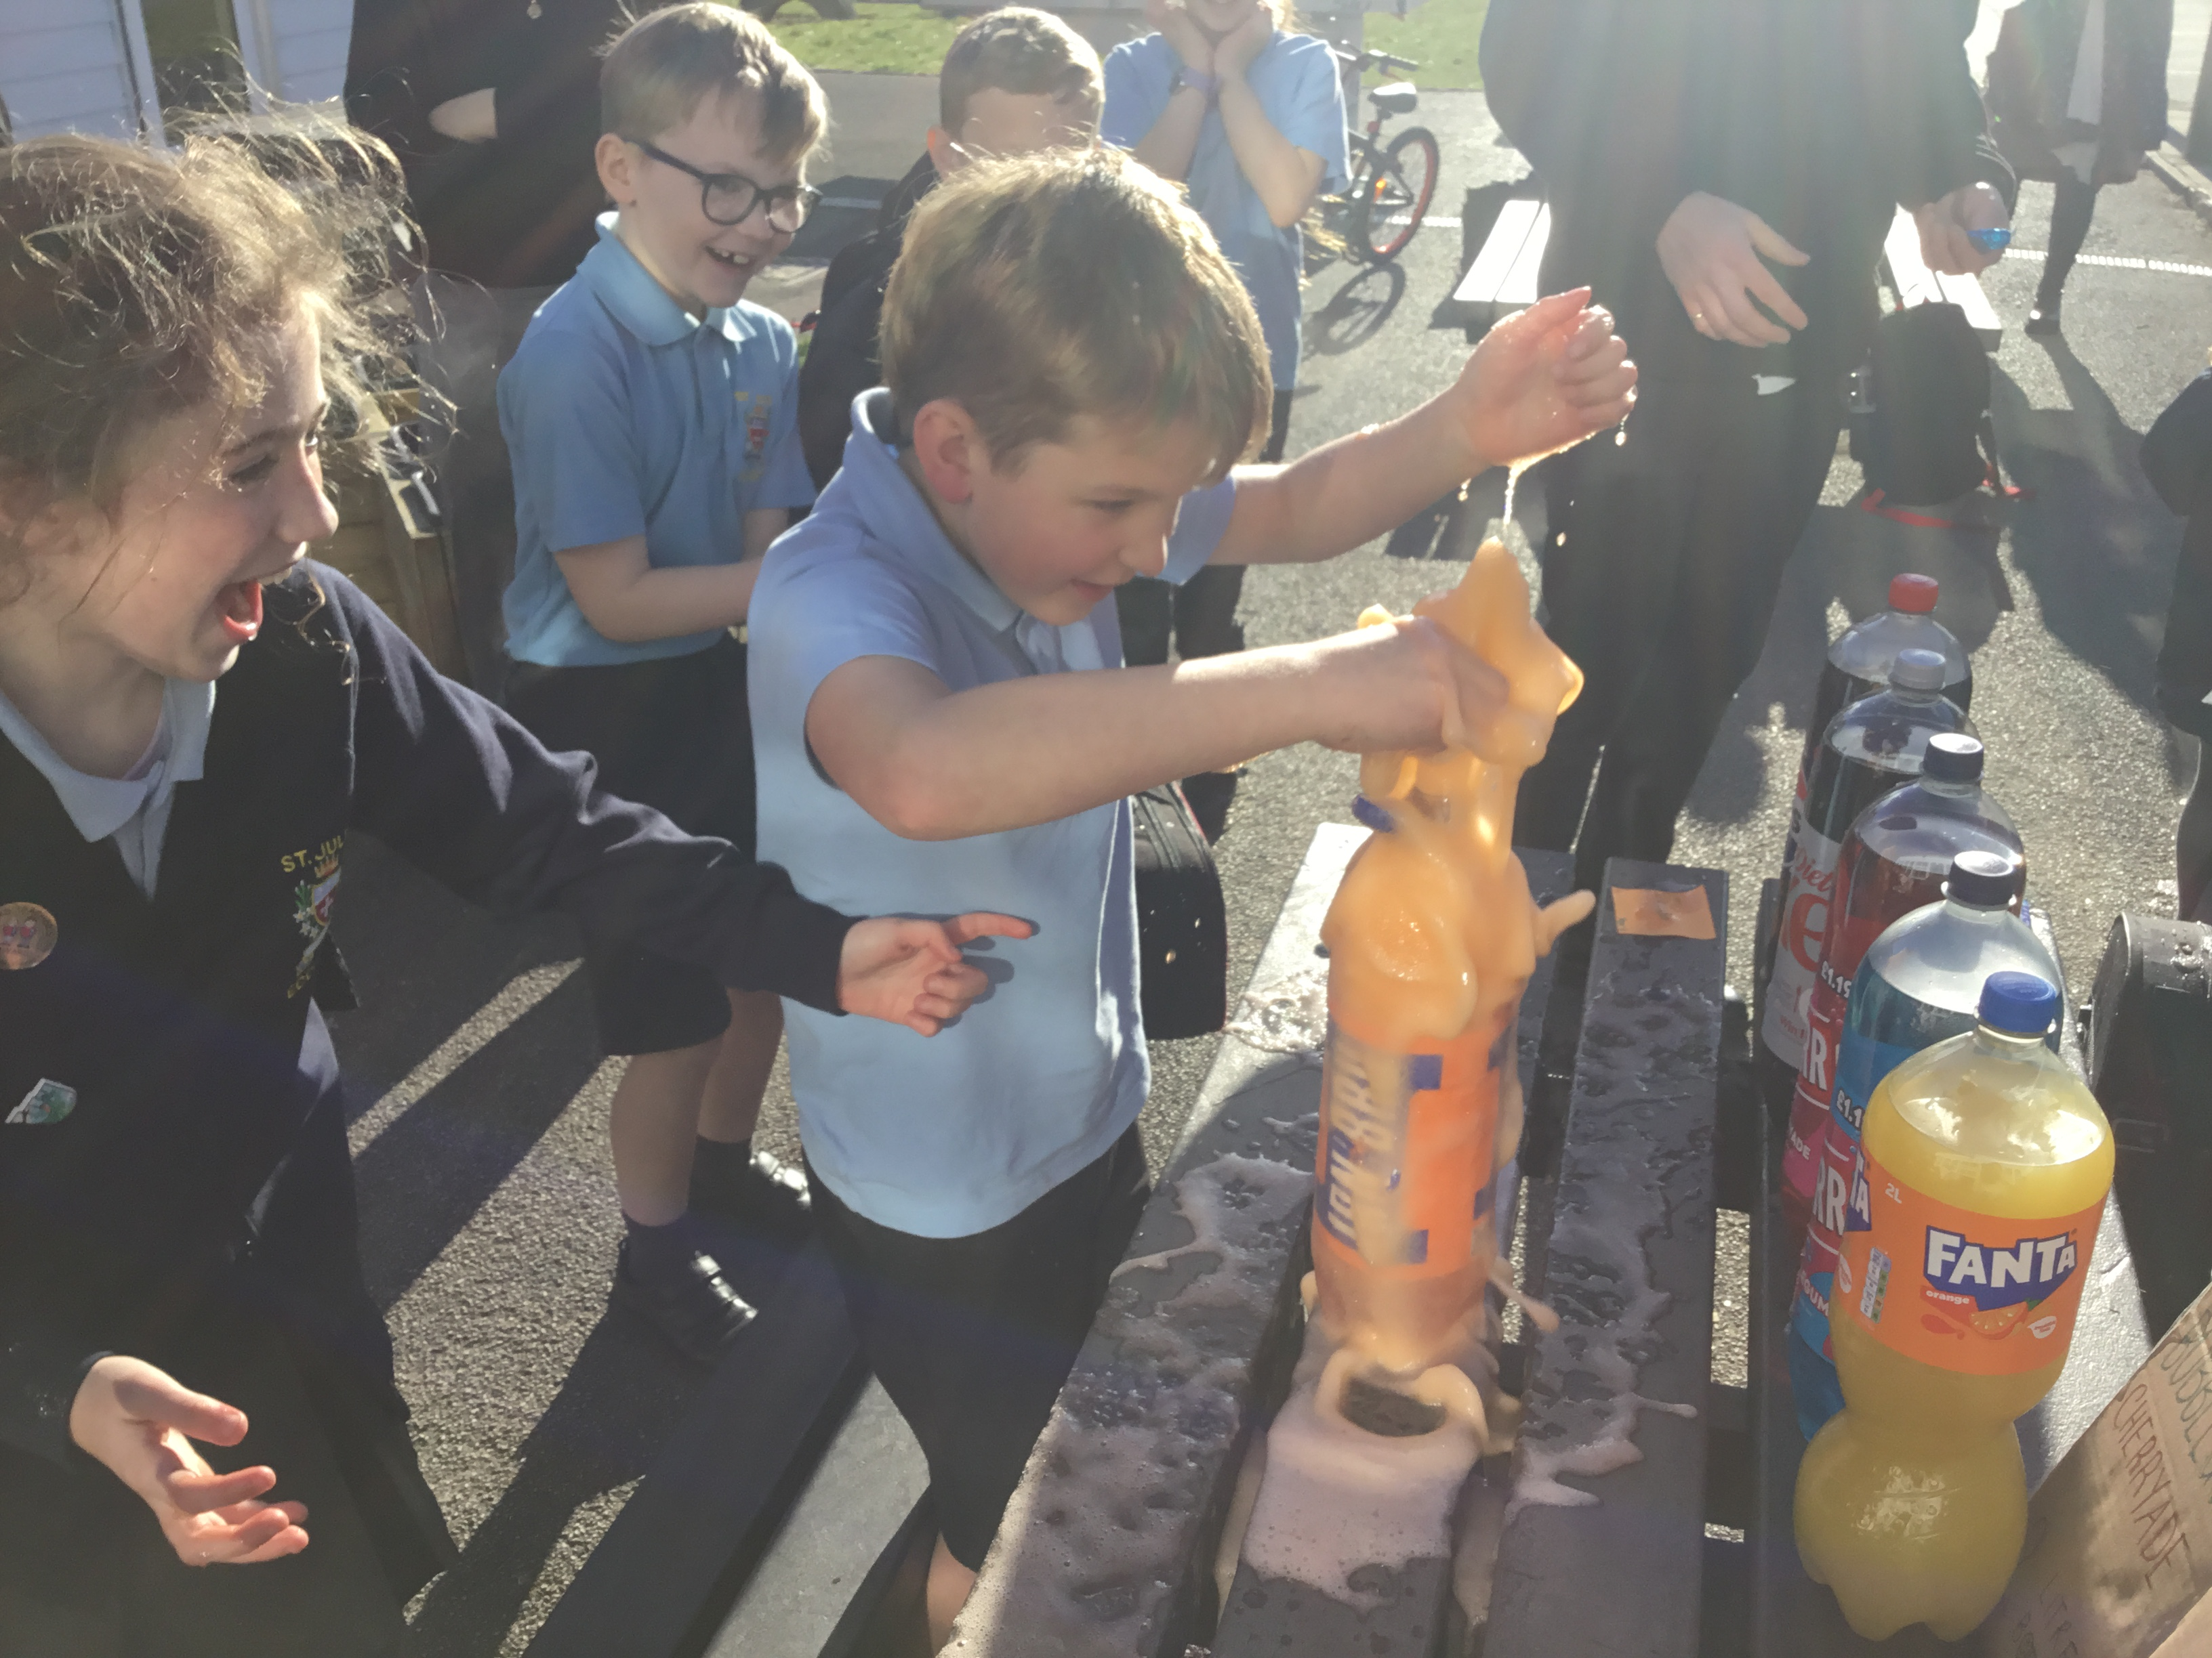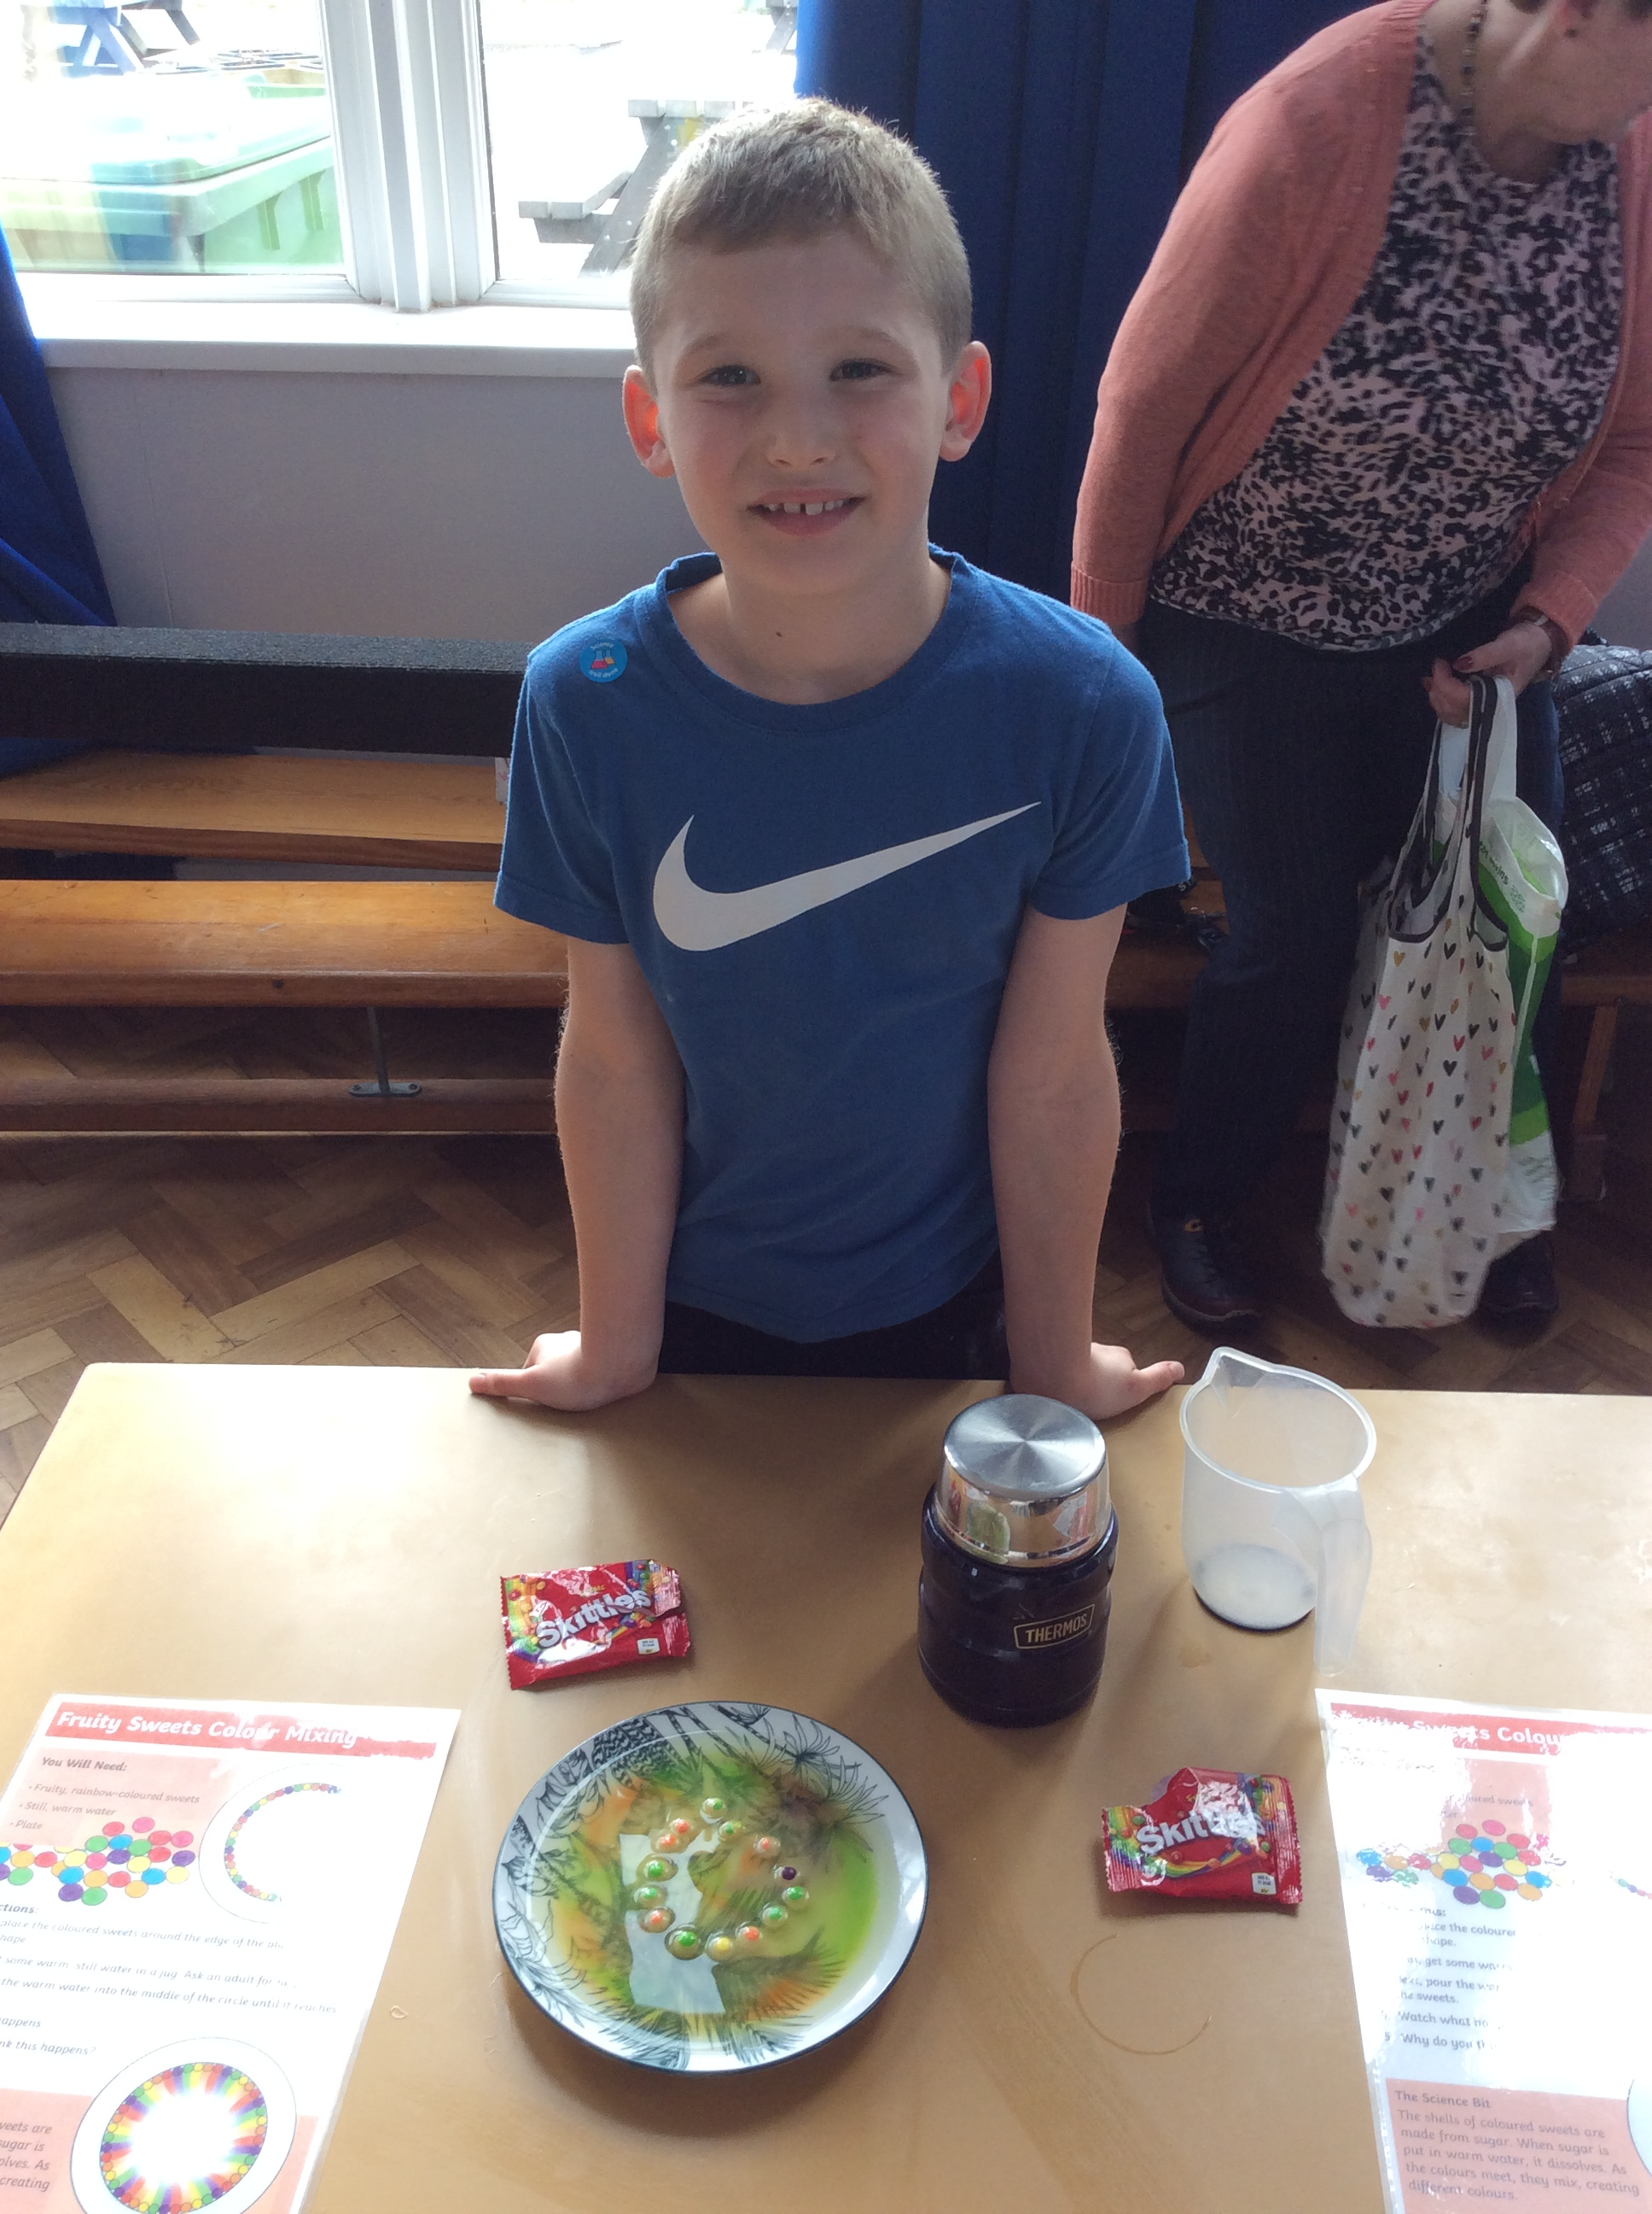

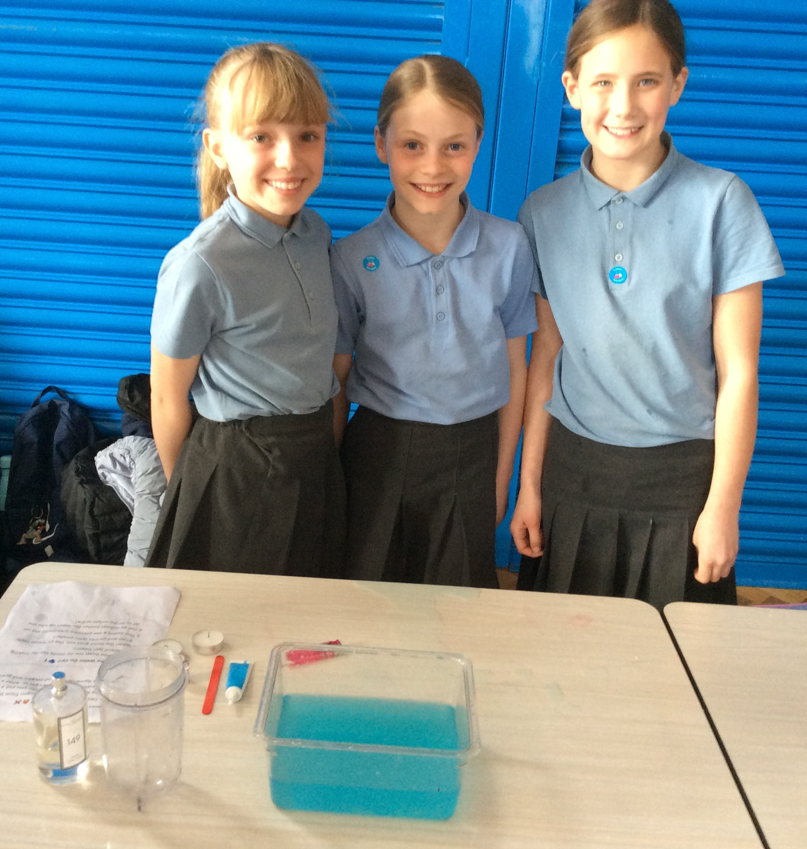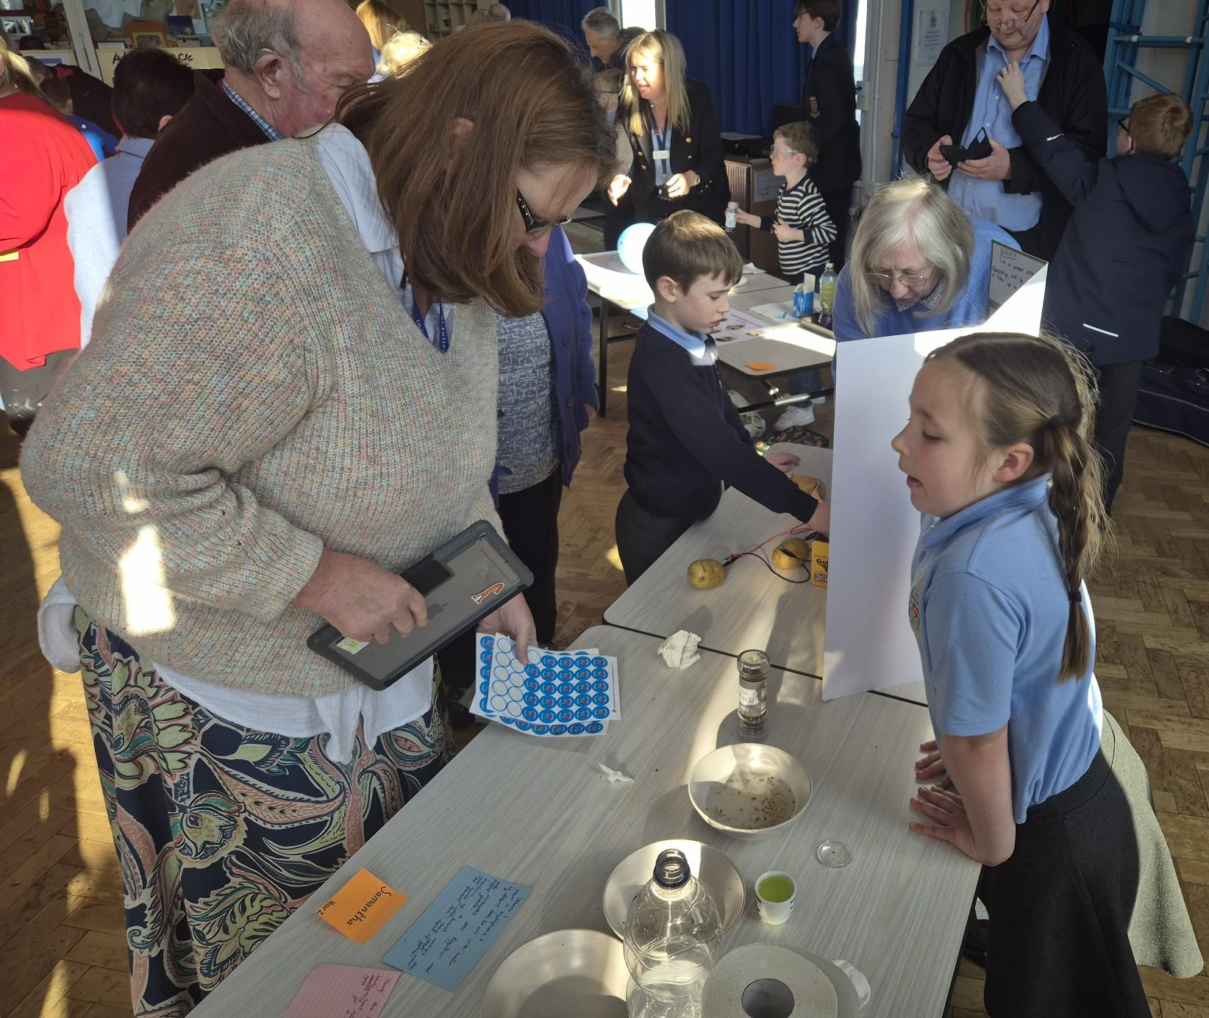

Mrs Wright
As I often say to the children on these occasions, we have some sad-happy news to share with you. We are very sad that Mrs Wright will be leaving St Julie’s at the end of this term but happy for her as she takes up her new position nearer to her home. Mrs Wright has been the happy, smiling face at the office window and the helpful voice on the end of the phone for 10 years and will be greatly missed by us all. I’m sure that everyone appreciates the great lengths that Mrs Wright always goes to in trying to answer your queries, solve technical glitches and provide help and advice – all with cheery words and a smile. The help and support Mrs Wright provides in school to all the staff and children will be missed greatly.


Eucharistic Adoration during Lent
During Lent we would like to offer children and their families the opportunity to spend some quiet time of reflection in front of the Eucharist at St Julie’s church. Fr Michael and children from each year group will lead the reflection each week from 3:30 – 4pm. Please take some time out from the hurly burly to come along:
Wednesday 19 March – Y4

Year 4 sacramental programme: As Year 4 continue their journey in preparation for making their First Holy Communion in May, the Eucharistic Adoration this coming Wednesday is being led by Year 4 children and would be an ideal opportunity for as many of the children from year 4 as possible to share that journey with their family. We would love to see you all in church at 3:30 – if your child attends an after school club we can arrange for staff to take them to church and then return to the club if requested.



Lent Fund raising
Lent is traditionally a time of fundraising. The whole school will be involved in fundraising activities to support our local charity, Nugent through the Good Shepherd Appeal. On Friday 28th March there will be an own clothes day in return for a donation to the Good Shepherd Appeal and the Minnie Vinnies will be organising an Easter raffle.
We also see the return of 'Tuna Tuesday' when pupils are asked to donate tins of tuna, which are donated to “Our Warm Welcome”. We are aware that finances are becoming increasingly tight for all and appreciate any donations that can be made.
If you can, please send in a tin of tuna on a Tuesday this half term. Thank you.

Parking
A polite reminder to parents/grandparents and carers who use the church car park that the marked bays are for use by disabled badge holders - both school and church users, and other marked bays, C and EM, are for church staff and clergy.


Break time snacks
We encourage the children to bring a healthy snack of fruit or toast for break time (no cereal bars please). If your child is bringing grapes, please ensure that they are sliced down the middle lengthways.
Please do not send in any other snacks for break time – fruit or toast only. Children can have a piece of fruit from school.
No nuts or products containing nuts to be sent into school.


PFA Spring events
Easter Bingo - Friday, 21st March at 6pm in the Parish Hall
Thursday 3rd April - PFA Easter Bake-off and cake & coffee after the Passion Service
Friday 4th April - PFA Easter bonnet competition
PFA would be grateful for donations of Easter eggs and chocolates for the Easter bingo. Please send in donations to the school office next week. Thank you.


Year Group | % Attendance for w/e 14.03.24
Year R | 98.18
Year 1 | 99.38
Year 2 | 93.57
Year 3 | 92
Year 4 | 93.71
Year 5 | 97.14
Year 6 | 97.71

Well done to Year 1 who had the highest attendance this week.


Year 1 Phonics Screening Check meeting
On Wednesday 26th March, the Year 1 team will be holding a meeting for parents and carers of children in Year 1 to provide information about the about the Year 1 Statutory Phonics Screening Check that takes place in June. The teachers will go through what the Phonics check entails and talk about how both you as parents and us as a school can best prepare your children. The meeting will be held in the classroom at 5:00pm and there will be an opportunity to ask questions.



St Julie’s Awards of the Week

 | Star for showing love | Book explorer | Marvellous mathematician
Reception | Austin | Luca | Jessie-May
Year 1 | Nelia | Anthony | Jessica
Year 2 | Easton | Matthew | Caleb
Year 3 | Zac T | Raphie | Jacob M
Year 4 | Freddie R | Nuala | Ben F
Year 5 | India | Benji | Alissa
Year 6 | Isaac | Eva | Phoebe


Diary w/c 17.03.2024

Monday 8am Gymnastics
3.20 Y1 & Y2 Football
3.20 Art KS2

Tuesday 3.20 KS2 Football

Wednesday 8am Multi Sports
Year 4 Eucharistic Adoration in church 3:30pm
No Ukulele this week as Mr Royle will be at the Eucharistic Adoration.

Thursday 3:20 KS2 Board Games
3.20 Y1 & Y2 Arts & Crafts
3.20 Dodgeball

Friday Y4 Forest School
3:20 Netball
PFA Easter Bingo – 6pm Parish Hall
Mass times:
Saturday 6pm at St Thomas of Canterbury
Sunday 9:30am at St Julie
Sunday 11am at Lowe House Church in St Helens

Further dates for your Diary
Tuesday 25 March - Year 2 Forest School
Wednesday 26 March - Year 3 Eucharistic Adoration in church 3:30pm
Monday 31 March - Year 3 Celebration of the Word 3pm in class
Monday 31 March - Easter after school crafts event
Tuesday 1 April - Year 2 Celebration of the Word 3pm in class
Wednesday 2 April - Year 6 Eucharistic Adoration in church 3:30pm
Thursday 3 April - Easter Passion Service in church led by Year 5, 2:00pm
Thursday 3 April - PFA Easter Bake-off
Friday 4 April - PFA Easter bonnet competition
Friday 4 April - School closes for Spring break
Tuesday 22 April - School reopens
Thursday 24 April - Year 4 swimming lessons commence at Queens Park
Thursday 24 April - Year 4 Sacramental meeting session 7 in church 6pm
Monday 5 May - May Day Bank Holiday
Saturday 10 May - First Holy Communion Mass 10am
Monday 12 May - Year 6 SATs begin
Saturday 17 May - First Holy Communion Mass 10am
Monday 19 May - May Procession led by Year 4 for whole school
Tuesday 20 May - School photographer for Holy Communion photos, Year 6 and Reception class

Wednesday 21 May - Year 6 residential at PGL until Friday 23 May
Friday 23 May - School closes for Whit holiday
Monday 2 June - Staff INSET day
Tuesday 3 June - School reopens
Wednesday 11 June - Fun Sports Day in House Teams 1:30pm
Wednesday 16 July - Year 6 Leavers Mass 6pm followed by disco

“A caring family school, where we learn, grow and walk in the footsteps of Jesus.”

St Julie pray for us, protect us and bless us.

