Dear Parents and Carers,


Pilgrims of Hope – June 25th 2025 Cathedral Mass

In January we launched the Jubilee Year in our whole school assembly with the theme of Pilgrims of Hope. The Pope has called on us all to be pilgrims on a journey of spreading hope for a better world.
I am excited to tell you that we plan to take our whole school on a very special pilgrimage to the Liverpool Metropolitan Cathedral for a Mass in which we will share our pledges of hope for the future and celebrate the actions for change we are taking. We will be leaving school by coach for a Mass that will begin at 10:40am – full details to follow. Please put the date in your diary as it would be wonderful if you could join us there to celebrate this very special Mass.
The cost of the coach hire to take us on our pilgrimage will be £10 per child and will be on School Money from next week.

Minnie Vinnies: Soft Toy sale
The soft toy sale was a huge success this week, raising £145 for the SVP. Margaret Markey, one of our Governors and a member of the SVP who volunteers at the SVP shop on Cambridge Road, along with some of our own Minnie Vinnies, set up the stalls and ran the sale. Thank you to everyone involved.
There will also be a St Vincent de Paul Pop Up Shop and coffee morning on Friday 4th April, commencing 9am in St Julie’s Church Hall. Please Pop in!
A VARIETY OF CLOTHING FOR ALL AT AFFORDABLE PRICES – Cash only.


Lent Fund raising – final week
This week will be the last Tuesday for sending in a tin of tuna on 'Tuna Tuesday.'
Your donations will then be given to “Our Warm Welcome”. Thank you for all the donations received so far.

Eucharistic Adoration during Lent
Next Wednesday we have our final Eucharistic Adoration as part of our Lenten preparation. Fr Michael and children from year 6 will lead the reflection from 3:30 – 4pm. Please take some time out from the hurly burly to come along. Wednesday 2 April – Y6

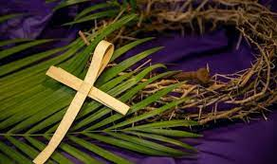
Passion Service – Thursday 3rd April 2pm in church
Easter is the most important festival in our Church’s year and so we invite everyone to share the events of the Passion of Our Lord on Thursday 3rd April at 2pm in church.
Please come and join with all the children as Year 5 lead us in retelling and performing the events of Holy Week. In song and prayer we will reflect on the events leading to Jesus’ crucifixion on Good Friday and then the resurrection of Jesus celebrated on Easter Sunday.
The service will be followed by an event in the school hall where cakes and refreshments will be on sale. We will also be grateful for any other donations of cakes for the coffee afternoon.
A polite reminder that, as with all school events, no photographs may be taken and phones should be switched off.


Sporting competitions
Our children have been out representing St Julie’s in two more sports events over the last week. A team from year 3 and year 4 took part in an indoor multi-skills competition held at De La Salle, playing against teams from other St Helens schools. They had a great time competing and demonstrated their skills and talent in a range of events. This morning in assembly, they told us all about the different activities and how much they enjoyed having a go. Certificates were also given to our team from Year 2 who took part in a Kurling event last Friday which they all thoroughly enjoyed. Once again, great teamwork from our children and fantastic ambassadors for St Julie’s. Well done everyone!



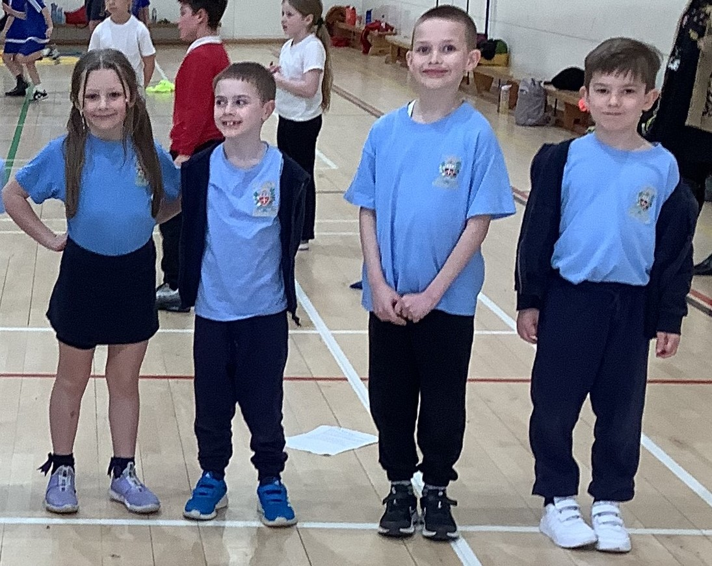

Hands Sign Language
Year 6 have been working with Gemma and Ian from the Hands Project since January, learning British Sign Language. On Thursday afternoon the children demonstrated all they had learned to the rest of the Junior children and to their families who were able to join us. What an amazing demonstration of their skills they showed us as they signed three pop songs and also stood up and signed information about their likes and dislikes. Thank you to Ian and Gemma who have taught the children so much about deaf awareness and inclusivity. We will share the recording of their performance with you once it has been edited. Well done Year 6, we are so proud of you all.


Easter Craft Session
There will be an after-school Easter Craft session on Monday 31st March open to all year groups. These are always popular sessions with the children enjoying making a variety of decorations and gifts to take home. Places can be booked via School Money


PFA Spring events
Thursday 3rd April - PFA Easter Bake-off and cake & coffee after the Passion Service
Friday 4th April - PFA Easter bonnet competition - £1 to enter in an envelope with your child’s name on please. A winner will be chosen from each class.
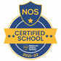

This week’s flyer from National Online Safety is about: “What parents and educators need to know about Blue Sky Social App.”


TT Rockstars Battles
The Battle of the Bands on TT Rockstars is back again! In the latest times tables challenge:
Year 3 v Year 5
Year 4 v Year 6
Starts Thurs 20th at 3:30pm until Thurs 3rd April at 7pm. Please encourage your child to take part – a fun way to learn times tables and develop rapid recall of multiplication and division facts.
Points can only be earned between 7am and 7pm

Scores: TTRockstars Battle as of 1pm Thursday...
Year 5 13,182 vs Year 3 4, 682
Year 4 34,040 vs Year 6 21,767 YOU still have time to change the scores…

Sunflower Club and morning clubs – dropping off
A polite reminder that when dropping off children at Sunflower Club or morning sports clubs, parents must not park in the marked bays in the school car park – these are for staff arriving and parking at school. Thank you.

Please make sure that all of your child’s school uniform, PE kit and coat have their own name written clearly on them. Names can fade so at this time of year when children remove cardigans and jumpers we are finding many of them are getting mixed up or lost.

Youth Open Art Competition and Exhibition
This week children brought home a copy of the entry form for the St Helens Youth Open Art competition.
The competition is open to all young people in St Helens up to the age of 19 (25 for SEND) and prizes will be awarded by the judges in a variety of different categories.
More information can be found here: Youth Open Art competition - St Helens Borough Council



St Julie’s Awards of the Week

 | Star for showing love | Book explorer | Marvellous mathematician
Reception | James A | Ivy | Remi
Year 1 | Blake Ha | Bobby | Evie
Year 2 | Lilia | Henry | Joseph
Year 3 | Hugo G | Isaac | Josefina D
Year 4 | Nuala | Gabriella D | Nathaniel
Year 5 | Lucas L | Veronica | Florence
Year 6 | Zack T | Ivy | Bonnie


“From the first day of term to the last, the small moments in a school day make a real difference to your child.” #AttendanceCounts
At St Julie’s our attendance is excellent and we know that parents and carers value the education that your children receive.
Parents must apply for leave of absence during term time in all instances. A form, to request in writing a leave of absence, is available from the school office or alternatively it can be requested via email. Parents must apply to the Headteacher at least 2 weeks before the intended absence and provide necessary evidence of the exceptional circumstance or discuss the circumstances with the Headteacher. The Headteacher will decide if the leave will be granted in accordance with DFE and Local Authority guidelines and how many days will be authorised. Where the Headteacher does not grant an application for leave of absence and parents decide to take the leave anyway, the absence will be unauthorised, and the parents may receive a Penalty Notice Fine.

Year Group | % Attendance for w/e 28.03.25
Year R | 95.45
Year 1 | 94.38
Year 2 | 97.86
Year 3 | 96
Year 4 | 98.29
Year 5 | 100
Year 6 | 94

Well done to Year 5 who had the highest attendance this week.

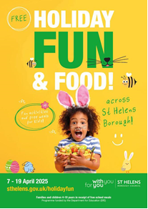
Holiday Activity and Food Programme
The Easter Holiday Activity and Food Programme (HAF) will be running from Monday 7th April 2025 to Saturday 19th April for all eligible children, young people and families. The activity bookings links will go live on Monday 24th March at 2.00pm for families to book their Easter activities. Please note that activity places are subject to availability.
If your child is aged 4-18 and eligible for benefit related free school meal sand would like to attend, please see our list of providers who will be running the activities. Children who are in receipt of a support plan or EHCP are also eligible for the HAF programme.
The LA would like to ensure that as many eligible families take this offer up over the Easter to remove some of the financial burden to families who are already on the brink. Please see below the link to the HAF webpage with all of the information about the Easter programme.
https://www.sthelens.gov.uk/article/4060/Holiday-activities-and-food-programme
Diary w/c 31.03.2024

Monday 8am Gymnastics

3:00 Y3 Celebration of the Word in class
3:20 – 4:45 Easter craft club (book via School Money)
3.20 Y1 & Y2 Football

Tuesday Tuna Tuesday – final donations during Lent
3:00 Y2 Celebration of the Word in class
3.20 KS2 Football
4:30 Y6 SATs and PGL meeting for parents

Wednesday 8am Multi Sports
Year 6 Eucharistic Adoration in church 3:30pm
3:20 Ukulele

Thursday Easter Bake Off and donations for coffee afternoon
2pm Passion Service for whole school in church led by Y5
Coffee and cake after service
3:20 KS2 Board Games
3.20 Y1 & Y2 Arts & Crafts
3.20 Dodgeball

Friday PFA Easter bonnet competition
Year 6 Forest School
3:20 Netball
School closes for Spring break

St Vincent de Paul Pop Up Shop and coffee morning Friday 4th April, commencing 9am in St Julie’s Church Hall. Please Pop in!
A VARIETY OF CLOTHING FOR ALL AT AFFORDABLE PRICES – Cash only.

Mass times:
Saturday 6pm at St Thomas of Canterbury
Sunday 9:30am at St Julie
Sunday 11am at Lowe House Church in St Helens

Further dates for your Diary
Tuesday 22 April - School reopens
Thursday 24 April - Year 4 swimming lessons commence at Queens Park
Thursday 24 April - Year 4 Sacramental meeting session 7 in church 6pm
Wednesday 30 April - Year 4 Celebration of the Word 3:00 in class
Monday 5 May - May Day Bank Holiday
Saturday 10 May - First Holy Communion Mass 10am
Monday 12 May - Year 6 SATs begin
Saturday 17 May - First Holy Communion Mass 10am
Monday 19 May - May Procession led by Year 4 for whole school
Tuesday 20 May - School photographer for Holy Communion photos, Year 6 and Reception class
Wednesday 21 May - Year 6 residential at PGL until Friday 23 May
Friday 23 May - School closes for Whit holiday
Monday 2 June - Staff INSET day
Tuesday 3 June - School reopens
Wednesday 11 June - Fun Sports Day in House Teams 1:30pm
Wednesday 25 June - Whole school pilgrimage to Liverpool Catholic Cathedral
Wednesday 16 July - Year 6 Leavers Mass 6pm followed by disco

“A caring family school, where we learn, grow and walk in the footsteps of Jesus.”

St Julie pray for us, protect us and bless us.

