Dear Parents and Carers,


May is the month of Mary
May is dedicated to Mary, a month in which we remember her devotion to God and her trust and faith in saying “yes” in all he asked of her. We are reminded of what a dedicated mother she was to her son Jesus, and as our mother we ask for her intercession in our prayers.

On Sunday 4th May, the crowning of Mary with flowers will take place during the 9:30am Mass.


Year 4 First Holy Communion
Our Year 4 children will be making their First Holy Communion over two Saturdays in May. One group will be on Saturday 10th May and another on Saturday 17th May.
Families should be seated in their allocated bench by 9:45am ready for the Mass to start at 10am.
There will be a collection for the Parish of St Julie’s during the Mass so please bring along a donation.
Year 4 will also be leading our May Procession on Monday 19th May as the whole school processes up to church for Mass at 9:30am.
The photographer will be in school on Tuesday 20 May to take individual photos of the children in Year 4 in their Holy Communion clothes, and a class photo.
The children will need to come to school that day in their outfit and bring uniform to change into afterwards.


Welcome to Reception Starters 2025
A very warm welcome to all the newest members of our St Julie’s school family; we look forward to seeing you all soon. A welcome letter has been sent out to all families inviting you to the New Intake Parents Meeting to be held on Tuesday 13th May at 5pm in the school hall.
We do have a number of places available in our Reception class so if you happen to know someone who has not yet applied for Reception in September, have friends or family that are moving into the area or of someone who is unhappy about their allocated place, please share this information. It is quite unusual for our school to have places available in Reception (all our KS2 classes are at full capacity), we are aware that both locally and nationally there is currently a dip in the numbers applying for school places in Reception classes due to birth rates. This makes the current availability a rare opportunity for families who may be considering joining our school community.



On Friday, 9th May school will be marking the 80th Anniversary of VE Day. Children can come into school wearing the colours red, white and blue. We look forward to marking this very special anniversary.

Children’s University Graduation Ceremony – Wednesday 18th June 2025

The Graduation is attended by children in KS2 who will be awarded with their next certificate for credits over the last year for their participation in enrichment activities, (Forest School, Cooking, Ambassador roles etc.) school clubs and out of school clubs and Children’s University Holiday Challenges. Children in the Infants have their credits logged but do not attend a Graduation until they are in Year 3.
The Graduation will be held in Hope Chapel, Liverpool Hope Park campus in Childwall, Liverpool. Further details and invitations (2 guests per child) will be sent out later in May but please save the date: Wednesday 18th June at 1pm.



St Julie’s Awards of the Week

 | Star for showing honesty | Book explorer | Marvellous mathematician
Reception | James D | Seb | Calvin
Year 1 | Toby | Francis | Myles
Year 2 | Easton | Sophie P | Daniel
Year 3 | Callum F | Hugo G | Theia C
Year 4 | Ted A | Isla S | Thomas O
Year 5 | Max | Alice | Sophia
Year 6 | Elizabeth | Thomas K | Ivy


“From the first day of term to the last, the small moments in a school day make a real difference to your child.” #AttendanceCounts
At St Julie’s our attendance is excellent and we know that parents and carers value the education that your children receive.
Parents must apply for leave of absence during term time in all instances. A form, to request in writing a leave of absence, is available from the school office or alternatively it can be requested via email. Parents must apply to the Headteacher at least 2 weeks before the intended absence and provide necessary evidence of the exceptional circumstance or discuss the circumstances with the Headteacher. The Headteacher will decide if the leave will be granted in accordance with DFE and Local Authority guidelines and how many days will be authorised. Where the Headteacher does not grant an application for leave of absence and parents decide to take the leave anyway, the absence will be unauthorised, and the parents may receive a Penalty Notice Fine.

Year Group | % Attendance for w/e 02.05.25
Year R | 95.45
Year 1 | 95.94
Year 2 | 94.29
Year 3 | 95.43
Year 4 | 97.43
Year 5 | 100
Year 6 | 94.57

Well done to Year 5 who had the highest attendance this week.


Sporting competitions
On Monday this week, a team from Year 2 took part in a Football competition at Ruskin Drive.
Our team demonstrated great skill and wonderful teamwork. The Year 2 team came 4th out of 12 schools taking part and were proud to receive their certificates in assembly this morning. Well done everyone!

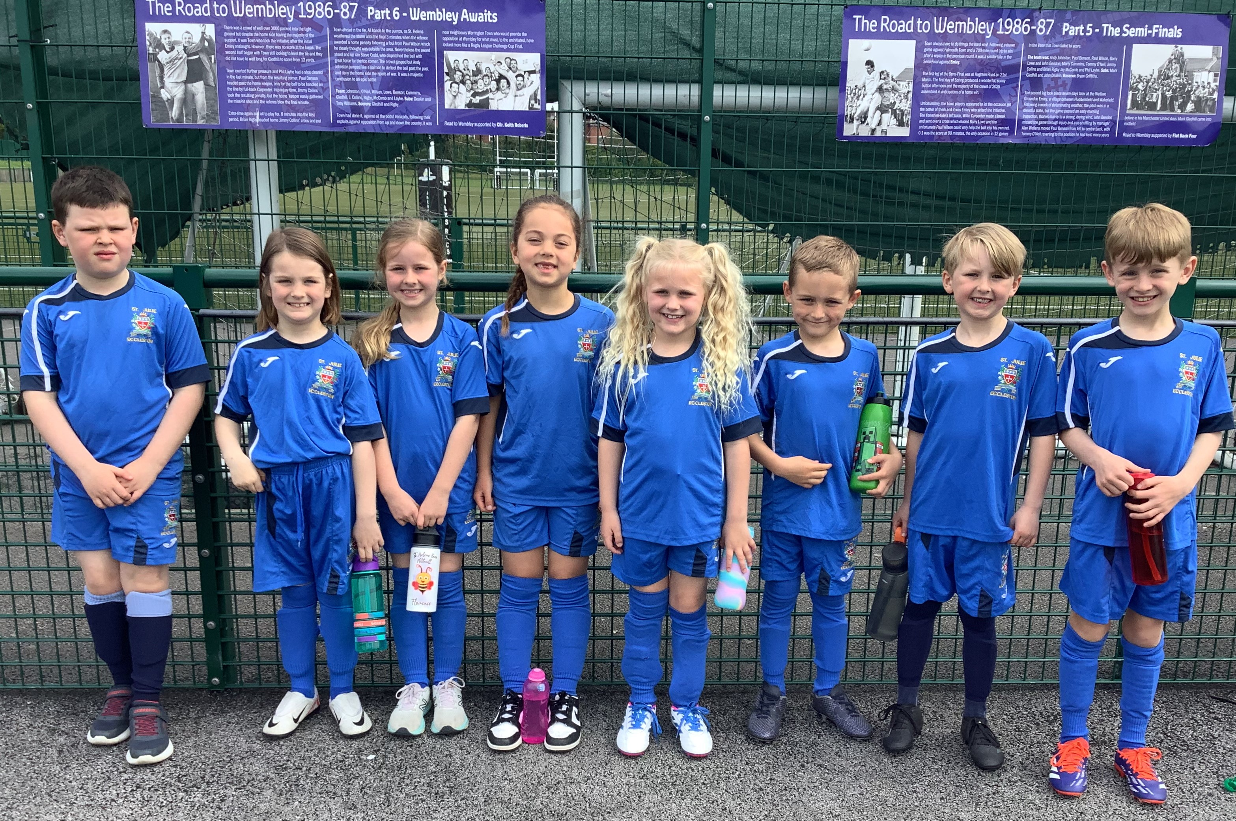


This week’s flyer from National Online Safety is, “10 Top Tips for safety on the road.”


Diary w/c 05.05.2024

Monday Bank Holiday

Tuesday 3.20 KS2 Football

Wednesday 8am Multi Sports
3:20 Y1 & Y2 Spanish

Thursday Year 4 swimming lesson
3.20 Construction club
3:20 KS2 Gardening
3.20 Dodgeball

Friday VE Day 80th Anniversary celebration – wear red, white and blue
3:20 Netball

Saturday First Holy Communion Mass 10am

Further dates for your Diary
Monday 12 May - Year 6 SATs begin
Saturday 17 May - First Holy Communion Mass 10am
Monday 19 May - May Procession led by Year 4 for whole school
Tuesday 20 May - School photographer for Holy Communion photos, Year 6 and Reception class
Wednesday 21 May - Year 6 residential at PGL until Friday 23 May
Thursday 22 May - Year 2 trip to Norton Priory
Friday 23 May - School closes for Whit holiday
Monday 2 June - Staff INSET day
Tuesday 3 June - School reopens
Tuesday 4 June - Year 6 transition – De La Salle staff/pupils visit to St Julie’s
w/c 9 June Year 1 Phonic Screening Check and Year 4 Multiplication Tables Check
Wednesday 11 June - Fun Sports Day in House Teams KS2 9:30am EFYS/KS1 1:30pm
Thursday 12 June - Year 5 trip to the Blue Planet Aquarium
Wednesday 18 June - Children’s University Graduation for KS2 at Liverpool Hope University 1pm
Wednesday 25 June - Whole school pilgrimage to Liverpool Catholic Cathedral
w/c 7 July - Year 6 transition week at De La Salle for those going to that High School
Monday 14 July - Year 6 Leavers’ Celebration event 2:00pm (Parents and grandparents)
Wednesday 16 July - Year 6 Leavers Mass 6pm followed by disco


“A caring family school, where we learn, grow and walk in the footsteps of Jesus.”

St Julie pray for us, protect us and bless us.

