Dear Parents and Carers,

Welcome back as we head towards the end of our school year. There are many, many events to pack into this half term and are excited for the activities we have planned. There are several trips out of school, Forest School days, class Celebration of the Word events, Arts celebration week and much more. Year 6 have their transition visits to High School as they look to their future and emotional Leavers events ahead of them.


One of our leavers this year will be Mrs McCahey who will be retiring after 35 years of teaching, 18 of those years at St Julie’s. We wish Mrs McCahey many happy adventures in the future and are thankful for the huge contribution she has made to our faith life at St Julie’s as our RE lead, both in school and in the local community. Her passion for history and for science has enthused many children over the years and as a dedicated member of the St Julie’s team she will be greatly missed.
From September, Mrs Clayton will be teaching 4 days and Mrs Johnson 1 day in Year 5. All children will get to meet their new teachers and experience their new classroom on the transition day on Tuesday 8th July.


Fun Sports Celebration Day
The Sports Council have been busy planning our annual Sports Celebration Day with Mrs Clayton. There will be a carousel of traditional sports and games, completed by each house team. The focus is to be on teamwork and fun as the house teams rotate through the activities. Parents are welcome to attend with the Junior event in the morning starting at 9:30am and Infants in the afternoon at 1:30pm.
To follow the event, you need to find your child – by their House Team colour – and then follow them around as they move through the activities. If a grandparent is coming along, please tell them the colour of your child’s House Team.


Pilgrims of Hope – June 25th 2025 Cathedral Mass
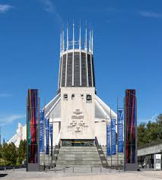
Preparations for our whole school pilgrimage to the Liverpool Metropolitan Cathedral for Mass are well under way. Chris McElroy, Director of Music at the Archdiocese, was in school this morning for a series of practices for the singing during the Mass. He was very impressed with the quality of our children’s singing, and particularly praised our Reception class who joined in joyfully.
We will be leaving school by coach for a Mass that will begin at 10:40am and returning in time for lunch around 12noon.
It would be wonderful if you could join us there to celebrate this very special Mass for our St Julie’s family.
As you can imagine, to take 225 children by coach to Liverpool is extremely costly. Thank you to those who have paid the £10 per child towards the transport. We are still £900 short of the total cost so if you haven’t yet paid, please do so via School Money.

Children’s University Graduation ceremony – Wednesday 18th June at Hope University Chapel

We are thrilled to be taking all of our Junior children to Hope University for the children’s University Graduation. Together we will be celebrating the many achievements our children have gained over the past year, including their participation in school clubs, holiday challenges and other enrichment activities in school like Forest Schools, Cookery etc.
2 guests per child can attend the Graduation which will be held in Hope Chapel, Hope Park campus in Childwall, Liverpool. Guests can arrive from 1pm for a 1:30pm start. Letters with full details will be sent out next week. As we are aware of having 2 trips to Liverpool in such a short space this year, we have not asked for payment for the coach for this event.


TT Rockstars Battles
The Battle of the Bands on TT Rockstars is back again! In the latest times tables challenge:
Year 2 v Year 3
Year 4 v Year 5
Teachers v Year 6
Starts 13th June at 7:00pm until Thurs 26th June at 7pm. Please encourage your child to take part – a fun way to learn times tables and develop rapid recall of multiplication and division facts.
Points can only be earned between 7am and 7pm

Year 6 Residential
The Year 6 children who went to PGL at Boreatton Park had a fabulous time last week. They faced their fears on the Giant Swing, Trapeze, Zip Wire and Climbing and showed great team spirit in working together in the puzzle park on their problem-solving challenges, amongst many more fun activities. They thoroughly enjoyed their time spent with friends in the tents and we were blessed with warm, sunny weather. Thank you to our dedicated staff who have looked after them so well while they were away from home.

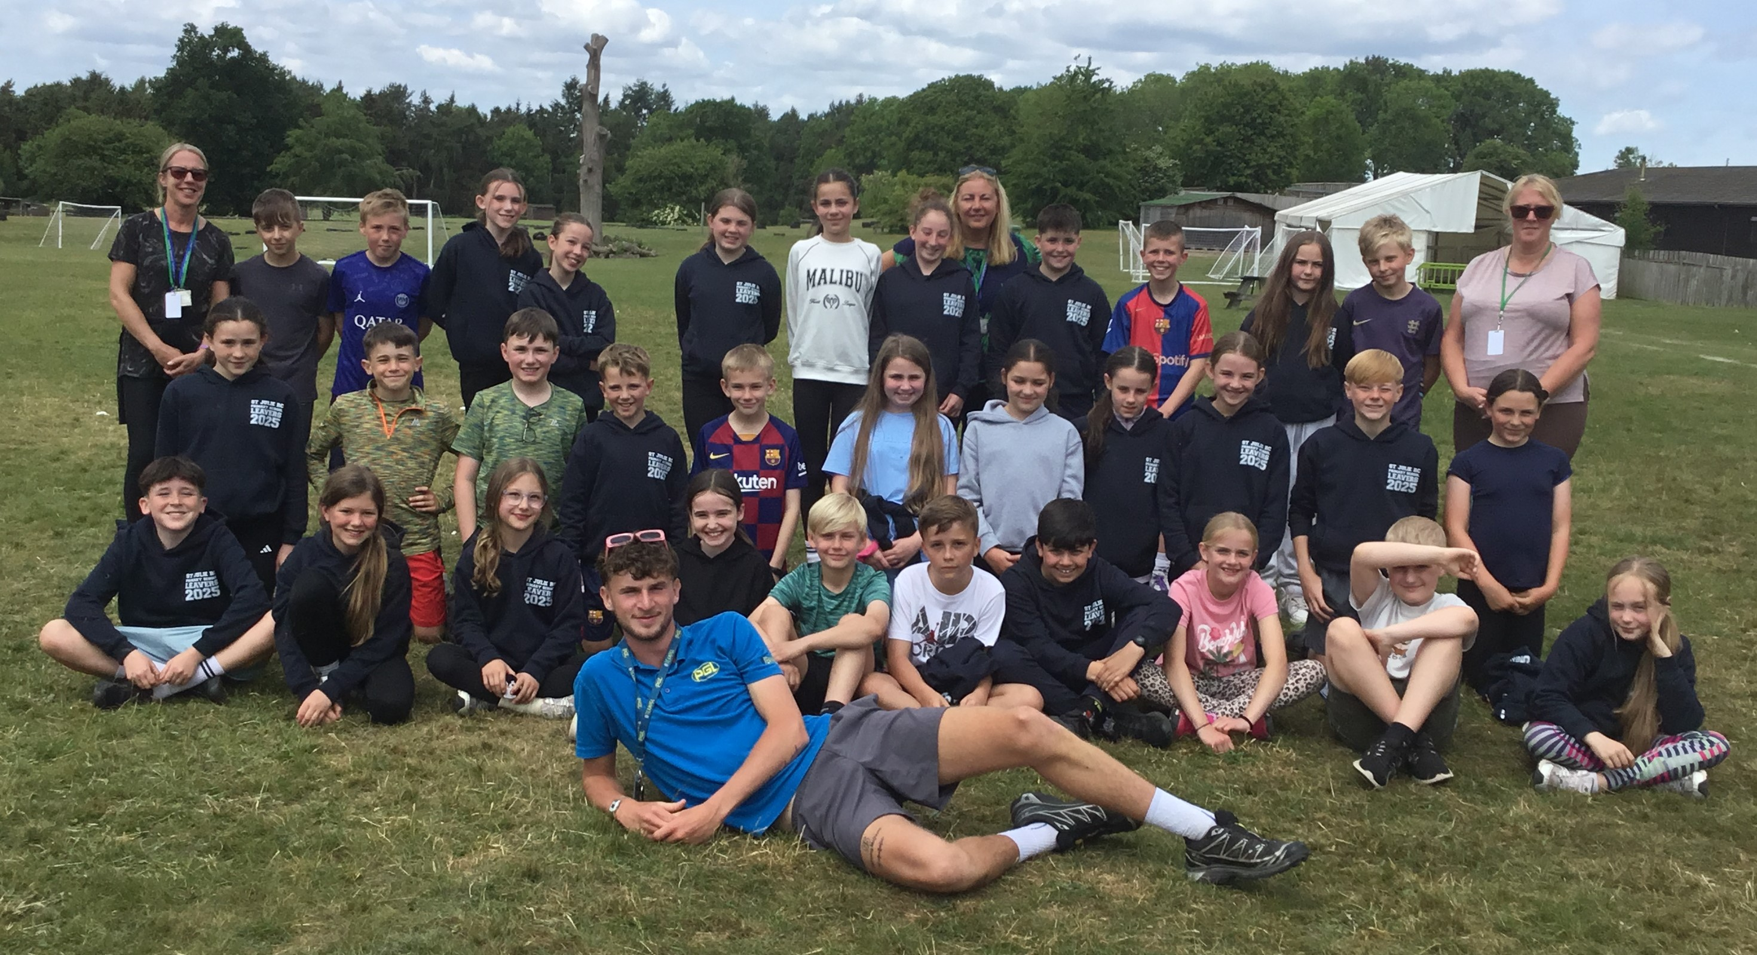


This week’s flyer from National Online Safety is, “What parents and educators need to know about Emojis.”

Primary School Admissions for September 2025 - Reception class
We do have some spaces available in our Reception Class for the September 2025 intake. If you know of any families who would be interested or would like any further information regarding these places, please contact the school office on telephone number 01744 678233



St Julie’s Awards of the Week

 | Star for showing hope | Book explorer | Marvellous mathematician
Reception | Calvin | Ivy | Matilda
Year 1 | Blake He | Daniel O | Bella H
Year 2 | Dorothy and Caleb | Taim | Seb
Year 3 | Penelope | Jasmine | Eliza
Year 4 | Sam B | Teddy H | Harry B
Year 5 | Scarlett | Alivia | Kate
Year 6 | Matthew | Poppy | Isla


“From the first day of term to the last, the small moments in a school day make a real difference to your child.” #AttendanceCounts
At St Julie’s our attendance is excellent and we know that parents and carers value the education that your children receive.
Parents must apply for leave of absence during term time in all instances. A form, to request in writing a leave of absence, is available from the school office or alternatively it can be requested via email. Parents must apply to the Headteacher at least 2 weeks before the intended absence and provide necessary evidence of the exceptional circumstance

Year Group | % Attendance for w/e 06.06.25
Year R | 95.45
Year 1 | 97.66
Year 2 | 89.58
Year 3 | 95
Year 4 | 97.14
Year 5 | 97.92
Year 6 | 95.71

Well done to Year 5 who had the highest attendance this week.


Diary w/c 09.06.2024

Monday 8am Gymnastics
Year 1 Phonic Screening Check
Road Safety talk Y3 & Y4
3:20 Y1/Y2 Football club

Tuesday Year 1 Phonic Screening Check
Road Safety talk Y6
3.20 KS2 Football

Wednesday 8am Rugby club
Fun Sports Day in House Teams KS2 9:30am EFYS/KS1 1:30pm
3:20 Y1 & Y2 Drawing club
3:20 Judo
3:20 KS2 Gardening

Thursday Year 5 trip to the Blue Planet Aquarium
Year 4 Multiplication Tables Check
3.20 Dodgeball
Y3/4 parent/child emotional regulation workshop led by Jayne Aspinall

Friday Y4 Celebration of the Word 3pm
3:20 Girls only football club
Mass times:
Saturday 6pm at St Thomas of Canterbury
Sunday 9:30am at St Julie
Sunday 11am at Lowe House Church in St Helens

Further dates for your Diary

Monday 16 June - EYFS and Y1 Songfest
Tuesday 17 June - Y3 Forest School
Wednesday 18 June - Children’s University Graduation for KS2 at Liverpool Hope University 1pm
Monday 23 June - Y4 Forest School
Wednesday 25 June - Whole school pilgrimage to Liverpool Catholic Cathedral
Friday 27 June - EYFS trip to Imagine That
Friday 27 June - Y6 Forest School
w/c 30 June - Arts celebration week
Tuesday 1 July - Y2 Forest School
Monday 7 July - Year 6 transition week at De La Salle for those going to that High School
Monday 14 July - Year 6 Leavers’ Celebration event 2:00pm (Parents and grandparents)
Wednesday 16 July - Y1 Forest School
Wednesday 16 July - Year 6 Leavers Mass 6pm followed by disco

Thursday 17 July - Y3 Library visit – Summer Reading Challenge

“A caring family school, where we learn, grow and walk in the footsteps of Jesus.”

St Julie pray for us, protect us and bless us.

