Dear Parents and Carers,

Children’s University Graduation ceremony

On Wednesday we celebrated the achievements of all of our Junior children at the Children’s University graduation held at Liverpool Hope University. It was a wonderful afternoon shared with parents, grandparents and friends.
Together we celebrated the many achievements our children have gained over the past year, including their participation in school clubs, holiday challenges and other enrichment activities in school. A wonderful memory for our children to cherish!

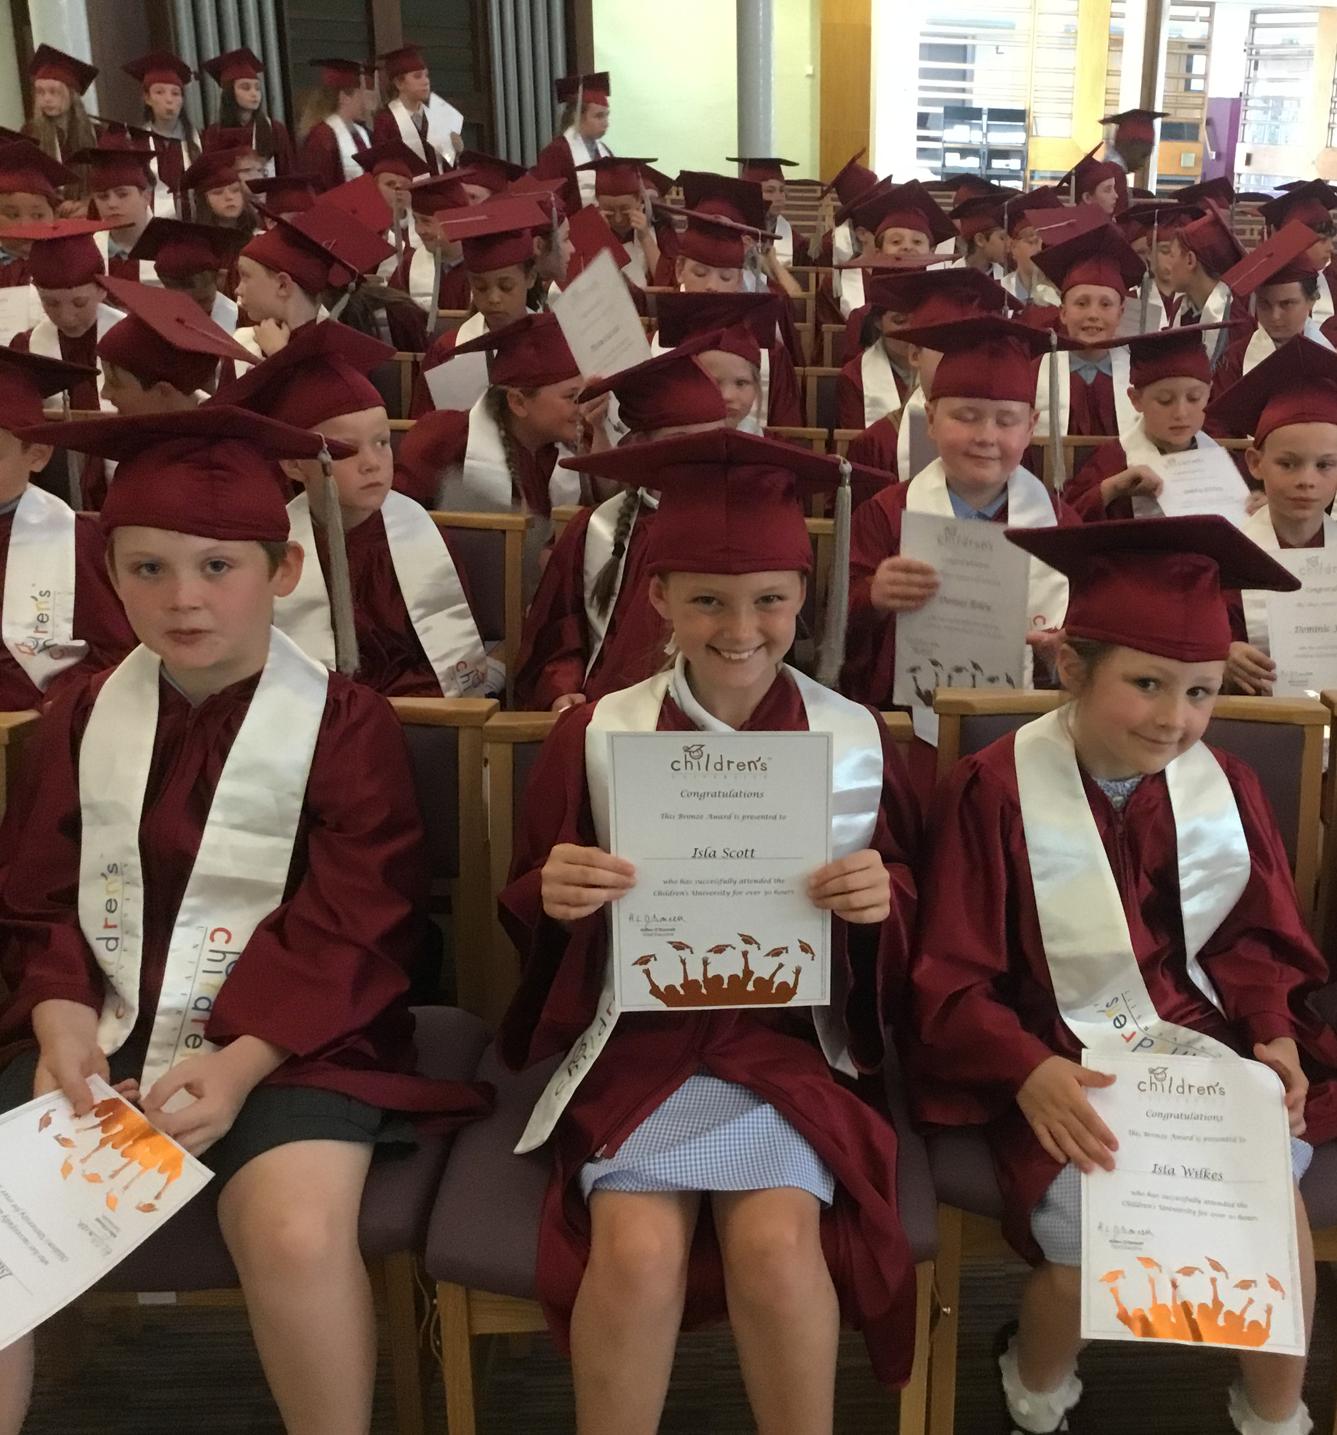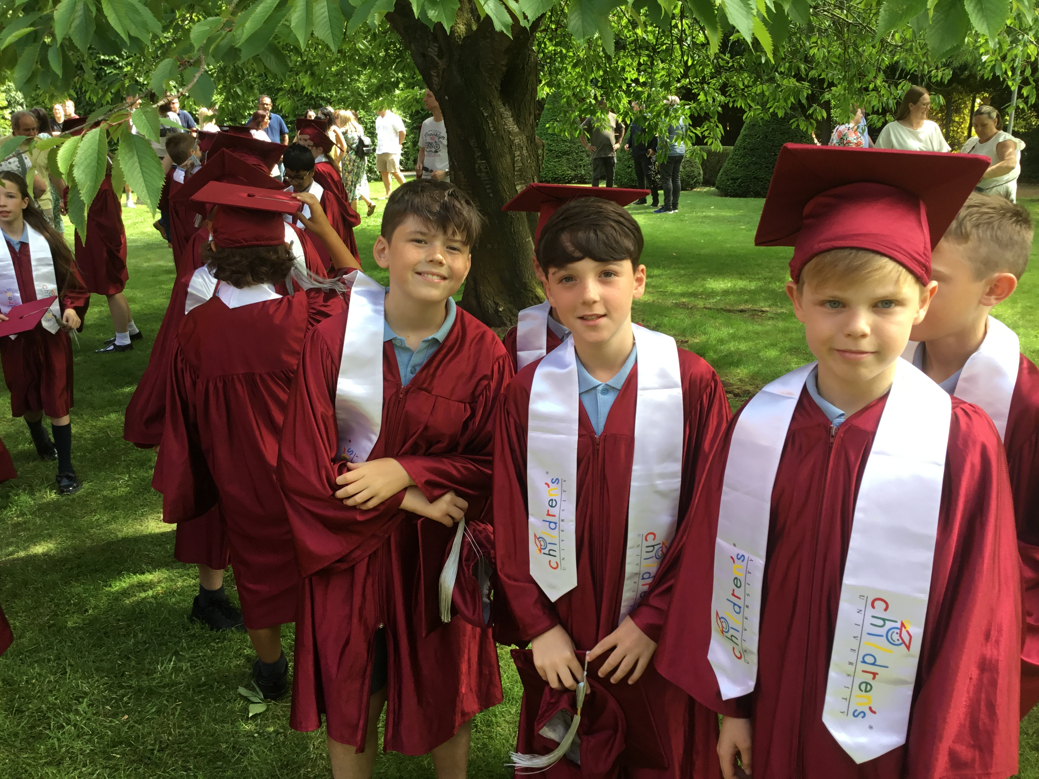


Reminder - Pilgrims of Hope – June 25th 2025 Cathedral Mass. Please come along…
Once again, we were joined this morning by Chris McElroy, Director of Music at the Archdiocese to practice our singing for the Mass. We do hope that you will be able to come along to the Cathedral to join us there to celebrate this very special Mass for our St Julie’s family.
As you can imagine, to take 225 children by coach to Liverpool is extremely costly. Thank you to those who have paid the £10 per child towards the transport. We are still £440 short of the total cost so if you haven’t yet paid, please do so via School Money.

We now have an X Account @stjulieprimary to share and celebrate the life of St Julie's. Please follow, like and share!
If you have not returned your consent form for your child’s photo to be/not to be featured in posts, please do so asap so that we can get posting!


Quadkids competitions
Congratulations to the team of year 3 and year 4 children who took part in the Quadkids competition on Tuesday at Sutton Academy and came 3rd place out of all the schools competing. Today a team from year 1 and Year 2 took part. We don’t have the results yet but they all thoroughly enjoyed the day and demonstrated their skills in the four events. Well done to the children for representing St Julie’s so brilliantly.


Amazing Art: parent/carer session
During the week commencing Monday 30th June we will be holding an Arts celebration week. Miss Pratt, our Arts Lead has several events planned including visitors to school providing capoeira sessions and samba drumming for the children. For that week and the week before and after, we would like to include you in our celebration of the Arts and so are inviting you into school to share an art activity with your child – in a similar way to our Share a Story and Marvellous Maths sessions. Don’t worry if you can’t make it, there will be school staff around to make sure all children can enjoy the art activity.
One adult is invited to come to school via the front entrance on Brooklands Road at 2:40pm to join their child for an art activity in the school hall:
Thursday 26 June - Year 2
Tuesday 1 July - Year 3
Wednesday 2 July – Year 4
Thursday 3 July – Year 1
Tuesday 8 July – Year 5
(Year 6 will be having their Leavers Celebration event)


TT Rockstars Battles
The Battle of the Bands on TT Rockstars is back again! In the latest times tables challenge:
Year 2 v Year 3
Year 4 v Year 5
Teachers v Year 6
Starts 13th June at 7:00pm until Thurs 26th June at 7pm. Please encourage your child to take part – a fun way to learn times tables and develop rapid recall of multiplication and division facts.
Points can only be earned between 7am and 7pm

Geography Poster Competition – Please send in your entries next week!
The Geography Ambassadors would like everyone to design a poster or information room (like a tourist information office – similar to the mini-museums that we made for the history competition) about a place you think James Ketchell would like to visit. It could be somewhere close to home, somewhere in the UK or somewhere around the world. Closing date: Monday 30th June 2025.
See flyer for more information.


This week’s flyer from National Online Safety is, “What parents and educators need to know about YouTube Kids.”


Tissues
We would be grateful for donations of a box of tissues for your child’s class. These will be kept as a stock by the teacher. Bless you!!



St Julie’s Awards of the Week

 | Star for showing hope | Book explorer | Marvellous mathematician
Reception | Whole class | Jessie-May | Imelda
Year 1 | Stanley | Jack | Alexander Harry
Year 2 | Austin Arthur | Reggie | Elliott
Year 3 | Ali | Isla W | Luke Ella
Year 4 | Dominic | Bobby | William
Year 5 | Sophia | Luca | Aveah
Year 6 | Archie | Mia F | Matilda


“From the first day of term to the last, the small moments in a school day make a real difference to your child.” #AttendanceCounts
At St Julie’s our attendance is excellent and we know that parents and carers value the education that your children receive.

Year Group | % Attendance for w/e 20.06.25
Year R | 99.55
Year 1 | 99.06
Year 2 | 99.33
Year 3 | 99.43
Year 4 | 94
Year 5 | 97.50
Year 6 | 96.29

Well done to Reception who had the highest attendance this week.


Diary w/c 23.06.2024

Monday 8am Gymnastics
Y4 Forest School
3:20 Y1/Y2 Football club

Tuesday 3.20 KS2 Football

Wednesday 8am Rugby club
Whole school pilgrimage to Liverpool Catholic Cathedral – parents welcome
3:20 Y1 & Y2 Drawing club
3:20 Judo
3:20 KS2 Gardening

Thursday Year 6 Tapas tasting
3.20 Dodgeball

Friday EYFS trip to Imagine That
Y6 Forest School
3:20 Girls only football club
Mass times:
Saturday 6pm at St Thomas of Canterbury
Sunday 9:30am at St Julie
Sunday 11am at Lowe House Church in St Helens

Congratulations and a big THANK YOU to Teddy H from Year 4 and Gracie D from Year 6 who completed the children’s Park Run last weekend and raised a fantastic amount in sponsorship for our school!


Sponsored Park Run
Our Sports Ambassadors are helping to promote the Government’s initiative of 60 Active Minutes Daily, throughout our school. As part of this, we are hoping that parents/guardians/teachers will support this initiative outside of school, by encouraging them and their child/ren to participate in the local Parkrun event.
What is the Parkrun?
Parkrun is a worldwide health and fitness movement where participants run, walk or jog five kilometres on a Saturday morning. If you register online, you are given a barcode, which enables you to get a personal time for each event. It is suitable for all ages and levels of ability – and more importantly IT IS FREE!
The 5K Parkrun on a Saturday morning must be run with a parent/guardian. Or if that is too long - the children’s 2K run is on a Sunday morning. If you find it difficult to run long distances, you can always complete a Parkwalk instead. Local event: St Helens Parkrun – The Bandstand, Victoria Park, City Rd, St Helens, WA10 2EH. CANCELLED ON SATURDAY, 21ST – SO PLEASE REGISTER AND VISIT THE PARK ON 14TH OR 28TH JUNE or any Saturday in July. Register online for further details.
The June 5K or 2K Parkrun Challenge: If you want to enter the 5K or 2K Challenge – please ask your Sports Ambassadors for a Sponsorship Form. As well as keeping fit, we also want to raise money for our school.
REMEMBER TO AIM FOR AT LEAST 60 ACTIVE MINUTES EVERY DAY!

Further dates for your Diary
w/c 30 June - Arts celebration week
Tuesday 1 July - Y2 Forest School
Tuesday 1 July - Year 3 Amazing Art session 2:40pm
Wednesday 2 July – Year 4 Amazing Art session 2:40pm
Thursday 3 July – Year 1 Amazing Art session 2:40pm
Friday 4 July - Reports out to parents (Year 6 will be Tuesday 8 July with SATs results)
Monday 7 July - Year 6 transition week at De La Salle for those going to that High School
Tuesday 8 July – Year 5 Amazing Art session 2:40pm
Tuesday 8 July - Year 2 Celebration of the Word with parents 3pm
Tuesday 8 July - Year 2 transition to Year 3 meeting for parents 3:20pm in Y3 classroom
Wednesday 9 July - Year 1 Celebration of the Word with parents 3pm
Monday 14 July - Year 6 Leavers’ Celebration event 2:00pm (Parents and grandparents)
Monday 14 July - Year 4 Grosvenor Museum, Chester
Tuesday 15 July - 2:45pm Music presentation for parents of children learning musical instrument and Y4
Wednesday 16 July - Y1 Forest School
Wednesday 16 July - Year 6 Leavers Mass 6pm followed by disco
Thursday 17 July - Y3 Library visit – Summer Reading Challenge
Friday 18 July - School closes for Summer break


“A caring family school, where we learn, grow and walk in the footsteps of Jesus.”

St Julie pray for us, protect us and bless us.

