School Games Swimming Gala

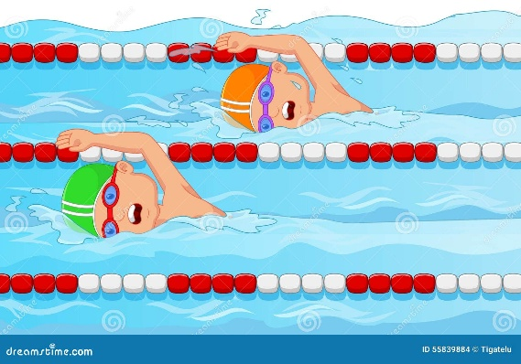

Congratulations to our fabulous Year 5 and 6 swimming squad! They all worked really hard to achieve their personal best swimming times. A great effort from all swimmers, resulted in St Julie’s being awarded third position overall. In addition, the boys and girls won medals in the medley and freestyle relays. Several children also received medals for their individual races. We are very proud of the St Julie’s squad – keep swimming!

