Dear Parents and Carers,

Pilgrims of Hope – Cathedral Mass
Our whole school pilgrimage to Liverpool Metropolitan Cathedral on Wednesday morning was a joyful and uplifting experience for everyone. The bells rang out for us as we arrived at the Cathedral and then the children sang Ave Maria as we processed in behind our school banner. The children were awestruck as they witnessed the huge size and height of the Cathedral and the amazing colours as the light shone through the impressive stained-glass windows. As always, the children were reverent throughout the Mass and sang their responses and hymns beautifully. The readers spoke confidently, not at all daunted by their surroundings. Some of Year 5 brought up the offertory along with the Pledges of Hope written by the children. Following the Mass the children processed around the inside of the Cathedral, looking out for the features that Fr Michael had discussed with them, making the links between the same features at St Julie’s Church.
Thank you to those parents, Governors and parishioners who were able to join us in our pilgrimage, to Fr Michael for celebrating the Mass and to Robert F from Year 6 who assisted with the Cathedral altar servers. Many thanks to Mrs McCahey whose idea it was back at the start of the year to take the whole school on this very special pilgrimage as part of the Jubilee year, Pilgrims of Hope, involving an enormous amount of hard work and organisation by her into making the occasion so special. It truly was a memorable experience to treasure; I certainly felt very emotional and so proud of our wonderful school community.
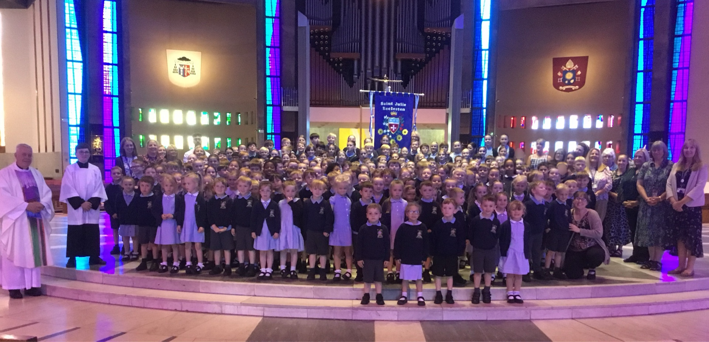

Sporting competitions
Quadkids Last week a team from Year 1 and Year 2 took part in the Quadkids competition at Sutton Academy. We were notified this week of the results and are very proud to say that they came 1st overall out of all the schools competing in the four events. This morning in assembly they were presented with their certificates and gold medals. Well done to the children for representing St Julie’s so brilliantly.
Swimming Gala Congratulations to our fabulous Year 5 and 6 swimming squad! They all worked really hard to achieve their personal best swimming times. A great effort from all swimmers, resulted in St Julie’s being awarded third position overall. In addition, the boys and girls won medals in the medley and freestyle relays. Several children also received medals for their individual races. We are very proud of the St Julie’s squad – keep swimming!


Amazing Art: parent/carer session
Our Arts celebration week got off to a great start with our first Amazing Art session with Year 2 on Thursday. It was a very therapeutic afternoon of drawing and shading. Mrs Mannion talked about the skills the children had been learning through their study of Amiria Gale, an artist and teacher from New Zealand who creates semi-abstract acrylic and mixed media paintings of shells. We hope all the adults enjoyed their art lesson and developed some new skills!
One adult is invited to come to school via the front entrance on Brooklands Road at 2:40pm to join their child for an art activity in the school hall:
Tuesday 1 July - Year 3
Wednesday 2 July – Year 4
Thursday 3 July – Year 1
Tuesday 8 July – Year 5
(Year 6 will be having their Leavers Celebration event)
Don’t worry if you can’t make it, there will be school staff around to make sure all children can enjoy the art activity.


TT Rockstars Battles
The results from the Junior battle were announced in assembly this morning…
Final scores
Year 2 v Year 3
Year 2 ... 37,392 Most valuable player Daniel
Year 3... 20,837 Most valuable player Jack
Congratulations to the Year 2 winners.
Year 4 v Year 5
Year 4... 10,774 Most valuable player William Mc
Year 5... 8, 505 Most valuable player Phinnaeus
Congratulations to the Year 4 winners
Teachers v Year 6
Teachers… 2,782 Most valuable player Miss Pratt
Year 6… 10,362 Most valuable player Elsie
Congratulations to the Year 6 winners
Well done to everyone who took part and showed great team effort.

Year 6 mini-enterprise: Friday 4th July
Year 6 have been organising a mini-enterprise as part of their PSHE lessons and will be holding an event on the afternoon. There will be a mixture games for children to join in with including, Penalty Shootout, Lucky Dip, Tombola and stalls selling craft based items and much more.
The children in each year group will have an opportunity to take part during the afternoon so please send them in with some coins (£2 - £3) in an envelope with their name on.

We now have an X Account @stjulieprimary to share and celebrate the life of St Julie's. Please follow, like and share!
If you have not returned your consent form for your child’s photo to be/not to be featured in posts, please do so asap so that we can get posting!


End of Year reports
School reports will be sent out on Friday 4th July to provide you with an overview of your child’s achievements and progress over this academic year. If you have any questions or comments we will be holding our drop-in Open Evening after school on Tuesday 8th July for Year 5 and Year 4 and Thursday 10th July for all other year groups from 3:20pm until 4:15pm.

Geography Poster Competition – Please send in your entries next week!
The Geography Ambassadors would like everyone to design a poster or information room (like a tourist information office – similar to the mini-museums that we made for the history competition) about a place you think James Ketchell would like to visit. It could be somewhere close to home, somewhere in the UK or somewhere around the world. Closing date: Monday 30th June 2025.

School Nurse drop-in
The school nurse, Andrea Whittle, will be holding a drop-in session on Monday morning next week between 8:30 and 10am. Just come along to the office if you wish to speak with her and we will show you through to the rainbow Room.



St Julie’s Awards of the Week

 | Star for showing hope | Book explorer | Marvellous mathematician
Year 1 | Anthony | Orlagh | Jessica
Year 2 | Sophie P Daniel | Dottie | Samantha
Year 3 | Jaxon M | Ivy B | Sienna
Year 4 | James K | Jackson H | Riley
Year 5 | Teddy B | Aoife | Benji
Year 6 | Poppy | Bonnie | Sophia

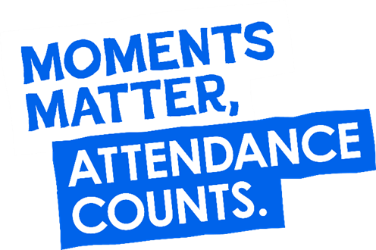
“From the first day of term to the last, the small moments in a school day make a real difference to your child.” #AttendanceCounts
At St Julie’s our attendance is excellent and we know that parents and carers value the education that your children receive.

Year Group | % Attendance for w/e 27.06.25
Year R | 98.18
Year 1 | 93.75
Year 2 | 98
Year 3 | 94
Year 4 | 98.86
Year 5 | 97.50
Year 6 | 97.14

Well done to Year 4 who had the highest attendance this week.

Pre-loved St Julie’s uniform
Before you spend money ordering uniform for September, don’t forget that the PFA have many items of school uniform available in the school foyer and more online. If you can, a small donation of any amount would be useful for school funds.

A reminder of our School Uniform Policy ahead of September: (Full document on the school website)

- Expectations for school uniform
The children are encouraged at all times to be tidy in their dress and in the care of their belongings. Adherence to the Uniform Policy is essential for maintaining expectations of good behaviour and health and safety regulations.

4.1 Our school’s uniform is:
Long or short grey trousers
Grey skirt or pinafore
Navy-blue sweatshirt/cardigan – available with an embroidered school badge from school’s uniform suppliers or without from any retailer
Sky-blue polo shirt – available with an embroidered school badge from school’s uniform suppliers or without from any retailer
Plain navy blue, grey or white socks
Plain navy blue or grey tights
Plain black flat school shoes, not trainer style or boots. Shoes with heels or flimsy sandals are not permitted for health and safety reasons.
Any colour of coat may be worn
Also available but not part of the official uniform are navy blue reversible fleece/waterproof jackets with St Julie’s embroidered logo (from Touchline Ltd)
Optional for Summer: sky-blue gingham dress available from any retailer
Black or white flat, sturdy sandals (no jelly/beach sandals) with socks
PE kit:
Navy blue loose shorts - no cycling shorts & no branded/logo shorts,
School T Shirt in the colour of their house/team with or without school logo
Slip on pumps.
Trainers for outdoor use
Plain navy blue fleece – from any retailer
Plain navy blue jogging bottoms – from any retailer

We ask that all uniform is clearly labelled with your child’s full name

Long hair must be tied back. Hair accessories should be small and in school colours – blue or black.
No extreme hair styles, e.g. multi-coloured, dyed hair, shaved lines, zig-zag, patterns
No nail varnish is to be worn

A watch or Fit Bit can be worn but must not have internet access or photo facility. Jewellery, unless for cultural reasons, must not be worn for school.
Earrings, necklaces, rings and all other forms of jewellery CANNOT be worn in school. If a child is wearing earrings or any other form of jewellery they will be asked to remove it for health and safety reasons.
If a child is having their ears pierced we advise that this is done at the start of school summer holiday so that the ears are sufficiently healed to enable earrings to be removed for school. If they cannot be removed then they must be covered with tape in school until sufficiently healed.

We thank you for supporting the school in maintaining standards and a consistent approach.
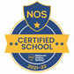
This week’s flyer from National Online Safety is, “What parents and educators need to know about NintendoSwitch2.”

Diary w/c 30.06.2024


Arts celebration Week
Monday 8am Gymnastics
8:30-10 School Nurse drop-in
Capoeira sessions in school
3:20 Y1/Y2 Football club

Tuesday Y2 Forest School
Year 3 Amazing Art session 2:40pm
3.20 KS2 Football

Wednesday 8am Rugby club
James Ketchell visit to school
Year 4 Amazing Art session 2:40pm
3:20 Y1 & Y2 Drawing club
3:20 Judo
3:20 KS2 Gardening

Thursday Samba sessions in school
Year 1 Amazing Art session 2:40pm
3.20 Dodgeball

Friday Conservation talk to Y5
Y6 Enterprise afternoon (£2 - £3 in coins in an envelope with child’s name on)
Reports out to parents
3:20 Girls only football club
Mass times:
Saturday 6pm at St Thomas of Canterbury
Sunday 9:30am at St Julie
Sunday 11am at Lowe House Church in St Helens

Willowbrook Hospice Colour Run
One of our Year 6 Pupils, Thomas H, is doing a colour run this weekend, fundraising for Willowbrook Hospice – Good luck Thomas!

Congratulations and a big THANK YOU to Jaxon M from Year 3 who completed the children’s Park Run last weekend and raised a fantastic amount in sponsorship for our school!


Sponsored Park Run
Our Sports Ambassadors are helping to promote the Government’s initiative of 60 Active Minutes Daily, throughout our school. As part of this, we are hoping that parents/guardians/teachers will support this initiative outside of school, by encouraging them and their child/ren to participate in the local Parkrun event.
What is the Parkrun?
Parkrun is a worldwide health and fitness movement where participants run, walk or jog five kilometres on a Saturday morning. If you register online, you are given a barcode, which enables you to get a personal time for each event. It is suitable for all ages and levels of ability – and more importantly IT IS FREE!
The 5K Parkrun on a Saturday morning must be run with a parent/guardian. Or if that is too long - the children’s 2K run is on a Sunday morning. If you find it difficult to run long distances, you can always complete a Parkwalk instead. Local event: St Helens Parkrun – The Bandstand, Victoria Park, City Rd, St Helens, WA10 2EH. CANCELLED ON SATURDAY, 21ST – SO PLEASE REGISTER AND VISIT THE PARK ON 14TH OR 28TH JUNE or any Saturday in July. Register online for further details.
The June 5K or 2K Parkrun Challenge: If you want to enter the 5K or 2K Challenge – please ask your Sports Ambassadors for a Sponsorship Form. As well as keeping fit, we also want to raise money for our school.
REMEMBER TO AIM FOR AT LEAST 60 ACTIVE MINUTES EVERY DAY!
Further dates for your Diary
Monday 7 July - Year 6 transition week at De La Salle for those going to that High School
Tuesday 8 July – Year 5 Amazing Art session 2:40pm
Tuesday 8 July - Year 2 Celebration of the Word with parents 3pm
Tuesday 8 July - Year 2 transition to Year 3 meeting for parents 3:20pm in Y3 classroom
Tuesday 8 July - End of year drop-in Open Evening from 3:20pm until 4:15pm Y4 and Y5
Wednesday 9 July - Year 1 Celebration of the Word with parents 3pm
Thursday 10 July - End of year drop-in Open Evening from 3:20pm until 4:15pm
Monday 14 July - Year 6 Leavers’ Celebration event 2:00pm (Parents and grandparents)
Monday 14 July - Year 4 Grosvenor Museum, Chester
Tuesday 15 July - 2:45pm Music presentation for parents of children learning musical instrument and Y4
Wednesday 16 July - Y1 Forest School
Wednesday 16 July - Year 6 Leavers Mass 6pm followed by disco
Thursday 17 July - Y3 Library visit – Summer Reading Challenge
Friday 18 July - School closes for Summer break


“A caring family school, where we learn, grow and walk in the footsteps of Jesus.”

St Julie pray for us, protect us and bless us.

