Dear Parents and Carers,

Amazing Art: parent/carer session
Our Arts celebration week has been full of learning and experimentation. Year 3 enjoyed getting messy making African canopic jars using clay, Year 4 shared their sketchbooks and revisited techniques from Autumn, Spring and Summer while Year 1 made a Daniel Mackie inspired animal/habitat. We hope all the adults enjoyed their art lesson and developed some new skills!
Next Tuesday it is time for Year 5! One adult is invited to come to school via the front entrance on Brooklands Road at 2:40pm to join their child for an art activity in the school hall.

Also as part of our Arts celebration week, all the children took part in some Capoeira and a drama session on Monday.


The Sound Collector by Year 3
Year 3 are writing their own poem based on The Sound Collector by Roger McGough. They have read and performed his poem as inspiration. Scan the QR code below to hear it....



Samba
On Thursday morning, the junior children took part in a Samba session. They learned about and used different instruments to play Samba ostinato patterns. Scan the QR code to hear what they produced.
James Ketchell Returns It was a pleasure to welcome James back to St Julie’s on Wednesday. He updated the children on his progress toward his new departure date of Sunday 27th July for his round the world sail and, as always, shared his infectious resilience and positivity. Year 3 and 4 joined him for his Everest workshop; trying some of his chocolate Chip ration packs (which received mixed reviews) and Year 2 and 5 completed some mapwork with our new atlases; locating some of the places James has visited. All the children represented our school magnificently and we were very impressed by the children’s use and knowledge of our new atlas resources. James also met our geography ambassadors and helped to judge our recent competition.
A huge thank you to all those children who entered the recent James Ketchell Competition. These have been judged by the geography ambassadors, teachers and James to find our winners, although James was so impressed that he thought they should all be winners.
It was a hard decision, but by combining votes and comments our winners are….
Oliver – Reception class
Evie – Year 1
Samantha – Year 2
Jackson – Year 4
All our entries have received a small prize and our winners were presented with a map book signed by James.

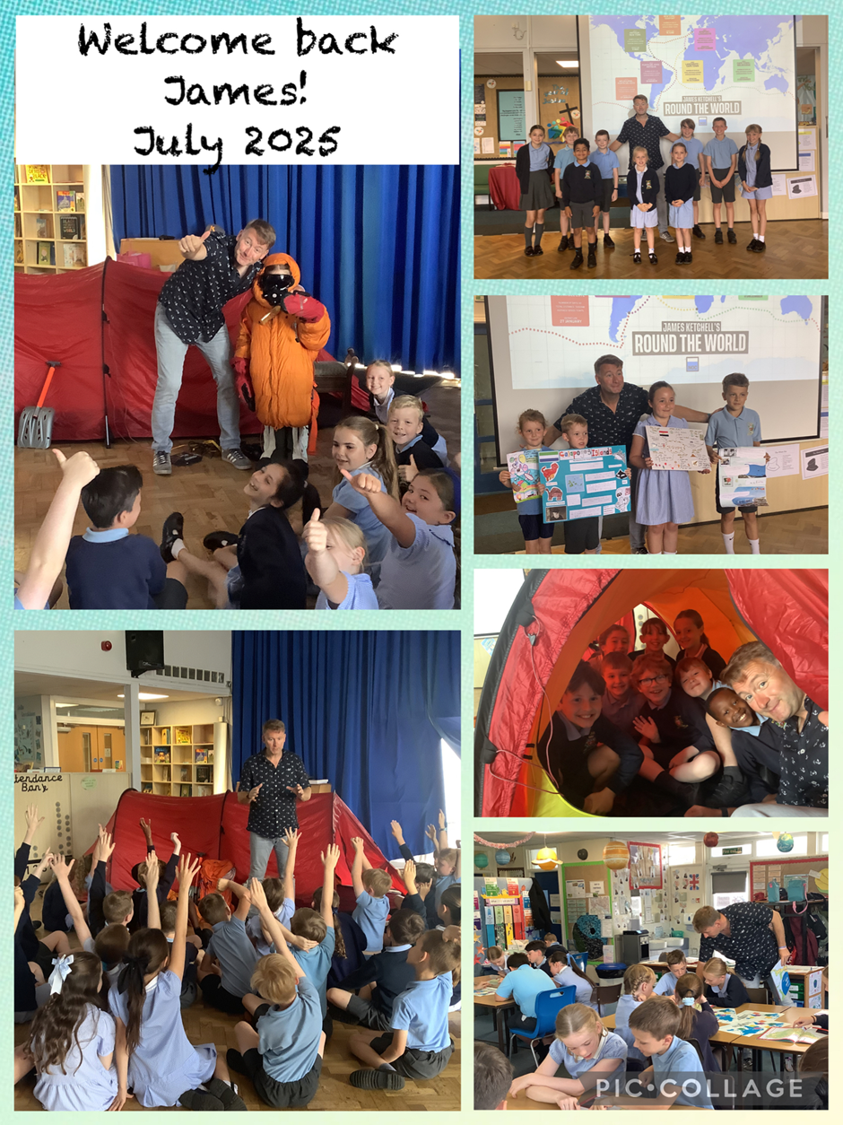


Meet your new teacher morning – Tuesday 8th July
Next Tuesday morning all of the children will move up to the next year group for the morning. This will be an opportunity for them to see what their classroom will be like in September and to meet their new teacher.
De La Salle will be running the full Year 6 Transition week from 7th to 11th July and should attend every day.
Our new intake visits for Reception September 2025 will also take place on Tuesday 8th July.
The class teachers from September 2025 will be:
Reception – Mrs Ashcroft
Year 1 - Mrs Kernick and Mrs Slocombe
Year 2 - Mrs Mannion (1 day Miss Wood)
Year 3 - Miss Pratt (1 day Miss Wood)
Year 4 - Mr Royle
Year 5 - Mrs Clayton (1 day Mrs Johnson)
Year 6 - Miss Carr

Year 6 De La Salle Transition week
Next week our Year 6 pupils who will be joining our feeder high school, De La Salle, in September will be spending the whole week in their new school. There is a mixture of excitement and nerves from the children but we wish them a happy time next week as they have a taste of the lessons and get used to their surroundings. Children who are moving on to other High Schools have had their taster sessions and should attend St Julie’s next week as usual.

New intake for Reception September 2025
Next week we will welcome our new starters for Reception in September as they come to school for a stay and play session with Mrs Ashcroft.

Year 2 Transition meeting
There will be a short transition meeting for current Year 2 parents as their child leaves the infants to start the juniors. The meeting will be in the Year 3 classroom on Tuesday 8th July straight after school. The teacher will explain the Junior routines and expectations and how you can help to prepare your child for Year 3. The children will be looked after in the hall while the meeting takes place.


End of Year reports
Today your child should have brought home their end of year report which will provide you with an overview of your child’s achievements and progress over this academic year. If you have any questions or comments we will be holding our drop-in Open Evening after school on Tuesday 8th July for Year 5 and Year 4 and Thursday 10th July for all other year groups from 3:20pm until 4:15pm.

Year 6 Mini-enterprise
Year 6 proved themselves to be upcoming entrepreneurs this week with their hugely successful mini-enterprise. They have worked hard for a number of weeks planning the event and making the games and products. Today there was huge excitement: each class enjoyed coming to Year 6 to take part. Thank you to everyone who sent in money. Year 6 will announce how much they made next week. Watch out Lord Sugar!

SchoolGrid
The kitchen have asked if parents can make sure they have asked their child about their food choice as this week some children have not had what food they would normally choose and then not eaten as much.

Instrumental tuition
Parents and carers of children learning to play the guitar with the Schools Music Service and Y4 children learning a string instrument are invited to come and watch a short performance on Tuesday 15 July at 2:45pm in the school hall. Unfortunately, Mrs Wellens who teaches keyboard is not available that day but will arrange a separate presentation for early next term.

Break-time snacks
A reminder that break-time snacks must be a piece of real fruit (no fruit sweets/bars) or toast. Thank you for supporting our healthy eating policy.



St Julie’s Awards of the Week

 | Star for showing hope | Book explorer | Marvellous mathematician
Reception | Jacob | Mae | Marty
Year 1 | Evie | Daniel | Anthony
Year 2 | Isaac | Reggie | Georgie
Year 3 | Luke | Josefina River | Josie Brooke
Year 4 | Thomas G | Jed | Darcey
Year 5 | Veronica | Harrison | Jude
Year 6 | Archie | Robert E | Robert F


“From the first day of term to the last, the small moments in a school day make a real difference to your child.” #AttendanceCounts
At St Julie’s our attendance is excellent and we know that parents and carers value the education that your children receive.

Year Group | % Attendance for w/e 04.07.25
Year R | 99.09
Year 1 | 96.25
Year 2 | 97
Year 3 | 94.57
Year 4 | 96.86
Year 5 | 96.67
Year 6 | 96.86

Well done to Reception who had the highest attendance this week.

Pre-loved St Julie’s uniform
Before you spend money ordering uniform for September, don’t forget that the PFA have many items of school uniform available in the school foyer and more online. If you can, a small donation of any amount would be useful for school funds.


This week’s flyer from National Online Safety is, “What parents and educators need to know about Apple iPads.”

Diary w/c 07.07.2025

Year 6 transition week at De La Salle for those going to that High School
Monday 8am Gymnastics
3:20 Y1/Y2 Football club

Tuesday Whole school transition morning including new Reception visits
Year 5 Amazing Art session 2:40pm
Year 2 Celebration of the Word with parents 3pm
Year 2 transition to Year 3 meeting for parents 3:20pm in Y3 classroom
End of year drop-in Open Evening from 3:20pm until 4:15pm Y4 and Y5
3.20 KS2 Football

Wednesday 8am Rugby club
2:30 Y3 Hands Sign Language performance for parents in school hall
Year 1 Celebration of the Word with parents 3pm
3:20 Y1 & Y2 Drawing club
3:20 KS2 Gardening

Thursday End of year drop-in Open Evening from 3:20pm until 4:15pm
3.20 Dodgeball

Friday 3:20 Girls only football club

Mass times:
Saturday 6pm at St Thomas of Canterbury
Sunday 9:30am at St Julie
Sunday 11am at Lowe House Church in St Helens

Congratulations and a big THANK YOU to Robert E and Elizabeth from Year 6 who completed the children’s Park Run last weekend and raised a fantastic amount in sponsorship for our school!


Sponsored Park Run
Our Sports Ambassadors are helping to promote the Government’s initiative of 60 Active Minutes Daily, throughout our school. As part of this, we are hoping that parents/guardians/teachers will support this initiative outside of school, by encouraging them and their child/ren to participate in the local Parkrun event.
What is the Parkrun?
Parkrun is a worldwide health and fitness movement where participants run, walk or jog five kilometres on a Saturday morning. If you register online, you are given a barcode, which enables you to get a personal time for each event. It is suitable for all ages and levels of ability – and more importantly IT IS FREE!
The 5K Parkrun on a Saturday morning must be run with a parent/guardian. Or if that is too long - the children’s 2K run is on a Sunday morning. If you find it difficult to run long distances, you can always complete a Parkwalk instead. Local event: St Helens Parkrun – The Bandstand, Victoria Park, City Rd, St Helens, WA10 2EH. PLEASE REGISTER AND VISIT THE PARK any Saturday in July. Register online for further details.
The July 5K or 2K Parkrun Challenge: If you want to enter the 5K or 2K Challenge – please ask your Sports Ambassadors for a Sponsorship Form. As well as keeping fit, we also want to raise money for our school.
REMEMBER TO AIM FOR AT LEAST 60 ACTIVE MINUTES EVERY DAY!
Further dates for your Diary
Monday 14 July - Year 6 Leavers’ Celebration event 2:00pm (Parents and grandparents)
Monday 14 July - Year 4 Grosvenor Museum, Chester
Tuesday 15 July - 2:45pm Music presentation for parents of children learning musical instrument and Y4
Wednesday 16 July - Y1 Forest School
Wednesday 16 July - Year 6 Leavers Mass 6pm followed by disco
Thursday 17 July - Y3 Library visit – Summer Reading Challenge
Friday 18 July - School closes for Summer break


“A caring family school, where we learn, grow and walk in the footsteps of Jesus.”

St Julie pray for us, protect us and bless us.

