Dear Parents and Carers,
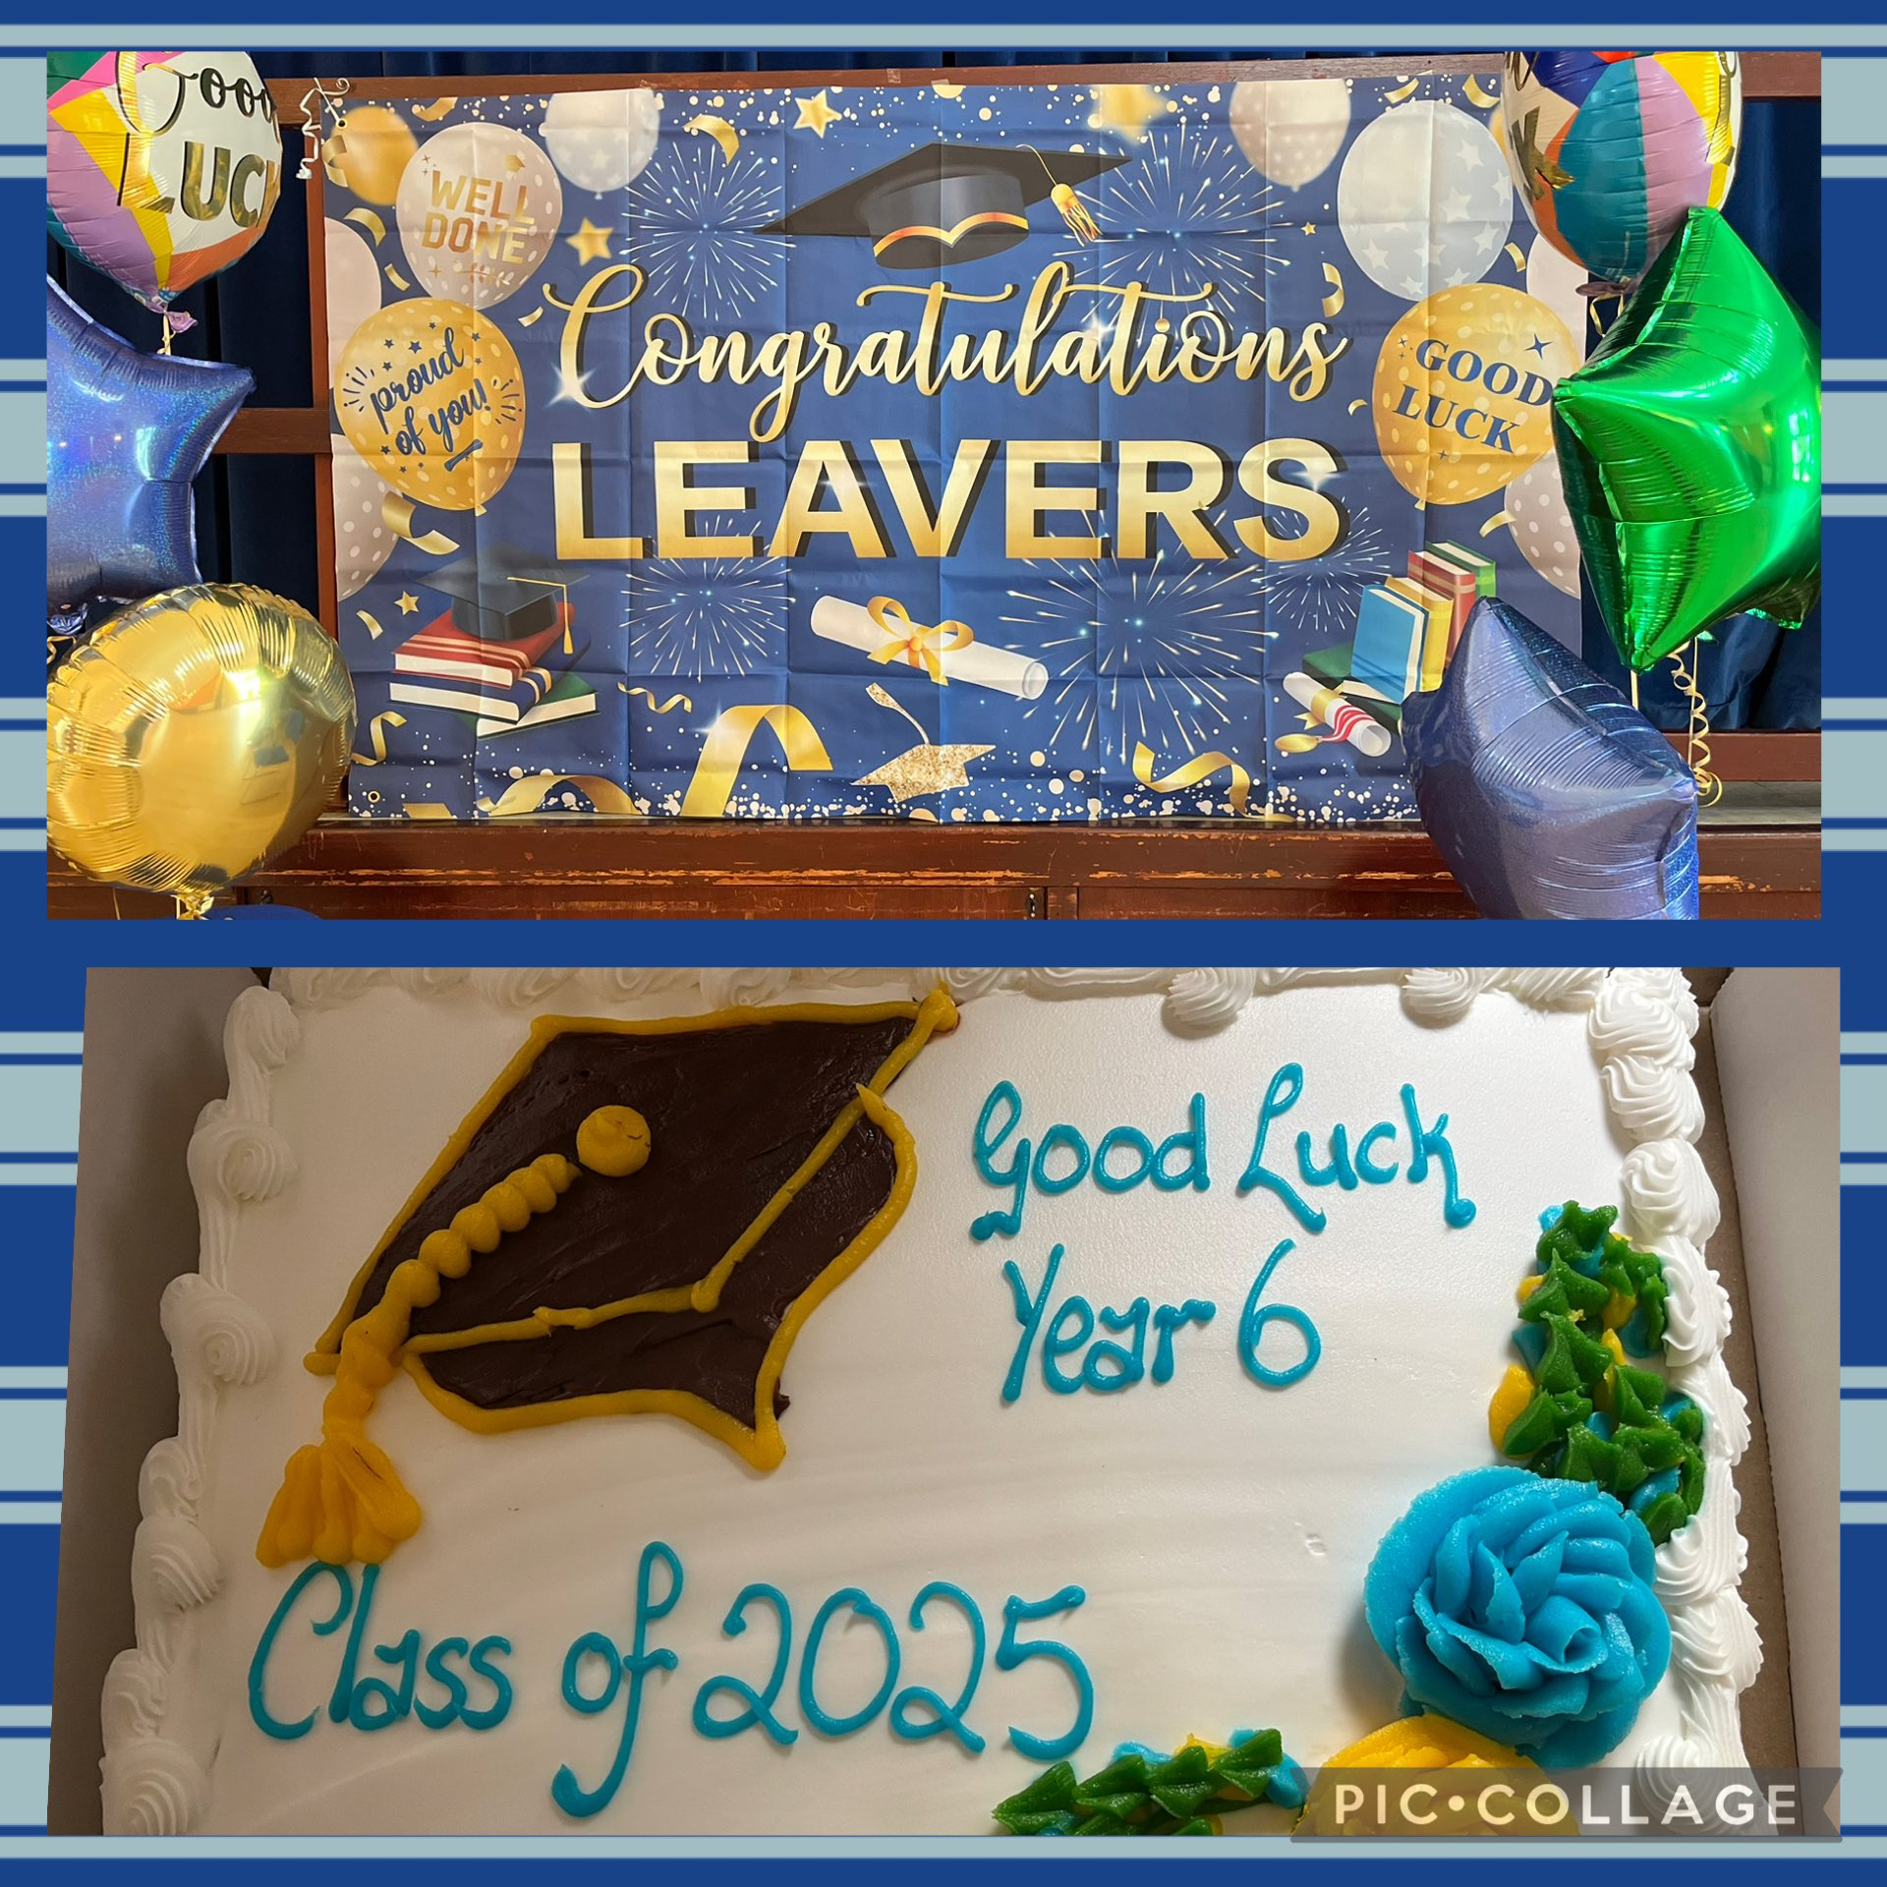
Today we said a fond farewell to our children in Year 6. It has been quite an emotional week saying our goodbyes.
On Wednesday night we celebrated Mass at St Julie’s Church with Year 6 and their families, giving thanks for their time at St Julie’s and the many achievements and happy memories they have of their journey through school. Our families then continued the celebrations in the Parish Hall. Thank you to the PFA for providing pizza, drinks, ice-cream and cake.
Today the whole school came together in the school hall for a celebration of Year 6’s many achievements. It was wonderful for the children to share their memories of their time at St Julie’s. At the end of the day they were presented with their parting gifts before parading out to a round of applause from their waiting parents. We want to wish our Y6 leavers every success in their new High Schools in September. We hope that they will pop back to St Julie’s to let us know how they are getting on. Thank you to all the families who have given so much support to the school over the years, we will miss you.
Good luck everyone from all the staff and governors at St Julie’s!


On Wednesday morning, we shared an assembly where we also said a fond farewell to Mrs McCahey as she starts her retirement. To work in a catholic school is not just a job – it is a vocation. It has been her daily commitment to live out our school values, to teach about Jesus and encourage everyone to be more like Him. Staff and children shared their memories of Mrs McCahey and presented her with cards and gifts. So we thank Mrs Mccahey for her faithful service as a teacher and for the impact she has had on our school, and beyond the classroom, on the lives of so many and we hope that the next stage of her journey will be an exciting new adventure.
We also say thank you to Fr Michael for the support he has given to St Julie’s Parish and as a governor at St Julie’s school over the past 2 years. Fr Michael has had a wonderful way of connecting with the children at our school Masses and in preparing children for the sacraments. We are grateful for the time we have had with him and wish him well on the next stage of his journey too as he leaves for a parish in Wigan.


PFA Colour Run
What a fantastic way to finish our school year. The children had an amazing time running and getting splattered with colour – all while raising money for school funds! Thank you to Lynsey and Keith for organising the Colour Run and for everyone who came to help out with setting up and during the very successful event.
Please do come along to the next PFA meeting in September to plan more exciting events for the next half term.


Children’s University Summer Challenges
The holiday challenges are a range of quick, fun and engaging activities that can be completed by children at home during the school holidays, enabling participating children to gain Children’s University credits while away from school.
The activities have a range of different themes i.e. art, literacy, maths, science, geography etc. It is a great way to provide children with an opportunity to gain those extra hours needed to reach a national award.
See the flyer attached or on the school website under Children tab – Children’s university. Send in evidence when completed to have it displayed in school and credits awarded. The children love seeing their pictures on our Children’s University wall!

Neurodevelopment pathway drop-in sessions – please see the flyer attached for dates.
Tennis camp at Eccleston Park tennis club – see flyer for details

School opens for the new academic year on Wednesday 3rd September.

School day:
8:50am until 3:20pm Children may enter via the two gates from 8:40am allowing them to settle into class before the register is taken at 8:50am
Please note that ALL children MUST be in school for 8:50am which is the start of the school day so please allow time for them to walk to their classroom. If a child is not in class for 8:50am they will be marked late. Texts will be sent if a child is late on several occasions.

Home time: Gates will open at 3.20pm for a parent/grandparent to collect their child/ren from their classroom. All teachers will release children from their classroom door in turn as they see an adult they recognise. All year groups must be collected by an adult.

Earrings CANNOT be worn in school. If a child is wearing earrings or any other form of jewellery they will be asked to remove it for health and safety reasons. If a child is having their ears pierced, we advise that this is done at the start of school summer holiday so that the ears are sufficiently healed to enable earrings to be removed for school. If they cannot be removed then they must be covered with tape in school until sufficiently healed.



St Julie’s Core Value Awards



Name/Year group | Core value | Reason
Seth Year 4 | Respect | Seth shows respect to everyone he meets. He is always polite and positive.
Imogen Year 5 | Unity | Imogen is a great team player and demonstrates that “Together Everyone Achieves More.”
Vienna Year 2 | Resilience | Vienna has demonstrated great determination and resilience this year.
Jessica Year 1 | Love | Jessica always thinks of other people and is a kind and caring member of our school family.
Isaac Year 6 | Honesty | Isaac is always honest and demonstrates what it means to always do the right thing at all times.
Zac Year 3 | Hope | Zac consistently has a positive attitude to everything he attempts in and out of school and has shown how he cares about the future of the world around him.

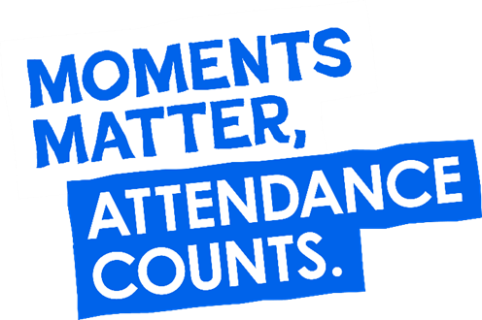
Year Group | % Attendance for w/e 18.07.25
Year R | 91.82
Year 1 | 91.88
Year 2 | 99.67
Year 3 | 93.14
Year 4 | 90.86
Year 5 | 95
Year 6 | 94.57

Well done to Year 2 who had the highest attendance this week.

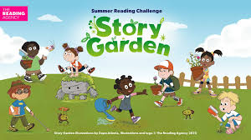
Summer Reading Challenge
Story Garden – Adventures in Nature and the Great Outdoors is the enchanting theme for the 2025 Summer Reading Challenge. Created by The Reading Agency and delivered in partnership with public libraries, this year’s Challenge encourages children to explore the connection between storytelling and nature.
What’s the Challenge?
This summer, children are encouraged to read 4 books of their choice during the school holidays. Whether it’s tales of woodland creatures, garden adventures, or epic journeys through the wild, every book read helps them grow their own Story Garden.
How to Get Involved: Signing up is easy and free! Simply visit any library in St Helens to register. Then read 4 books throughout the summer holidays. Children will receive a Summer Reading Challenge pack upon borrowing their first book.
Exciting Events and Activities Throughout the summer: St Helens libraries will host a variety of events designed to engage and inspire young makers. Don't miss out on any of the action! Check out our What's On calendar for a full list of events and details https://sthlibrarieswp.koha-ptfs.co.uk/ whats-on/
Year 3 will be visiting Eccleston Library on Thursday afternoon to hear all about this year’s Summer Reading Challenge.

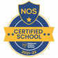
This week’s flyer from National Online Safety is, “What parents and educators need to know about staying safe around water.”


Advance notice: Swimming Lessons
September’s Year 6 class will begin their swimming lessons from Thursday 11th September, and every Thursday afternoon until half term, at Queen’s Park Leisure Centre in St Helens. A letter with full details has been sent out.

Mass times:
Saturday 6pm at St Thomas of Canterbury
Sunday 9:30am at St Julie
Sunday 11am at Lowe House Church in St Helens

On behalf of staff and governors at St Julie’s we would like to thank you for your support throughout the year and wish you a very happy and peaceful summer holiday.

Mrs Hodgson

“A caring family school, where we learn, grow and walk in the footsteps of Jesus.”

