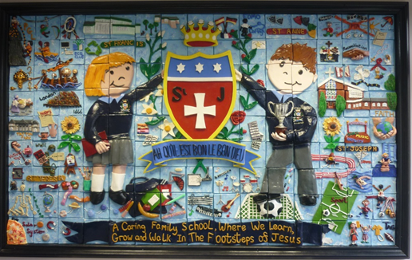
Welcome Back!
What a delight to welcome back all our children and families this week. We hope that you all had a restful break! The children were full of news and stories of their holiday experiences. This week we welcomed back Mrs Wright to our school office and welcome Mrs Wallace as our new Clerical Assistant on Tuesday, Wednesday and Thursday mornings. The school office team will be happy to help you with any queries.
We would like to give a big welcome to all our Reception children who started their St Julie’s journey on Thursday and have been staying until after their lunch. They all looked smart in their new school uniforms and settled well in their new classroom. We are looking forward to seeing the children again next week when they attend full time.

St Julie’s school mission and core values
In assembly this morning we started the school year by reviewing our school mission statement and core values with all staff and children. Everyone agreed that our mission statement, “A caring family school where we learn, grow and walk in the footsteps of Jesus,” is lived out every day in our school and truly reflects how we treat each other. We also thought about how our six core values guide our footsteps. The children spoke so confidently about what the values mean to them and how they link to our British Values too.

During the school year we will focus on one of our core values each half term starting with Respect. Our Star of the Week award will be for a child in each class who that week has shone brightly for showing Respect.
Over the week we have also been talking about how we can show that we are “smart and ready for learning.” This begins with us being on-time for school and in school every day and wearing our correct uniform. The picture shows you the other important actions we discussed. Ask your child what they mean…

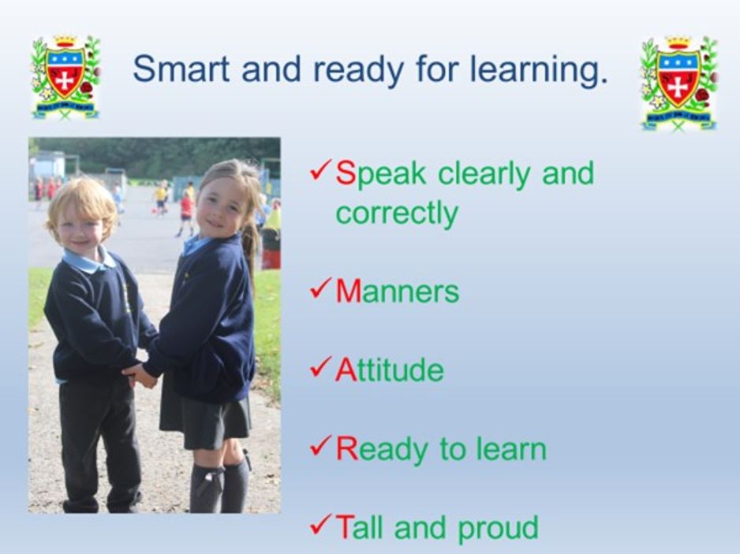

Welcome Fr Henry Nevin
We welcome Fr Henry as the new Parish Priest at St Julie’s. On Sunday this week, 7th September, he will be celebrating his first Sunday Mass at 9:30am and as the parish officially welcome Fr Henry it would be wonderful if as many children and their families as possible from school could join them.
Our Year 4 children will be starting their First Holy Communion preparation this half term and it would be a great opportunity for Year 4 children and their families to start their journey this Sunday by attending Mass and sharing the Mass with Fr Henry.
Likewise, for our new Reception children and their families this is a great opportunity to join the parish community. Little Church begins this Sunday during the 9:30 Mass and welcomes all school-age children. They will be taking part in a special presentation to welcome Fr Henry.
Please come along to welcome our new Priest.


Year Group Meetings for parents
As we start the new school year you are invited to attend a meeting led by the class teacher to outline the approach to teaching mathematics and reading for the year group and how you can support your child in their reading journey. We believe that children should have access to as many reading opportunities as possible, to read widely and deeply, and that being read to should continue throughout primary school so that all children can experience the sheer joy of reading, read books with powerful themes, books by modern authors as well as great works of literature.
The meetings will be held in your child’s classroom and should last no longer than 30 minutes. The meeting is intended for parents only – not the children. It would be great if all children are represented by an adult attending and you will have the opportunity to ask questions:

Monday 8th September 4:30pm Year 3

Tuesday 9th September 4:30pm Year 6

Wednesday 10th 4:30pm Year 1
5:00pm Year 4

Thursday 11th 4:30pm Year 2
5:00pm Year 5

The Reception class meeting will be held on Thursday 18th September at 4:30pm.

Instrumental Tuition at St Julie Catholic Primary School
A message from the Schools Music service for Junior children:
We are delighted to let you know that The Schools Music Service will be returning to provide instrumental music tuition in your school from this term onwards.
We currently offer classes on clarinet, flute, guitar, keyboard and violin in school, in small group half hour sessions, during the school day.
It is our belief that music greatly enriches the life of a child, both academically and socially.

If you would like more information about classes here is a link to our website where you can see how everything works - www.schoolsmusicservice.co.uk
If you know what instrument your child would like to learn, or you have learned with us before, you can register for classes on our website and we will sort everything out for you.
Please watch our short video for more information.
Also, if your child has had music tuition with us in the previous academic year, please ensure that you have made a new application for this year's tuition to put them back onto the teacher's pupil list.

Our teachers are extremely excited to be coming back to your school and we look forward to meeting you all soon.
Start of the year reminders:

Earrings A reminder that earrings CANNOT be worn in school. If a child is wearing earrings or any other form of jewellery they will be asked to remove it for health and safety reasons. A message was posted in the July bulletin that if a child is having their ears pierced, we advise that this is done at the start of school summer holiday so that the ears are sufficiently healed to enable earrings to be removed for school. Thank you.

Pre-loved St Julie’s uniform
A reminder that we have many items of pre-loved school uniform in school. If you require any pieces of uniform please call at the school office where we have uniform sorted into age groups. If you can, a small donation of any amount would be useful for school funds. Currently we have a large amount of stock so we are not taking any more donations at this time.

Cloakrooms
Our cloakrooms are very small for the number of children and their belongings therefore please do not send in backpacks/large bags or large water bottles. Thank you for your support with this.

Packed lunches
For children having a packed lunch I encourage you to not send in too much food. We are a Healthy School and so a sandwich/wrap, fruit and one small treat is sufficient. Children can bring in a healthy snack of fruit or toast for break times and infant children continue to receive milk and fruit.


Food Allergies
Please take care not to include nut based products in lunch boxes as we have several children in school who suffer from nut allergies. We encourage the children to bring a healthy snack of fruit or toast for break time (no cereal bars please). If your child is bringing grapes, please ensure that they are sliced down the middle lengthways.


Water bottles
Please remember to send a water bottle in to school with your child so that they can remain hydrated throughout the day. Juice or flavoured water is not permitted.

Asthma inhalers
Forms have been given out to those children who we have been notified use an inhaler. Please update the form for this year and return to school as soon as possible. If your child no longer uses an inhaler please inform school so we can remove them from the register.
Administering medicine in school: If children do need prescribed medication to be given whilst in school it can be administered providing the correct paperwork is completed which is available from the school office. However, school cannot administer the first dose of any medication due to potential allergic reactions. Only prescribed medication can be administered in school.


Tissues
We would be grateful if every child could bring in a box of tissues for their class. These will be kept as a stock by the teacher to get us through the year. Bless you!!

Please ensure names are in all school uniform – it is extremely difficult to find lost items if there are no names in them.
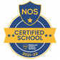
This week’s flyer from National Online Safety is, “10 top tips for parents and educators supporting children going back to school.”


Punctuality
Thank you to all those parents/carers and grandparents who have ensured that the children are in school on time this week; we have had very few late marks this week.
The children can come in from 8:40am but MUST be in their classroom for 8:50am when the register is called.
From next Monday if your child is marked as late, you will receive a text reminder about being in school on time.


“From the first day of term to the last, the small moments in a school day make a real difference to your child.” #AttendanceCounts

At St Julie’s our attendance is excellent and we know that parents and carers value the education that your children receive.

TERM TIME ABSENCE: You should be aware that the law has now changed regarding penalty notices for unauthorised absence from school. This change came into effect from 19th August 2024.
Please be aware that NO holidays in term time will be authorised.

Useful website Is my child too ill for school? - NHS (www.nhs.uk)

Year Group | % Attendance for w/e 05.09.25
Year R | 100
Year 1 | 98.48
Year 2 | 100
Year 3 | 100
Year 4 | 97.62
Year 5 | 90.95
Year 6 | 98.15

Well done to Reception, Year 2 and 3 who had the highest attendance this week.


St Julie’s Awards of the Week

 | Star of the week for showing respect
Year 1 | Mae
Year 2 | Francis
Year 3 | Cameron
Year 4 | Theo H
Year 5 | Liberty-Rose
Year 6 | Benji


St Julie’s Sunflower Club
Our Sunflower Club provides breakfast and after school wraparound care for the children of St Julie Catholic Primary School. The club is to be run by experienced, trained staff who aim to provide a safe, fun environment with a variety of enrichment activities. Both breakfast and after school club are available throughout term time but must be booked in advance.

The Sunflower Club opening hours are:
Breakfast Club 7:45am to 8:40am Monday to Friday term time only
After School Club 3:20pm – 5:45pm Monday to Friday term time only

BREAKFAST CLUB - The cost is £5.00 per session per day per child
AFTER SCHOOL CLUB - The cost from 3.20pm to 4.30pm is £5.00 or from 3.20pm to 5.45pm is £9.00
per session per day per child.
If your child attends a school run activity club, staff will collect them from their activity when it finishes and the charge for Sunflower Club will be £5.

After School Clubs
Due to the teachers running the Year Group meetings for each class next week, our programme of after school clubs for Year 1 up to Year 6 will begin week commencing Monday 15th September. A full list of clubs available will be sent home next week for you to sign up to.
Gilchrist Sports Coaching will be starting their clubs next week. A flyer has been sent out for you to register and pay for their clubs.

Diary w/c 08.09.2025

Monday 8am Gymnastics - All Years
4:30pm Maths/Reading Meeting Y3

Tuesday 4:30pm Maths/Reading Meeting Y6

Wednesday 8am Multi-sports - All Years
4:30pm Maths/Reading Meeting Y1
5:00pm Maths/Reading Meeting Y4

Thursday Year 6 swimming 2-3pm
4:30pm Maths/Reading Meeting Y2
5:00pm Maths/Reading Meeting Y5

3:20 – 4:15 KS2 Dodgeball

Friday 3:20 – 4:15 KS2 Girls only football

“A caring family school, where we learn, grow and walk in the footsteps of Jesus.”

St Julie pray for us, protect us and bless us.

