|  |  |  |
| --- | --- | --- |
| St Julie Catholic Primary School – Science | | |
| Topic: Can you feel the force? | Year: 5 | Strand: Physics: Forces |

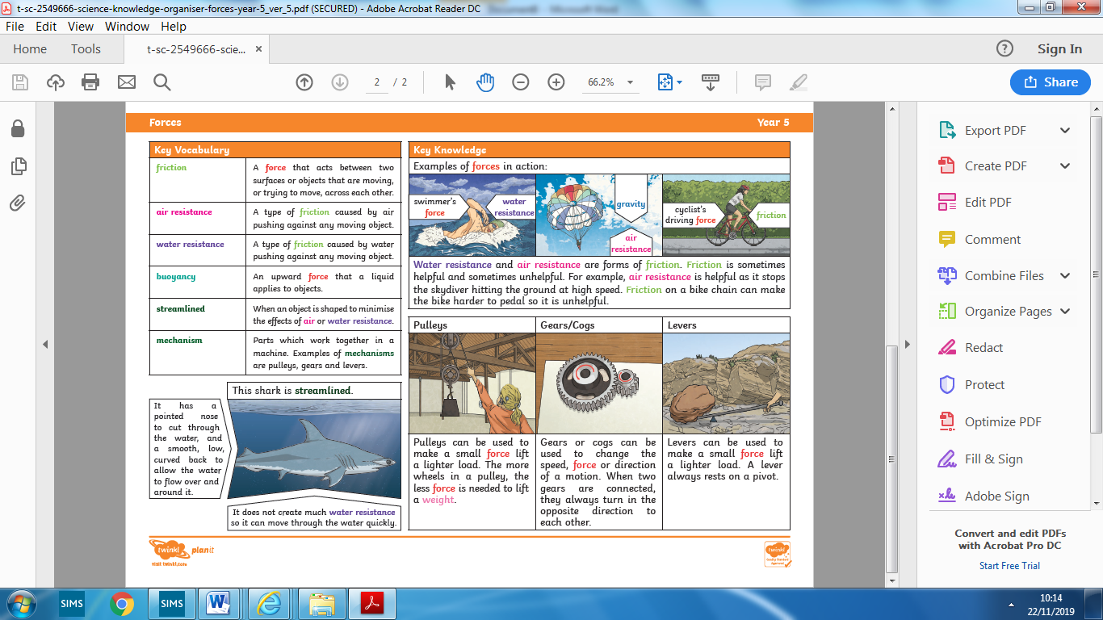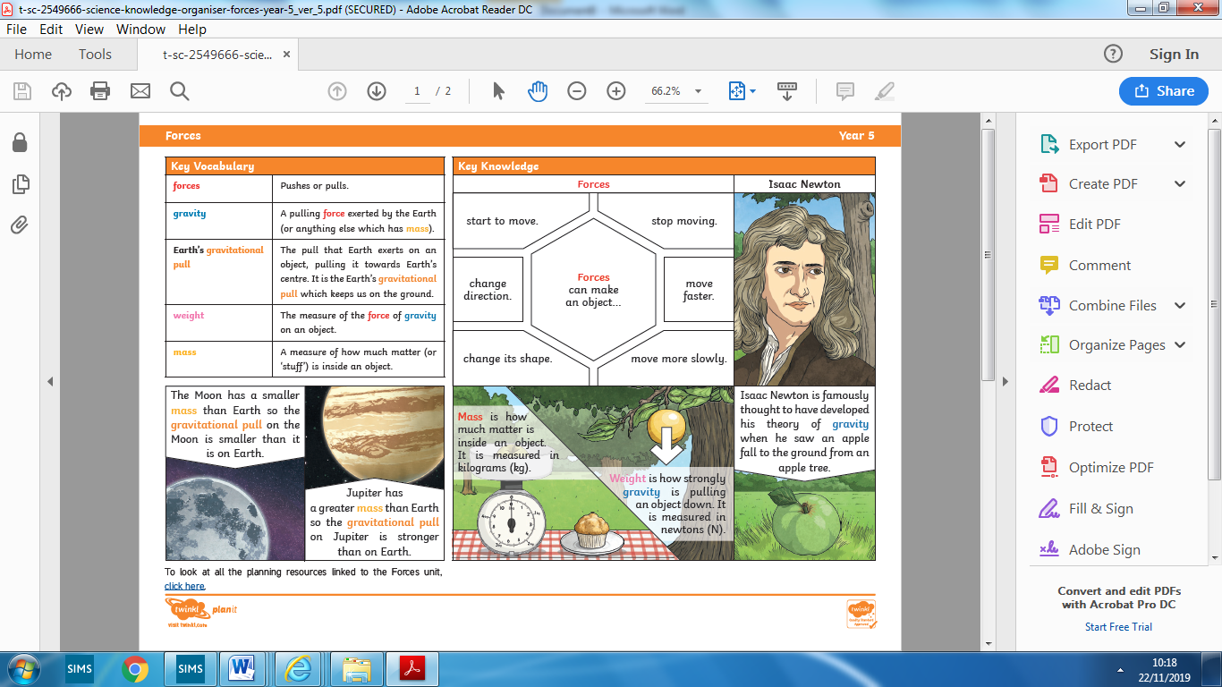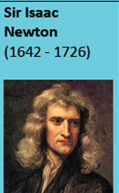

Pulleys can make a small force lift a big force. The more wheels on a pulley, the less force is needed to lift a weight.

Levers can make a small force lift a big force. A lever always rests on a pivot.

**Sticky knowledge about:**

1.Newton and his discoveries about gravity

2.The links between the mass and weight of objects,

3.Force is measured in Newtons (N)

4.Friction, air /water resistance are slowing down forces

5. A simple machine is a mechanism that helps us to do work.

**By the end of this topic I will:**

* **Know** how to identify /describe a balanced or unbalanced force
* **Know** and identify the effects of friction
* **Know**/identify/explain the effects of air resistance
* **Know**/identify/explain the effects of water resistance
* **Know** that pulleys, gears and levers are simple machines
* **Know** that simple machines can make a small force into a bigger force

**In experiments I will:**

* Identify and use variables
* Repeat measurements for accuracy

**STICKY KNOWLEDGE**

Scientist who ‘discovered’ the concept of gravity when sitting under a tree and an apple fell to the ground near him.

**What should I already know?**

1. A force is a: push, pull, turn twist
2. Objects will move at different speeds on different surfaces
3. Magnetism is a force