Dear parents and carers,

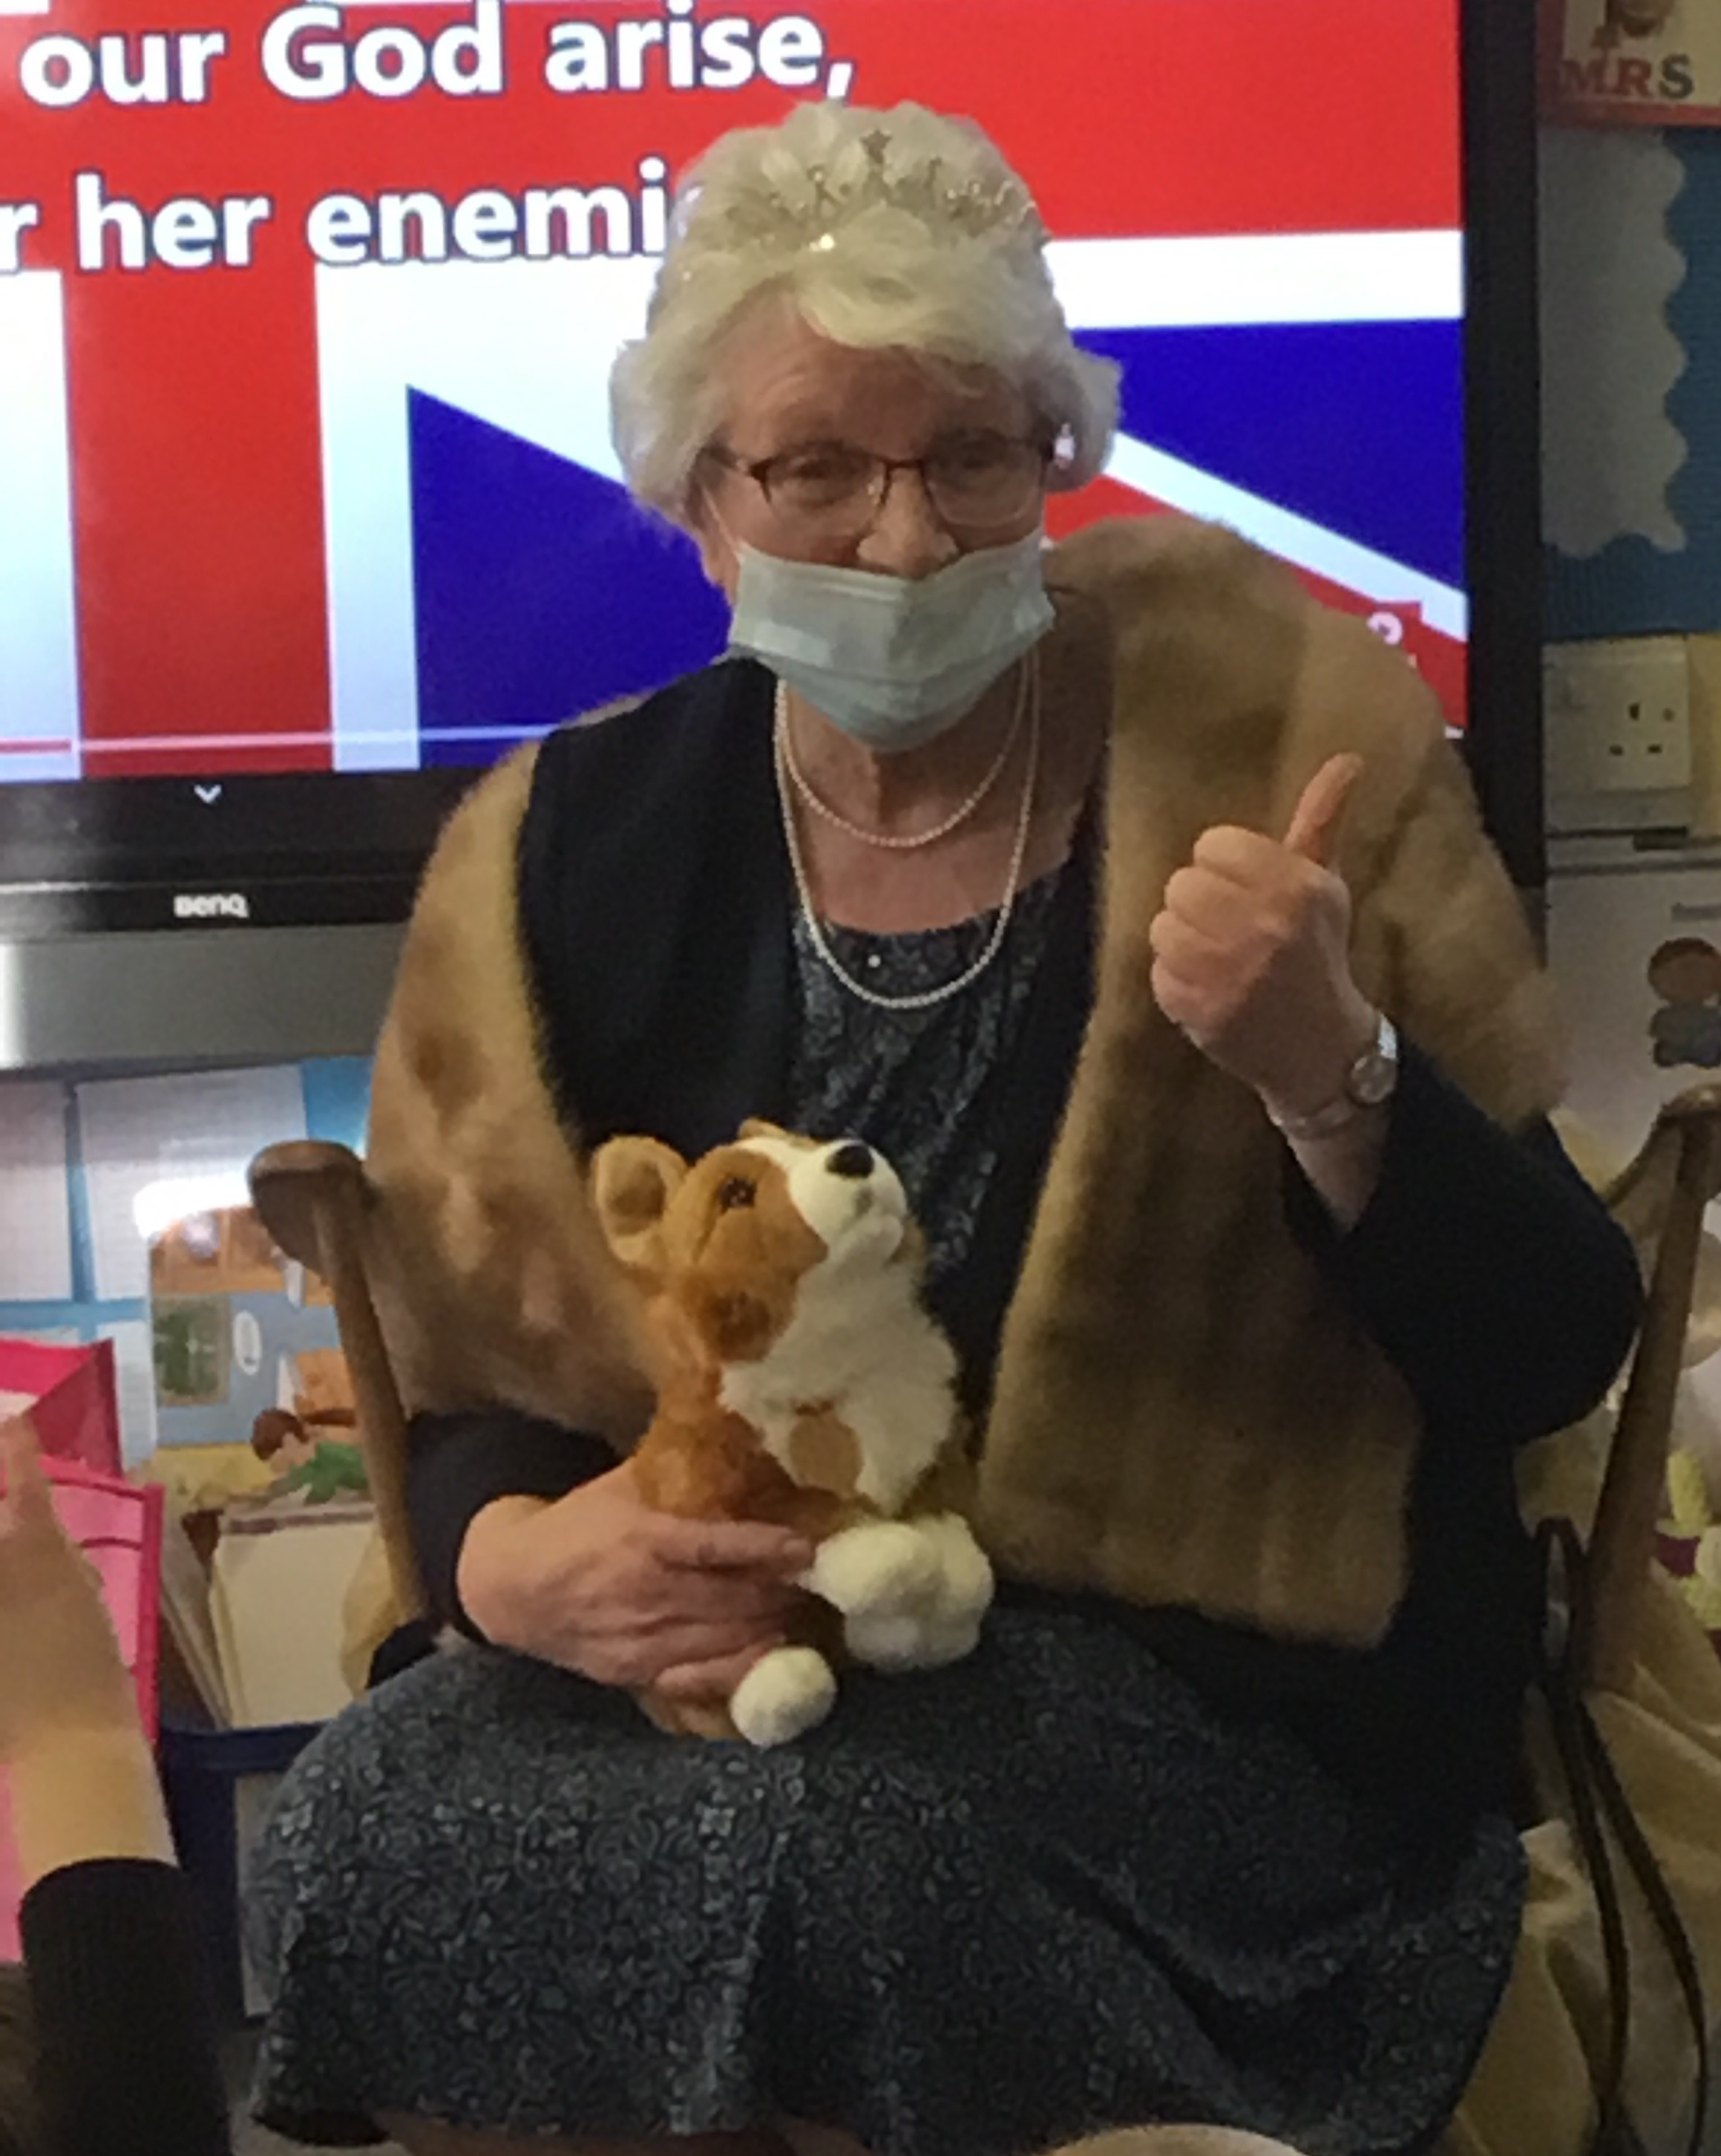
Reception Class visited by the Queen!
On Thursday afternoon this week the children in the Reception class were honoured by a visit from the Queen.
Her Majesty was delighted to talk to the children about her very important role and answered the children’s many interesting questions. Although we don’t normally permit dogs on the school premises, we did make an exception for her Corgi!
The children then shared an afternoon tea of scones and jam with the Queen before she left St Julie’s to continue her Royal duties elsewhere. We are deeply grateful to the Queen for taking time out of her busy schedule, particularly in her Diamond Jubilee Year, to visit our lovely children and support their learning.

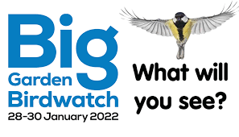
RSPB Big Schools Birdwatch
During the day today, the children have spent time in the school grounds as part of the RSPB Schools Birdwatch. The mild weather made for a perfect day of bird spotting as the children observed the variety of birds in our school grounds with their binoculars and marked them off on their clipboards. Year 3 told me that they had spotted starlings, blackbirds, house sparrows, magpies, woodpigeons, a robin and a pied wagtail.
You will find more information about the Birdwatch on every class page on our school website. Mrs Mccahey would like you to respond to the blog about your observations in your own garden or local park and children who participate in the Birdwatch will earn Children’s University credits.


Parents Evening - Tuesday 8th and Wednesday 9th February
With Coronavirus rates still high in St Helens, we are continuing to use School Cloud rather than face-to-face meetings with parents for our Parents Evening. The Spring Parents Evening will be held on Tuesday 8th February and Wednesday 9th February 2022 from 3.30pm– 7.00pm. Appointments can be made from 4.00pm Monday 31st January and will close at 4.00pm on Monday 7th February. Should you wish to make any changes after this date please contact the school office. Each appointment will last 10 minutes.
Once your slot is booked you will receive an email confirming your appointment/s. A letter with further details about how to access the system will be sent next week.
The weekend before the meetings, your child/ren will bring home a selection of their books for you to look at over the weekend. Books must be returned on the Monday morning for the children to use for their learning.


Crucial Crew
Our Year 5 children attended Crucial Crew at a venue in St Helens this morning. Crucial Crew is a multi-agency safety event aimed at Year 5 children designed to provide children with life skills that will enable them to keep themselves and others safe. Representatives from the Emergency Services and other local agencies delivered a diverse range of safety scenarios to raise the children’s awareness of threats and dangers, in a fun and interactive way. Many of the leaders there commented on the exceptional behaviour of the children, saying that they stood out amongst the other schools they have worked with. Well done to all of Year 5 for representing themselves and our school in such a mature and positive way.

Covid mitigations in school
As you know the Government has reverted to Plan A from 27 January. This week we have had 7 confirmed cases of Covid in school and as cases are still high in St Helens our existing mitigations in school will remain in place as regards mask wearing. All visitors and staff in school wear masks and all staff continue to LFT test twice per week. Thank you to those parents who also continue to test their children regularly and have kept children at home when they have tested positive.



Year Group | % Attendance for w/e 28.01.22
Reception | 95.43
Year 1 | 97.14
Year 2 | 97.71
Year 3 | 94.17
Year 4 | 96.86
Year 5 | 94.29
Year 6 | 86.00
Well done to Year 2 for the highest attendance this week!


Let the TT Rockstars Battles commence! Get your brains switched on and fingers at the ready for the next times tables challenge:
Year 3 v Year 6 Year 4 v Year 5
Battle commences on 27th January at 3:30pm and ends on Friday 9th February at 8pm. Only points earned between 6am and 8pm will count in the battles.

Eccleston Library – Chinese New Year Crafts
Our local library is holding a craft making session to celebrate the Chinese New Year. The session is on Tuesday 1st February at 3:30pm with lots of things to make and do in celebration of the Year of the Tiger!
Places are limited so booking is essential – please telephone 677575



St Julie’s Stars of the Week

Reception | Logan B
Year 1S | Danielle C
Year 1J | Sam B
Year 2 | Lucy B
Year 3 | Thomas H
Year 4 | Amelie H
Year 5 | Crucial Crew
Year 6 | Declan H

DIARY w/c 31st January 2022

MONDAY Comic Book club Y3 3.15-4.15 pm

TUESDAY Multi skills Year 2 3.15-4.15 pm

WEDNESDAY Spanish Year 1 3.15-4.15 pm
Gymnastics Year 4 3.15-4.15 pm
Science Year 2 3.15-4.15 pm
Science Club Year 5 3.15-4.15 pm
Young Voices Year 6 3.15-4.15pm

THURSDAY Swimming Year 5

FRIDAY



“A caring family school, where we learn, grow and walk in the footsteps of Jesus.”

St Julie pray for us, protect us and bless us.

