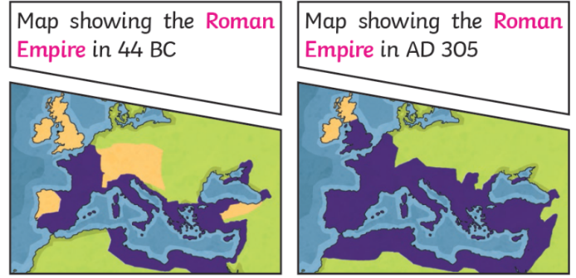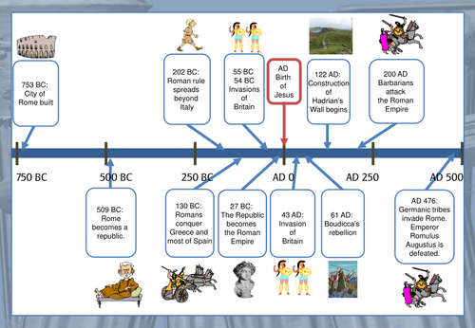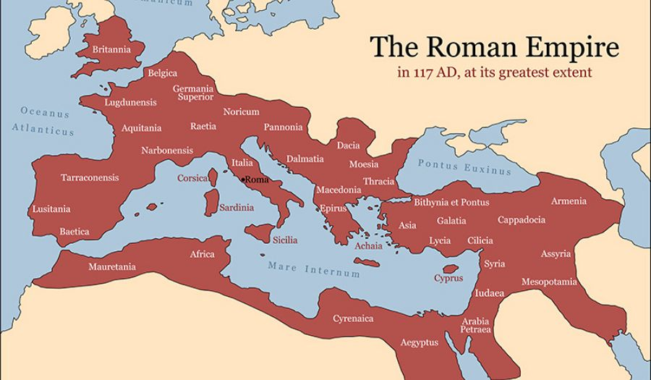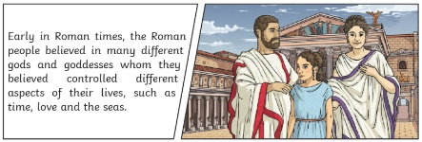

**Historical skills**

I can **understand** Roman beliefs and different ruling systems of Ancient Rome

I can **explain** why the Roman Empire expanded

**Sticky Knowledge**

Two brothers, Romulus and Remus, who were abandoned after they were born, created Rome.

Roman ruling systems changed from Kings, to a Republic then an Emperor.

The Roman Empire expanded across Europe and Africa and reached Britain in 42 AD.

The Romans created Public Baths to wash, relax and socialise.

Roman gladiators entertained the people in Amphitheatres such as the Coliseum in Rome.

Roman people believed in many Gods and Goddesses.

**What will I learn during this unit?**

1. To be able to describe how Rome was founded
2. To describe the Roman ruling systems
3. To understand how the Roman Empire expanded
4. To explain life as a Roman citizen
5. To research Roman entertainment (Gladiators)
6. To understand Roman religion and beliefs

|  |  |
| --- | --- |
| **Key Vocabulary** | |
| Paxa Romana | A period of 200 years when the Roman empire was very peaceful and rich. |
| Assassinate | To kill someone for political reasons. |
| Roman Empire | The name used for the land controlled by the Romans |
| Emperor | The leader of an empire |
| Republic | A government where the people are in charge, rather than the King. |
| Gladiator | A man trained to fight with weapons against other men or wild animals in an arena (Amphitheatre) |

**What should I already know?**

* Changes in Britain from the Stone age to the Iron age
* What a monarch/ruler is.