Dear parents and carers,

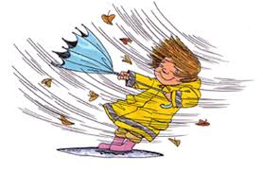
After a blustery start to this half term, torrential rain and then a day where we experienced what seemed like all four seasons in one day, the children have settled back into school life and are excited for book week and World Book Day next week!

Following the governments announcements on the changes to isolation, I have had a few parents asking about the advice for children coming to school with Covid symptoms. We have received the advice below and will follow this until we are told to change.

Should parents send their child to school if they think they have COVID-19?
If a child has any of the main symptoms or a positive test result, the public health advice remains unchanged and is to stay at home and avoid contact with other people.
Anyone with any of the main COVID-19 symptoms should order a test and is advised to stay at home while waiting for the result.
If they test positive, they are advised to follow public health advice.

Adults and children who test positive will continue to be advised to stay at home and avoid contact with other people for at least 5 full days and then continue to follow the guidance until they have received 2 negative test results on consecutive days.

We still have several cases of Covid in our school community (a total of 6 in school this week) so continue to do all we can to limit the spread of the virus and we appreciate your ongoing support with this.
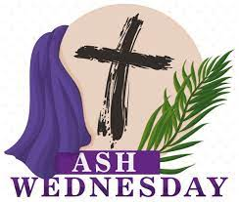
Ash Wednesday
On Wednesday 2nd March children in the Juniors will receive ashes in school to mark the beginning of Lent. Lent is the most important festival in the Christian Calendar and as a Catholic school this is very important to us.
Ash Wednesday marks the start of our Lenten journey through to the celebration of Easter. Please see the RE section on the school website and the tab “A journey through Lent” for activities and prayers for you and your child to share together.


Y5 Sacrament of Reconciliation
As you know a group of our Year 5 children were able to meet with Fr Philip in St Julie’s Parish Church to receive their first Sacrament of Reconciliation in January. Unfortunately, Fr Philip has been unable to meet with the children since due to unforeseen circumstances. We have now arranged with Fr that he will complete the First Confessions for Year 5 on March 4th and March 11th in school.

Year 4 sacrament of Reconciliation
As restrictions have now been reduced by the Archdiocese, Fr Philip is now able to return to the usual practice of the children making their First Confession in Church on a Saturday morning. Parents and carers are invited to bring their child to Church to make their confession on the morning of Saturday 5th March or Saturday 11th March between 9am and 2pm.
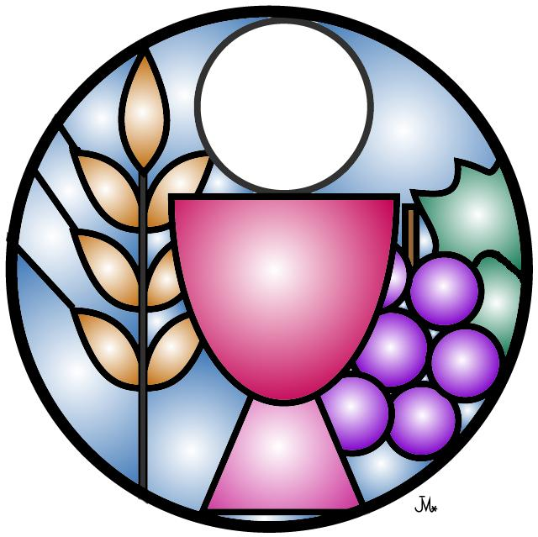
Year 4 and Year 5 Sacrament of the Eucharist
Letters were sent home with details of the Masses for First Holy Communion.
The First Holy Communion Mass for Year 4 will be on Saturday 11th June 2022.
The First Holy Communion Mass for Year 5 will be on Saturday 21st May 2022.
There will be 2 Masses at St Julie’s Parish Church on the day in order to accommodate the number of children and their families at 10 am and 1pm (split alphabetically by surname)
Please return the cut-off slip to school if you have not already done so.
Fr Philip has specified that for the Holy Communion Mass children should wear smart clothing such as shirt and trousers, a dress or traditional Holy Communion dress with shoes – no sportswear, casual clothing or trainers.



Year Group | % Attendance for w/e 25.02.22
Reception | 97.14
Year 1 | 92.29
Year 2 | 98.29
Year 3 | 98.33
Year 4 | 95.63
Year 5 | 90.29
Year 6 | 94.00
Well done to Y3 for the highest attendance this week!

St Julie’s Parish Church meeting
A message from Fr Philip:
“I am proposing to hold an open meeting in the parish hall for all who would like to come along. The purpose of this is to look to the future of the parish and how we can best work together to serve the community of Saint Julie’s. The proposed date for this meeting will be Tuesday 22nd March at 7pm. All are welcome.” Fr Philip

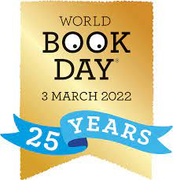
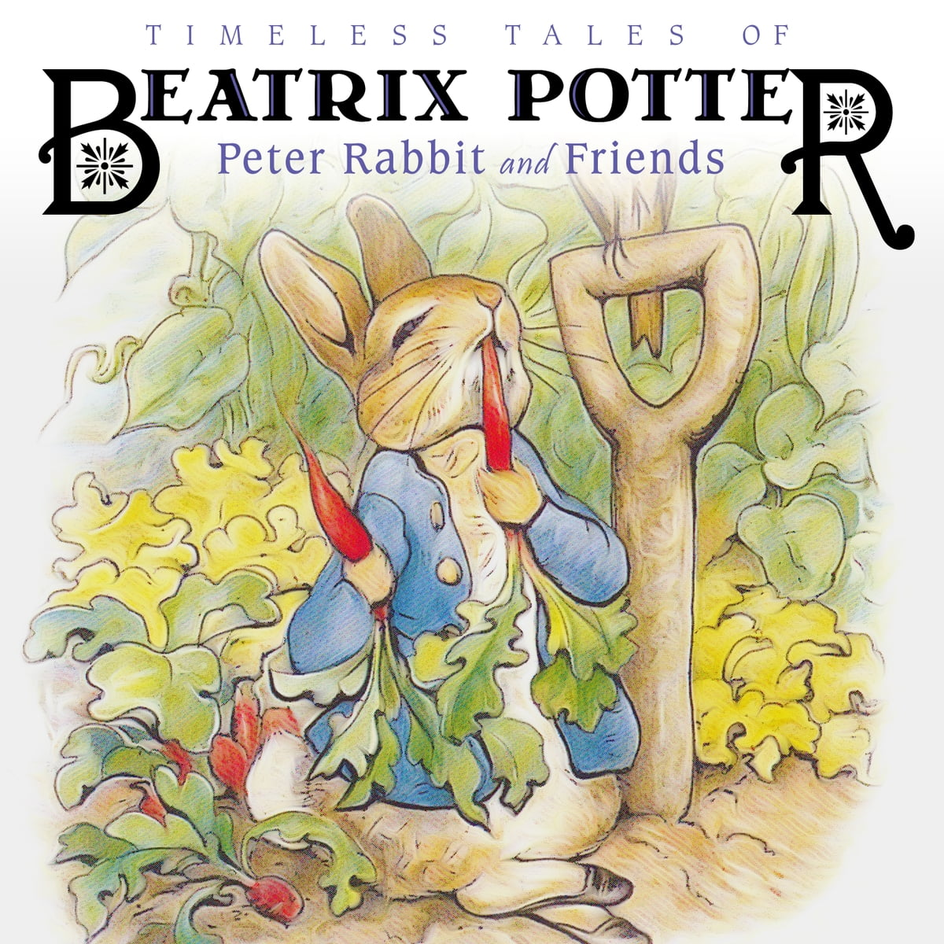
Book Week including World Book Day
At St Julie’s we celebrate our love of reading throughout the year but during the week commencing 28th February we will be holding a themed Book Week and joining the rest of the country in celebrating World Book Day 2022.
During the week children in KS2 will focus on William Shakespeare while children in KS1will look at the works of Beatrix Potter.
On Thursday 3rd March, World Book Day, the children will be thinking about their own favourite authors and can come to school dressed as a book character. If your child does not wish to dress up they should wear school uniform as usual.



The School Council have asked that we hold a book swap on Thursday so could each child bring in one book in good condition that they are happy to swap (forever!) for another book.


St Julie’s Science Fair
We are delighted to announce the return of our Science Fair. This has now become a traditional part of St Julie’s Science Week. The event will take place over two afternoons during National Science Week:
KS2: Monday 14th March
KS1 & Early Years: Wednesday 16th March
The children are encouraged to investigate an area of science of particular interest to them at their age appropriate level and present their findings to the school. Children may submit joint entries.
A certificate will be awarded to each entry reflecting a good understanding of the scientific principle under study. Children are encouraged to present their investigations in a creative way.
PLEASE NOTE: the science fair will take place during the school day and parents will not be able to attend. Therefore, children must be able to present their science investigation on their own. However, we are happy to accept photographic displays of the children doing an investigation at home together with an explanation of their findings.

Please complete the entry form attached with this bulletin (or ask your teacher for a form) and return to Mrs McCahey by Thursday 10th March.

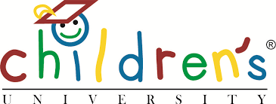
Children’s University Challenges
In assembly this morning I gave out certificates to children who had completed the holiday challenges set by the Children’s University. They will have their credits logged which will go towards certificates awarded by the University. Some of the challenges on the half term activity list would still be ideal for the children to complete and develop their knowledge:
Get Curious! Encourages children to research a female scientist of their choice and write a fact sheet about what they have learnt.
Get Fair! The children can complete an activity by watching a video from Fair Trade Foundation and complete the activity pack.
Get Safe! Work through videos from Childnet and take part in fun activities.
See the flyer attached or on the school website under Children tab – Children’s university. Send in evidence when completed to have it displayed in school and credits awarded.


St Julie’s Stars of the Week

Reception | Luke H
Year 1S | Dominic F
Year 1J | Nuala L
Year 2 | Thomas B
Year 3 | Harry G
Year 4 | Charlie L
Year 5 | Evan F
Year 6 | Georgia N

DIARY w/c 28th February 2022

Mr Gaynor will not be in school on Tuesday so there will be no guitar lesson this week.

Snacks
A reminder that break time snacks should be fruit or toast only. Thank you.

MONDAY Art club Y3 3.15-4.15 pm
NO Y6 Football due to staff absence
Indoor Athletics Y4 3:15 – 4:15pm

TUESDAY Multi skills Year 3 3.15-4.15 pm

WEDNESDAY Spanish Year 1 3.15-4.00 pm
Gymnastics Year 3 3.15-4.15 pm
Science Year 2 3.15-4.15 pm
Science Club Year 5 3.15-4.15 pm
Young Voices Year 6 3.15-4.15pm

THURSDAY World Book Day – dress as a book character; book swap
Year 6 Learning to work session 5

FRIDAY Y5 First Confession in school

SATURDAY Y4 First Confession at St Julie’s Church 9am – 2pm

Citizens Advice Uniform Cost Survey
Citizens Advice St. Helens are seeking the views of parents who are finding difficulty in providing school uniform for their children. They have designed this questionnaire to help them to better understand the impact that the cost of school uniform has on their everyday budgets.
http://sthelenscab.org.uk/school-uniform-survey/
All information and data collected will be confidential to Citizens Advice.

“A caring family school, where we learn, grow and walk in the footsteps of Jesus.”

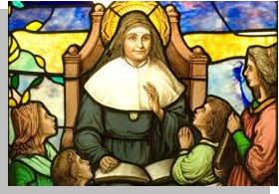
St Julie pray for us, protect us and bless us.

