Dear parents and carers,

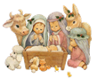
Nativity
Thank you to those who joined us this morning for our nativity in church. Year 2 performed the nativity beautifully and it was very emotional to at last be able to see the children perform in front of parents and grandparents. All the children sang their hearts out creating a wonderful atmosphere and bringing home the true message of Christmas.
Thank you also to those who came to listen to the Year 4, Year 3, Year 1 and Reception carols this week. All the children were enthusiastic to perform in front of a real audience and certainly put us all in the mood for Christmas. Thank you for keeping to the one adult per child and mask wearing, meaning we can do our best to keep everyone safe in these continually challenging times.

Year 5 have their Carol performance on Monday 20th December 2:45pm – We can invite one adult per child in the class into the school hall to be seated at a safe distance away from each other. The hall will be well ventilated and masks must be worn. Entrance to the hall will be via the main school entrance on Brooklands Road.

All performances will be recorded and made available via Teams as last year for all to enjoy.

Sponsored Santa dash – donations received so far £460. Thank you.

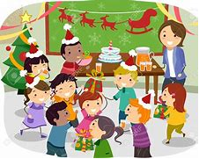
Christmas Party Days
A reminder that Monday is Christmas Party day for the Juniors and Tuesday is Christmas Party day for the infants. The children should come to school dressed in their party clothes but please remember that they will still be playing out at break and lunchtime so should be warmly dressed and have sensible footwear.
Party Lunch Boxes will be served at lunchtime to those who have ordered them.


Year Group | % Attendance for w/e 17.12.21
Reception | 92.86
Year 1 | 98.57
Year 2 | 97.43
Year 3 | 91.34
Year 4 | 96.25
Year 5 | 96.57
Year 6 | 87.14
Well done to Year 1 for the highest attendance this week!

The Golden Table
Each week in assembly a Lunchtime Supervisors Award and Mrs Finney’s Kitchen Award are presented to children who have shown outstanding behaviour and good manners during lunchtime. At the end of each half term their names go into a draw for a Golden Ticket.
On Thursday the winners of this half term’s Golden Tickets were invited to eat their lunch at the Golden table with special treats. Well done to the children - they certainly enjoyed their gold star treatment.
Thank you to all our lunchtime supervisors and kitchen staff who care for all the children, ensuring they are happy and well-fed at lunchtime.

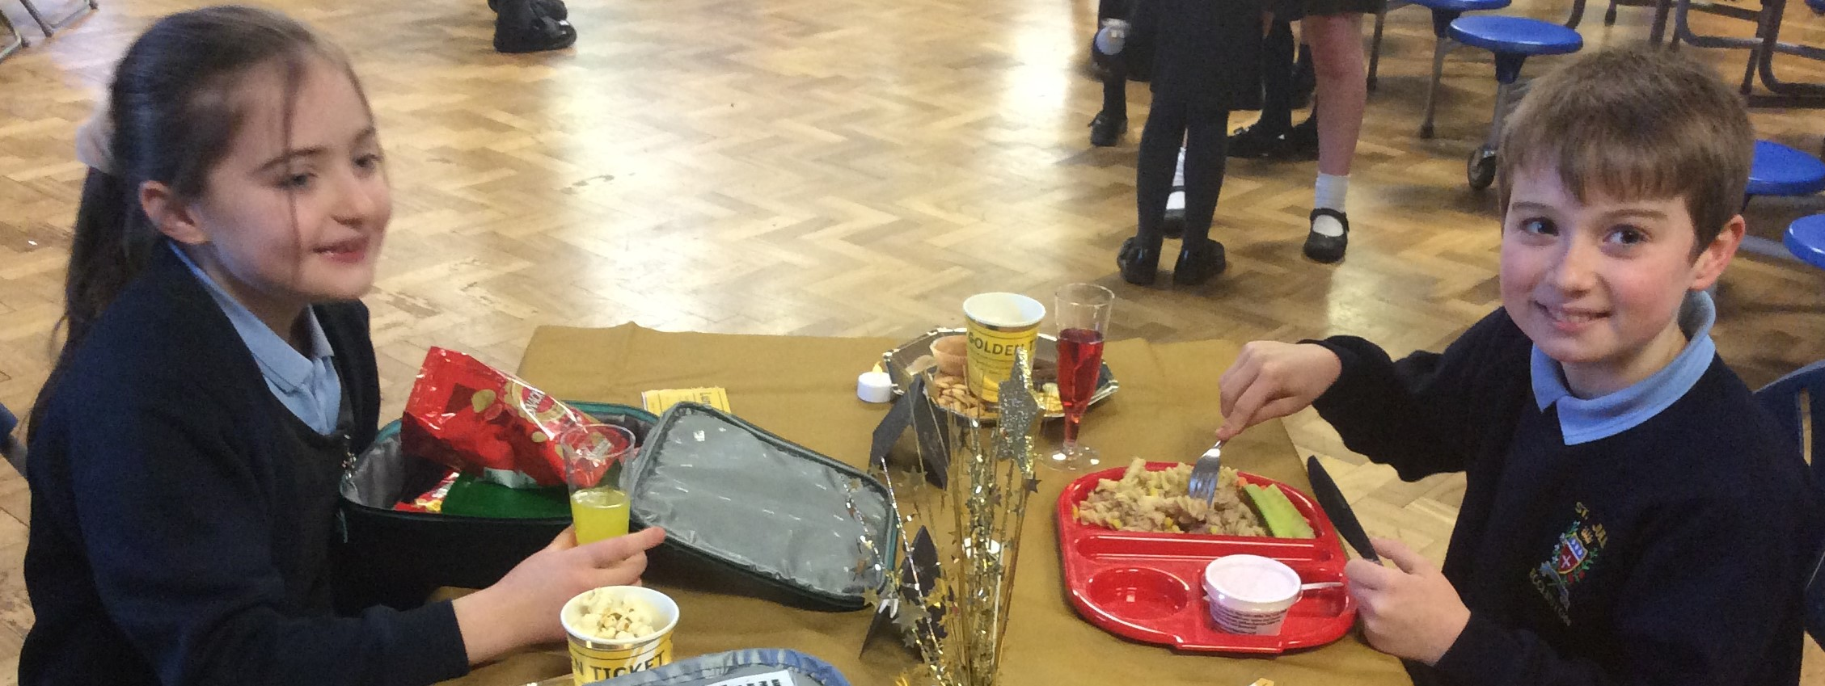

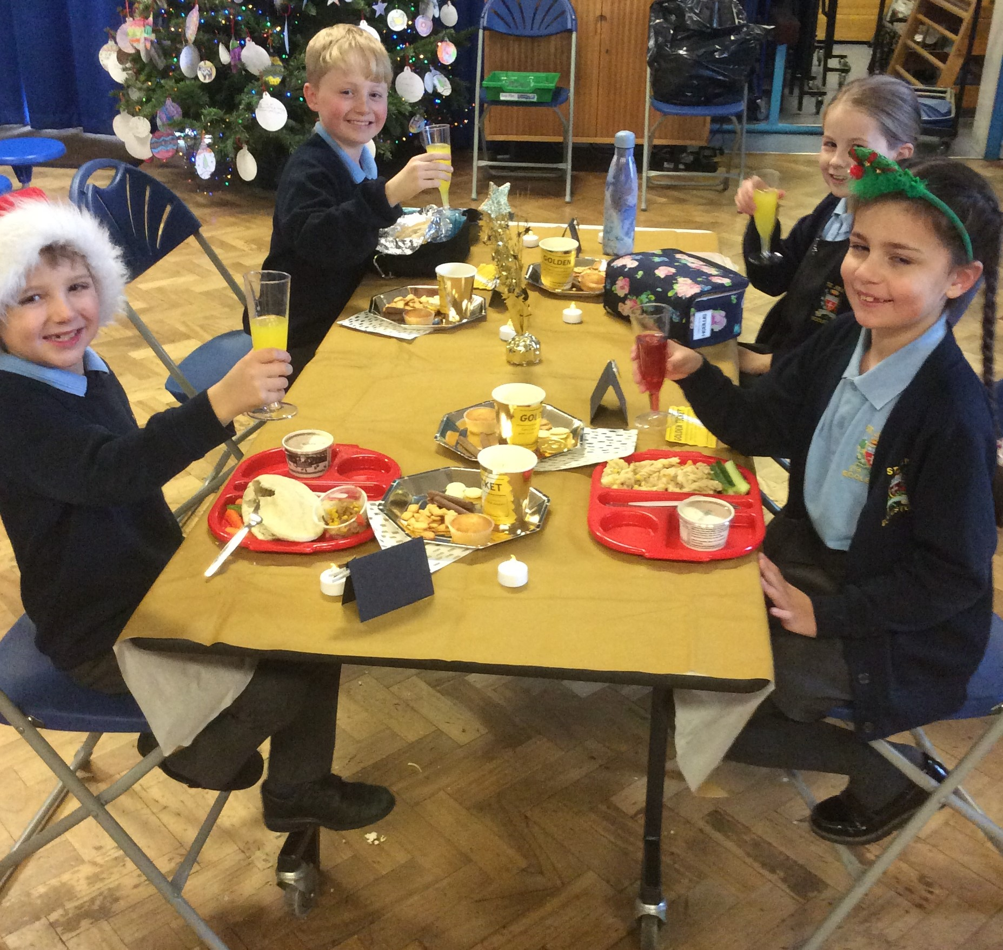
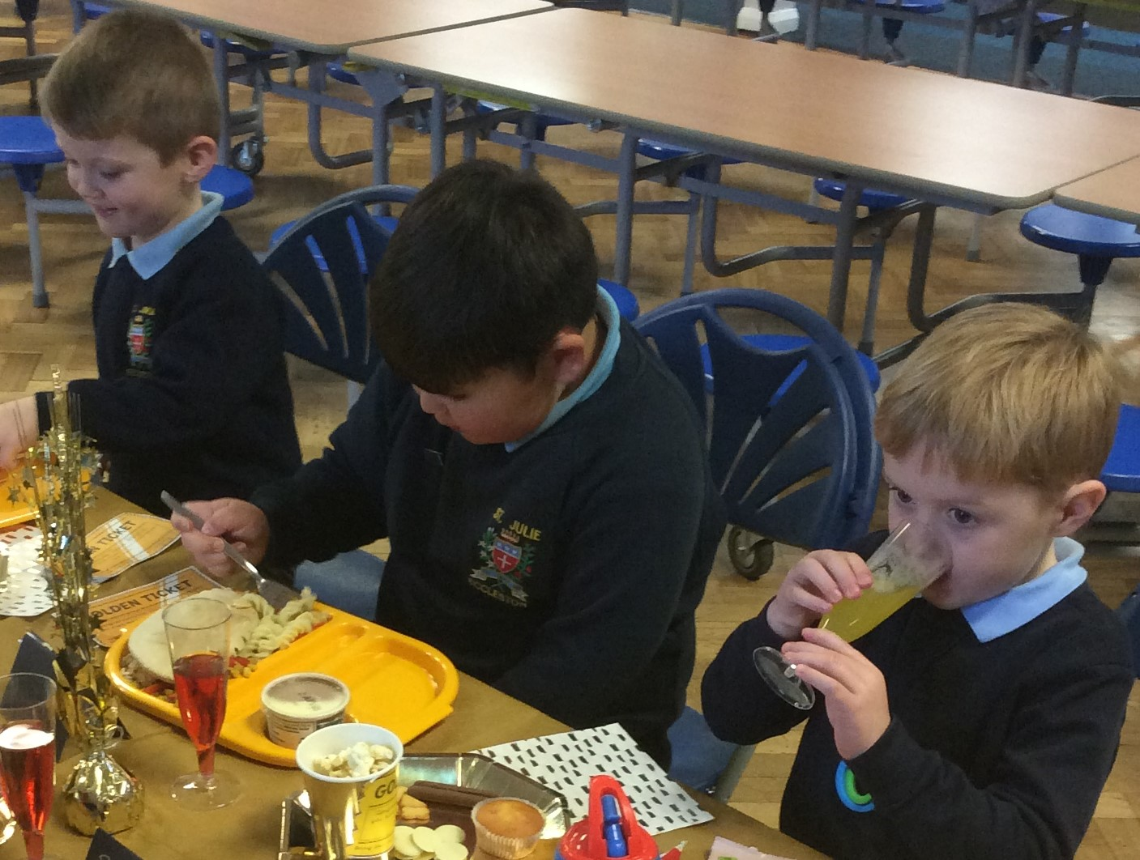

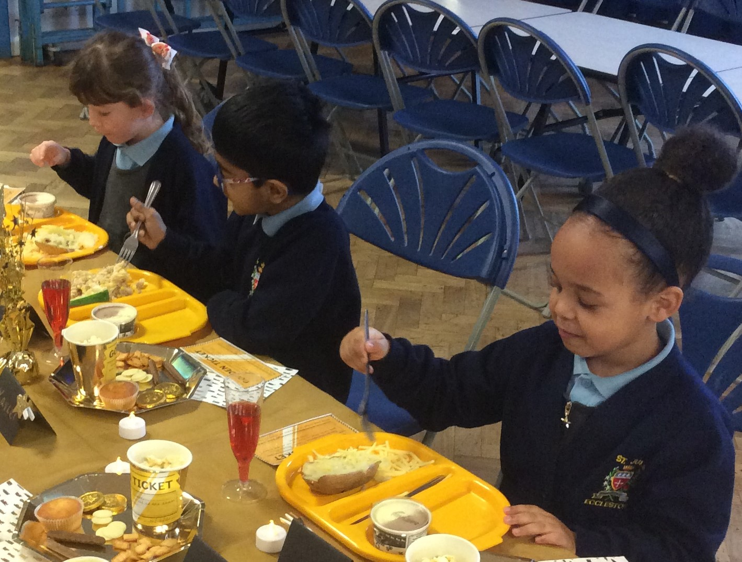

Why not share the pleasure of reading this Christmas?

Reading for pleasure opens up new worlds for children. It gives them the opportunity to use their imagination to explore new ideas, visit new places and meet new characters.
Reading for pleasure also improves children’s well-being and empathy. It helps them to understand their own identity and gives them an insight into the world and the views of others. Research shows that reading for pleasure can be directly linked to children’s success throughout their time at school and even into adulthood.

So what better gift can you give to your child this Christmas? There are recommended reading lists for all year groups on the school website on the Curriculum Page – Reading tab.


PFA Christmas fundraising events

Infant Christmas colouring competition
Thank you for all the entries received, the winners will be announced next week.

Reindeer Food and Reindeer Hot Chocolate treat bags are still on sale from the school office - £2 each or both for £3

Build A Bear raffle £3 per strip of tickets – please send money into school in an envelope with your child’s name and class on to be entered into the raffle draw.

Do you want to buy a Christmas story book? The author Kitty K came into school a few years ago to share her book “Is Christmas cancelled?” with the children. PFA have copies of the books to sell. They are only £5 and Kitty will donate £1 from every sale to the PFA. The link below is to the story. If you would like to buy a copy please send £5 in an envelope marked Christmas book on Monday.

https://m.youtube.com/watch?fbclid=IwAR3kdZIkAzSIlBe58xMQt-j2ZFbTtaDv60araVFVEB3mKb8qN1M64dlTpIY&v=Z43NEDbndQg&feature=youtu.be


Winter Challenge 2021 – Children’s University
During the Christmas holiday, children can earn credits for Children’s University by completing activities at home. There are 6 activities ranging baking festive treats to writing a Christmas story. The Challenge sheet is attached with this bulletin or please see the Children’s University tab on the website for details of all the activities and how to submit the work for accreditation. I really enjoyed seeing the wonderful entries from the Autumn challenge and their photos and work is displayed in school!
You will also find a link below to the Children’s University Home Learning Portal, full of activities, virtual masterclasses and seasonal activities that children can access and gain additional credits.
https://bit.ly/CUHomelearning

TTRockstars Battle results are in...

Year 3 11, 421 v Year 5 9,713 Year 4 2,991 v Year 6 8,107



St Julie’s Stars of the Week

Reception | Everyone for their first Christmas performance!
Year 1S | George Mc
Year 1J | Jaxon
Year 2 | Lucy B
Year 3 | Lexi-Mai B
Year 4 | Thomas J
Year 5 | Bree K
Year 6 | Eva F

Diary w/c 20.12.2021
Monday Junior Christmas Party
2:45pm Y5 Carols – 1 adult only – Main school entrance

Tuesday Infant Christmas Party
School closes for Christmas break

Further dates for your Diary
Wednesday 5 January 2022 - School reopens for Spring term
Thursday 6 January 2022 - Year 5 swimming lessons – Queens Park
Tuesday 11 January 2022 - School photographer
Thursday 13 January 2022 - Year 6 learning to Work programme session 4
Thursday 13 January 2022 - Year 5 Sacramental Programme Parish Hall 6:30 – 7:30pm
Friday 21 January 2022 - Sacrament of Reconciliation for Year 5 in school
Friday 28 January - Y5 Crucial Crew – St Helens Masonic Hall
Thursday 27 January 2022 - Year 4 Sacramental Programme Parish Hall 6:30 – 7:30pm
Friday 4 February 2022 - Sacrament of Reconciliation for Year 4 in school
Tuesday 8 February - Young Voices concert
Thursday 10 February - School closes for half-term
Monday 21 February - School reopens.
Thursday 24 February 2022 - Year 5 Sacramental Programme Parish Hall 6:30 – 7:30pm
Thursday 10 March 2022 - Year 4 Sacramental Programme Parish Hall 6:30 – 7:30pm
Saturday 21 May 2022 - First Holy Communion Mass for Year 5
Saturday 11 June 2022 - First Holy Communion Mass for Year 4

The staff and Governors wish you a very Happy and Peaceful Christmas and thank you for all your support throughout the year.


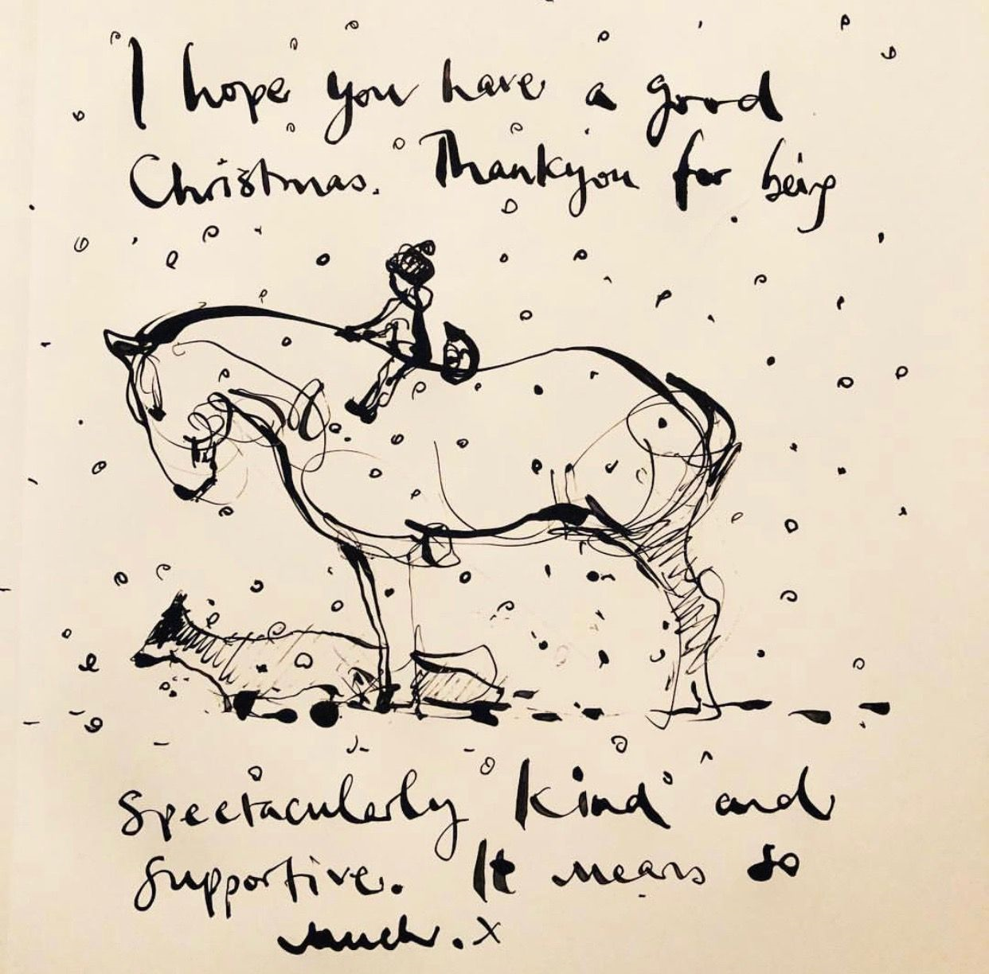

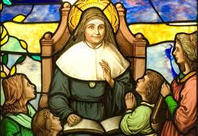
“A caring family school, where we learn, grow and walk in the footsteps of Jesus.”

St Julie pray for us, protect us and bless us.

ACCESSING COVID-19 TESTING IN ST HELENS
Symptomatic testing and testing for close contacts
PCR tests can be booked at any of the NHS sites that operate Monday – Sunday 8am – 8pm on the gov.uk website https://www.gov.uk/get-coronavirus-test
PCR tests for home delivery can also be ordered by calling 119.

COVID Updates
In line with the new Government recommendations published on the 14th December, the following guidelines should be followed. These guidelines replace all previous recommendations:
• All adults who are fully vaccinated and children aged 5 to 18 years and 6 months, identified as a contact of someone with COVID-19 – whether Omicron or not – should take a lateral flow device (LFD) test every day for 7 days instead of self-isolating. Daily testing by close contacts will help to slow the spread of COVID-19 and protect education settings—allowing schools to continue to deliver face to face education.
• All Lateral Flow Test results should be reported through the online reporting system. School should also be informed of the result.
• If any family members test positive, they should self-isolate and order a PCR test to confirm the result. If the PCR is positive, they must self-isolate for 10 days and close family members are encouraged to take a PCR.
• Lateral Flow tests are available through community test sites, local pharmacies or online.

