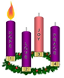
Advent
This Sunday marks the start of Advent and the children will begin their Advent journey in school next week. Advent is a time of preparation, reflection and welcoming Jesus

into our lives. It is a great time for the family to spend time at home thinking of all they have to be grateful for and praying together for their hopes for the future.
Please see the RE tab on the website for more Advent activities and the RE newsletter.

Christmas is coming!
We are going all out this year to ensure the children have a fabulous Christmas time in school and started this week with the arrival of THREE wonderful Christmas trees generously gifted by the PFA.
There is a tree in the school hall for the children to decorate with their Christmas wishes and one that can be seen at each gate which will be lit for friends and family to enjoy at drop off and pick up times.
Please see the letter attached for details of all the Christmas events we have planned for the next few weeks.

Christmas events
As you know the rates of Coronavirus are still high in St Helens and we are being encouraged to remind everyone to keep testing and to stay safe by trying to reduce the risk of spreading the virus.
At St Julie’s we want to carry on with as many of our Christmas activities as possible and offer parents the opportunity to join in some of the celebrations, however we do have to do this in as safe a way as possible so that families and all our staff can stay well for the Christmas period.
With this in mind it is our plan at this stage for each class in KS2 and Year 1 and Reception to perform a short performance of Christmas Carols. The class performances will be at the end of the day – 2:45pm just before the children are collected from school.
We can invite one adult per child in the class into the school hall to be seated at a safe distance away from each other. The hall will be well ventilated and masks must be worn.
The performance will be recorded and made available via Teams as last year for all to enjoy.
Thursday 9th December 2:45pm - Year 6
Monday 13th December 2:45pm - Year 1
Tuesday 14th December 2:45pm – Year 4
Wednesday 15th December 2:45pm – Year 3
Thursday 16th December 2:45pm – Reception
Monday 20th December 2:45pm – Year 5
Please note that plans may change in response to the local COVID-19 situation and rising infection rates.

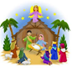
Year 2 Nativity
As Year 2 have always traditionally performed our Nativity, we plan for them to present this in
St Julie’s Church on Friday December 17th at 10am. As the Church is more spacious than our school hall, we will be able to invite two adults per child in the class. Masks will need to be worn and we ask that adults maintain a safe distance from other adults inside the church to minimise the risk of the spread of infection. We will need to clean the church after the Nativity so ask that the toilets are not used. The Year 2 Nativity will be recorded and made available for all to enjoy via Teams.
Please note that plans may change in response to the local COVID-19 situation and rising infection rates.


Junior Road Safety Officers
This week our newly appointed Junior Road Safety Officers (JRSO) from Year 5 attended a welcome event at the Town Hall. Noah B and Bree represented our school well in sharing their ideas of how we can keep ourselves safe and will be working on projects along with the Year 6 JRSOs.
On Tuesday the Road Safety Team will be in school to talk to Reception, Year 4 and Year 6.

Author visit
On Wednesday afternoon EYFS and KS1 enjoyed a visit from Sean Perkins a local author who specializes in children's picture books. Sean enjoyed sharing his second book entitled 'Oscar and Ben' with all of the children. The book is specifically aimed at KS1 and early years readers. If you would like to purchase Sean’s book ‘Oscar and Ben’ the price will be £7 and they are available at the school office (see separate letter regarding the purchase of the book)
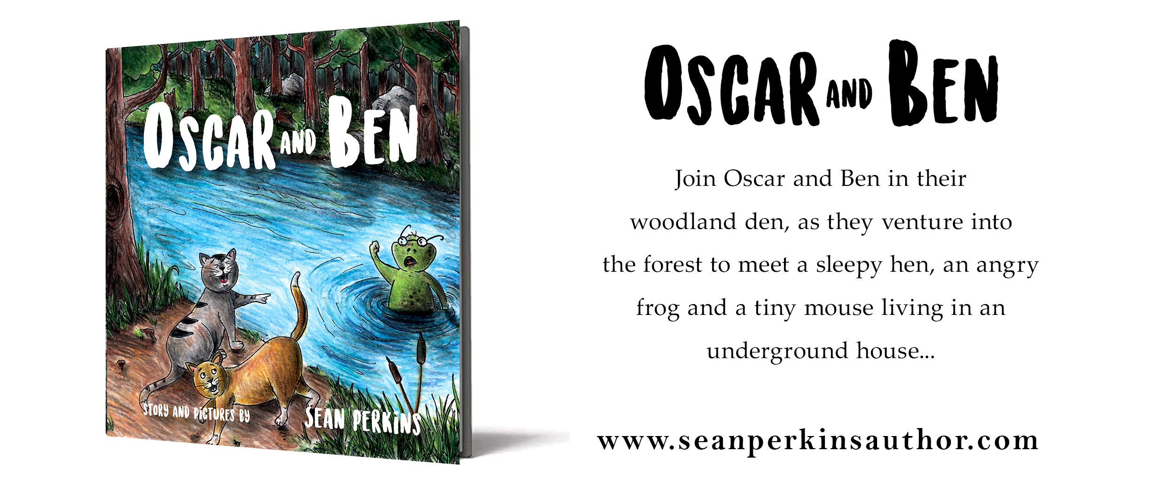
Christmas cards
As you know we are trying to minimise the possible transmission of the virus. With this in mind we ask that this year the children do not bring in Christmas cards to be distributed to their friends in class.

Year 5 and Year 4 Sacramental programme
As the With You Always programme is taking part close to the run up to Christmas this year and with increased Covid numbers in the area, Mrs Mccahey has said that she will carry out this week’s session with the children in class. This way school can support the parish and families in an area that is central to our faith at this time. The parent booklet will be sent home with the booklet completed by your child in school so that you can still discuss and share the content with your child. Meetings will continue with the Fr Philip and the Catechists in the new year.

Children In Need
Thank you for your donations, £178.00 was raised via School Money which will be sent off to the charity.



Year Group | % Attendance for w/e 26.11.21
Reception | 93.43
Year 1 | 87.71
Year 2 | 95.14
Year 3 | 98.61
Year 4 | 94.06
Year 5 | 92.86
Year 6 | 95.14
Well done to Year 3 for the highest attendance this week!

Christmas Dinner
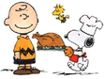
That time of year is nearly upon us! Christmas dinner will be on Wednesday 15th December but orders need to be placed in advance. If any junior child who normally has a packed lunch would like to have a Christmas dinner, please pay £2.50 via school Money from next Monday. If your child is in the infants, there is no charge but we ask that you email school as soon as possible, for catering purposes. Deadline for orders is Friday 3rd December.

Illness
We have been informed that a number of children in schools have tested positive after an episode of vomiting. Can we advise that if your child has an episode of vomiting or diarrhoea they have a Lateral Flow Test or PCR before returning to school. Following any incidence of diarrhoea and/or vomiting the period to be kept away from school is 48 hours from the last episode of diarrhoea or vomiting. If your child is feeling unwell, we would encourage considering a lateral flow test.
We encourage parents to continue to test families twice per week using the Lateral Flow Test kits. Please report the result of all tests whether negative or positive on the Government Report a Test website as this helps to give a picture of the uptake of local testing. Regular testing helps to keep the staff and children in school safe.


Pieces of silver Christmas challenge
29th November – 10th December

Which class can raise the most money in 2 weeks?

Bring in your pieces of silver (or even gold) to fill the treasure box and the winning class will receive a treat for each child.

The Big PTA Christmas Raffle – this is now live, thank you to those who have bought tickets.
St Julie’s PFA have registered with the Parentkind PTA raffle to raise money for your children in school. Please see the leaflet attached to follow the link to buy tickets.
Just one £3 ticket enters you into 12 draws – 12 chances to win up to £5,000! The PFA gets 50% commission from every ticket sold.

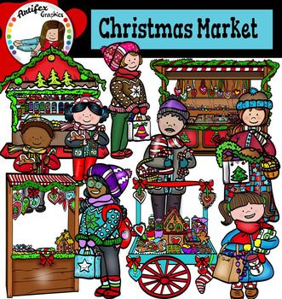
PFA Christmas Fayre
Unfortunately, as mentioned above, as transmission rates of Covid continue to rise in St Helens schools have been advised that at this time they should avoid holding gatherings which meant that the decision had to be made to cancel the planned Christmas Fayre in the Parish Hall.
But do not worry, the PFA will bring the Christmas Fayre to you!
26th November – 13th December: St Julie’s PFA Virtual Christmas Book and Gift Fair
You can visit the virtual fundraising fair to view products, make your choice, pay online and arrange delivery all from the comfort of home – and raise funds for school at the same time.
You can access the site now to browse https://stjulieprimary.thegiftfamily.co.uk/


Easyfundraising By downloading this app you can collect FREE funds for St Julie’s every time you shop online!
Just visit easyfundraising.org.uk, search for St Julie Catholic Primary PFA and follow the simple steps to sign up. Then start shopping using the links to over 2,000 retailers including Amazon, John Lewis, M&S, Argos, Next, ASOS and many more. Every time you shop, you’ll earn a donation for the school at no additional cost to you! Start donating as you do your Christmas shopping!
Church car park – drop off and pick up
Fr Philip has asked that parents do not park in the bays marked with a C when dropping off and picking up children at school. On several occasions his car has been blocked in the garage when he has urgent calls to make. Please pass this message to whoever takes your child to and from school. Thank you.


Parking
For the safety of children and other road users please do not park on the junction of Acacia Grove and Brooklands Road – this causes a narrowing of the road at the junction. Do not stop here to drop children off even for a few moments. There is plenty of parking further up and down Brooklands Road. I have also been asked by a resident of Acacia Grove to ask parents to be respectful of the people who live in this road by not parking across their drive ways.

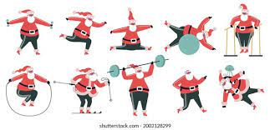
School Games Christmas Challenges
The School Games Physical Activity Advent Calendar has lots of ideas about how we can all be fit and healthy in the run up to Christmas. The Advent calendar has ideas for in school that teachers will be using along with suggested activities for families to do together at home, including a walk around the neighbourhood to see all the Christmas decorations, decorating your bike/scooter with tinsel for a festive ride, links to Christmas songs to get the family dancing and many more fun ideas. The Physical Activity Calendar has been emailed with this bulletin or can be seen on the school website under children/sports/sports reports.



St Julie’s Stars of the Week

Reception | Noah C
Year 1S | Olivia P-A
Year 1J | Ben M
Year 2 | Imogen K
Year 3 | Isla R
Year 4 | Heidi D
Year 5 | Daniel L
Year 6 | Thomas W

Diary w/c 29.11.2021
Monday Reception visit to Eccleston Library
Christmas Tree lighting in school
Y4 Garage band 3:15 – 4:15

Tuesday Y5 Forest School day (warm clothes and wellingtons)
Road safety talk in school – reception, Y4 and Y6
Y6 Table Tennis 3:15 – 4:15

Wednesday Y5 walk to Christ Church, Eccleston war graves.
Y2 Spanish 3:15 - 4:00
Forest School club 3:15 – 4:15
Young Voices choir 3:15 – 4:15
Thursday Y5 Board Games and Lego 3:15 - 4:15
Y3 Board Games and Lego 3:15 - 4:15

Friday

Further dates for your Diary
Thursday 9th December - Year 6 Learning to work – session 3
Friday 10th December - Christmas Jumper day and Santa Dash
Monday 13th December - Christmas Craft day in school
Wednesday 15th December - Christmas Dinner
Friday 17th December - Year 5 trip to the Imperial war Museum
Tuesday 21st December - School closes for Christmas break

Wednesday 5th January 2022 - School reopens for Spring term
Thursday 13 January 2022 - Year 5 Sacramental Programme Parish Hall 6:30 – 7:30pm
Friday 21 January 2022 - Sacrament of Reconciliation for Year 5 in school
Thursday 27 January 2022 - Year 4 Sacramental Programme Parish Hall 6:30 – 7:30pm
Friday 4 February 2022 - Sacrament of Reconciliation for Year 4 in school
Thursday 24 February 2022 - Year 5 Sacramental Programme Parish Hall 6:30 – 7:30pm
Thursday 10 March 2022 - Year 4 Sacramental Programme Parish Hall 6:30 – 7:30pm
Saturday 21 May 2022 - First Holy Communion Mass for Year 5
Saturday 11 June 2022 - First Holy Communion Mass for Year 4

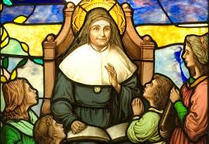
“A caring family school, where we learn, grow and walk in the footsteps of Jesus.”

St Julie pray for us, protect us and bless us.


