Dear Parents/Carers,
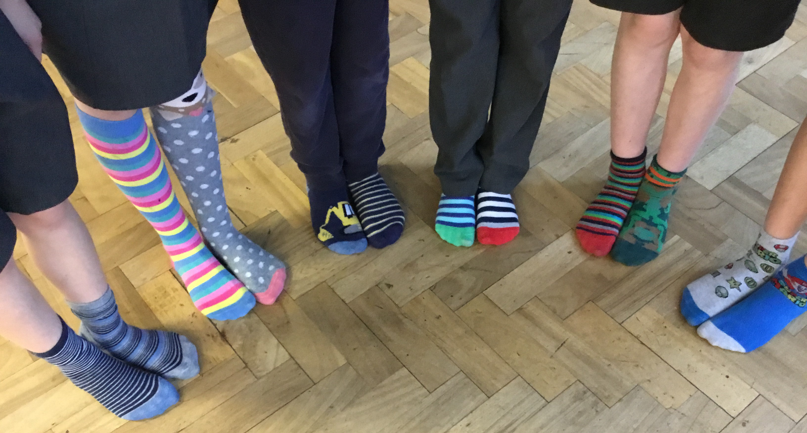
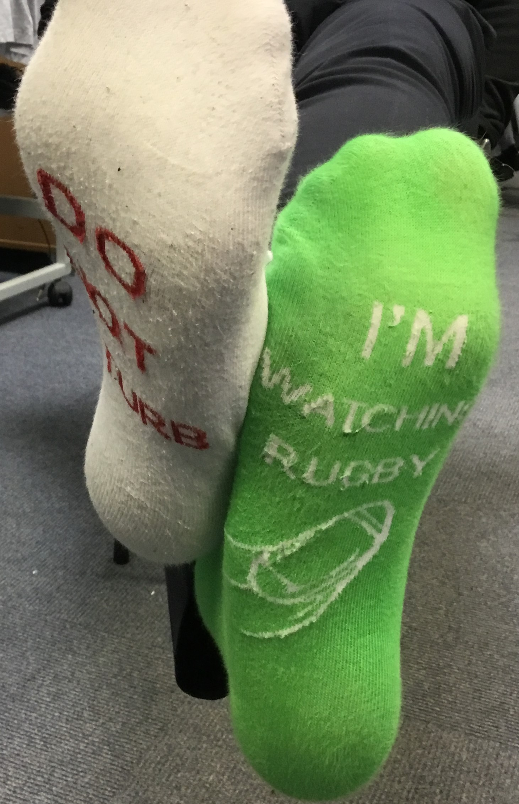
Anti-bullying week – wear Odd Socks to school on Monday
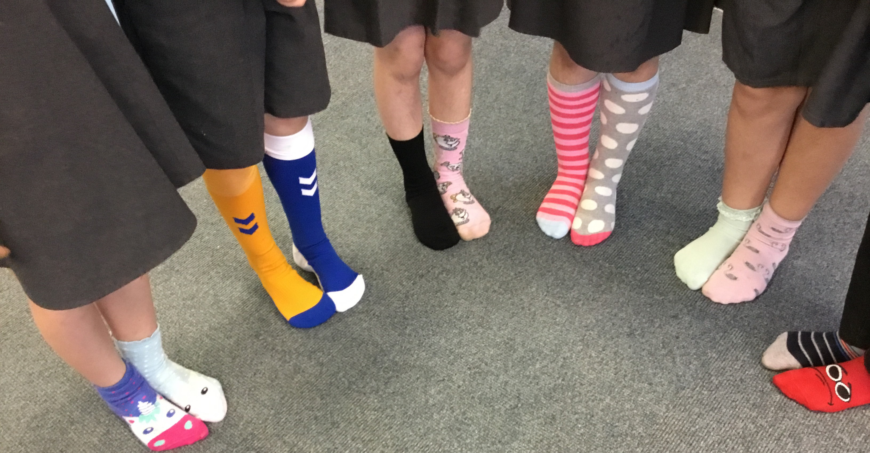
We started our week with Odd Socks Day in school and having shared the book, “Felix the Fox and his awesome odd socks” the children talked about how it is ok to be different and how we respect each other’s differences. The story reminded everyone about how to be a good friend and to celebrate that we are all unique. During the week the children thought about what bullying is and focused on STOP – Several Times On Purpose.
With this year’s theme for national Anti-Bullying Week 2021 being One Kind Word the children have eagerly been sharing their kind words.

Children in Need

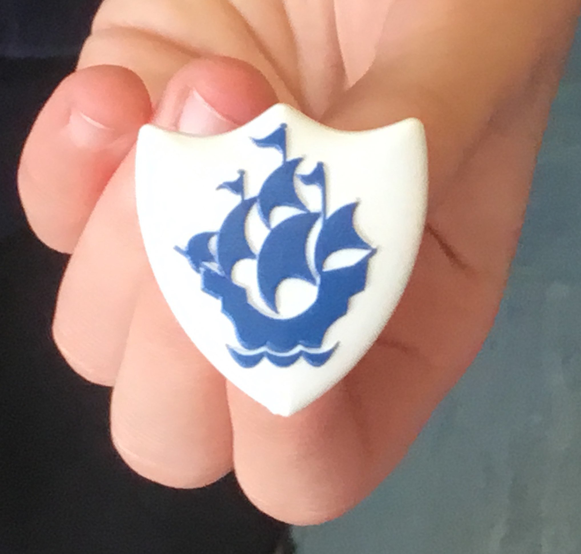
The children enjoyed wearing their spotty clothes and accessories today and were able to talk about how they were raising money for children around the country who would benefit from support for lots of different reasons. As always, your children are thoughtful and caring for those around them. Thank you for the donations received today which will be sent on to the charity. Donations for Children in Need can still be made via School Money.
Congratulations to Holly from Year 6 on her live performance on Blue Peter yesterday. In assembly this morning she gave us an insight into behind the scenes at the BBC and she received an actual Blue Peter badge! Well done Holly!


Year Group | % Attendance for w/e 19.11.21
Reception | 94.57
Year 1 | 86.57
Year 2 | 98.86
Year 3 | 95.56
Year 4 | 92.50
Year 5 | 98.00
Year 6 | 91.71
Well done to Year 2 for the highest attendance this week!

Illness
We have been informed that a number of children in schools have tested positive after an episode of vomiting. Can we advise that if your child has an episode of vomiting or diarrhoea they have a Lateral Flow Test or PCR before returning to school. Following any incidence of diarrhoea and/or vomiting the period to be kept away from school is 48 hours from the last episode of diarrhoea or vomiting. If your child is feeling unwell, we would encourage considering a lateral flow test.
We encourage parents to continue to test families twice per week using the Lateral Flow Test kits. Please report the result of all tests whether negative or positive on the Government Report a Test website as this helps to give a picture of the uptake of local testing. Regular testing helps to keep the staff and children in school safe.

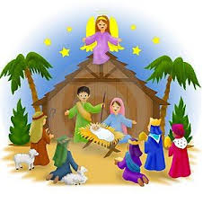
Christmas events
As you know the rates of Coronavirus are still high in St Helens and we are encouraging everyone to keep testing. Obviously, we want to minimise the spread of the virus whilst also making sure we can carry on with as many of our Christmas activities as possible and offer parents the opportunity to join in some of the celebrations. Information on our Christmas events will be emailed to you during next week.


The Big PTA Christmas Raffle – this is now live, thank you to those who have bought tickets.
St Julie’s PFA have registered with the Parentkind PTA raffle to raise money for your children in school. Please see the leaflet attached to follow the link to buy tickets.
Just one £3 ticket enters you into 12 draws – 12 chances to win up to £5,000! The PFA gets 50% commission from every ticket sold.

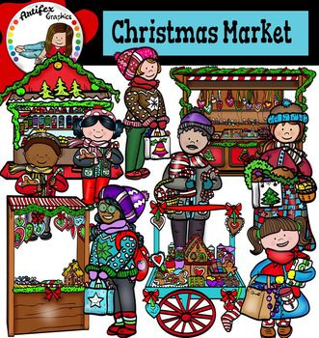
PFA Christmas Fayre
Unfortunately, as mentioned above, as transmission rates of Covid continue to rise in St Helens schools have been advised that at this time they should avoid holding gatherings which meant that the decision had to be made to cancel the planned Christmas Fayre in the Parish Hall.
But do not worry, the PFA will bring the Christmas Fayre to you!
26th November – 13th December: St Julie’s PFA Virtual Christmas Book and Gift Fair
You can visit the virtual fundraising fair to view products, make your choice, pay online and arrange delivery all from the comfort of home – and raise funds for school at the same time.
You can access the site now to browse https://stjulieprimary.thegiftfamily.co.uk/

Flu immunisations
The school nursing team were in school yesterday to administer the nasal spray in school to children whose parents had given online consent. The nursing team worked from the lists that they had; school was not involved in any of the administration. The nurses advised me that there are drop in clinics for any child who has missed having their flu vaccine.
Drop in Flu Vaccine clinics details:
Friday 17th December, Monday 20th December, Tuesday 21st December.
Clinic times as follows:- 9:30am - 12:30pm & 13:10pm - 15:30pm.
Ashtons Green Clinic
Ashtons Green Drive
Parr
St Helens
WA9 2AP
Tel:- 01744 624353

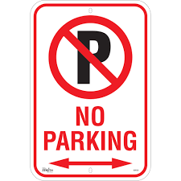
Parking
For the safety of children and other road users please do not park on the junction of Acacia Grove and Brooklands Road – this causes a narrowing of the road at the junction. Do not stop here to drop children off. There is plenty of parking further up and down Brooklands Road. I have also been asked by a resident of Acacia Grove to ask parents to be respectful of the people who live in this road by not parking across their drive ways.



St Julie’s Stars of the Week

Reception | Jacob M
Year 1S | Lucas W
Year 1J | Liberty-Rose B
Year 2 | Molly T
Year 3 | Phoebe H
Year 4 | Alfie H
Year 5 | Louie L
Year 6 | James M

Diary w/c 22.11.2021

Monday Y4 Garage band 3:15 – 4:15
Governors’ Finance Committee 4:30pm
Governors’ Curriculum Committee 5:00pm

Tuesday Author Visit in school KS1
NO Table tennis due to PE staff meeting

Wednesday Y2 Spanish 3:15 - 4:00
NO Forest School club – staff absence
NO Young Voices choir – staff absence
Thursday Y5 Board Games and Lego 3:15 - 4:15
Y3 Board Games and Lego 3:15 - 4:15
Friday

Further dates for your Diary
Thursday 2 December - Year 5 Sacramental Programme 6:30 – 7:30pm
Thursday 16 December - Year 4 Sacramental Programme 6:30 – 7:30pm
Thursday 13 January 2022 - Year 5 Sacramental Programme Parish Hall 6:30 – 7:30pm
Friday 21 January 2022 - Sacrament of Reconciliation for Year 5 in school
Thursday 27 January 2022 - Year 4 Sacramental Programme Parish Hall 6:30 – 7:30pm
Friday 4 February 2022 - Sacrament of Reconciliation for Year 4 in school
Thursday 24 February 2022 - Year 5 Sacramental Programme Parish Hall 6:30 – 7:30pm
Thursday 10 March 2022 - Year 4 Sacramental Programme Parish Hall 6:30 – 7:30pm
Saturday 21 May 2022 - First Holy Communion Mass for Year 5
Saturday 11 June 2022 - First Holy Communion Mass for Year 4

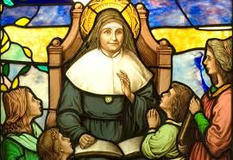
“A caring family school, where we learn, grow and walk in the footsteps of Jesus.”

St Julie pray for us, protect us and bless us.

