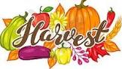
Harvest Service
At this time of year we take time to reflect on the nutritious food that we have readily available to us and give thanks to God.
Unfortunately, due to the continued high numbers of people affected by Covid in our area we are unable to invite parents to join us for our Harvest celebration. However, we will be taking the children up to St Julie’s Church for a short service of praise and thanksgiving. We are excited to be able to visit the church again as a school family after such a long time.
The infants will celebrate the Harvest at 10:30am followed by the Juniors at 11:00am.
We would be very grateful for donations of tinned and dried food products which we will then be taken to the St Helens Foodbank and Teardrops. Please send in donations from Monday – see list of suggested items on the last page of this bulletin. Thank you.

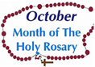
Month of the Rosary
This week Year 3 received a visit from two members of the Walsingham Association in St Julie’s Parish to talk to them about how to pray the Rosary and to reflect on the Mysteries which tell the story of Mary and her son Jesus. The children were each given a prayer card to take home.

Spanish Day
The children looked fabulous on Wednesday in their Spanish costumes and red and yellow clothes! They thoroughly enjoyed learning more about the Spanish culture and tasting a range of Spanish food. If you want to create your own Spanish night at home these are some of the foods they were invited to try:
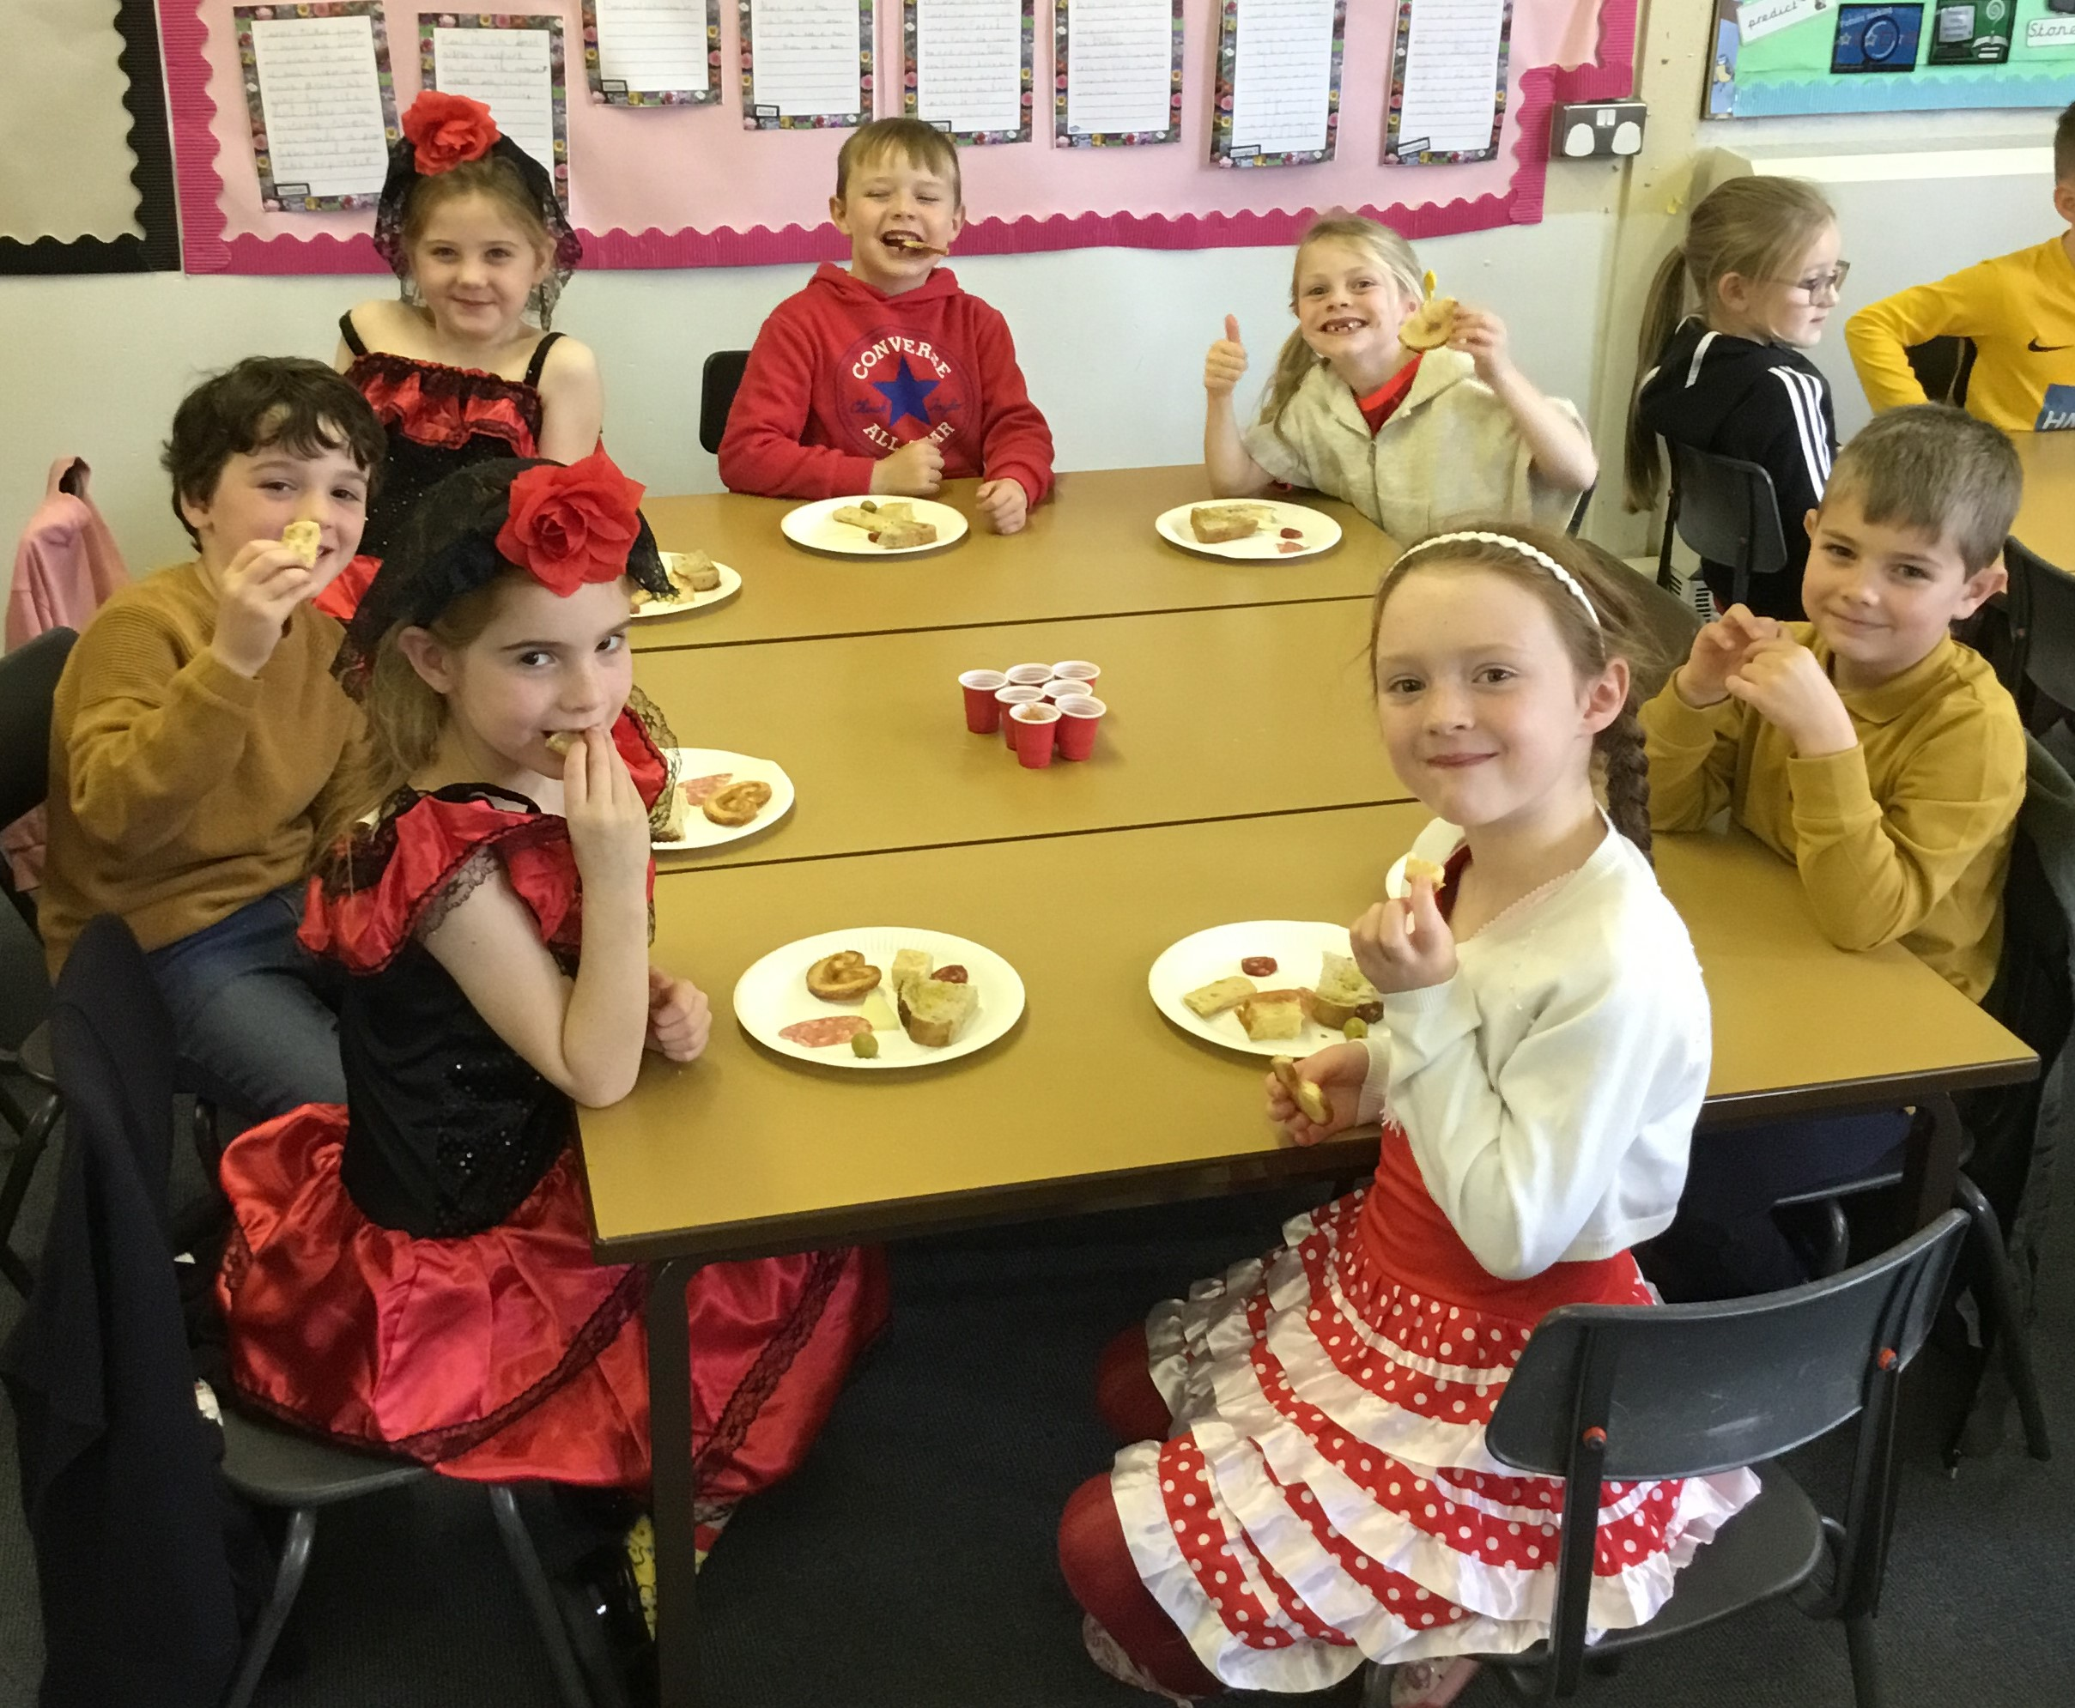
bread with olive oil and sugar (pan con aceite de oliva y azúcar)
olives (plain green and with anchovies) (aceitunas)
cured Spanish meats (chorizo and salchcion)
Spanish cheese (manchego)
Spanish omelette (Tortilla Espanola)
Spanish breadsticks with sesame seeds (palitos de pan)
gazpacho (cold tomato soup)
Spanish biscuits (Palmeritas)

Thank you to Señorita Ana, our Spanish teacher, and Mrs Mannion for organising the event.


A visit from the Dentist!
The children in Reception had a visit on Thursday from Mrs Stead the Dentist. They learnt all about the importance of brushing their teeth twice a day and had lots of ideas about what foods were healthy and good for their teeth.

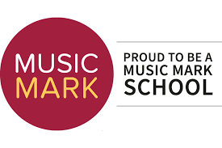
Recognition for our curriculum
We were delighted to receive two awards this week recognising the breadth of our curriculum.
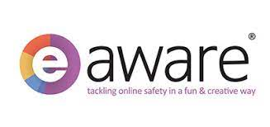
We have been nominated by our local Music Service/Hub to become a Music Mark School. They have recognised the value that we place on music and all we do to ensure that pupils at our school are able to access and engage with a high-quality music education.

The eAWARE Team awarded St Julie’s a certificate for our commitment to raising Online Safety Awareness during 2020-2021.


The Royal British Legion Poppy Appeal
Poppies, wristbands, reflectors, zip pulls and snap bands will be available from the school office from next week for a donation of £1 per item in aid of the Royal British Legion poppy appeal.


Parents Evening - Tuesday 19th October
Thank you to those who have booked their appointment for Parents Evening next week. On Monday you will receive an email with protocols for using School Cloud and a link that you will need to join the meeting on Tuesday. In preparation for the session and to make sure it runs smoothly please check the camera and microphone on your device are working.


Practical Cookery Workshops
In line with the National Curriculum Design and Technology Programmes of Study for Food and Nutrition every class will experience a practical cooking session provided by “Apple of my Eye” during the school year. Reception class have their session on Monday – thank you to those who have already paid on School Money.
We ask for a payment of £6 per child to cover the cost which can be paid via School Money.


TT Rockstars Battles - Yes! They’re back!!
Get your brains switched on and fingers at the ready for the next times tables challenge:
Year 3 v Year 4 Year 5 v Year 6
Battle commences on 14th October at 9:30am and ends on Thursday 28th October at 6:00pm. Good luck everyone!

Youth Open Art Competition
We have many talented artists at St Julie’s so are delighted that the Youth Open Art Competition is running again this year. The competition is open to children in Key Stage 1 and Key Stage 2 and can be in a range of mediums. Please see the entry form attached to this bulletin for full details. Art work needs to be submitted at the World of Glass on Monday 1st November or Tuesday 2nd November. Get creative over the half term holiday!

School Money/School Spider
A reminder that any payments need to be made via School Money. There is no payment system on School Spider.


Year Group | % Attendance for w/e 15.10.21
Reception | 98.57%
Year 1 | 99.14%
Year 2 | 95.71%
Year 3 | 98.33%
Year 4 | 99.38%
Year 5 | 96.86%
Year 6 | 94.83%

Well done to Year 4 for the highest attendance this week!


PFA
The next event will be for our Juniors: a Movie Night after school on Friday 5th November, 3:15 until 5pm costing £5 per child. Letters will be sent home next week in school bags to sign up and pay. The film will be Hotel Transylvania – refreshments included.
The next meeting of the PFA will be held next Wednesday 10th November at 6.30 pm in the school.


Easyfundraising By downloading this app you can collect FREE funds for St Julie’s every time you shop online!
Just visit easyfundraising.org.uk, search for St Julie Catholic Primary PFA and follow the simple steps to sign up. Then start shopping using the links to over 2,000 retailers including Amazon, John Lewis, M&S, Argos, Next, ASOS and many more. Every time you shop, you’ll earn a donation for the school at no additional cost to you!

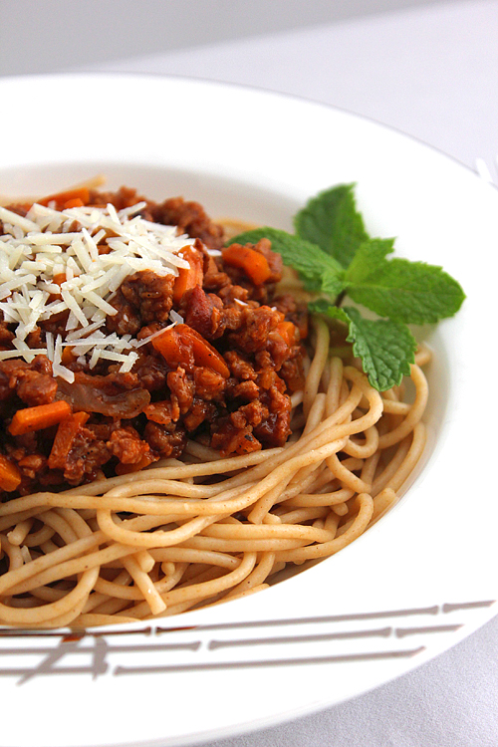
Winter Menu
The winter menu commences on Monday, 1st November and can be viewed on the school website. Please take some time to go through the menu with your child so that they are familiar with the new meals.

Coronavirus update
While rates continue to rise in St Helens, The Director of Public Health has asked us to encourage parents to continue to test families twice per week using the Lateral Flow Test kits. Please report the result of all tests whether negative or positive on the Government Report a Test website as this helps to give a picture of the uptake of local testing.
Regular testing helps to keep the staff and children in school safe.

Anyone who tests positive for Covid-19 MUST isolate for 10 days. If a member of your family does test positive for Covid, I would be grateful if you could inform school and please ensure that other family members test daily so that we can monitor any potential spread of the virus in school.

Primary School Admissions
The website is open for parents who wish to apply on line: www.sthelens.gov.uk/admissions.
Children who turn 5 between 1 September 2022 and 31 August 2023 are eligible to apply for a place in primary school. The deadline for submission of primary school applications is 15 January 2022.

Secondary School Admission
Children in Y6 should apply for a secondary school place by 31 October 2022 apply on line: www.sthelens.gov.uk/admissions



St Julie’s Stars of the Week

Reception | Josefina D
Year 1S | Teddy H
Year 1J | Ted A
Year 2 | Veronica H
Year 3 | Mia P
Year 4 | Olly P
Year 5 | Alexa V
Year 6 | Frankie F

Diary w/c 18.10.2021

There will not be any guitar or woodwind lessons this week as Mr & Mrs Gaynor are unavailable. Lessons will recommence after half term.

Monday Apple of my Eye cookery session in school – Reception class
Y4 TT Rockstars 3:15 - 4:15
Y3 Lego 3:15 - 4:15
Tuesday Y6 Athletics 3:15 - 4:15
Parents’ Evening appointments via School Cloud

Wednesday Y2 Spanish 3:15 - 4:00
Y1 Forest School 3:15 - 4:15
Y6 Young Voices choir 3:15 - 4:15
Thursday Harvest Festival (sorry, just for children – no parents/carers)
Y6 Swimming lesson at Queens Park
Y5 Board Games and Lego 3:15 - 4:15
Close for half term

Friday Staff Inset day

Further dates for your Diary
Thursday 21 October - Close for Half Term
Monday 1 November - School re-opens
Monday 8 November - Apple of my Eye cookery session in school – Year 4
Monday 15 November - Odd Socks Day for Anti-bullying week
Thursday 18 November - Flu immunisations in school

“A caring family school, where we learn, grow and walk in the footsteps of Jesus.”

St Julie pray for us, protect us and bless us.

Non Perishable Food

- UHT Milk
- Large Box Cereal

- Custard
- Rice Pudding
- Tin Vegetables (Carrots / Sweetcorn / Peas)
- Tin Tomatoes
- Tin Potatoes
- Soup
- Tin Fish
- Hot Dogs or meatballs
- Tin of Corned beef or Ham
- Pasta
- Pasta sauce
- Pickles or Beetroot
- Pack Biscuits
- Coffee or Hot Chocolate
- Tea Bags
- Jam or Marmalade or Honey
- Curry sauce
- Rice
- Instant Mash
- Kidney or Butter Beans / Chick peas
- Spaghetti Hoops or Ravioli
- Fray Bentos
- Beans
- Tinned Fruit

