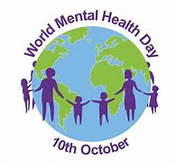
World Mental Health day
Sunday 10th October, is World Mental Health Day when we are encouraged to think about our own mental health and that of those around us. If you know anyone who is struggling, please encourage them to seek help and support. The Health and Wellbeing section of our school website has ideas, suggestions and websites to support you and your family and friends.
World Mental health day also provides us with the opportunity to think about the practical things we can do to support our own mental Health:

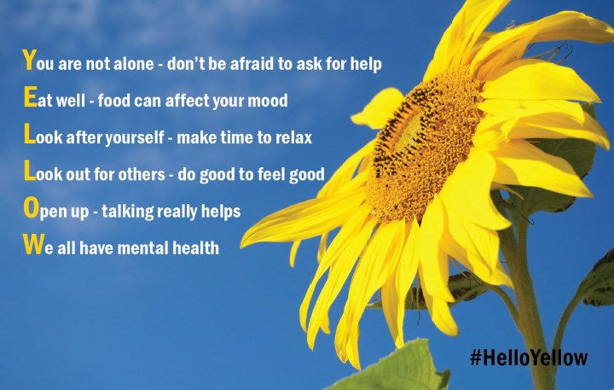


Spanish Themed Day – Wednesday 13th October
Thank you to those who have completed the survey on School Spider informing school of any allergies ahead of the food tasting sessions on Wednesday – if you haven’t done so, please complete it as soon as possible. The £2 donation can be paid on School Money – thank you to those who have made their donation.
Children can wear Spanish costume or clothes in the colours of the Spanish flag on the day.


Year Group | % Attendance for w/e 8.10.21
Reception | 96.57
Year 1 | 97.71
Year 2 | 100
Year 3 | 99.72
Year 4 | 97.81
Year 5 | 94.57
Year 6 | 95.43

Well done to Year 2 for the highest attendance this week!


Parents Evening - Tuesday 19th October
With Coronavirus rates still high in St Helens, we are continuing to use School Cloud rather than face-to-face meetings with parents for our Parents Evening. The school introduced the new intuitive and easy to use online booking and video call system – “School Cloud.” Last April and we received a lot of positive feedback from parents about the system. It allows you to choose your own appointment times with teachers, book online and attend a web-based video call in place of a face-to-face meeting. Once your slot is booked you will receive an email confirming your appointment/s. A letter with further details about how to access the system will be sent next week.
As usual at this time of year, our first parent’s night is a pastoral chat to see how your child has settled in their new class and so appointments will be 5mins

Appointments can be made when the system goes live from 4.00pm Monday 11th October and will close at 4.00pm on Monday 18th October.

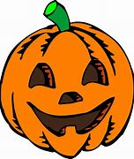
PFA
The first event will be for our Infants: a Hallowe’en DVD after school on Friday 15th October, 3:15 until 5pm costing £5 per child – due to Covid, none of them will have ever been to a PFA event so please come along! Letters will be sent home next week in school bags to sign up and pay.
The next meeting of the PFA will be held next Wednesday 10th November at 6.30 pm in the school.

Car park safety
Can we please ask parents/carers to be careful when using the Church car park at the end of the day. Please be patient when exiting the car park and pay attention to other cars and pedestrians. When walking through the car park please keep children close to you.
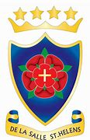
De La Salle Open Evening
Due to higher numbers of coronavirus cases in the area the school have been advised by Public Health England and the LEA to postpone the event scheduled for this week.

For families with children in Year 5 and Year 6 the new date will be 21st October and a virtual experience will also be available on the De La Salle High school website.

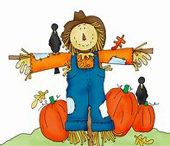

Scarecrow Festival
Please see the attached flyer for the Scarecrow festival which will take place in St Helens 26th October to 1st November. Households are invited to make a scarecrow and pay £5 to enter to display their creation over the week; a winner will be chosen by the St Helens community. It is hoped that the event will not only raise money for Willowbrook Hospice and Andy Reid MBE’s Standing Tall Foundation but encourage people to come together as a community.

Coronavirus update
While rates continue to rise in St Helens, The Director of Public Health has asked us to encourage parents to continue to test families twice per week using the Lateral Flow Test kits. Please report the result of all tests whether negative or positive on the Government Report a Test website as this helps to give a picture of the uptake of local testing.
Regular testing helps to keep the staff and children in school safe.

Anyone who tests positive for Covid-19 MUST isolate for 10 days. If a member of your family does test positive for Covid, I would be grateful if you could inform school and please ensure that other family members test daily so that we can monitor any potential spread of the virus in school.

Primary School Admissions
The website is open for parents who wish to apply on line: www.sthelens.gov.uk/admissions.
Children who turn 5 between 1 September 2022 and 31 August 2023 are eligible to apply for a place in primary school. The deadline for submission of primary school applications is 15 January 2022. The Archdiocese have asked us to remind parents seeking a reception class place at our school, even if you have a sibling in the school, of the need for baptism prior to application and to take prompt action if baptism has not already taken place.

Secondary School Admission
Children in Y6 should apply for a secondary school place by 31 October 2022 apply on line: www.sthelens.gov.uk/admissions


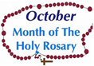
Month of the Rosary
October is dedicated as the Month of the Rosary because we celebrate the memorial of Our Lady of the Rosary each year on October 7. We have our lovely prayer garden dedicated to Mary which the children can visit for quiet prayer and refection.



St Julie’s Stars of the Week

Reception | Brooke W
Year 1S | Danielle C
Year 1J | Fionnuala L
Year 2 | Xavier O
Year 3 | Mia F
Year 4 | Isaac S
Year 5 | Matthew A
Year 6 | Rory B

Diary w/c 11.10.2021

Monday Y4 TT Rockstars 3:15 - 4:15
Y3 Lego 3:15 - 4:15
Tuesday Y6 Athletics 3:15 - 4:15

Wednesday Spanish Theme Day (Spanish costume or red/yellow clothes)
Y2 Spanish 3:15 - 4:00
Y1 Forest School 3:15 - 4:15
Y6 Young Voices choir 3:15 - 4:15
Thursday SEND Drop-in
Y6 Swimming lesson at Queens Park
Y5 Board Games and Lego 3:15 - 4:15

Friday PFA Hallowe’en DVD 3:15-5:00pm (pre booked only)

Further dates for your Diary
Wednesday 13 October - Spanish Themed Day
Friday 15 October - PFA Hallowe’en DVD for Infants: 3:15 – 5:00
Monday 18 October - Apple of my Eye cookery session in school – Reception class
Tuesday 19 October - Parents’ Evening via School Cloud
Thursday 21 October - Close for Half Term
Monday 1 November - School re-opens
Monday 8 November - Apple of my Eye cookery session in school – Year 4
Monday 15 November - Odd Socks Day for Anti-bullying week
Thursday 18 November - Flu immunisations in school

“A caring family school, where we learn, grow and walk in the footsteps of Jesus.”
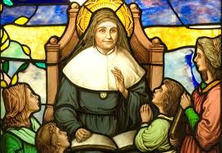

St Julie pray for us, protect us and bless us.

