Dear parents and carers,

Nugent Care “Good Shepherd” Appeal
In Assembly this morning we spoke about how we can help those less fortunate than ourselves through donations of money, food resources and by giving our time and prayers. We are conscious of the many families at this time who need our support and the Good Shepherd Appeal helps those in need in our own locality. Today the children enjoyed their fundraising activities for the Good Shepherd Appeal and through your generosity raised £441.14 – thank you.

Prayers for the people of Ukraine
Our thoughts and prayers are with all the people and families suffering in the Ukraine and those fleeing from the war-torn country. St Julie’s Church is always open during the day for private prayers and this afternoon at the end of the school day was an opportunity to come together as a parish to pray for the people of Ukraine.
For those wanting to make a financial donation, the Archdiocese of Liverpool have provided information of how to donate by text – see flyer attached for details.
The Archdiocese have partnered with the Ukrainian Catholic Eparchy (diocese) of Sambir-Drohobych in the Lviv region of western Ukraine and their Bishop Hryhoriy (Gregory) Komar. The Bishop has requested the specific items outlined in a poster which is attached.
Our collection points in the St Helens area will be:
- St Anne and Blessed Dominic Parish Centre, 40 Monastery Road, Sutton, WA9 3ZD
- St Mary’s Parish Centre, Birchley Road, Billinge, WN5 7QT
- St Patrick’s Parish Centre, 111 Common Road, Newton-le-Willows, WA12 9JH
- St Teresa’s Parish Centre, Devon Street, St Helens, WA10 4HW
The parish centres are open every day 9am-11pm.

On Wednesday 16th March as part of the Day for Ukraine the children are asked to bring in a £1 donation and the children will receive a blue and yellow ribbon to wear with their uniform and take part in prayerful reflection.
All money raised will be forwarded to the Disasters Emergency Committee (DEC).


Year 4 sacrament of Reconciliation
Parents and carers are invited to bring their child to St Julie’s Church to make their first confession on the morning of Saturday 12th March between 9am and 2pm. Please enter the church and quietly take a seat in one of the benches. Prayer cards will be available for quiet reflection to settle your child and help them to prepare. Fr Philip will be hearing confession in the side chapel: please approach when you can see that he is available. Fr Philip will spend some time helping your child to settle and feel at ease, and then take them through their first confession.
Children must have made the sacrament of Reconciliation in order to make their First Holy Communion so Fr Philip will be making a record of who attends over the next 2 Saturdays.

A grand day out!
This week saw a welcome return to school trips as on Wednesday Year 1 and then on Friday Reception ventured out to Knowsley Safari Park. The children were so excited to take their packed lunches onto the coach and spend a fantastic day exploring and seeing the wildlife – they couldn’t stop talking about all the amazing animals they had seen! Trips for other classes will be planned for the rest of the school year and the diary updated when they are confirmed.

Science Week -
Next week is National Science week and in addition to their usual curriculum science lessons the children will be taking part in many science activities.
Each of our classes now has their own planter in which to grow flowers, fruit or vegetables which they will be planting up next week. Thank you to Mr Maitland, one of our parents who generously built the wooden planters.

St Julie’s Science Fair Children are invited to bring in their science investigations for the Science Fairs in school taking place during the afternoon:
KS2: Monday 14th March
KS1 & Early Years: Wednesday 16th March
The children are encouraged to investigate an area of science of particular interest to them at their age appropriate level and present their findings to the school. Children may submit joint entries.
A certificate will be awarded to each entry reflecting a good understanding of the scientific principle under study. Children are encouraged to present their investigations in a creative way.

Thank you also to Mr and Mrs Cracknell, parents in Reception who built and donated this amazing Bug Hotel for our school grounds.

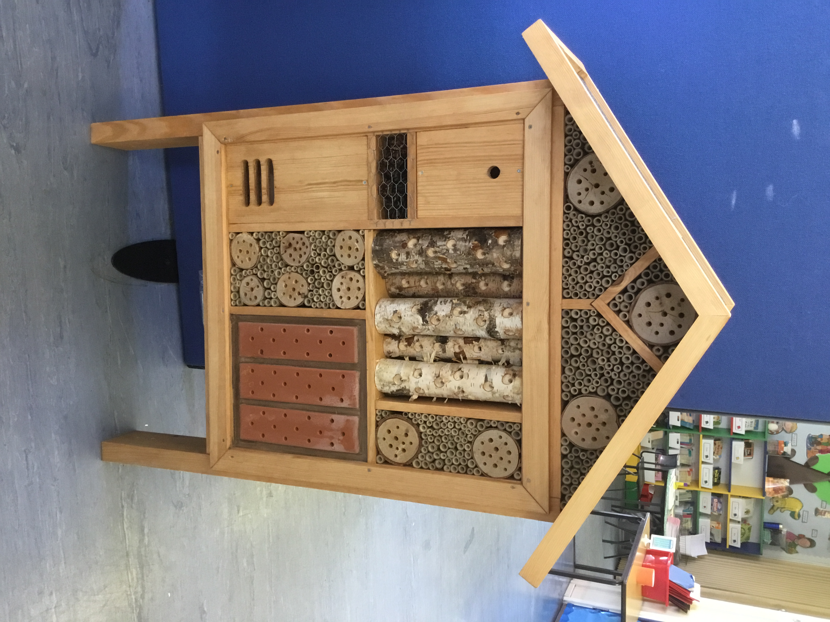

Gymnastics Success!
Congratulation to Albie and Alice from Year 4, and Phoebe, Mia and Bertie from Year 3 who made up our Gymnastics team who went to the St Helens School Games Gymnastics Competition last Friday. They competed with 11 other schools and achieved 1st place! In assembly this morning they were presented with a fabulous trophy and individual winners medals. They now go on to compete in the Merseyside final provisionally booked for Tuesday 26th April. Our thanks to Miss Bennett who has coached them so well and well done to all the children.

Parking
A further reminder to please take great care when dropping off and collecting children. Please park responsibly with the safety of pedestrians and road users in mind. Please do not park on the junction of Acacia and Brooklands Road as this causes a dangerous bottle neck. There is more room to park further down Brooklands Road rather than on Acacia and walk the short distance to the school.

PFA Meeting – Monday 21st March at 5:30pm in school
We are delighted to be able to get back to having our PFA meetings in school. The PFA have raised an enormous amount of money over the years to provide the children with much needed resources and improvements to the learning environment. Our school really needs all of your support so please put the date of the next meeting in your diary and come along.

PFA events


Easter film night KS1 Friday 18th March 3.15 pm. 3:15 until 5pm costing £5 per child. Letters will be sent home next week in school bags to sign up and pay – refreshments included.

Easter Film night for KS2 will be on Friday 25th March, 3:15 – 5pm



Year Group | % Attendance for w/e 11.03.22
Reception | 97.99
Year 1 | 98.29
Year 2 | 96.57
Year 3 | 97.78
Year 4 | 93.13
Year 5 | 97.71
Year 6 | 97.14
Well done to Y1 for the highest attendance this week!

School Attendance
A reminder that holidays taken during term time will NOT be authorised.

Should parents send their child to school if they think they have COVID-19?
If a child has any of the main symptoms or a positive test result, the public health advice remains unchanged and is to stay at home and avoid contact with other people.
Anyone with any of the main COVID-19 symptoms should order a test and is advised to stay at home while waiting for the result.
If they test positive, they are advised to follow public health advice.

Adults and children who test positive will continue to be advised to stay at home and avoid contact with other people for at least 5 full days and then continue to follow the guidance until they have received 2 negative test results on consecutive days.

We still have several cases of Covid in our school community (a total of 3 in school this week) so continue to do all we can to limit the spread of the virus and we appreciate your ongoing support with this.



St Julie’s Stars of the Week

Reception | Thea C
Year 1S | Freddie R
Year 1J | Nathaniel W
Year 2 | Annabelle B
Year 3 | Lily Y
Year 4 | Sophia S
Year 5 | Phoebe H
Year 6 | Lois L

DIARY w/c 14th March 2022

MONDAY Apple of my eye Year 2 cookery session
Science Fair KS2 during school day
Art club Y3 3.15-4.15 pm
Y6 Football 3.15-4.15 pm
Indoor Athletics Y4 3:15 – 4:15pm

TUESDAY Year 5 Forest School – outdoor clothing
Multi skills Year 3 3.15-4.15 pm

WEDNESDAY £1 donation for Ukraine Day ribbon
Science Fair - Infants during school day
Spanish Year 1 3.15-4.00 pm
Gymnastics Year 3 3.15-4.15 pm
Science Club Year 2 3.15-4.15 pm
Science Club Year 5 3.15-4.15 pm
Young Voices Year 6 3.15-4.15pm

THURSDAY Year 1 Forest school

FRIDAY PFA Infant film night 3:15 – 5pm

Eccleston Library – Jester Crafts
Become a Jester from Shakespeare’s “A Midsummer Night’s Dream” making a Jester’s hat and more. Tuesday 22 March 3:30pm – places limited so booking essential. Tel: 677575

Dates for your Diary

Monday 21 March Y3 Apple of my eye cookery session
Tuesday 22 March Y6 Forest School
Wednesday 23 March Reception Forest School
Thursday 24 March NHS Vision and hearing checks Reception class
Friday 25 March PFA KS2 film night 3:15 – 5pm
Monday 28 March Y5 Apple of my eye cookery session
Wednesday 30 March Y3 Forest School
Thursday 31 March Y2 Forest School
Friday 1 April Easter Passion Service Y5 9.30 am
Close for Easter break
Tuesday 19 April Re-open
Thursday 21 April Y4 Swimming lessons start at Queen’s Park
Monday 2 May Bank Holiday
Thursday 5 May Y5 Sacramental meeting 6.30 pm Parish Hall
Monday 9 May KS2 SATs week
Saturday 21 May Y5 First Holy Communion Masses at 10am and 1pm
Thursday 26 May Y4 Sacramental meeting 6.30 pm Parish Hall
Friday 27 May Queen’s Diamond Jubilee party day
Friday 27 May Close for half term
Wednesday 8 June Re-open
Saturday 11 June Y4 First Holy Communion Masses at 10am and 1pm

A prayer for Ukraine
Loving God,
We pray for the people of Ukraine,
for all those suffering or afraid,
that you will be close to them and protect them.
We pray for world leaders,
for compassion, strength and wisdom to guide their choices.
We pray for the world
that in this moment of crisis,
we may reach out in solidarity
to our brothers and sisters in need.
May we walk in your ways
so that peace and justice
become a reality for the people of Ukraine
and for all the world.
Amen.


“A caring family school, where we learn, grow and walk in the footsteps of Jesus.”
St Julie pray for us, protect us and bless us.

