ST JULIE CATHOLIC PRIMARY SCHOOL ECCLESTON



A caring, family school where we learn, grow
and walk in the footsteps of Jesus.

Starting School

PARENTS’ HANDBOOK

2020 - 2021

Welcome to the St Julie School Family. We hope that the information in this booklet, alongside the main school prospectus will provide you with everything you need to know about your child’s first few weeks in school. Please don’t hesitate to contact me if you require any further support. I look forward to getting to know you over the coming months and years.
A Hodgson
Headteacher
THE STAFF
Mrs A Hodgson Headteacher
Child Protection Officer
Designated Safeguarding Lead

Mrs H Slocombe Deputy Headteacher
Deputy Designated Safeguarding Lead
Assessment Co-ordinator
Reception/Year 1 Class Teacher
KS1 Teaching Staff:
Mrs J Ashcroft Foundation Stage Leader/ Class Teacher
P.S.C.H.E. Co-ordinator
Pastoral Lead
SENCO

Mrs L Mannion Year 2 Class Teacher
Primary Languages Co-ordinator
History Co-ordinator

Mrs L Sherman Year 2 / Year 1 Teacher
Geography Co-ordinator

Mrs J Andrew Reception / Year 1 Teacher
KS1 English Co-ordinator

Mrs C Kernick Year 2 Class Teacher

KS2 Teaching Staff:
Miss C Pratt Year 3 Class Teacher
Design Technology Co-ordinator
Art Co-ordinator

Mr P Royle Year 4 Class Teacher
Music Co-ordinator

Mrs H McCahey Year 5 Teacher/ KS2 Leader/ Curriculum Co-ordinator
Religious Education Co-ordinator
Science/Eco Co-ordinator

Miss Carr Year 6 Teacher
Computing Co-ordinator/ KS2 English Co-ordinator

Mrs L Clayton Year 6 Part-time Teacher
PE Co-ordinator

Miss L Wood Support Teacher Part-time
Maths Co-ordinator

Mrs H Dooley Support Teacher Part-time

Teaching Support Staff:

Mrs A Owen Part-time Learning Assistant
Mrs S Tootill Part-time Learning Assistant
Miss H Alexander Part-time Learning Assistant
Mrs P Smith Part-time Learning Assistant
Mrs D Trantum Part-time Learning Assistant
Mrs P Pincock Full-time Learning Assistant (SEN support)
Miss L Cliffe Full-time Learning Assistant and Part-time SEN support
Mrs A Gilchrist Full-time Learning Assistant (SEN support)
Mrs C Balmer Full-time Learning Assistant (SEN support)
Mrs T Andrews Full-time Learning Assistant (SEN support)
Mrs S Postlethwaite Full-time Learning Assistant
Mrs K Whitter Full-time Learning Assistant (SEN support)

Midday Supervisors:

Mrs D Trantum Midday Supervisor
Mrs S Postlethwaite Midday Supervisor
Mrs P Smith Midday Supervisor
Miss L Cliffe Midday Supervisor
Mrs A Gilchrist Midday Supervisor
Miss S Darwin Midday Supervisor

Administration Staff:

Mrs S O’Reilly Office Manager
Mrs S Wright Part-time Clerical Assistant
Miss R Smith Part-time Clerical Assistant

Premises Staff:

Mrs L Lyon Cleaner in Charge
Miss S Darwin School Cleaner

Kitchen Staff:

Mrs M Finney
Mrs N O’Brien

The Governing Body

Chair of Governors: Cllr T Sims
11 Portico Avenue
Eccleston Park
Prescot
Merseyside
L35 7JL
Tel: 0151 426 5118

Clerk to the Governors:
Mrs A Houghton Tel: 671274
Foundation Governors:
Canon T Neylon Parish Priest
St Julie Presbytery
Howards Lane,
Eccleston
Tel: 28196

Mrs C Scott
Mr C Platt

LA Representative Governor:
Mr D Bain

Elected Parent Governors:
Mrs C Worthington
Mrs C Blade

Non-teaching Staff Governor:
Mrs S O’Reilly
Headteacher Governor:
Mrs A Hodgson St. Julie Catholic Primary School,
Brooklands Road,
Eccleston,
St. Helens.
WA10 5HG
Tel: 678233 Fax: 678234

THE GOVERNORS
Governors are like a Board of Directors and make decisions about how the school is run. The full Governing Body meet at least twice each term and each Committee at least once a term in the school.
Governors are appointed to represent the interests of the Catholic Trustees, the Local Education Authority but primarily the interests of you the parents and your children. As part of their role they help:-

1) To ensure that the National Curriculum is taught and formulate school policies.
2) Interview and select staff.
3) Decide on how the school budget is spent.
4) Support the Headteacher and the Staff.

School Governors have legal duties, powers and responsibilities. They can only act together, they cannot act individually.

School Governors are:

1) Parents.
2) Members of the school staff.
3) Members of the Parish appointed to represent the Catholic Archdiocesan Trustees.
4) Local Council Representatives.
5) The Headteacher.
Parents’ Governors:

1) Have children at the school.
2) Parents elect one every four years.
Parent Governors are on the Governing Body as they bring a parent’s perspective to the issues facing the school. They speak and act as individuals. They have equal status on the Governing Body and have voting rights.
Parent Governors set an example to other parents in becoming actively involved in the school. They are frequent visitors to the school, help in the classroom and are active members of our Parents and Friends Association.
The minutes of the Governor Meetings are available in the office for any parent to read.

ABOUT THE SCHOOL
St. Julie's is a one-form entry school sited in a beautiful, spacious setting which provides the children with ample space and opportunities for recreational and sporting activities.
The school building is in two sections. The main building consists of the hall, four spacious classrooms, an ICT suite, the administration block, reception area and an attached kitchen where the school meals are cooked daily. There are four junior classes located in this building.
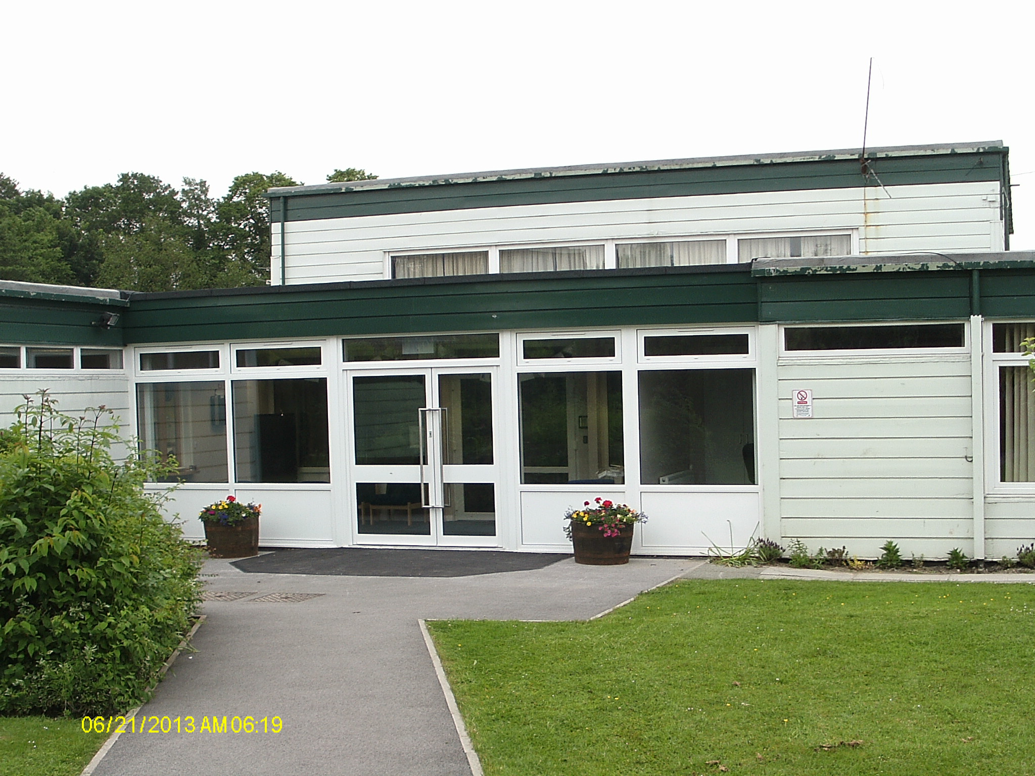
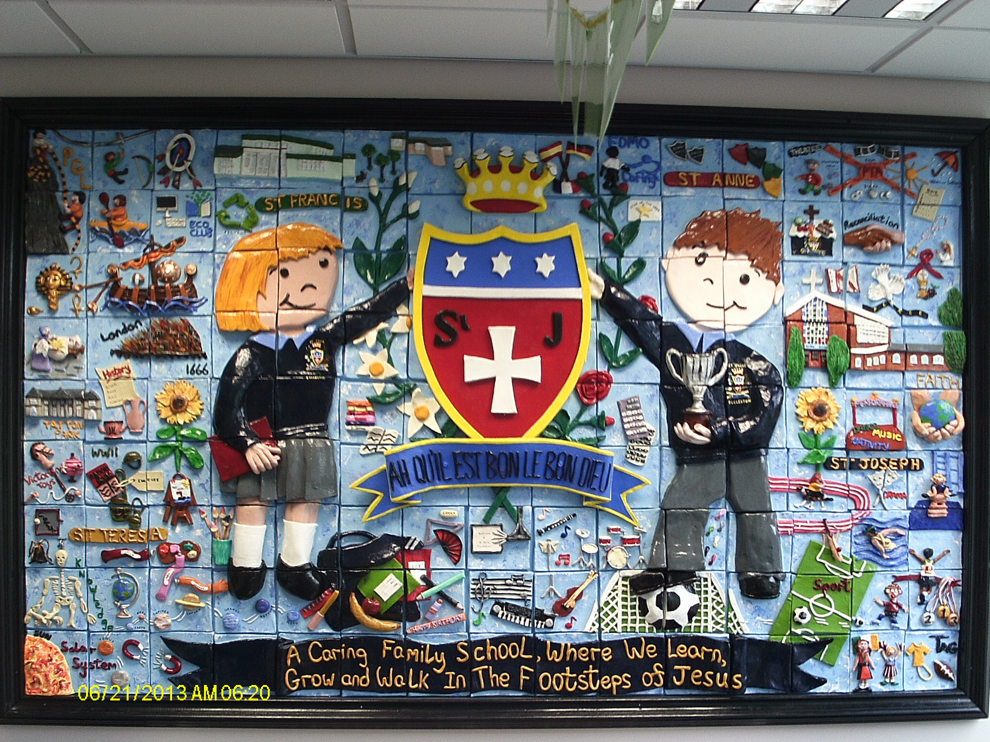
The main entrance to the school
The second smaller building, which is connected to the main building by a 20 metre tarmac pathway, houses our Foundation Stage Area, and Key Stage 1 infant classes, which are presently organised into four teaching classes.
It is in this building that your child will begin his/her school life at St. Julie's. Thanks to our Parents Association, the classes are well equipped in play and games apparatus and furniture which help the children to settle easily into their new environment and develop the essential social skills necessary for life in a school, as well as providing a rich and relevant starting point for language development. The layout provides ample space for the various curricular areas without the children being cramped or forced to maintain an unnatural silence for fear of disturbing other children.
We are very pleased that you have chosen St. Julie's to be the place where your child begins his/her formal Primary Education. As parents you are your child's first teachers and their home, their first learning environment. Hence the importance of the parents’ role as educators in the early formative years of a child's life cannot be overstated. However, you as parents must prepare yourself for a new and powerful influence which is about to enter your child's life - the school. Your child is about to enter a private little world of its own, which for the most part they may keep hidden from you (and it often hurts).
However, it is our intention to open up that world to you as much as possible for we see this next phase in your child's education very much as a partnership between you and ourselves. We hope you show interest and enthusiasm for all that happens to your child at school and, together, we will ensure that they get the best education possible for him or her. For example your active support will be sought in helping your child in their reading development.

In order to cement this partnership, the school has a Home-School Agreement, (which we hope all parents will sign up to) that sets out plainly our respective roles in ensuring a successful education for all the children.
We hope you will quickly build up a rapport with your child's teacher facilitating an easy interchange of information enabling both parties to carry out their respective roles more effectively.
There may be problems - they are part of life - but our door is always open to you to discuss any problems which affect your child - you will find our teachers very approachable.
PLEASE NOTE Your child cannot be admitted if I have not seen their Birth Certificate and Proof of their Baptism. Please bring the necessary documents with you on your child’s first day at school, if you have not already done so.

The School Day

The school day is as follows:
8.50 a.m. - School starts.
12.00 noon - Infants Lunch.
1.15 p.m. - Afternoon session begins.
3.15 p.m. - Home time.

For the children's first full week at school we would ask you to make sure you are 5 or 10 minutes early at home time as they can get quite upset if you are not there when it’s time to go home.

UNIFORM

Full details of the school uniform may be found in the school prospectus. Orders for sweatshirts and polo shirts embroidered with the school logo can be ordered on-line (further details and a password for the uniform website will be provided). We do insist that the children wear shoes at school not trainers. School shoes should be black. No high heels or boots will be permitted.
Please mark all your child’s belongings clearly with their names.
P.E. KIT

A T-shirt, blue shorts and plimsolls (preferably without laces) all kept in a tie-bag clearly marked with the name of your child. These can be brought into school at the beginning and taken home at the end of each half term. To enable the children to get used to the house system we will ask you to provide a T shirt of a particular colour. Details will be given at the induction afternoons.

DINNERS
You have three options at lunchtime: -
Take your child home for dinner
School dinners
Packed lunch
All children in reception, Year1 and Year 2 have been offered a universal free school meal since September 2014, however parents and carers who receive the qualifying benefits should still make an application for free school meals. This is because your school can get additional government funding dependent on the number of children that qualify for statutory free school meals (based on your entitlement to certain benefits and awards).
Please claim even if your child does not wish to take a free meal. If you qualify for statutory free meals, you may also be entitled to school clothing allowance.
Such entitlement is kept entirely confidential. For further details please see the Council website:http://www.sthelens.gov.uk/themes/parent/benefits/free-school-meals/
The school has the Healthy School award for Food and Nutrition – please help us to achieve this by providing only healthy food items in the lunchbox. A lunchbox of sweets, chocolate etc. can undo all the good work and will contradict the messages given to the children in the curriculum.
If you choose to send your child to school with a packed lunch may we please ask you to co-operate by adhering to the following guidelines: -
1. Place the lunch in a strong plastic container marked with their name.
2. We ask you to provide water with their meal. Fizzy drinks and canned drinks are not allowed.
3. Please make the lunches’ healthy food only, no nuts or nut products, with one small treat if required.
4. Ensure that any other item which could leak, e.g. yoghurt, is secure.

As part of our Healthy School initiative for Food and Nutrition we will provide parents with advice on the contents of a healthy packed lunch as provided by Health Education Trust.
As part of a government funded health scheme, the infants are provided with a piece of fresh fruit or vegetables every day. We respectfully ask parents who wish to provide a mid-morning snack for their child to provide fruit or toast only.
MILK
Children whose family is on Income Support are entitled to school milk. However, St. Helens Council wish to give all Infants children opportunity to receive milk. At a charge of *£2.00 per term your child can receive a third pint of milk a day. The charge is not to be subject to refunds in the case, for example, of absence from school. There is also the option of having fluoridated milk to help with your child’s dental care.
WATER
We encourage you to provide your child with a bottle of water each day, which they can have access to at any time in the day. In the coming year we will issue the children with their one water bottle. These should be taken home each evening, washed and replenished ready for the next day. Fresh water is available in all classes for replenishment.
Parental involvement
Within the school itself we try to develop a sense of 'family' both with the children and the parents. Parental involvement in the school is positively encouraged and can take several forms: -
i) assisting in the supervision of Educational trips.
ii) support for or help in the organisation of the activities of the Parents Association which provide much needed additional funding for the school.
Open evenings
There will be three formal Open Evenings each year.
These give you an opportunity to discuss your child's progress with his/her teacher. The first in November has a pastoral theme and is an opportunity for parents to discuss any ‘settling in’ problems their child may have – it is also an early contact with the class teacher to establish a working relationship. The second, in February, is a mid-term report and focuses upon the progress the children have made and where they need to go. The final one in July accompanies the end of year report which is sent out to all parents. In addition, you will find the staff ready to talk to you anytime if you have any questions or areas of concern.
We encourage open dialogue between both parties and hope that those of you who can will become actively involved in the life of the school both in parental involvement in classroom activities or by supporting the school's Parents' Association which works hard to support the school financially and in providing opportunities for parents to come closer together socially.
*Cost of milk may vary

ST. JULIE'S PARENTS AND FRIENDS ASSOCIATION

Officers of the Association:
Chair: Mrs Louise Lester
Secretary: Mrs Y Evans
Treasurer: Mrs M Roberts

Meetings of the Association are open to all parents and we hope many of you will get involved. The fundraising of the P.F.A. has become increasingly vital to the school and provides many valuable resources for the school which could not otherwise be obtained.

The Association attempts to provide a full calendar of events which are varied to suit all tastes. Some examples of the activities they organise are:
DANCES (LIVE MUSIC AND DISCO)
QUIZ NIGHTS
SPONSORED WALK
LADIES NIGHT
FASHION SALES
BEAUTY EVENINGS
BARBECUES/DANCES
THEATRE TRIPS
FILM AFTERNOONS
ACTIVITIES AT THE PARISH GALA
SEASONAL GIFTS
WEATHER LOTTERY

