
Dear parents and carers,


This morning in assembly we celebrated the determination and focus with which our Year 6 children approached their SATs this week. We showed them how proud all the staff are of their hard work. Each, and everyone of them did their very best and we can’t ask any more of them than that. They received a rousing “Three Cheers!” from their school family before beginning their Forest School Friday. Well done everyone!

Share a Story session.
This week we continued our reading for pleasure sessions. It was the turn of Year 2 children to share a cosy reading session with a grown up, relaxing and snuggling up on the bean bags. There was a wonderful atmosphere in the school hall with the quiet buzz of voices reading and enjoying a good book.
After half term we will continue inviting you in to share an afternoon session with your child, this time with a focus on maths. More details in the following weeks.

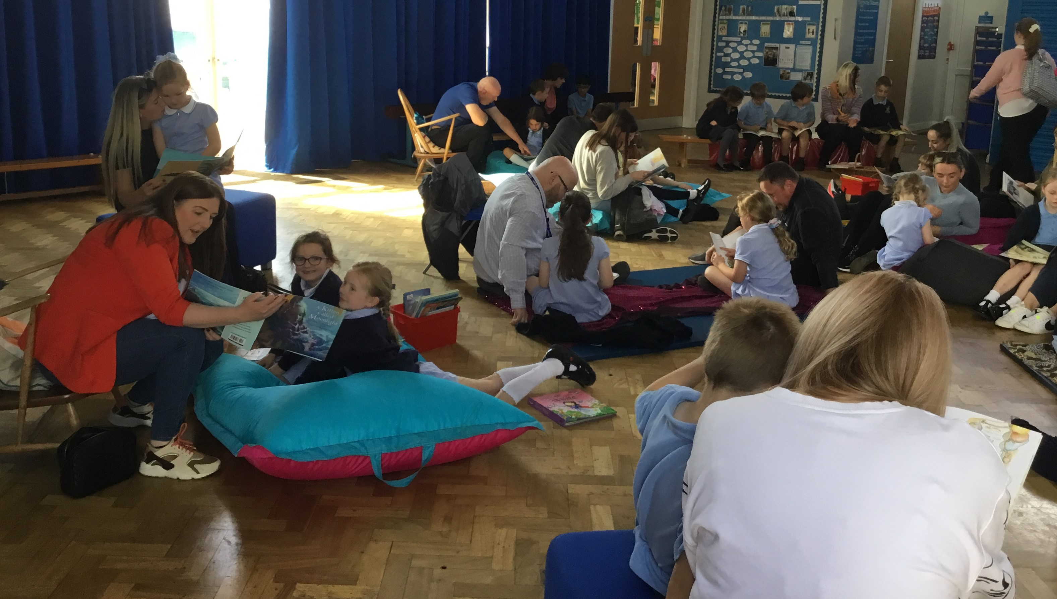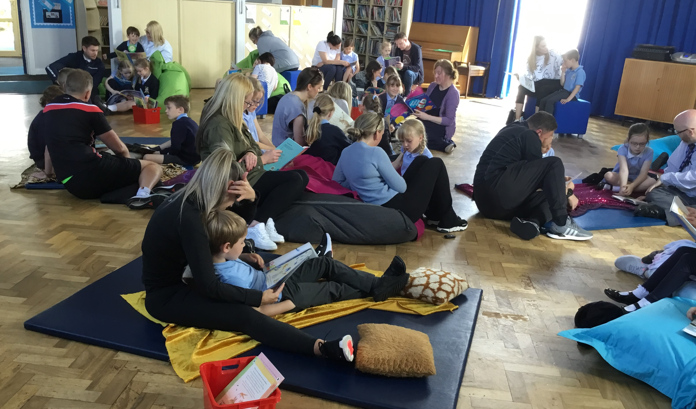

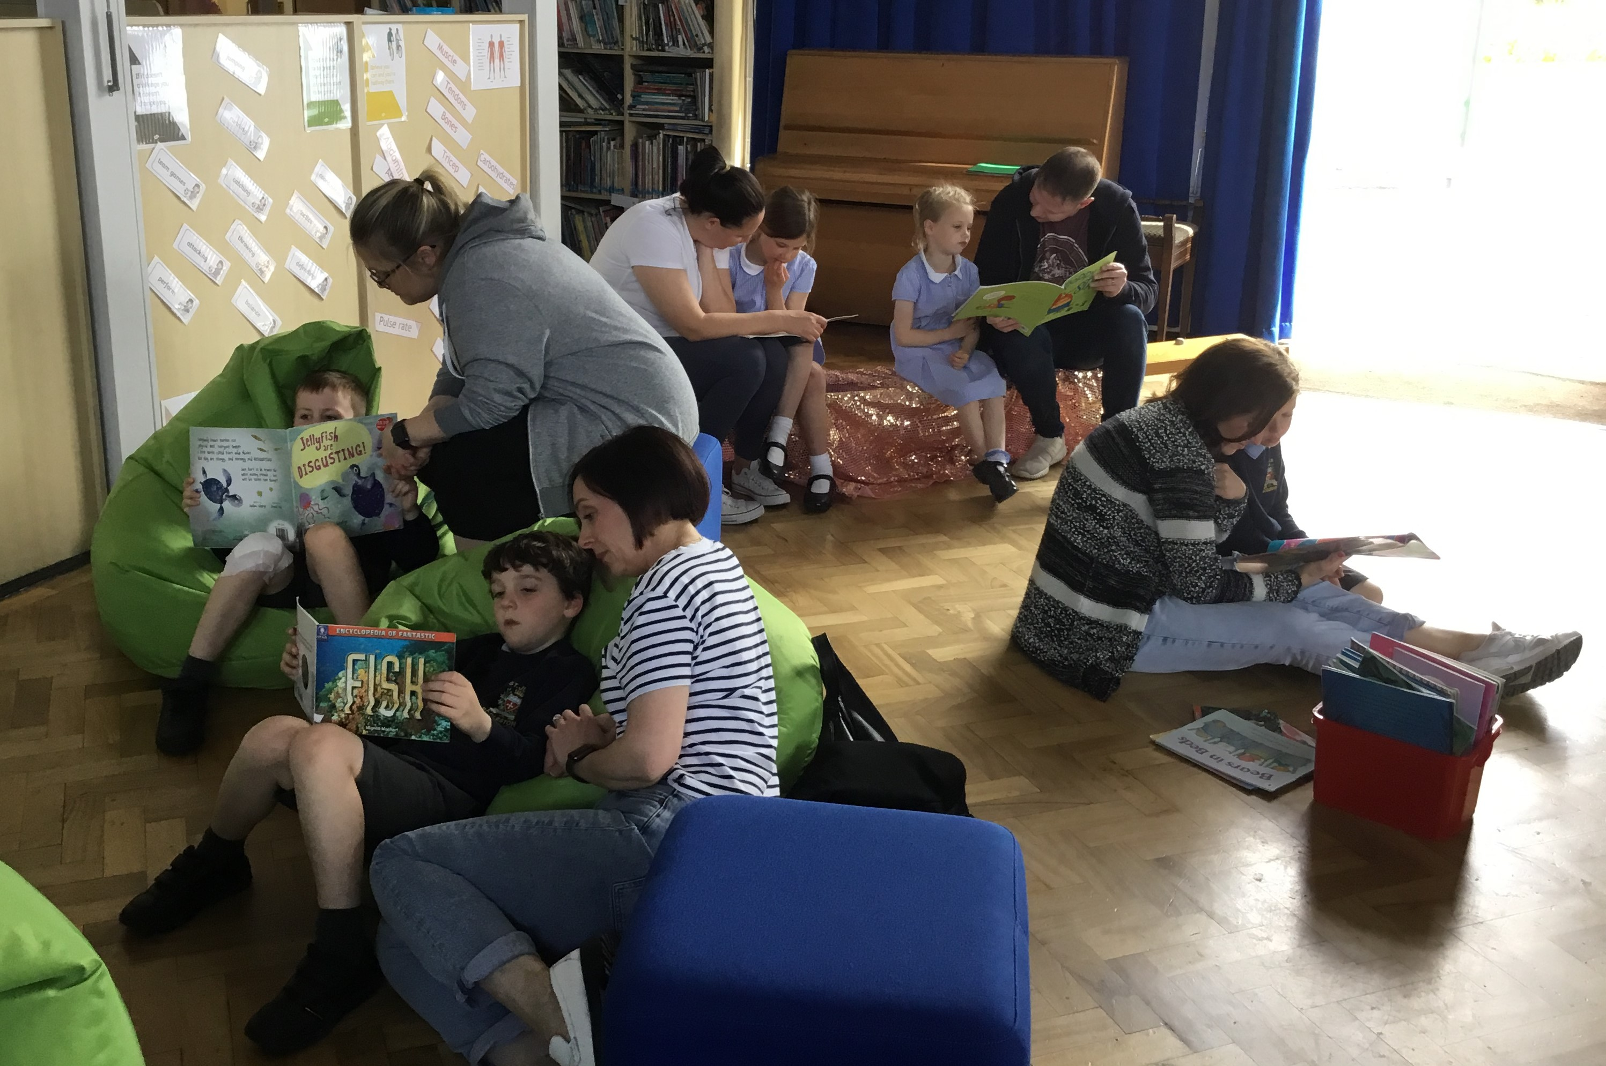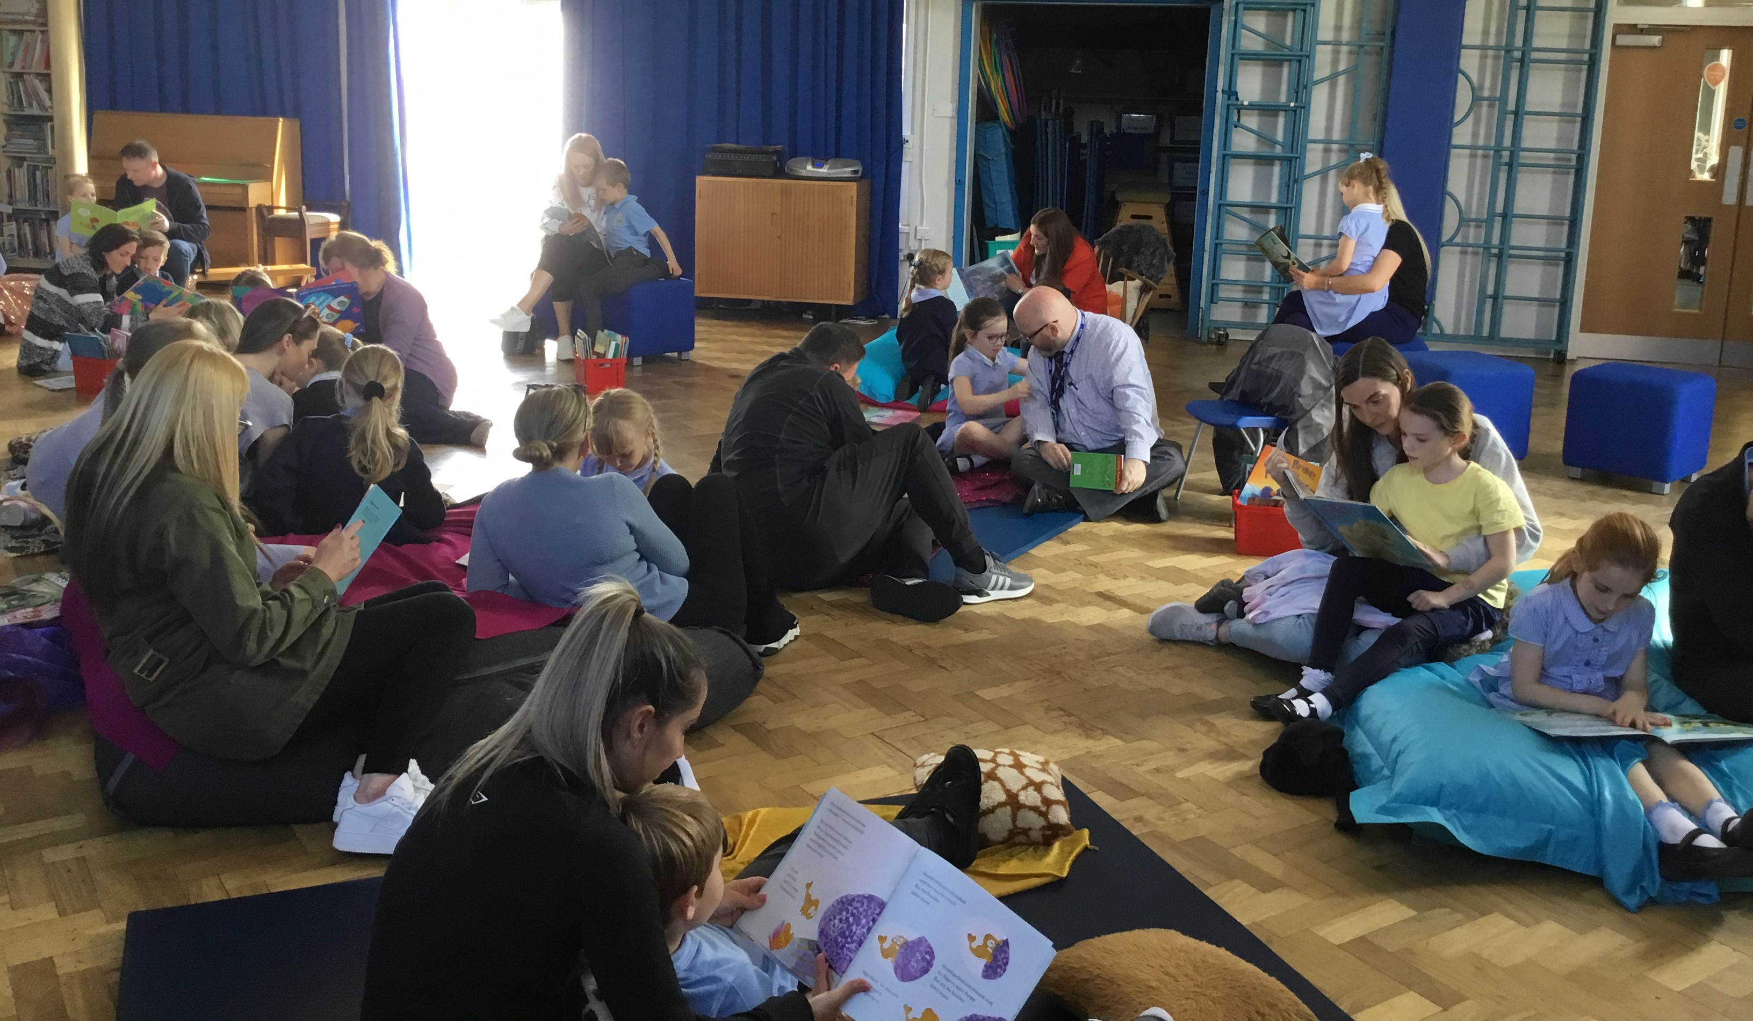

Poet Visit – Monday 16th May
On Monday 16th May all classes will be visited by poet Andy Tooze. Andy will spend time reading his own poems to the children and answer questions about their stimulus, form and content. He will give the children a variety of simple, helpful hints to enable them to compose their own poems.
Andy will also have signed copies of his own books ‘Green Shoots Rising’, ‘The Poetry Bug’ and ‘The Poetry Bug Strikes Again.’
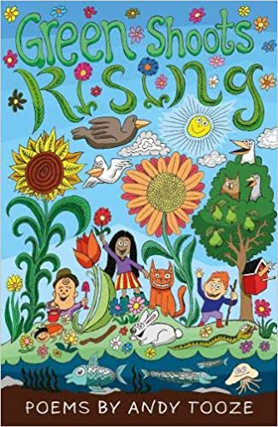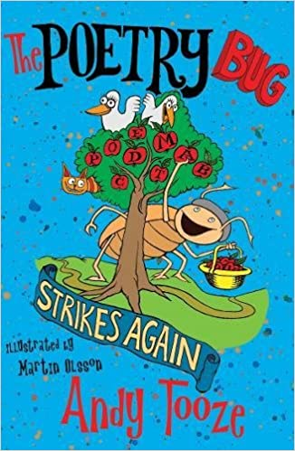

If you wish your child to purchase one of the poetry books, please send in £5 in an envelope with your child’s name on it on Monday.

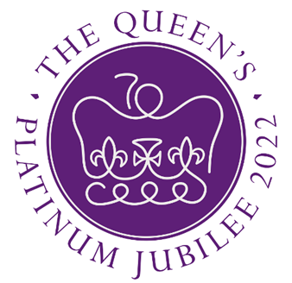
Jubilee Sports day – Wednesday 25th May
This year we are hoping for a sports day with a difference to celebrate the Queen’s Platinum Jubilee – weather permitting! The Sports Council have been involved in the planning of the event. There will be a carousel of traditional sports and games, completed by each house team with children in the Juniors split into Upper (Y6 and Y5) and Lower (Y3 and Y4) Juniors. The focus is to be on teamwork and fun as the house teams rotate through the activities. Parents are welcome to attend with the Junior event in the morning starting at 9:30am and Infants in the afternoon at 1:30pm.


The Queen’s Platinum Jubilee Street Party day – Friday 27th May
All the children can come to school dressed in red, white and blue on Friday 27th May. We are hoping to eat outside on the playgrounds in traditional street party fashion. Children who have a school dinner will receive a Jubilee Party Box containing sandwiches, a sausage roll, crisps, cake, jelly, chips and juice. Children who have a packed lunch can bring their own Jubilee Packed Lunch or can order a Party Box from the school kitchen by completing the survey on School Spider. Boxes should be ordered as soon as possible and will cost £2:50 payable on School Money once the survey is completed.

School grounds
In assembly this morning the children were reminded that they must not play on the equipment in the school grounds after school when there is no teacher there to supervise them. We ask that parents and carers please leave the grounds so that gates can be closed for security. Thank you.


Healthy Lunchbox
As a healthy school we encourage you to ensure that there is a good nutritional balance of food groups in the children’s lunchboxes – please avoid sending too many crisps, biscuits and chocolate.



Year Group | % Attendance for w/e 13.05.22
Reception | 87.43
Year 1 | 94.86
Year 2 | 94.86
Year 3 | 95.56
Year 4 | 95.00
Year 5 | 94.57
Year 6 | 97.71
Well done to Year 6 who had the highest attendance this week.

A reminder that holidays taken during term time will NOT be authorised.



St Julie’s Stars of the Week

Reception | Kayla F
Year 1S | Olivia P-A
Year 1J | Darcey C
Year 2 | Elissa W
Year 3 | Luca B
Year 4 | Myla Mc
Year 5 | Tiana M
Year 6 | Brandon T

DIARY w/c 16th May 2022

MONDAY Poet Andy Tooze in school all day.
Art club Y4 3.15-4.15 pm
Football Y6 3;15-4:15pm weather permitting
Garage Band Y3 3:15 – 4:15pm

TUESDAY
Football Year 5 (Mr Woodward) 3.15-4.15 pm

WEDNESDAY Year 6 leave for residential at Colomendy
Multi-sports Year 1 3.15-4.00 pm
Science Year 2 (group 2) 3.15 – 4.15pm
Science Year 5 3.15 – 4.15pm
Gymnastics Year 3 and 4 3.15-4.15 pm
Young Voices Year 6 3.15-4.15pm

THURSDAY Year 4 Swimming at Queen’s Park

FRIDAY 3:15-5:00pm PFA Infant Film evening

SATURDAY Year 5 Holy Communion Masses 10am and 1pm

Dates for your Diary

Wednesday 18 – 20 May Y6 Residential Colomendy
Saturday 21 May Y5 First Holy Communion Masses at 10am and 1pm
Tuesday 24 May De La Salle visit to St Julie’s Y6 transition
Wednesday 25 May Jubilee Sports Day KS2 am KS1 pm
Wednesday 25 May Young Voices concert MEN arena
Thursday 26 May Y4 Sacramental meeting 6.30 pm Parish Hall
Friday 27 May Queen’s Platinum Jubilee party day
Friday 27 May Close for half term
Wednesday 8 June Re-open
Saturday 11 June Y4 First Holy Communion Masses at 10am and 1pm
Monday 20 June Children’s University Graduation at Hope Park Campus 1pm
Monday 4 – Friday 8 July Year 6 at De La Salle
Wednesday 13 July Year 6 Leavers’ Celebration event 1:45pm (Parents and grandparents)
Tuesday 19 July Year 6 Leavers’ Mass 6pm St Julie’s Church

A prayer for Ukraine
Loving God,
We pray for the people of Ukraine,
for all those suffering or afraid,
that you will be close to them and protect them.
We pray for world leaders,
for compassion, strength and wisdom to guide their choices.
We pray for the world
that in this moment of crisis,
we may reach out in solidarity
to our brothers and sisters in need.
May we walk in your ways
so that peace and justice
become a reality for the people of Ukraine
and for all the world.
Amen.
“A caring family school, where we learn, grow and walk in the footsteps of Jesus.”
St Julie pray for us, protect us and bless us.

