Dear parents and carers,


Today we said a fond farewell to our children in Year 6. It has been quite an emotional week saying our goodbyes
On Tuesday night we celebrated Mass at St Julie’s Church with Year 6 and their families, giving thanks for their time at St Julie’s and the many achievements and happy memories they have of their journey through school. We also said a fond farewell to Fr Philip as he leaves for his new parish. Our families then continued the celebrations in the Parish Hall. Thank fully the evening was a little cooler than the day had been but still too hot for dancing, so Year 6 took the party outside for some last fun on the grass. Thank you to the PFA for providing pizza, drinks and cake.
Today the whole school came together in the school hall for a celebration of Year 6’s many achievements. It was wonderful for the children to share their memories of their time at St Julie’s. At the end of the day they were presented with their parting gifts before parading out to a round of applause from their waiting parents. We want to wish our Y6 leavers every success in their new High Schools in September. We hope that they will pop back to St Julie’s to let us know how they are getting on. Thank you to all the families who have given so much support to the school over the years, we will miss you.
Good luck everyone from all the staff and governors at St Julie’s!

St Julie’s PFA Summer Gala – Sunday 18th September
What a great way to start the new term! Please join us on Sunday 18th September for our Summer Gala which will feature attractions and entertainment for all the family. Tell your friends and family to come along!

The Golden Table
On Tuesday the winners of this half term’s Golden Tickets were invited to eat their lunch at the Golden table with a special Summer time theme – the intense heat added to that holiday feeling! Well done to the children - they certainly enjoyed their gold star treatment.
Thank you to all our lunchtime supervisors and kitchen staff who care for all the children, ensuring they are happy and well-fed at lunchtime.

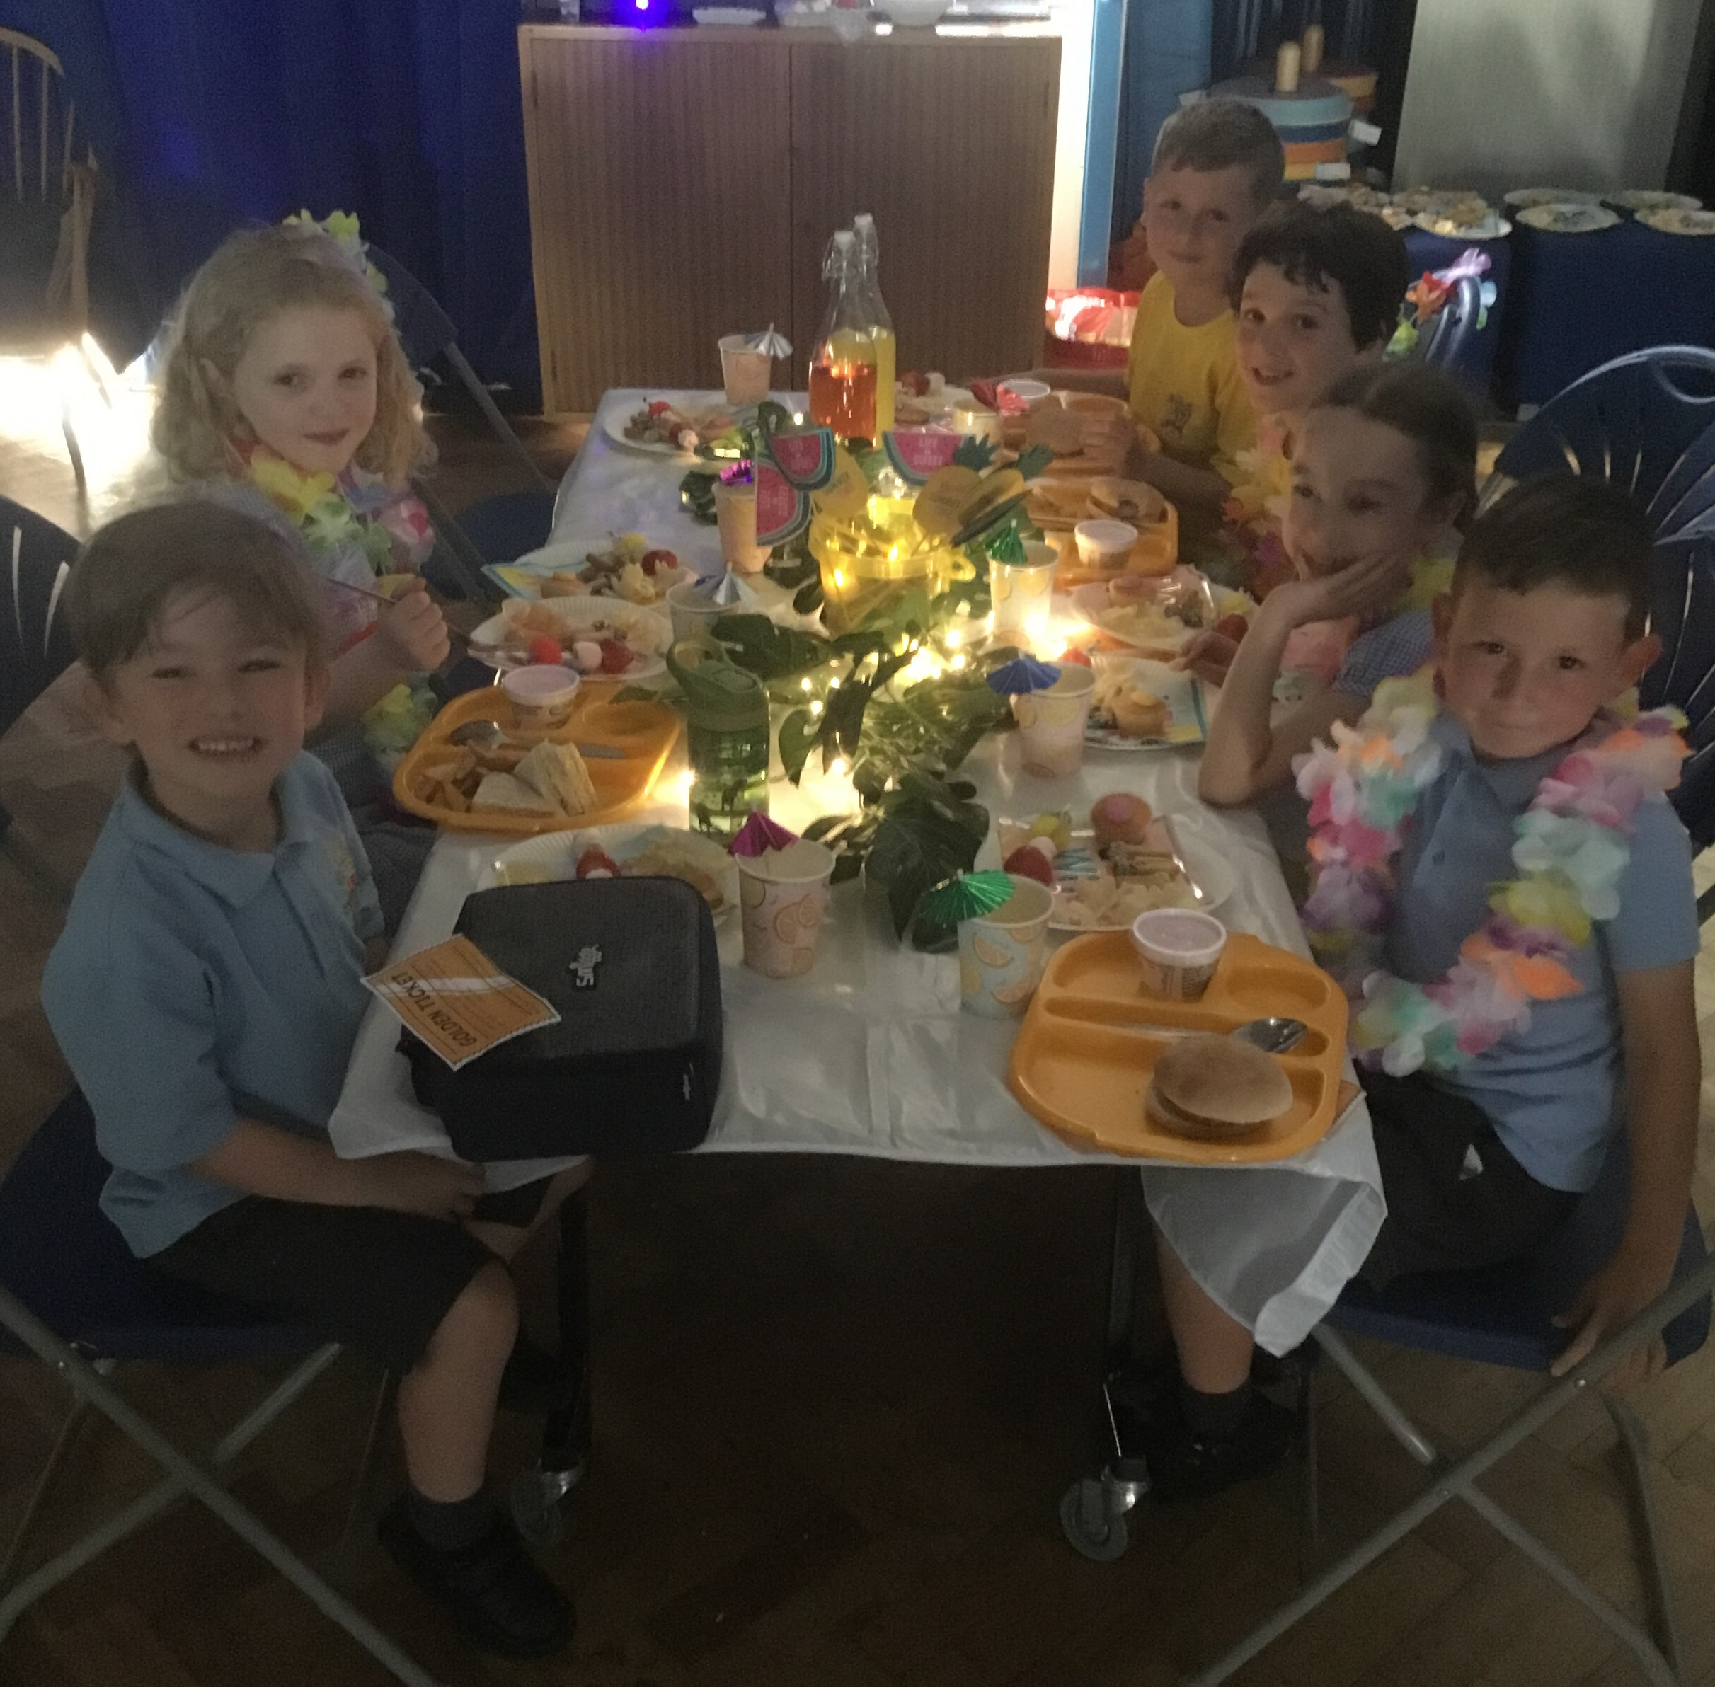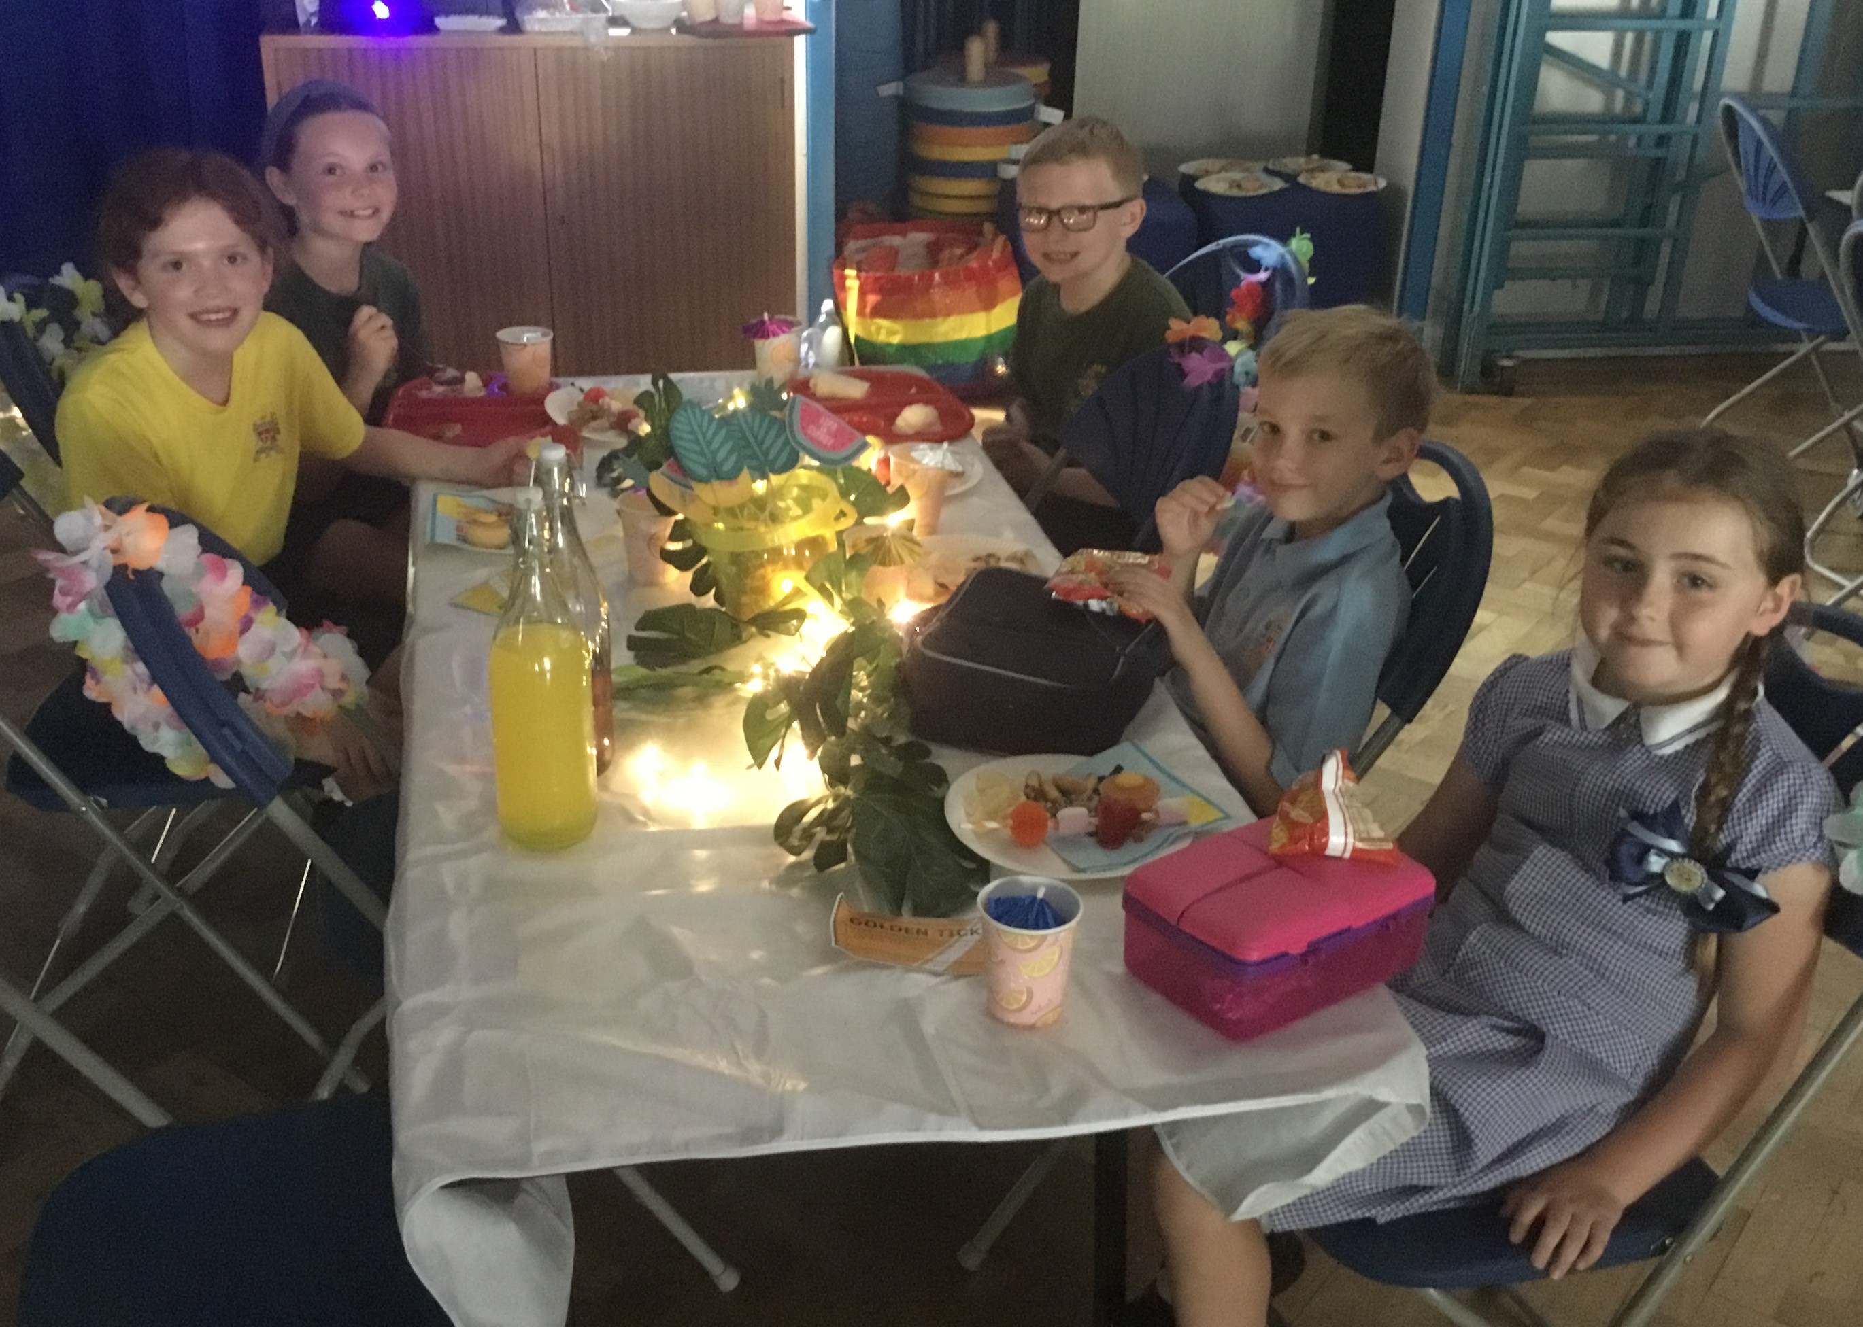

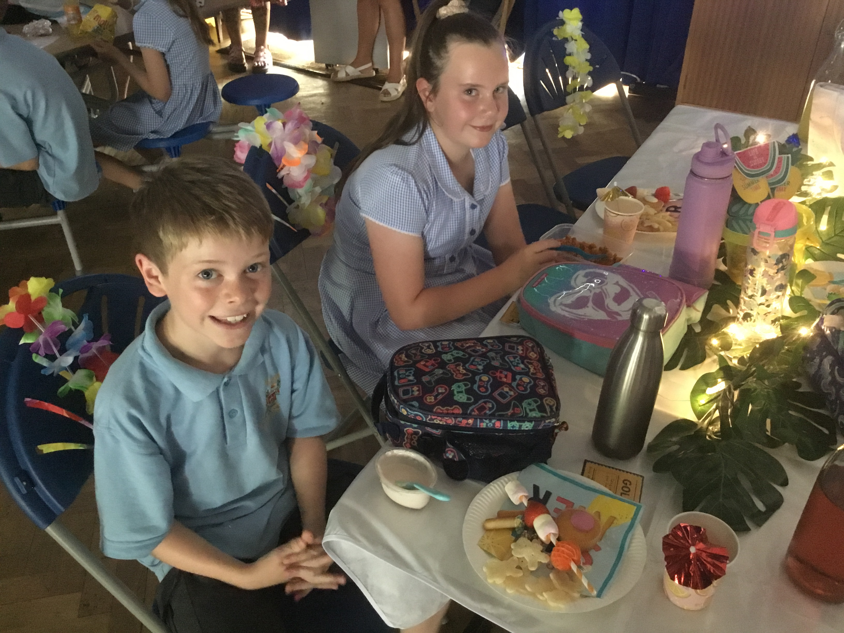

School opens for the new academic year on Monday 5th September.

Arrangements for September 2022 – Change to school day: 8:50am until 3:20pm
The system in place for entering school in the morning has been running successfully for two years now and many parents have made positive comments about it reducing congestion in the morning, helping children leave their adult and walk in confidently to school. Teachers say it helps the children have a more calm and relaxed start to the day. We will therefore continue with allowing children to enter via the two gates from 8:40am.
However, children will now have to be in school for 8:50am (NOT 8:55 as previously) so please allow time for them to walk to their classroom. If a child is not in class for 8:50am they will be marked late. Texts will be sent if a child is late on several occasions.
Children should enter the school grounds via the gate they have been using this year which was organised alphabetically by surname:
Surnames | Drop off time | Registration starts | Location
A – C inclusive | 8:40 | 8:50 | Brooklands Road
H – K inclusive | 8:40 | 8:50 | Brooklands Road
P – S inclusive | 8:40 | 8:50 | Brooklands Road
D – G inclusive | 8:40 | 8:50 | Church car park
L – O inclusive | 8:40 | 8:50 | Church car park
T – Z inclusive | 8:40 | 8:50 | Church car park

Gates will be locked at 8:50 so please ensure you arrive on time.
Anyone arriving after 8:50am will need to enter via the main entrance and will be marked late.
Home time: Gates will open at 3.20pm for a parent/grandparent to collect their child/ren from their classroom. All teachers will release children from their classroom door in turn as they see an adult they recognise. All year groups must be collected by an adult.
Earrings CANNOT be worn in school. If a child is wearing earrings or any other form of jewellery they will be asked to remove it for health and safety reasons. If a child is having their ears pierced, we advise that this is done at the start of school summer holiday so that the ears are sufficiently healed to enable earrings to be removed for school. If they cannot be removed then they must be covered with tape in school until sufficiently healed.

Summer Reading Challenge
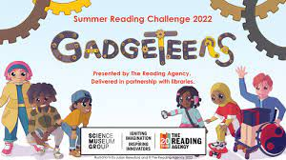
This morning we had a visit from Mandy from Eccleston Library to tell all the children about this year’s Summer Reading Challenge. Our children love reading and the Summer Reading Challenge is a great way for children to keep having access to wonderful books over the Summer holidays.
Join the ‘Gadgeteers’ Summer Reading Challenge 2022 for a very special science-themed Challenge that will inspire children to use their imagination and creativity! In partnership with Science Museum Group the Challenge will be brought to life by top children’s writer and illustrator Julian Beresford. Children can sign-up at their local library and then read any books to collect special stickers and other rewards along the way – all for FREE. Everyone who completes the challenge of reading 6 books or more will receive a certificate and medal.
Lots of exciting events and activities will take place throughout the summer, both in libraries and online. You can sign up at Eccleston Library from 11th July.

Bikeright FREE Learn to Ride sessions
Bikeright are offering FREE Learn to Ride children's sessions during the summer holidays. Free bikes and helmets will be provided. Children need to be at least 7 years old and older. The sessions are being hosted at St Helens Fire Station.
Parents and carers can book on these sessions via the link https://www.bikeright.co.uk/courses/child-group/

On behalf of staff and governors at St Julie’s we would like to thank you for your support throughout the year and wish you
a very happy and peaceful summer holiday.
Mrs Hodgson

St Helens Festival of Imagination
Don't miss the St Helens Festival of Imagination - a time to explore a world of books, words, storytelling and fun with authors and poets on Friday 22nd & Saturday 23rd July 2022

There are lots of events for school age children, but for children from the age of 3, there are short
films like the Gruffalo being shown at Lucem House community cinema. Children can have their face painted and lunch is provided. Each child who registers also receives a £5 book voucher.
For the films, there is no need to book, just register when you turn up on the day
For older siblings who would like to attend the storyteller event or the author talks, book your free tickets here https://orlo.uk/aygLG

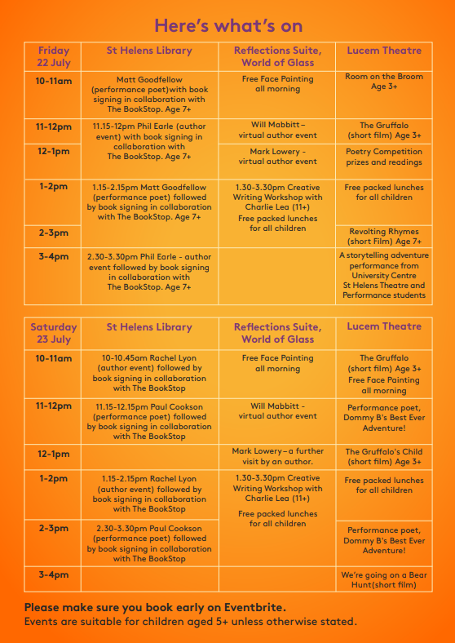

“A caring family school, where we learn, grow and walk in the footsteps of Jesus.”
St Julie pray for us, protect us and bless us.

