|  |  |
| --- | --- |
| St Julie Catholic Primary School - History | |
| Year: 1 - Summer | Topic: Changes within living memory/ Event beyond living memory |

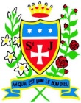

**How has flight changed since humans learned to fly?**

|  |  |
| --- | --- |
| Key Vocabulary | |
| **Aviation** | The flying or operation of an aircraft. |
| **Inventor** | Someone who is the first to think of an idea. |
| **Astronauts** | A person who is trained to travel in a spacecraft. |
| **Mankind** | Human beings / the human race. |
| **Space race** | The competition between nations to get to the moon. |
| **Tourism** | Holidays to visit places of interest. |

**What should I already know?**

How toys have changed within living memory.

That kings and queens have ruled our country and our Queen now is Queen Elizabeth II.

**Sticky Knowledge**

* The 1st manned hot-air balloon flight took off from Paris, France in 1783.
* The Wright Brothers first successful plane flew in 1903.
* Amy Johnson was the first woman to fly solo from London to Australia.
* Insects, monkeys and dogs flew into space before humans.
* Yuri Gargarin was the first man in space, he stayed there for 2 hours.
* Valentina Tereshkova was the first woman to fly to space.
* In 1969 Apollo 11 was the first aircraft to land on the moon.
* New aircraft are being made that can take tourists into space.

**History Skills** I can **compare** the first planes and modern planes. I can **recognise** key events in space travel and **sequence** them on a timeline.

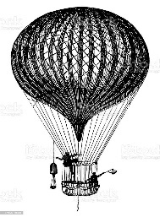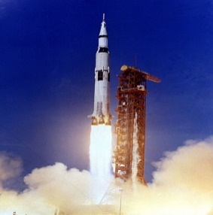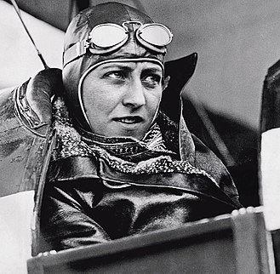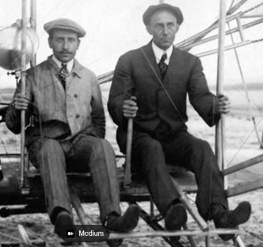

Hot air balloon

The first aeroplane

Apollo 11

Space tourism

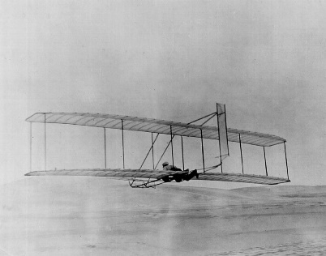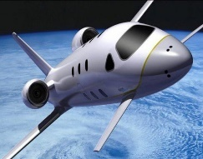

Amy Johnson

The Wright Brothers