Dear Parents,

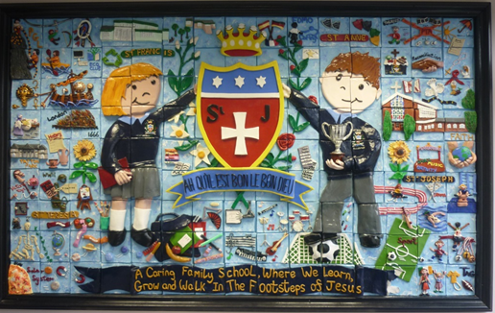
Welcome Back!
A very warm welcome back to school, I hope you had an enjoyable summer. The children all look refreshed and have made a great start to their learning and the staff are all excited about the wonderful opportunities ahead of us this year.
We would like to give a big welcome to all our Reception children who started their St Julie’s journey on Tuesday and have been staying until after their lunch. They all looked smart in their new school uniforms and settled well in their new classroom. We are looking forward to seeing the children again next week when they attend full time.

St Julie’s school mission and core values
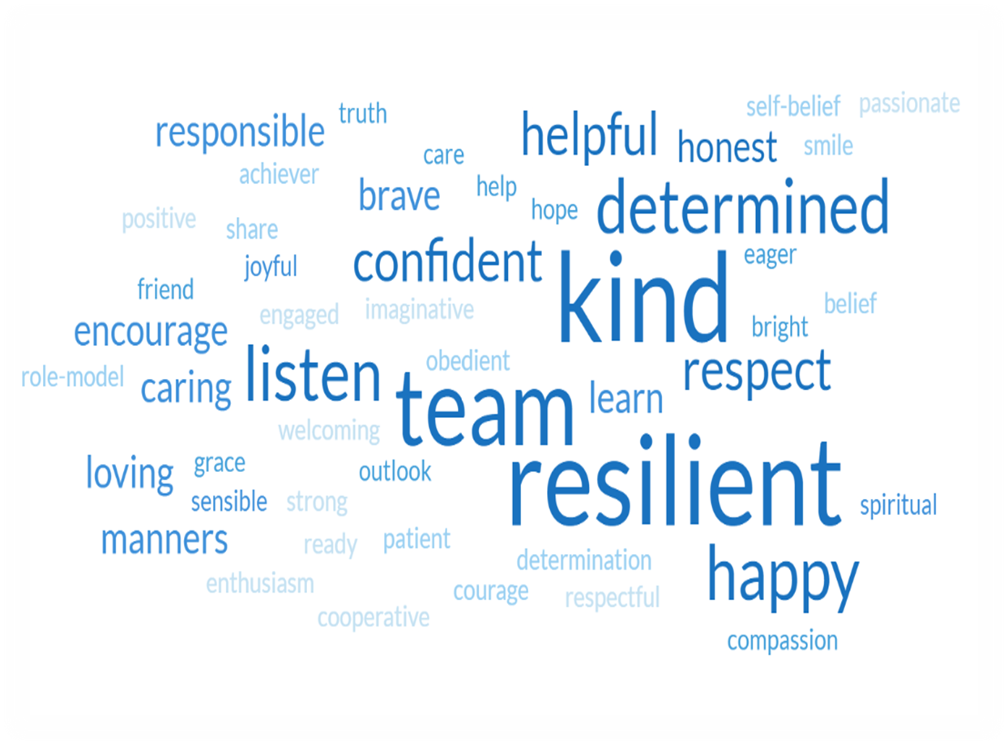
We have started the school year by reviewing our school mission statement and core values with all staff and children. Everyone agreed that our mission statement, “A caring family school where we learn, grow and walk in the footsteps of Jesus,” is lived out every day in our school and truly reflects how we treat each other. Some of the thoughts shared by the children were,” We work together as a team.” “We never go against each other, we care for each other,” “Do what Jesus does,” “Respect everyone and have manners.”
As a school community we also considered what our core values are. The children had many values that they thought were important and that we learn to show at St Julie’s as you can see.
These can be encompassed in our 6 Core Values that guide our footsteps:


During the school year we will focus on one of our core values each half term starting with Respect. Our Star of the Week award will be for a child in each class who that week has shone brightly for showing Respect.


Yesterday we were extremely saddened to hear Queen Elizabeth II, the UK’s longest-serving monarch had died at the age of 96. This morning in assembly we gave thanks to God for her devotion to her people. We shared our memories of the joyful celebrations we had in school in May as we celebrated the Queen’s Platinum Jubilee.. The infant children talked about her love of corgis and of horses, how she was kind to everyone and kept people safe. Some of the Junior children said that a big part of our lives has left us, that she brought happiness and kindness to the world. Some said that she made good life choices; that she worked hard and didn’t stop. Many of the children recalled that she had said, “Try your best everyday.”
Our Queen certainly embodied all the values that we hold dear. Not only was she our Queen, but a mum, grandmother and great grandmother. Our thoughts and prayers are with her family at this sad time.

In remembrance
I wrote to parents earlier in the week with the sad news of the passing of Catherine Morris after a short illness. Many parents with older siblings will remember Mrs Morris as the Headteacher at St Julie’s from 2009 to 2015 before moving on to Headship at Holy Rosary in Aintree. Under Catherine’s leadership, St. Julie grew from strength to strength, and she helped the school develop into the successful learning environment that it is today. Catherine’s legacy will never be forgotten, and we will miss her greatly. Our school community is devastated at the sudden loss of such a great friend.

On Friday 16th September at 3:45pm a Mass will be celebrated for Catherine at St Julie’s school in the school hall for staff, Governors and anyone who knew Mrs Morris that would like to attend.
Please keep Catherine’s husband, Paul, and her boys, Joe and Robert, and her family and friends in your prayers.
May she rest in peace.

St Julie’s School gala
Unfortunately, we have had to take the decision today to cancel the St Julie’s School Gala which had been rescheduled for Sunday 18th September. As you will know, following the death of Queen Elizabeth the nation has entered a period of mourning and as a school and public body we have a civic duty to recognise the period of mourning. Therefore, as I’m sure you will appreciate, out of respect the gala will not go ahead.


The PFA AGM will be held in school on Wednesday 28th September at 6pm in school.
Please come along to find out what the PFA is all about – they are always looking for support in any way you can and for fresh ideas. All are welcome!

School lunch changes
A reminder that the school catering staff ask for 2 weeks’ notice of a change from packed lunch to hot meal or vice versa.

After School Clubs
Our programme of after school clubs for Year 1 up to Year 6 will begin week commencing Monday 19th September. A full list of clubs available will be sent home next week for you to sign up to.


Summer Reading Challenge ‘Gadgeteers’
This is the final week to take part. In order to complete the challenge, collect the stickers and receive their very own ‘Gadgeteers’ certificate, pupils need to read and return their six library books to their local library before 1pm on Saturday 10th September.
They will then be invited to a special presentation when The Mayor of St Helens, Councillor Sue Murphy, will present certificates to all the children.

Children’s Liturgy at St Julie’s Parish Church
It is hoped to begin “Little Church” on Sunday 18th September.
The meeting for leaders and helpers will now be held after the 9.30 mass on Sunday 11th September. It is open to all who are interested in helping/leading the Liturgy sessions for Primary aged children. We hope our past liturgy group members will be able to attend and we welcome new members. We will arrange with Father Michael for the delivery for the Liturgy of our children. The children’s liturgy is open to all Primary School pupils, ranging from Reception to Year 6. If you are interested in helping to re-establish the liturgy group, please ring John Leake on 07753410686 or speak to Clair Kernick at St Julie’s school.

Church car park – Monday 12th September
On Monday repair work will be carried out on the Church Hall. Please expect disruption and limited space availability on the Church car park.


Year Group Reading Meetings
As we start the new school year you are invited to attend a meeting led by the class teacher to outline the approach to teaching mathematics and reading for the year group and how you can support your child in their reading journey. We believe that children should have access to as many reading opportunities as possible, to read widely and deeply, and that being read to should continue throughout primary school so that all children can experience the sheer joy of reading, read books with powerful themes, books by modern authors as well as great works of literature.
The meetings will be held in your child’s classroom and should last no longer than 30 minutes. It would be great if all children are represented by an adult attending and you will have the opportunity to ask questions.
Tuesday 13th September 4:30pm Year 6
5:00pm Year 1
Wednesday 14th 4:30pm Year 3
5:00pm Year 4
Thursday 15th 4:30pm Year 2
5:00pm Year 5

Home School Agreement
Home School Agreements will be sent out this week. Please ensure that you read it and that you also share it with your child as these form part of our behaviour policy. Once read, please sign the agreement and return it to school. Thank you.

Please ensure names are in all school uniform – it is extremely difficult to find lost items if there are no names in them.


Attendance
Following the impact of the past 2 years of disruption to children’s learning it is more important than ever that children are in school every day. Excellent attendance at school is important to allow a child to fulfil their potential. I am confident in your support in ensuring that your child strives for 100% attendance each week. Holidays during term time will not be authorised
Prior to the pandemic our whole school attendance for the year was 98% so this is the target we are aiming for this year.
Each week we will report on attendance figures for each year group.

Year Group | % Attendance for w/e 09.09.22
Year R | 100%
Year 1 | 100%
Year 2 | 97.71%
Year 3 | 100%
Year 4 | 97.22%
Year 5 | 98.75%
Year 6 | 99.71%

Well done to all the children in Reception, Year 1 and Year 3 who have made a fantastic start to the new school year!
I am delighted to say that our whole school attendance this week is 98.99%


Punctuality
Thank you to all those parents/carers and grandparents who have ensured that the children are in school on time this week; we have had very few late marks this week.
The children can come in from 8:40am but must be in their classroom for 8:50am when the register is called.
From next Monday if your child is marked as late, you will receive a text reminder about being in school on time.

Instrumental Tuition at St Julie's Catholic Primary School

We are delighted to let you know that The Schools Music Service will be returning to provide instrumental music tuition in your school from this term onwards.
We currently offer classes on clarinet, flute, guitar, keyboard and violin in school, in small group half hour sessions, during the school day.
It is our belief that music greatly enriches the life of a child, both academically and socially.

If you would like more information about classes here is a link to our website where you can see how everything works - www.schoolsmusicservice.co.uk

If you know what instrument your child would like to learn, or you have learned with us before, you can register for classes on our website and I will sort everything out for you.
Please watch our short video for more information.
Also, if your child has had music tuition with us in the previous academic year, please ensure that you have made a new application for this year's tuition to put them back onto the teacher's pupil list.
Our teachers are extremely excited to be coming back to your school and we look forward to meeting you all soon.




St Julie’s Awards of the Week

 | Star for showing Respect | Book explorer | Marvellous mathematician
Reception | Everyone!
Year 1S | Josefina D | Daisy D
Year 1J | Sienna H |  | Raphie B
Year 2 | George N | Freddie F | Olly McA
Year 3 | Alice J | Luca P | Benji L
Year 4 | Ivan W-S | Evie M | Tommy D
Year 5 | Hannah B | Heidi D | Lucas C
Year 6 | Hannah | Matthew A | Evan F

Diary w/c 12.9.22

Monday

Tuesday 4:30pm Y6 Parent Reading Meeting
5:00pm Y1 Parent Reading Meeting

Wednesday 4:30pm Y3 Parent Reading Meeting
5:00pm Y4 Parent Reading Meeting

Thursday 4:30pm Y2 Parent Reading Meeting
5:00pm Y5 Parent Reading Meeting

Friday Mass for Mrs Morris in the school hall at 3:45pm

“A caring family school, where we learn, grow and walk in the footsteps of Jesus.”


St Julie pray for us, protect us and bless us.

