Dear Parents,




Month of the Rosary
Every year we celebrate the memorial of Our Lady of the Rosary on October 7th and the month of October is dedicated as the Month of the Rosary. We have our lovely prayer garden dedicated to Mary which the children can visit for quiet prayer and refection.
Parishioners from St Julie’s Rosary Group will be coming in to visit Year 3 on Wednesday morning to talk to them about the Mysteries of the Rosary.

Welcome Fr Michael
This week we were delighted to welcome Fr Michael Harwood to our school. Mrs McCahey, our RE Lead, and I met with Fr Michael to make plans for the year ahead. Fr Michael is the Parochial Administrator for St Julie’s Parish and will be saying Mass at St Julie’s on Sunday at 9:30am, Monday 9:30am and Thursday 9:30am.
Little Church is up and running at Sunday Mass for all the children from St Julie’s school to attend.

Fr Michael is also Priest for St Thomas of Canterbury Parish and asked me to pass on to you that if any of you know some of their Parishioners who were previously involved as Eucharistic Ministers or Readers could they make themselves known to him if they are willing to continue when the Church reopens – see details below:

Opening of Saint Thomas of Canterbury. It was announced at the consultation meeting held on Tuesday 20th September that Archbishop Malcolm has agreed that the church can open for a period of 12 months. The timescale for the opening is Advent, so there is much to do in a short space of time. I suggest the way forward is to establish a small parish committee. If you are a parishioner of Saint Thomas of Canterbury and willing to join this committee, please register your interest with Marilyn by Thursday 29th September stmaryandstthomas@rcaolp.co.uk Many thanks, Father Michael.

Year 6 Collective Worship
Year 6 would like to invite family members to join them in their classroom for their first Collective Worship of the year on Wednesday 5th October at 3pm. Please enter the school via the main school entrance on Brooklands Road.
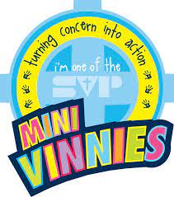
Minnie Vinnies
Mrs McCahey was delighted with the number of children who came to the first Minnie Vinnie’s meeting on Thursday lunchtime – 51 of them! Their mission as Minnie Vinnies was explained again to the children and they will continue to meet On Thursday lunchtime – if the number remains high, the group will be split so that they can meet on alternate weeks.


World Mental Health week
The theme of 2022's World Mental Health Day, set by the World Federation for Mental Health, is 'Make mental health and wellbeing for all a global priority.' To give you some notice we would like the children to raise awareness by wearing something green with their school uniform on Friday 14th October.

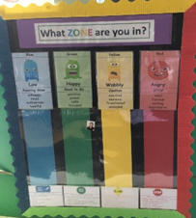
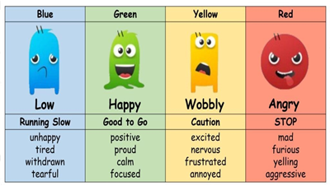
Zones of Regulation
At St. Julie’s Primary School, we recognise the importance of promoting positive mental health and emotional wellbeing to our students and their families. We aim to create an open culture around the discussion of mental health and wellbeing and to empower our children be able to regulate their emotions. By implementing the Zones of Regulation curriculum we aim to teach our pupils to identify emotions in themselves and others and provide them with bank of strategies to help regulate their emotions and improve their wellbeing.
The Zones of Regulation is a range of activities to help your child develop skills in the area of self-regulation. Self-regulation can go by many names, such as self-control, self-management and impulse control.
Please refer to the website under the Health and Wellbeing tab to find out more information about the Zones of Regulation and the parent information letter attached with this bulletin.

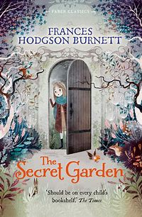
M&M Productions: “The Secret Garden.”
We are excited to welcome back M&M Theatrical Productions to St Julie’s following a break of 2 years due to the pandemic. They have presented Classic Literature Adaptations for several years at the school and this year will be performing an adaption of Frances Hodgson Burnett’s “The Secret Garden,” on Friday 7th October.
The school hall will be transformed into a theatre where all the children can enjoy the production. The cost of the production is expensive but we consider it to be good value in providing the children with a theatrical experience without the additional cost of a coach. To cover the cost of the performance we ask for £4 per child which can be paid via School Money. Thank you to those who have already paid. The payment is made via School Money.


National Poetry Day – Thursday 6th October
This year's National Poetry Day is on Thursday 6 October 2022. The theme for National Poetry Day 2022 is The Environment. During the day the children will take part in different poetry activities
We will also be holding our very own poetry competition. We would like the poem to be about The Environment, all poems must be returned to school by Tuesday 11th October. All children entering the competition will receive a certificate and the reading ambassadors will judge the winning entries.
We also have a selection of books by the Children’s Laureate, Joseph Coelho, in the school library that the children can read and share with their friends.


This Year's "Cycle to School Week" is from the 3rd to the 7th October.
Cycle to School Week is a week-long event where families are encouraged to try cycling and scooting to school.
It’s a great way to celebrate the vast benefits an active school run brings, including its positive impact on children’s health and wellbeing, local air quality and carbon emissions.
However, please remind your children that for the safety of others, they must not ride bikes and scooters on the playground or school drive on the way home. Thank you.


PFA
Thank you to all those who came along to the meeting last Wednesday – it was wonderful to see new faces and many great ideas were shared. The Chair of the PFA is putting together a letter with future events and resources that we want to fundraise for which will be emailed out shortly.
The first event will be for our Autumn Fair after school on Friday 21st October, 3:15 until 5pm
The next meeting of the PFA will be held next Wednesday 16th November at 6.00 pm in the school.


Healthy school
A reminder that children can bring one healthy snack of fruit or toast to school for break time. However, as a healthy school please do not send in any chocolate or sugary snacks. Infants can also choose to have a piece of fruit each day. Water bottles must contain water only – no juice. Thank you for helping us to maintain a healthy lifestyle for our children.

Drop off and pick up
I need to remind parents/carers about driving and parking safely in the church car park and to not park/stop on the corner of Acacia Grove/Brooklands Road. Can parents please parents ensure they walk their child to the gates and to the teacher rather than leaving them at the top of the car park.


Parents Evening - Tuesday 18th October
For 2 years now the school has used the online booking and video call system – “School Cloud” for our Parents Evening. We have received a lot of positive feedback from parents about the system as it allows parents to speak with the teacher from work or home and avoids waiting in a queue at the school. The online system allows you to choose your own appointment times with teachers, book online and attend a web-based video call in place of a face-to-face meeting. Once your slot is booked you will receive an email confirming your appointment/s. A letter with further details about how to access the system will be emailed to you on 7th October.
As usual at this time of year, our first parent’s night is a pastoral chat to see how your child has settled in their new class and so appointments will be 5mins.

Appointments can be made when the system goes live from 4.00pm Monday 10th October and will close at 4.00pm on Monday 17th October.


Science at St Julie’s
Mrs McCahey has sent home a Parent Voice Survey for science this week. The Science page on the school website is full of information about the science curriculum that your children are taught at St Julie’s and ideas for how you can support science at home. Please share your views via the survey so that we can work in partnership to continue to enhance our science provision. We look forward to receiving your completed questionnaires.
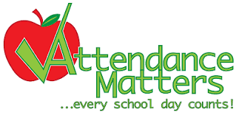
.
Attendance
Following the impact of the past 2 years of disruption to children’s learning it is more important than ever that children are in school every day. Excellent attendance at school is important to allow a child to fulfil their potential. I am confident in your support in ensuring that your child strives for 100% attendance each week. Holidays during term time will not be authorised
Prior to the pandemic our whole school attendance for the year was 98% so this is the target we are aiming for this year.
Each week we will report on attendance figures for each year group.

Year Group | % Attendance for w/e 30.09.22
Year R | 98.15
Year 1 | 93.14
Year 2 | 97.14
Year 3 | 96.57
Year 4 | 98.61
Year 5 | 95.31
Year 6 | 98.86

Well done to Year 6 who had the highest attendance this week.
Our whole school attendance this week is 96.83%

All About Family Autumn edition
Please see the link below to the Autumn edition of All About Family St Helens magazine.
Inside you will find advice on:
Making the Most of Open Days
Cyber Bullying
New Children's Books
Merseyside Fire Brigade Autumn Safety Advice
Back to School Internet Safety
Family Events

www.allabout-family.co.uk/st-helens/
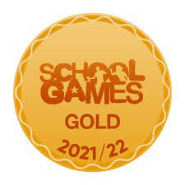

Year 6 Boys Football Competition

On Tuesday a team of year 6 boys went along to Ruskin to compete in a tournament. They represented our school well and showed great team spirit. Well done!

Year 4 Dodgeball Competition
On Wednesday a group of Year 4 children went to the Dodgeball competition at the Broadway centre. They had an enjoyable afternoon and demonstrated great team work as they competed against other school in the area. Congratulations on your great effort.


Raise valuable funds for St Julie’s while you shop with “Easyfundraising”
By downloading this app you can collect FREE funds for St Julie’s every time you shop online!
Just visit easyfundraising.org.uk, search for St Julie Catholic Primary PFA and follow the simple steps to sign up. Then start shopping using the links to over 2,000 retailers including Amazon, John Lewis, M&S, Argos, Next, ASOS and many more. Every time you shop, you’ll earn a donation for the school at no additional cost to you!




St Julie’s Awards of the Week

 | Star for showing core value of Respect | Book explorer | Marvellous mathematician
Reception | Rose | Teddy | Matthew
Year 1S | Ivy B | Gia G
Year 1J | Toby F |  | Joel R
Year 2 | Thomas G | Ben F | Riley G
Year 3 | Xavier O | Thomas B | Max H
Year 4 | Thomas H | Gracie D | Bertie B
Year 5 | Kai B Isaac S | Anna F | Seb G
Year 6 | Owen R | Isabella D | David B

Pre-loved St Julie’s uniform
We have many items of school uniform stored at the school office which was collected for a uniform sale held at the Village Hall back in July. If you require any pieces of uniform please call at the school office where we have uniform sorted into age groups. If you can, a small donation of any amount would be useful for school funds.

Diary w/c 03.10.22
Monday KS2 Comic book club 3:20 – 4:15

Tuesday Y5/6 Tag Rugby 3:20 - 4:15

Wednesday Y6 Collective Worship 3pm in the classroom.
Y2 Spanish 3:20 - 4:00
Y1 Construction club 3:20 - 4:15
Y5/6 Young Voices choir 3:20 - 4:15
Y4/5 Cheerleading 3:20 - 4:15
KS2 Sewing/craft 3:20 - 4:15

Thursday KS2 Eco club 3:20 – 4:15
Y3/4 Lego club 3:15 - 4:15

Friday M&M Theatrical Productions, “The Secret Garden”

Further dates for your Diary
Friday 14 October - World Mental health day – wear something green with school uniform
Tuesday 18 October - Apple of my Eye cookery session in school – Reception class
Tuesday 18 October - Parents’ Evening via School Cloud – details will be sent later
Friday 21 October - Close for Half Term
Tuesday 1 November - School re-opens
Wednesday 2 November - Flu immunisations in school

Scarlet Fever Guidance
The North West Health Protection Team has this week provided an update on Scarlet Fever:

Rates of scarlet fever are continuing to rise, both regionally and nationally, and are higher than would be expected for this time of year.
Signs and Symptoms of Scarlet Fever: sore throat, headache, fever, nausea and vomiting. After 12-48 hours a red, pinhead rash develops, giving the skin a sandpaper-like texture. Infections can be spread through direct physical contact and through shared contact with surfaces.
Action to take: children should not attend school until 24 hours after starting antibiotic treatment and whilst scarlet fever is circulating, it is important that any children and adults with chickenpox stay off school/work until all blisters have dried over—usually 5 days after they first appeared.

“A caring family school, where we learn, grow and walk in the footsteps of Jesus.”



St Julie pray for us, protect us and bless us.

