Dear Parents,

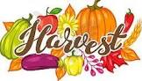

Harvest Service
At this time of year we take time to reflect on the nutritious food that we have readily available to us and give thanks to God. All parents are invited to join us as we celebrate our Harvest Festival in church on Thursday 20th October starting at 1:30pm. We will also be welcoming our Reception class into our St Julie’s family during the service. The theme this year is to brighten up the harvest in support of our brothers and sisters around the world who are hungry and build a brighter world together. Therefore, we would like children to wear bright accessories with their school uniform on Thursday.
We would be very grateful for donations of tinned and dried food products which we will then be taken to the St Helens Foodbank and Teardrops. Please send in donations from Monday – Items needed at the food bank include: Coffee/sugar/pasta sauces/noodles/tinned fruit/custard/toiletries/long life milk/juice/instant mash/pasta in sauce/long grain rice/tinned tomatoes/jam/chocolate/crisps. Thank you.

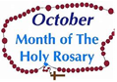
Month of the Rosary
This week Year 3 received a visit from two members of the Walsingham Association in St Julie’s Parish to talk to them about how to pray the Rosary and to reflect on the Mysteries which tell the story of Mary and her son Jesus. The children were each given a prayer card to take home.
Junior children are invited to join Mrs McCahey on Friday lunchtimes during October
to pray the Rosary. They can bring in their own Rosary beads if they have them or we have many available in school.

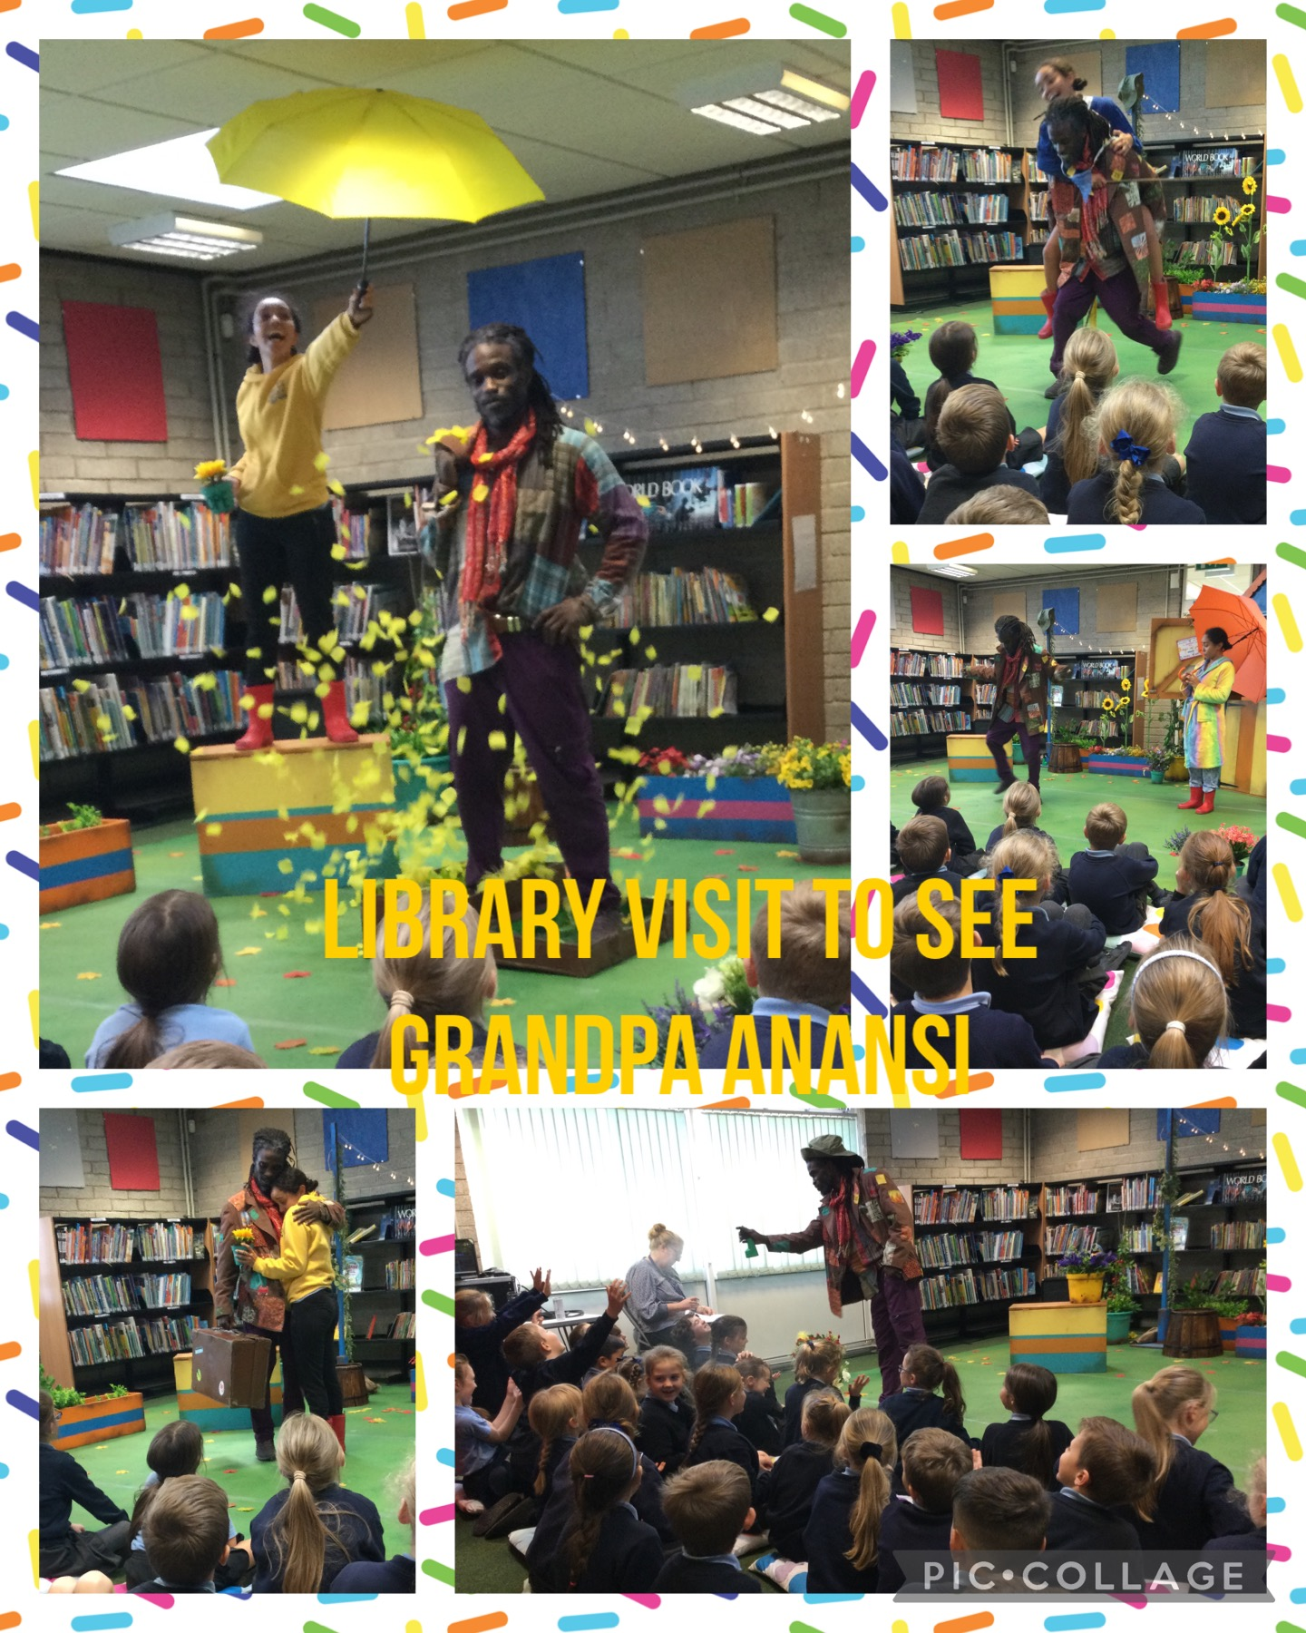
Year 3 visit to Eccleston Library
To celebrate Black History month Eccleston library hosted a performance of Grandad Anansi yesterday which Year 3 attended.
Grandad Anansi is an uplifting tale of love, courage and letting go. With evocative live music, humorous and heartfelt inter-generational adventure as Grandad tried to find a way to tell his granddaughter about his plans to return to Jamaica, his beloved homeland.
The children were enthralled by the live performance and said it was “amazing!”

Rugby League World Cup
At the start of the Rugby League world cup, our children were excited to welcome players from the Tongan team
to St Julie’s on Tuesday afternoon. The children asked thoughtful questions about the players’ home countries and playing rugby at such a high level. As a welcome gesture we presented the players with St Julie’s favourite flowers – sunflowers.

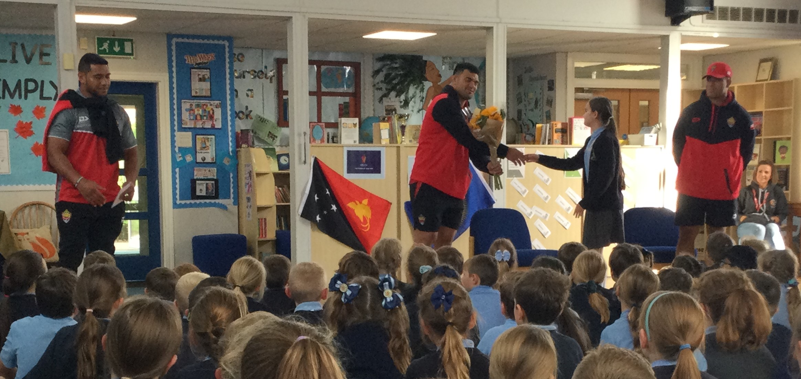

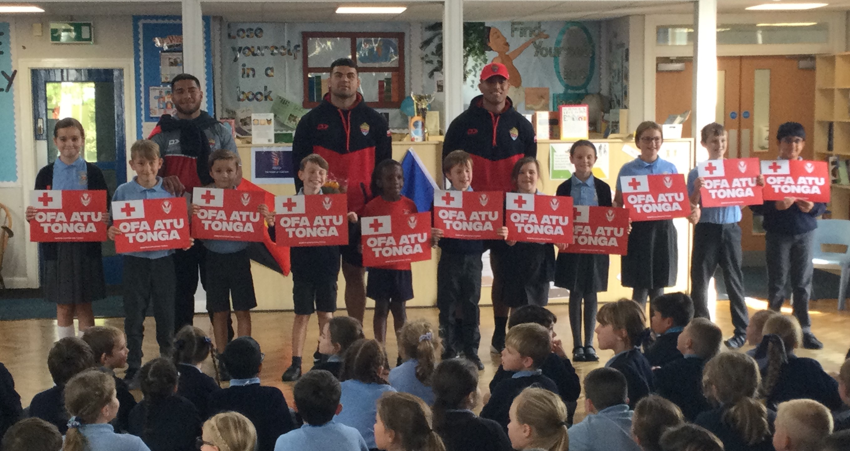


Competitions this week:
On Monday there was a Year 4 Boys’ football competition and then on Friday a Year3/4 Girls’ football competition held at Sutton Academy. The children representing St Julie’s performed well as a team and enjoyed competing against other local schools.
On Thursday a Team from Year 6 competed in the Rugby World Cup Festival at Ruskin. They did themselves and their school proud by winning 7 matches, getting through to the final and winning the silver medal.

Year 6 Playground Leader Team
Several of our Year 6 children have trained with the St Helens School Games team as Playground Leaders. Having completed their training they were presented with their certificates today and begun putting their skills into practice this afternoon, teaching our Year 2 children new games that they can play during their playtimes.
Congratulations to Lucy, Rosie, Owen, Hollie, Robbie, Tiana, Grace, Charlotte, Daniel, David, Sophie, Tehilla, Evan, Hannah, Louie and Molly.

Poetry Competition winners
On National Poetry Day we launched a competition for children to write a poem with the theme of The Environment. We were delighted with the huge number of entries from our enthusiastic poets. Our Reading Ambassadors had the tough job of choosing the 3 winners and this morning in assembly presented them with their certificates and prizes. The winning poets proudly read their poems out loud in the hall; they were:
Jacob Mooney
Phinnaeus Kelly
Alice Balmer



At the start of the school year we had a whole school book focus on the Oliver Jeffers book Here We Are. The children from Reception up to Year 6 all enjoyed sharing and discussing the picture book and produced great pieces of writing as a result. Oliver Jeffers will be at Waterstones bookshop in Liverpool tomorrow, Saturday 15 October, at 12noon signing copies of his brand new children’s book, Meanwhile Back On Earth. If you get chance to pop along, please send a photo into school.


Parents Evening - Tuesday 18th October
Thank you to those who have booked their appointment for Parents Evening next week. On Monday you will receive an email with protocols for using School Cloud and a link that you will need to join the meeting on Tuesday. In preparation for the session and to make sure it runs smoothly please check the camera and microphone on your device are working.


Children’s University
Children at St Julie’s are all part of the Children’s University which is a charity which aims to encourage children to participate in extra-curricular activities in and outside school. Children can gain points for taking part in accredited extra-curricular sessions which will earn them diplomas which are presented at a graduation ceremony. You can read even more about the Children’s University programme on our dedicated webpage St Julie's Catholic Primary School: Children's University (st-julie.st-helens.sch.uk).
Children can log the points they earn outside school in a Children’s University Passport to Learning which must be signed and dated each time an activity is completed. You can purchase a Passport to Learning from the school office for £5. Just let us know that you require one and a School Money payment will be set up for you. A passport isn’t needed for earning points at clubs in school, just for out of school clubs and for any of the Children’s University holiday challenges that children complete.


Practical Cookery Workshops
In line with the National Curriculum Design and Technology Programmes of Study for Food and Nutrition every class will experience a practical cooking session provided by “Apple of my Eye” during the school year. Reception class have their session on Tuesday – thank you to those who have already paid on School Money.
We ask for a payment of £6 per child to cover the cost which can be paid via School Money.

.
Attendance
Excellent attendance at school is important to allow a child to fulfil their potential. I am confident in your support in ensuring that your child strives for 100% attendance each week. Holidays during term time will not be authorised
Prior to the pandemic our whole school attendance for the year was 98% so this is the target we are aiming for this year.
Each week we will report on attendance figures for each year group.

Year Group | % Attendance for w/e 14.10.22
Year R | 96.67
Year 1 | 97.71
Year 2 | 92.00
Year 3 | 98.86
Year 4 | 95.28
Year 5 | 98.75
Year 6 | 93.71

Well done to Year 3 who had the highest attendance this week.
Our whole school attendance this week is 96.14%


Forest School
The children are all eager to carry on their outdoor adventures and to go exploring in the school grounds again.
Next week Forest School sessions will be for:
Year 1 on Monday 17th October
Year 6 on Thursday 20th October
The children should come in their own outdoor clothes for the day – with trainers if it has been dry or wellies if the ground will be wet. Year 6 are requested to bring in their uniform so that they can get changed at lunchtime ready for the Harvest Festival.
The dates for the other year groups will be added next half term.


The Royal British Legion Poppy Appeal
Poppies, wristbands, reflectors, zip pulls and snap bands will be available from the school office from next week for a donation of £1 per item in aid of the Royal British Legion poppy appeal.

Catechists to support Sacramental programme
Fr Michael has put a message in the church bulletin this week asking for volunteers to help with the sacramental programme this year:
Volunteers are needed to work with Father Michael, in parental support in the preparation of children for First Holy Communion. It would be only 1 hour per month for 9 months, in the evening. Parents with children of the age to receive this sacrament will already be at the classes so we hope that some parents would feel that they could get more involved. Please contact the church office if you would like to volunteer.
Office stjulie@rcaol.org.uk 01744 28196

PFA
Thank you to all those who came along to the meeting last Wednesday – it was wonderful to see new faces and many great ideas were shared. The Chair of the PFA is putting together a letter with future events and resources that we want to fundraise for which will be emailed out shortly.
The first event will be for our Autumn Fair after school on Friday 21st October, 3:15 until 5pm
The next meeting of the PFA will be held next Wednesday 16th November at 6.00 pm in the school.


Raise valuable funds for St Julie’s while you shop with “Easyfundraising”
By downloading this app you can collect FREE funds for St Julie’s every time you shop online!
Just visit easyfundraising.org.uk, search for St Julie Catholic Primary PFA and follow the simple steps to sign up. Then start shopping using the links to over 2,000 retailers including Amazon, John Lewis, M&S, Argos, Next, ASOS and many more. Every time you shop, you’ll earn a donation for the school at no additional cost to you!




St Julie’s Awards of the Week

 | Star for showing core value of Respect | Book explorer | Marvellous mathematician
Reception | Cameron T | Matthew C | Florence L
Year 1S | River D | Theo H | Zac T
Year 1J | Hugo H
Year 2 | Freddie R | Callum F | Freddie F
Year 3 | Aoife J  Lucas L | Aveah D  Joseph W | Alissa  Ryan G
Year 4 | Elsie C  Lexi-Mai B | Sophia L  Archie H | Mia F  Elizabeth S
Year 5 | Ava B | Alfie H | Daniel H
Year 6 | Finley C | Molly L | Sadie D-F

Diary w/c 17.10.22
Monday Forest School – Year 1
KS2 Comic book club 3:20 – 4:15

Tuesday Apple of my Eye cookery session in school – Reception class
Y5/6 Tag Rugby 3:20 - 4:15
Parents’ Night meetings

Wednesday Y2 Spanish 3:20 - 4:00
Y1 Construction club 3:20 - 4:15
Y5/6 Young Voices choir 3:20 - 4:15
Y4/5 Cheerleading 3:20 - 4:15
KS2 Sewing/craft 3:20 - 4:15

Thursday Forest School – Y6 (bring uniform to change into)
1:30pm Harvest Festival
KS2 Eco club 3:20 – 4:15
Y3/4 Lego club 3:15 - 4:15

Friday Autumn Fair 3:20pm school hall
Close for half term break

Further dates for your Diary
Friday 21 October - Close for Half Term
Monday 31st October - Staff Inset day – school closed for children
Tuesday 1 November - School re-opens
Wednesday 2 November - Flu immunisations in school
Tuesday 8 November - Learn to work programme session 2 – Year 6
Friday 11 November - Year 5 trip to Imperial war Museum
Monday 14 November - Odd Socks Day for Anti-bullying week
Wednesday 16 November - PFA meeting 6pm
Monday 28 November - Apple of my eye cookery session Year 4
Thursday 1 December - Forest School day Year 5
Tuesday 6 December - Learn to work programme session 3 – Year 6
Friday 9 December - Christmas Jumper Day
Wednesday 14 December - Christmas Dinner day
Thursday 15 December - Nativity in Church – Year 2
Monday 19 December - Junior Christmas Party day
Tuesday 20 December - Infant Christmas party day
Wednesday 21 December - School closes for Christmas break.


“A caring family school, where we learn, grow and walk in the footsteps of Jesus.”

