Dear Parents,

Welcome back to school, we hope you had a restful half term break. It was wonderful to start our new half term by taking our Junior children up to Mass at St Julie’s church on Tuesday morning to celebrate the feast day of All Saints. The children also got to see Fr Michael, our new Priest, who will also be coming into school in the next few weeks to visit each class. Many of the parishioners commented on how wonderful it was to see the children at Mass and how thoughtful and respectful they all were.


November is the month of the Holy Souls
Traditionally, during the month of November, we remember and pray for those who have died and gone before us. Mrs McCahey has asked if you wish to have the name of a loved one included in our Remembrance Book for the month of November, please send it into school in an envelope marked for her attention as soon as possible.


The Royal British Legion Poppy Appeal
Poppies, wristbands, reflectors, zip pulls and snap bands will be available from the school office from next week for a donation of £1 per item in aid of the Royal British Legion poppy appeal.


Children’s University Autumn Challenge
Thank you to those children who took up the challenge to complete activities set by the Children’s University and have sent their evidence in to school. We have some very creative children. Their credits will be logged and can be added to a Children’s University Passport if they send it in or wish to purchase one for £5.00. Please contact the office who can set up a payment on School Money for you if you wish to purchase a Passport.
The activities can still be viewed on our website if you want to complete an activity this weekend.
See the Children tab on the website for more details about Children’s University.

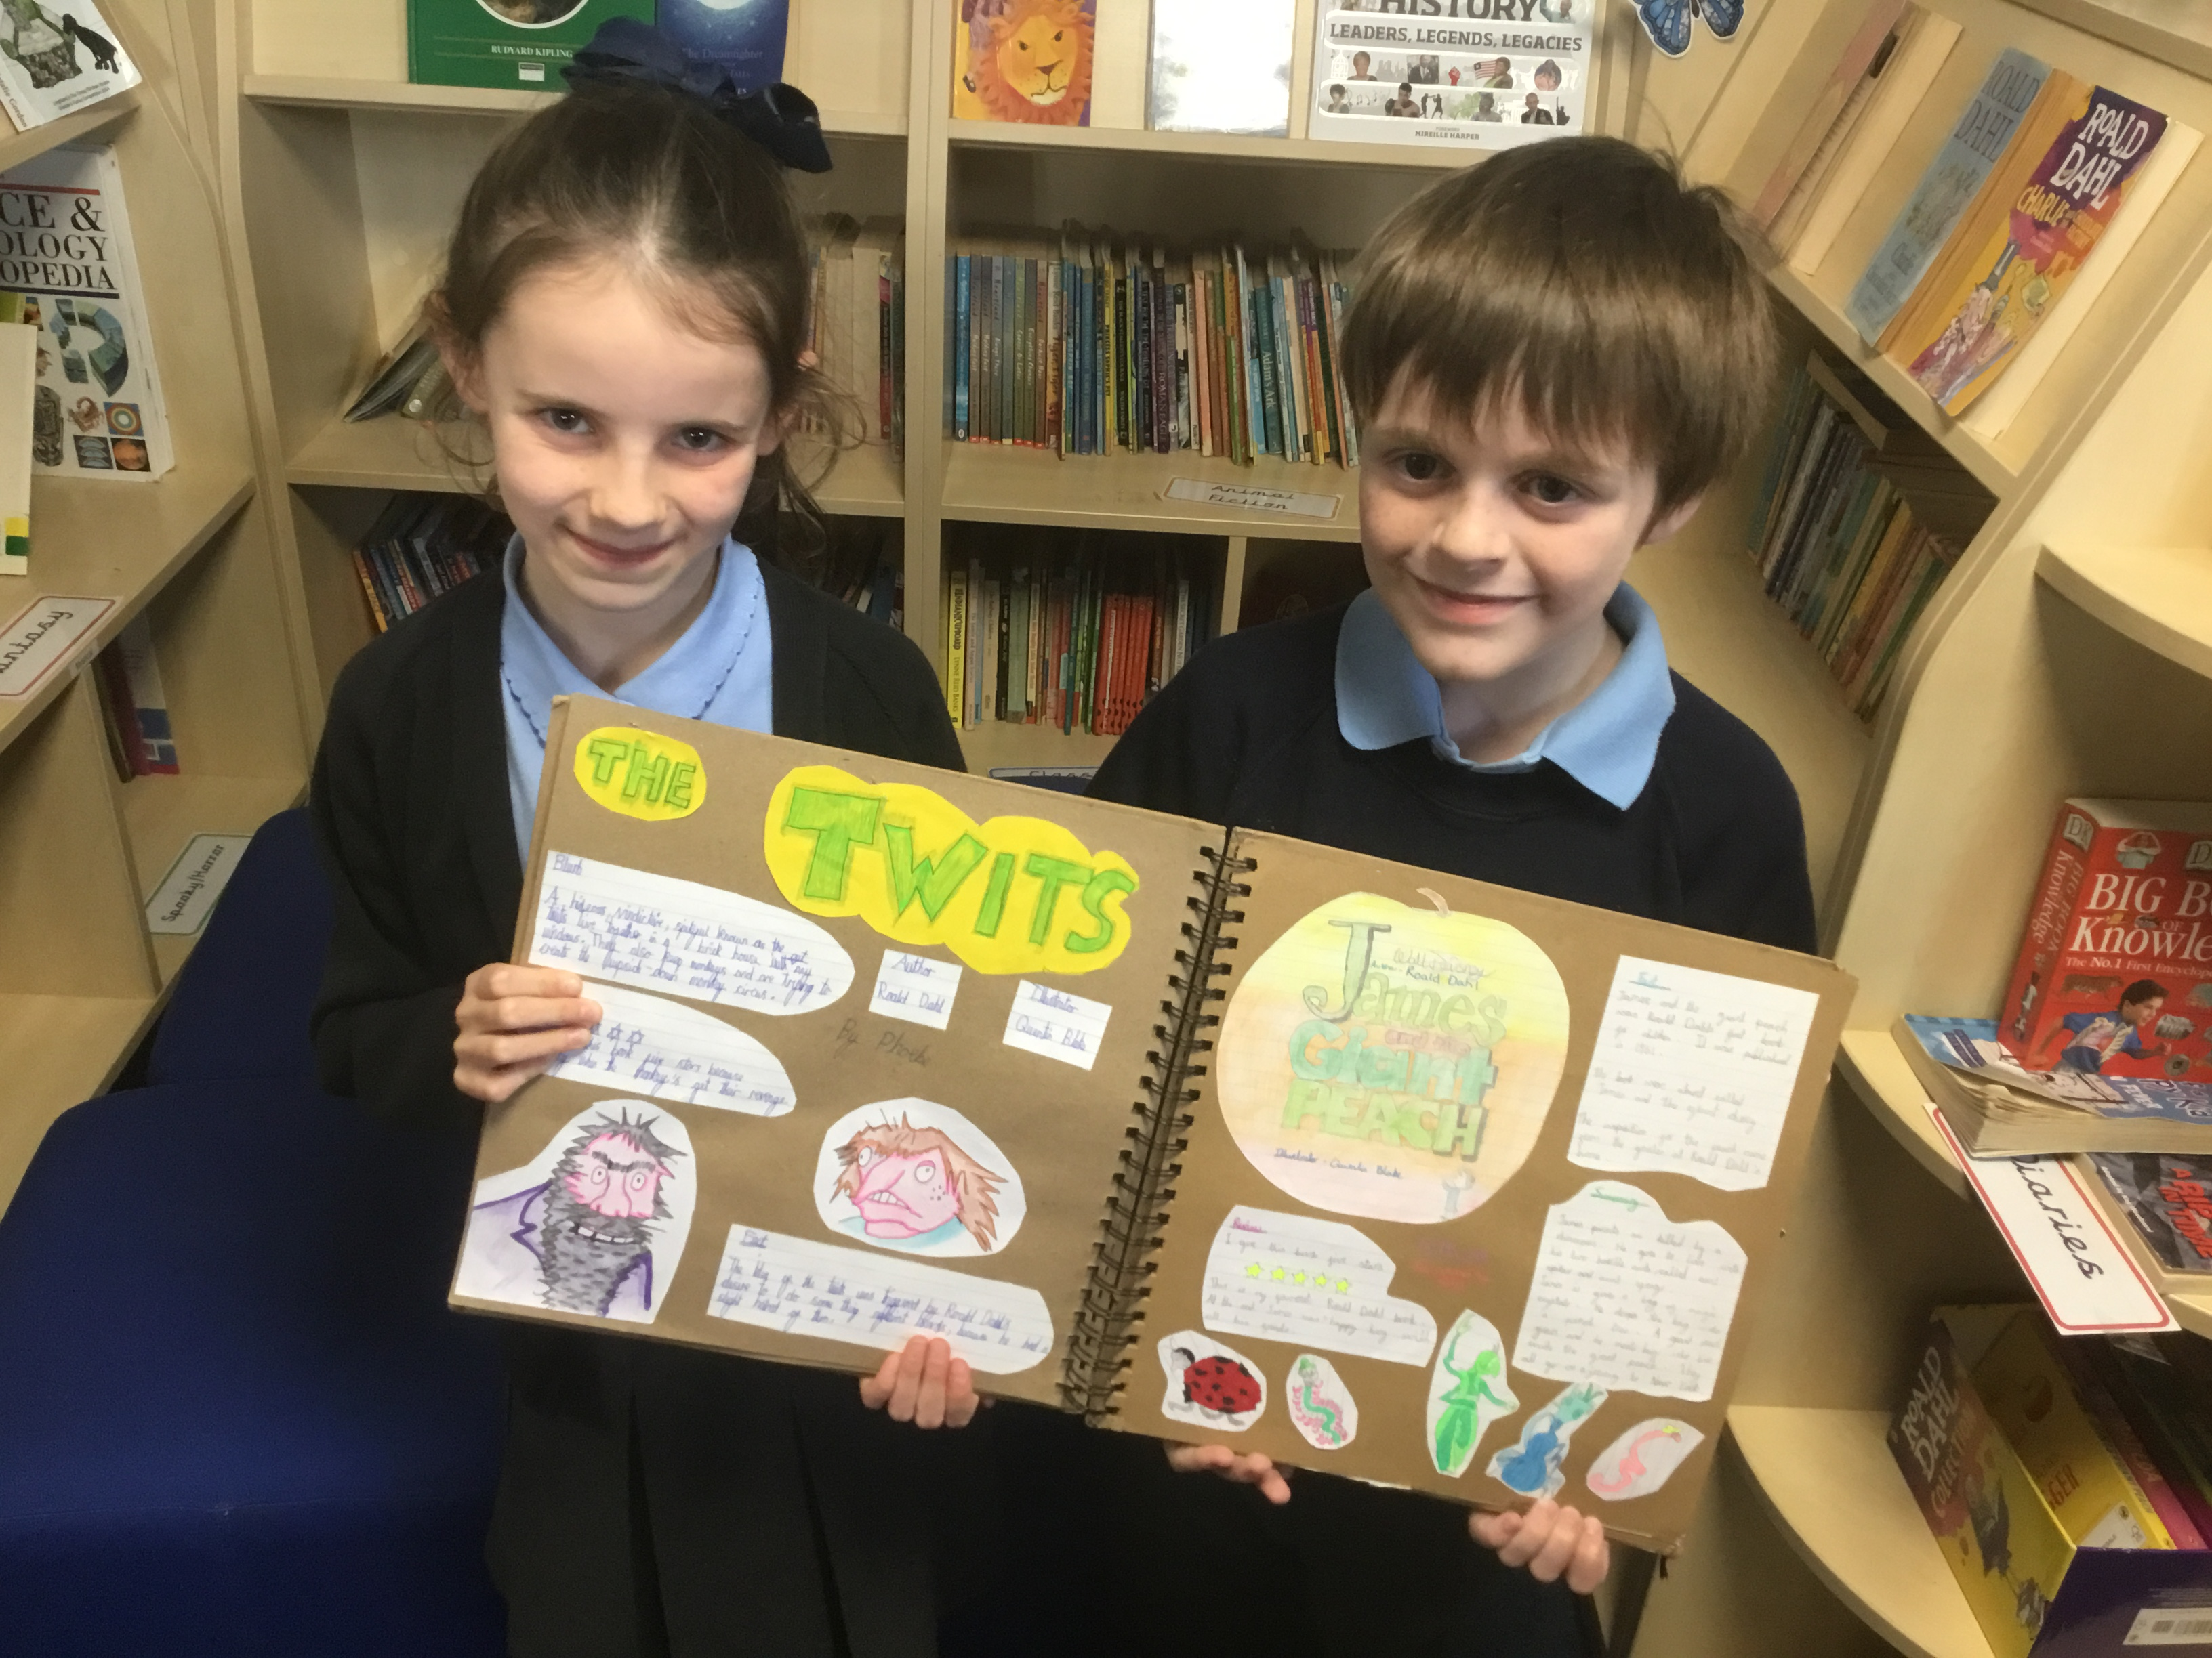
Reading for Pleasure
I was delighted to meet with two of our Reading Ambassadors yesterday as they proudly showed me their class Reading Journal. The children told me that they started the Journal in Year 3 and love doing it so much that they have taken it with them into Year 4 now. They explained that someone from the class takes the large book home each week and completes a page with information about a favourite book, choosing how to showcase the book and the author in whatever way they choose. Both children were excited to talk about how they enjoy looking through the journal to find out about the other books that their friends have read and often this makes them choose to read a recommended book. Their Reading Journal has become a real class treasure.

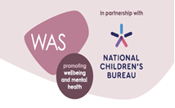
Wellbeing Award For Schools (WAS)
To continue promoting health and wellbeing, St Julie’s is taking part in the Wellbeing Award for Schools (WAS).
The Wellbeing Award is developed in partnership with the National Children’s Bureau (NCB), the award is intended to help schools prepare and equip themselves to promote emotional wellbeing and positive mental health across the whole-school community. NCB’s vision is an education system where good emotional wellbeing and mental health are at the heart of the culture and ethos of all schools, so that pupils, with the support of their teachers, can build confidence and flourish.
In order to evaluate our current provision, we need your input. Your views are important in helping us understand what we are doing well and how we can do even better. An email has been sent today with further information attached about the award.
Can you please complete the wellbeing survey following the link https://app.awardplace.co.uk/stakeholder-evaluations/user-survey/63614ebeca897

Please see the flyer attached with this bulletin that contains information about free mental health and wellbeing Apps.

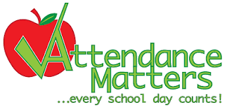
Attendance
Excellent attendance at school is important to allow a child to fulfil their potential. I am confident in your support in ensuring that your child strives for 100% attendance each week. Holidays during term time will not be authorised
Prior to the pandemic our whole school attendance for the year was 98% so this is the target we are aiming for this year.
Each week we will report on attendance figures for each year group.

Year Group | % Attendance for w/e 4.11.22
Year R | 93.98
Year 1 | 94.64
Year 2 | 98.21
Year 3 | 97.14
Year 4 | 98.26
Year 5 | 100.0
Year 6 | 95.00

Well done to Year 5 who had the highest attendance this week.
Our whole school attendance this week is 96.75%

School emails
If you wish to email a member of the school staff, please do this via the school email address marking it for the attention of the named teacher. A member of the office staff will then forward your email to the correct member of staff as soon as they can within working hours. The teacher’s response will then be forwarded back to you, again from the school email. Our school policy is that you do not email teachers directly. Thank you for supporting the school in this way. stjulies@sthelens.org.uk


Microsoft Teams
Please remember to check the class Teams page for your child regularly as this is where homework will be set and messages for the class will be posted.

Parent Questionnaire
Thank you to those who responded to the Parent Questionnaire that was sent out before the half term. A summary of the responses and our actions along with the outcomes of the pupil questionnaire is attached with this bulletin.


Christmas Jumper Day – Friday 9th December
Children grow so quickly that often a Christmas jumper is only worn a couple of times before a child has outgrown it. To help reduce costs at what is a very expensive time of year we would like to be able to offer pre-loved Christmas Jumpers from the school foyer. If you have a Christmas jumper in good condition, please could you send it into school, washed and with a hanger – these will then be available to take from the school foyer for a small donation. Thank you.

Walk Once a Week

Well done to all those who have walked to school at least once a week during October 2022. They will each receive a badge.
Reception | 17 children
Year 1 | 10 children
Year 2 | 16 children
Year 3 | 14 children
Year 4 | 18 children
Year 5 | 15 children
Year 6 | 14 children

Congratulations to the winning class, Year 4, who will look after the trophy this month.

PFA Events
Thank you to all those who came to the Autumn fair. It was a huge success raising a fantastic amount of £850!
This term’s events include:
Friday 18th November - Infant DVD Afternoon 3:20 – 5pm
Friday 25th November - Junior DVD afternoon 3:20 – 5pm

Thursday 24th November - Christmas Bingo 6:30pm Parish Hall
Friday 2nd December - Christmas light switch on 4:30pm in school hall
Sunday 11th December - Christmas Fair 2 – 5pm Parish Hall

Next PFA meeting: Wednesday 16th November, 6pm in school. All welcome.



St Julie’s Awards of the Week

 | Star for showing core value of Unity. | Book explorer | Marvellous mathematician
Reception | Daniel S | George H | Sophie P
Year 1S | Callum F |  | Noah C
Year 1J | Amaya K | Alba M
Year 2 | Olivia P-A | Zara F | Dominic F
Year 3 | Alexa D | Aoife J | Jude Q
Year 4 | Phoebe H | Zak P | Eva P
Year 5 | Noah D | Ava B | Lucas P
Year 6 | Robbie S | Hannah R | Phoebe H

Diary w/c 07.11.22
Monday KS2 Boardgames 3:20 – 4:15
KS2 Garage band 3:20 – 4:15

Tuesday Learn to work programme session 2 – Year 6
Y5/6 Athletics 3:20 - 4:15

Wednesday Y2 Spanish 3:20 - 4:00
Y1/2 Lego/Construction club 3:20 - 4:15
Y5/6 Young Voices choir 3:20 - 4:15
Y4/5 Cheerleading 3:20 - 4:15
KS2 Sewing/craft 3:20 - 4:15
Thursday

Friday Year 5 trip to Imperial War Museum

Further dates for your Diary
Monday 14 November - Odd Socks Day for Anti-bullying week
Wednesday 16 November - PFA meeting 6pm
Thursday 17 November - Forest School day Year 3
Monday 28 November - Apple of my eye cookery session Year 4
Thursday 1 December - Forest School day Year 5
Thursday 1 December - Year 6 trip to Prescot Shakespeare Theatre – A Christmas Carol
Tuesday 6 December - Learn to work programme session 3 – Year 6
Friday 9 December - Christmas Jumper Day
Wednesday 14 December - Christmas Dinner day
Thursday 15 December - Nativity in Church at 10am – Year 2
Monday 19 December - Junior Christmas Party day
Tuesday 20 December - Infant Christmas party day
Wednesday 21 December - School closes for Christmas break.



“A caring family school, where we learn, grow and walk in the footsteps of Jesus.”

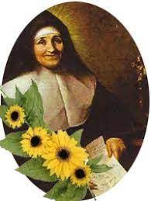

St Julie pray for us, protect us and bless us.

