Dear Parents,


Remembrance Day
Our children have spent the last two weeks learning about and reflecting on the sacrifices made by so many brave men and women during times of conflict. Today everyone observed 2 minutes silence at 11am during which the children were respectful and reflective. In school they have completed lots of different activities, thoughtful poems, artwork and writing and have created some lovely poppy displays. In history lessons, Year 5 have been investigating the World War 1 graves in Eccleston and today went on a trip to Imperial War Museum. The Reception class had their own Remembrance Service in the school grounds, proudly holding their poppies:

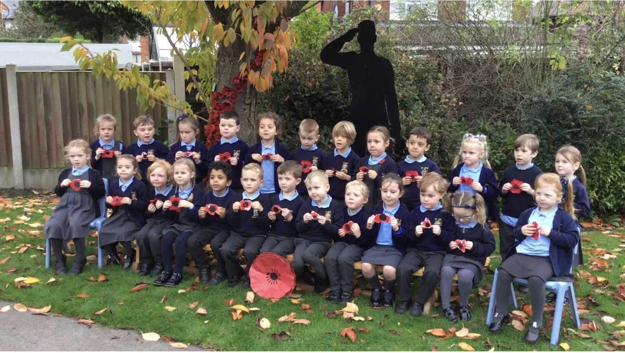

Children’s Liturgy
Children's liturgy is running again at St Julie’s Church at the 9.30 mass on Sunday mornings. It would be lovely to see the children there and this week is a Remembrance theme.


Judaism Week
During the year the children learn about other faiths. This week the children have been studying the Judaism aspect of the Come and See programme. You may like to talk to your child about what they have learnt.

Faith In Action
The Chaplain from De La Salle, Sam, visited Year 6 this week to launch their journey on achieving the Faith In Action award. During the year the children will be reflecting on how they live out our St Julie’s Core Values and our mission of following in the footsteps of Jesus and recording the activities and actions they have taken. This will link closely with our Live Simply aims this year too.


Anti-bullying week – wear Odd Socks to school on Monday
Next week is national Anti-Bullying Week 2022 and the theme this year is: Reach Out.
We will start with Odd Socks Day to mark the first day of Anti-Bullying Week. The children are encouraged to wear odd socks to school on Monday to highlight that we are all unique and that it is good to be different.
A flyer is attached with this bulletin from National Online Safety titled, “What parents & carers need to know about how to combat online bullying.”

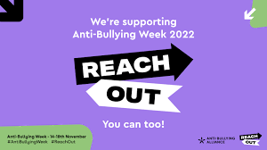

The theme for this year’s anti-bullying week is let's come together to reach out to stop bullying. Anti-Bullying Week will remind everyone whether it’s in school, at home, in the community or online, let’s reach out and show each other the support we need. The theme is intended to empower us to do something positive to counter the harm and hurt that bullying causes. With that in mind, we will be having an additional focus on Random Acts of Kindness in school – those simple gestures that can change someone’s day and the happy, warm feeling that treating people with kindness gives us all.


Marvellous Maths sessions
Last Summer we held our first Marvellous Maths sessions for each class which were well attended, and parents told us that they had appreciated the opportunity to come into school and share maths activities with their child/ren. We are going to be holding these sessions again over the next few weeks, starting with Year 3 on Tuesday 15th November. The aim of the sessions this term is to provide information to parents/carers about how they can support their child with maths homework. The teacher will provide an overview of the calculation strategies the children are taught to use in their current year group. There will be an opportunity to ask questions and then to share some activities with the children using the strategies and manipulatives discussed.
Parents/carers are invited to come to school via the front entrance on Brooklands Road at 2:40pm to join their child for the session. Don’t worry if you can’t make it, there will be school staff around to make sure all children can join in the maths activities.
Tuesday 15th November – Year 3
Thursday 17th November – Year 4
Monday 21st November – Reception
Tuesday 22nd November – Year 6
Wednesday 23rd November – Year 5
Thursday 24th November – Year 1
Thursday 1st December – Year 2


Children in Need
The children are invited to come in wearing spots on Friday 18th November in return for a donation for Children in Need to be made via School Money. The amount can be overtyped to allow you to donate what you feel is appropriate. This will be set up from next Monday. Spotty accessories with their school uniform may be worn: Pudsey ears, spotty ties, spotty tops, socks, bows etc. School shoes must be worn – no boots or trainers.


Boccia Competition
This week a team from year 2 went to take part in a Boccia competition. In assembly this morning they received their certificates and proudly told everyone about the rules for Boccia and how much they had enjoyed taking part. Congratulations to Lucas, Bobby, Teddy, Jackson, Zara and Freddie who represented St Julie’s so well.


Year 2 Nativity and Christmas Carol Services
Everyone is invited to join us in St Julie’s Church for the performance of the Nativity by Year 2 on Thursday 15th December at 10am. The whole school will be joining in with the Carols and the traditional retelling of the birth of Jesus, bringing us the true meaning of Christmas.
The other classes will each be performing a carol service in the school hall, dates as follows:

Wednesday 7th December 2:45pm - Reception
Friday 9th December 2:45pm - Year 4
Monday 12th December 2:45pm – Year 1
Tuesday 13th December 2:45pm – Year 6
Wednesday 14th December 2:45pm – Year 5
Thursday 15th December 2:45pm – Year 3

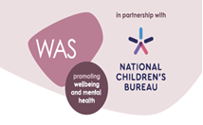
Wellbeing Award For Schools (WAS)
To continue promoting health and wellbeing, St Julie’s is taking part in the Wellbeing Award for Schools (WAS).
The Wellbeing Award is developed in partnership with the National Children’s Bureau (NCB), the award is intended to help schools prepare and equip themselves to promote emotional wellbeing and positive mental health across the whole-school community. NCB’s vision is an education system where good emotional wellbeing and mental health are at the heart of the culture and ethos of all schools, so that pupils, with the support of their teachers, can build confidence and flourish.
In order to evaluate our current provision, we need your input. Your views are important in helping us understand what we are doing well and how we can do even better. An email has been sent today with further information attached about the award.
Can you please complete the wellbeing survey following the link https://app.awardplace.co.uk/stakeholder-evaluations/user-survey/63614ebeca897


Attendance
Excellent attendance at school is important to allow a child to fulfil their potential. I am confident in your support in ensuring that your child strives for 100% attendance each week. Holidays during term time will not be authorised
Prior to the pandemic our whole school attendance for the year was 98% so this is the target we are aiming for this year.
Each week we will report on attendance figures for each year group.

Year Group | % Attendance for w/e 11.11.22
Year R | 97.78
Year 1 | 91.71
Year 2 | 98.29
Year 3 | 99.71
Year 4 | 96.67
Year 5 | 98.75
Year 6 | 98.57

Well done to Year 3 who had the highest attendance this week.
Our whole school attendance this week is 97.35%


Christmas Jumper Day – Friday 9th December
Children grow so quickly that often a Christmas jumper is only worn a couple of times before a child has outgrown it. To help reduce costs at what is a very expensive time of year we would like to be able to offer pre-loved Christmas Jumpers from the school foyer. If you have a Christmas jumper in good condition, please could you send it into school, washed and with a hanger – these will then be available to take from the school foyer for a small donation. Thank you.


PFA Events

The PFA would be grateful for donations of chocolate for the Christmas Bingo taking place on Thursday 24th November. Please send into school next week. Many thanks.

This term’s events include:
Friday 18th November - Infant DVD Afternoon 3:20 – 5pm Letters have been sent home today – please check your child’s book bag.
Friday 25th November - Junior DVD afternoon 3:20 – 5pm
Thursday 24th November - Christmas Bingo 6:30pm Parish Hall
Friday 2nd December - Christmas light switch on 4:30pm in school hall
Sunday 11th December - Christmas Fair 2 – 5pm Parish Hall
Next PFA meeting: Wednesday 16th November, 6pm in school. All welcome.

Christmas Dinner

Mrs Finney will be serving her tasty, Christmas Dinner on Wednesday 14th December. If your child normally has a packed lunch but would like to have a school meal on Christmas Dinner Day, a survey will be available on School Spider next week for you to complete. The lunch costs £2.50 and can then be paid for via School Money once you have completed the request on School Spider. All children who have a hot dinner already will get a Christmas dinner so you do not need to complete the School Spider survey.



St Julie’s Awards of the Week

 | Star for showing core value of Unity. | Book explorer | Marvellous mathematician
Reception | Nancy H | Cameron T | Lucy A-H
Year 1S | Gia G | Josefina D | Lennie R
Year 1J | Daniel R
Year 2 | Freddie F | Seth C | Thomas O
Year 3 | Molly T | Elissa W | Annabelle B
Year 4 | Bonnie R | Amelia B | Robert E
Year 5 | Eleanor | Sophia S | Charlie L
Year 6 | Matthew A | Noah B | Ava F

Diary w/c 14.11.22
Monday KS2 Boardgames 3:20 – 4:15
KS2 Garage band 3:20 – 4:15
Governors’ Personnel Committee

Tuesday 2:40pm Marvellous Maths session – Year 3
Y5/6 Athletics 3:20 - 4:15

Wednesday Y2 Spanish 3:20 - 4:00
Y1/2 Lego/Construction club 3:20 - 4:15
Y5/6 Young Voices choir 3:20 - 4:15
Y4/5 Cheerleading 3:20 - 4:15
KS2 Sewing/craft 3:20 - 4:15
6pm PFA meeting in school – please come along

Thursday Year 3 Forest School Day
2:40pm Marvellous Maths session – Year 4

Friday PFA Infant DVD night until 5pm

Further dates for your Diary
Monday 28 November - Apple of my eye cookery session Year 4
Thursday 1 December - Forest School day Year 5
Thursday 1 December - Year 6 trip to Prescot Shakespeare Theatre – A Christmas Carol
Tuesday 6 December - Learn to work programme session 3 – Year 6
Friday 9 December - Christmas Jumper Day
Wednesday 14 December - Christmas Dinner day
Thursday 15 December - Nativity in Church at 10am – Year 2
Monday 19 December - Junior Christmas Party day
Tuesday 20 December - Infant Christmas party day
Wednesday 21 December - School closes for Christmas break.



“A caring family school, where we learn, grow and walk in the footsteps of Jesus.”

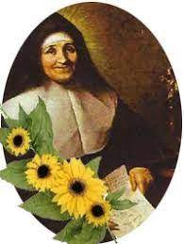

St Julie pray for us, protect us and bless us.

