Dear Parents,


Advent
This Sunday marks the start of Advent and the children will begin their Advent journey in school next week. Advent is a time of preparation, reflection and welcoming Jesus

into our lives. It is a great time for the family to spend time at home thinking of all they have to be grateful for and praying together for their hopes for the future.
Please see the RE tab on the website for more Advent activities and the RE newsletter.

Christmas is coming!
Next week we will take delivery of THREE wonderful Christmas trees generously gifted by the PFA marking the start of a most exciting time for the children in school. The tree in the school hall will be for the children to decorate with their Christmas wishes and there will be one that can be seen at each gate which will be lit for friends and family to enjoy at drop off and pick up times.
The official switch on will take place on Friday 2nd December at 4:30pm. Please come along to enjoy the singing around the tree. The PFA will be selling seasonal refreshments and selling raffle tickets – so don’t forget to bring your wallet!

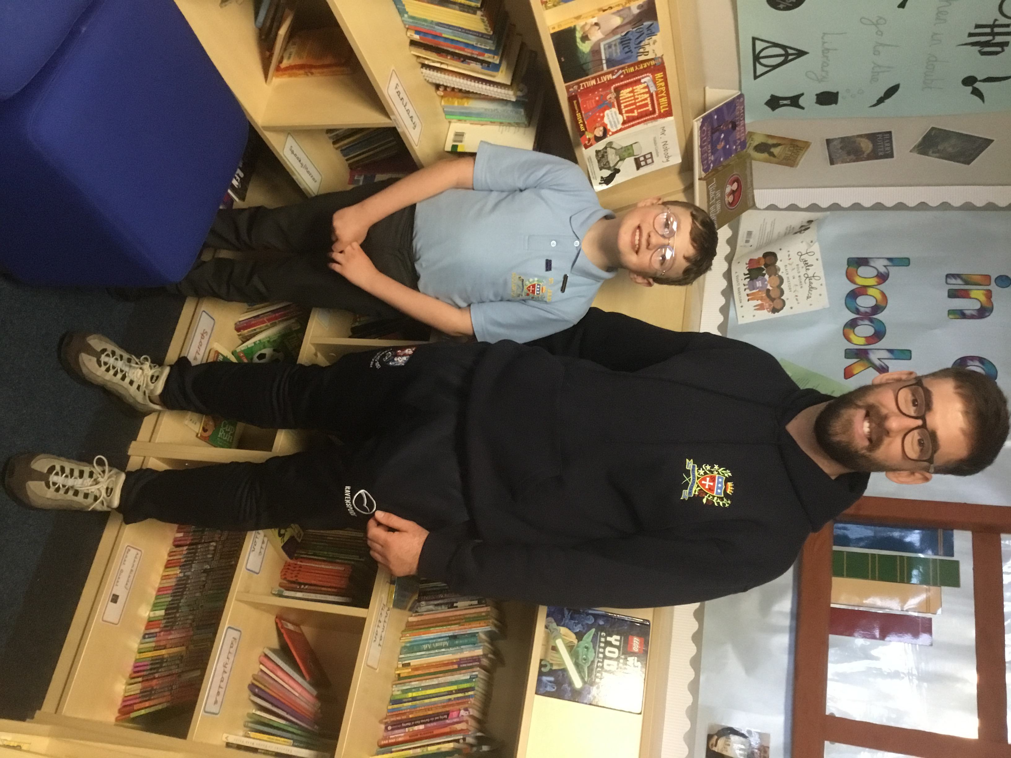
Congratulations to Mr Royle!
This week we were delighted to hear that Mr Royle had been nominated by Robert in Year 4 as his most inspirational teacher in a competition run by the Magic Breakfast show. The radio show came to St Julie’s on Monday and during the interview announced that in fact Robert and Mr Royle had won the competition! A huge thank you to Robert for nominating Mr Royle, who was honoured to be chosen. The radio presenter Eloise Carr came to school to conduct the interviews and Robert and Mr Royle also chatted to Ronan Keating and Harriet Scott back in the studio in London. It was a great surprise to learn that St Julie’s will be receiving a prize of £2000 and a set of Roald Dahl books too! The children in Year 4 also made their radio debut saying “Good morning” to listeners all over the country. Mr Royle spoke on air about how he loves teaching the children, seeing their smiling faces every day, supporting them and then the wonder of that light bulb moment when learning has taken place. Well done Mr Royle and all of our amazing staff at St Julie’s who go over and above for all the children every day!

Sacramental programme for Year 4
Parents/carers of children in Year 4 who have been baptised and wish their child to receive the Sacraments of Forgiveness (First Confession) and the Eucharist (First Holy Communion) are invited to attend an initial meeting on Thursday 1st December at 6pm in the school hall. The catechists will explain the Sacramental preparation required in the Always With You programme in order for your child to prepare to make the Sacraments. It is important that if you wish to start the Sacramental journey you attend the meeting. Further dates will be given out at the meeting.

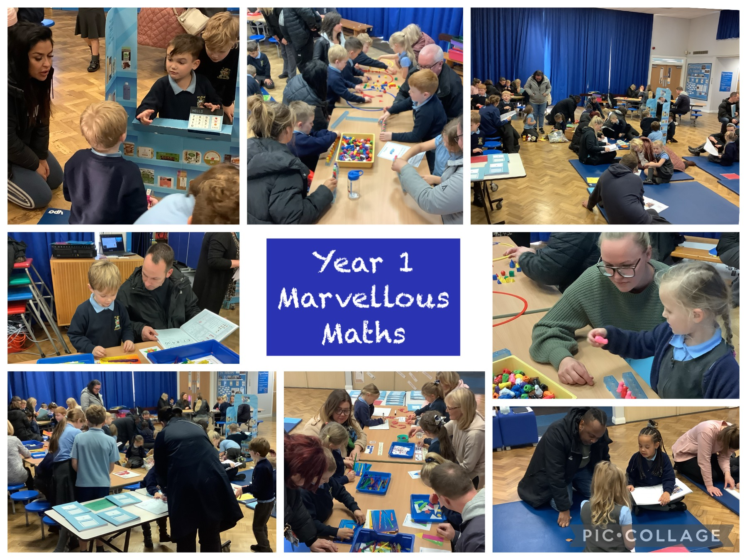
Marvellous Maths sessions
Thank you once again to all those who have joined the children for their maths session. We hope you have found them helpful and informative – the feedback has certainly been very positive.
The final session is for Year 2 on Thursday 1st December.
Parents/carers are invited to come to school via the front entrance on Brooklands Road at 2:40pm to join their child for the session. Don’t worry if you can’t make it, there will be school staff around to make sure all children can join in the maths activities.


The role of the Wellbeing Ambassador was decided by the team and is listed below:
- To spread happiness and peace throughout the school.
- To welcome new children and staff to the school.
- To be kind, caring and helpful towards others.
- To always treat others as you would like to be treated yourself.
- To promote and put into place the 'Six Core Values'. (Respect, Unity, Resilience, Love, Hope and Honesty)
- To always walk in the Footsteps of Jesus’

The Wellbeing Ambassadors are made up of pupils from Y2-Y6 classes.
Year 2: Darcey C and Fraser W
Year 3: India S and Thomas H
Year 4: Robert F and Josie-Mo F
Year 5: Myla M and Daniel B
Year 6: Isla B, Daniel L and Tiana M


Children in Need
Thank you for your donations, £150.00 was raised via School Money which will be sent off to the charity.


Parking
When dropping off at the Church gate, please drive slowly and park sensibly - do not leave children at the top of the car park but walk them down to the gate to a member of staff. Please walk children along the path around the car park for their safety and please take care when backing out and driving your car through the car park.

For the safety of children and other road users please do not park on the junction of Acacia Grove and Brooklands Road – this causes a narrowing of the road at the junction. Do not stop here to drop children off. There is plenty of parking further up and down Brooklands Road.

Message from church:
The concrete inspection of the church will take place on Monday 28th November. It would be most helpful if you could use the rear car park so as to allow the contractors access to the front and sides of the church.

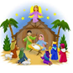
Year 2 Nativity and Christmas Carol Services
Everyone is invited to join us in St Julie’s Church for the performance of the Nativity by Year 2 on Thursday 15th December at 11:15am. (Please note the change of time due to cleaning taking place in Church.) The whole school will be joining in with the Carols and the traditional retelling of the birth of Jesus, bringing us the true meaning of Christmas.
The other classes will each be performing a carol service in the school hall, dates as follows:
Wednesday 7th December 2:45pm - Reception

Thursday 8th December 2:45pm - Year 4 (change of day so can include violin performance)
Monday 12th December 2:45pm – Year 1
Tuesday 13th December 2:45pm – Year 6
Wednesday 14th December 2:45pm – Year 5
Thursday 15th December 2:45pm – Year 3

Attendance
Excellent attendance at school is important to allow a child to fulfil their potential. I am confident in your support in ensuring that your child strives for 100% attendance each week. Holidays during term time will not be authorised
Prior to the pandemic our whole school attendance for the year was 98% so this is the target we are aiming for this year.
Each week we will report on attendance figures for each year group.

Year Group | % Attendance for w/e 25.11.22
Year R | 99.26
Year 1 | 97.14
Year 2 | 95.71
Year 3 | 98.86
Year 4 | 92.78
Year 5 | 97.81
Year 6 | 97.71

Well done to Year R who had the highest attendance this week.
Our whole school attendance this week is 97.04%


Christmas Jumper Day – Friday 9th December
Children grow so quickly that often a Christmas jumper is only worn a couple of times before a child has outgrown it. To help reduce costs at what is a very expensive time of year we would like to be able to offer pre-loved Christmas Jumpers from the school foyer. If you have a Christmas jumper in good condition, please could you send it into school, washed and with a hanger – these will then be available to take from the school foyer for a small donation. Thank you.


PFA Events
The PFA Bingo was a huge success last night. Thank you to all those who came and filled the church hall. The amount raised was tremendous - £543.
Thank you also for your generous donations today for the Christmas Fair – it is going to be another wonderful event.
This term’s events include:
Friday 2nd December - Christmas light switch on 4:30pm in school hall
Sunday 11th December - Christmas Fair 2 – 5pm Parish Hall
Next PFA meeting: Wednesday 11th January 2023, 6pm in school. All welcome.

Christmas Dinner

Mrs Finney will be serving her tasty, Christmas Dinner on Wednesday 14th December. If your child normally has a packed lunch but would like to have a school meal on Christmas Dinner Day, a survey will be available on School Spider next week for you to complete. The lunch costs £2.50 and can then be paid for via School Money once you have completed the request on School Spider. All children who have a hot dinner already will get a Christmas dinner so you do not need to complete the School Spider survey.



St Julie’s Awards of the Week

 | Star for showing core value of Unity. | Book explorer | Marvellous mathematician
Reception | Caleb | Georgie | Cameron
Year 1S | Noah C |  | Jasmine J
Year 1J | Josie K | Daniel R
Year 2 | Nuala L | George McN | Ben M
Year 3 | India S | Georgia S | Rory B
Year 4 | Sophia L | Josie-Mo F | Alexander F
Year 5 | Alfie H | Lucas P | Evie
Year 6 | Lucy K | Sophie K | Alexa V


Parent Governor election
St Julie’s Governing Body are now looking to elect a Parent Governor. Details about the role of Governors and Nomination papers have been emailed to parents. If you would like to stand for election please complete the nomination form and return it to the school no later than Friday 2nd December 2022. You may also include a short personal statement to support your nomination, which should be no longer than 250 words. Self-nominations will be accepted but if you are nominating another parent, please seek their prior consent. Forms can be sent in or emailed to the school office - emails marked “Parent Governor nomination.” Thank you.

Diary w/c 28.11.22
Monday Apple of my eye cookery session Year 4
KS2 Boardgames 3:20 – 4:15
KS2 Garage band 3:20 – 4:15

Tuesday Y5/6 Athletics 3:20 - 4:15

Wednesday Y2 Spanish 3:20 - 4:00
Y1/2 Lego/Construction club 3:20 - 4:15
Y5/6 Young Voices choir 3:20 - 4:15
Y4/5 Cheerleading 3:20 - 4:15
KS2 Sewing/craft 3:20 - 4:15

Thursday 2:40pm Marvellous Maths session – Year 2
Year 6 trip to Shakespeare of the North Theatre
KS2 Eco club 3:20 – 4:15
Sacramental meeting for Year 4 parents/carers 6pm in school hall.

Friday Forest School Year 5
Christmas Tree light switch on 4:30pm

Further dates for your Diary
Monday 5 December - Year 1 trip to Warrington Museum
Tuesday 6 December - Learn to work programme session 3 – Year 6
Wednesday 7 December - Reception Carol Singing 2:45pm
Thursday 8 December - Year 2 Forest School
Thursday 8 December - Year 4 Carols and Violins 2:45pm
Friday 9 December - Year 3 Share a Story session 2:40pm
Friday 9 December - Christmas Jumper Day
Sunday 11th December - PFA Christmas Fair; 2 – 5pm Parish Hall
Monday 12 December - Year 1 Carol Singing 2:45pm
Tuesday 13 December - Year 6 Carol Singing 2:45pm
Wednesday 14 December - Christmas Dinner day
Wednesday 14 December - Year 5 Carol Singing 2:45pm
Thursday 15 December - Nativity in Church at 11:15am – Year 2
Thursday 15 December - Year 3 Carol Singing 2:45pm
Monday 19 December - Junior Christmas Party day
Tuesday 20 December - Infant Christmas party day
Wednesday 21 December - School closes for Christmas break.


“A caring family school, where we learn, grow and walk in the footsteps of Jesus.”

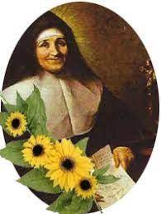

St Julie pray for us, protect us and bless us.

